Bangladesh Medical Association (BMA)
List of Life Member-1136
29. BMA Khulna Branch

Sl No | Voter No | Voter Details
1 | Voter No  LM-0400053  No Image | DR. RAZIA SULTANA  F/Name:  M/Name:  BM & DC Reg. No:  NID:  Cell:  Address: Road # 6, House # 25, Sonadanga R/A, Khulna.  Blood Group:  TRANSFERED to BMA Dhaka City  LM-1405543
2 | Voter No  LM-2900001  No Image | DR. MAHBUBUR RAHMAN  F/Name:  M/Name:  BM & DC Reg. No:  NID:  Cell:  Address:  Blood Group:  E X P I R E D
3 | Voter No  LM-2900002  No Image | DR. ALHAJ DR. CAPT. M.A. WAHED  F/Name:  M/Name:  BM & DC Reg. No:  NID:  Cell:  Address:  Blood Group:  E X P I R E D
4 | Voter No  LM-2900003  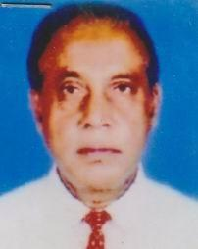 | DR. MD. AMANULLAH  F/Name: Late Md. Mohiuddin Ahmed  M/Name:  BM & DC Reg. No: 2231  NID:  Cell: 01711334463  Address: 11,Bhairab Starand Road, Khulna  Blood Group: B+
5 | Voter No  LM-2900004  No Image | DR. ASHRAF HOSSAIN KHAN  F/Name:  M/Name:  BM & DC Reg. No:  NID:  Cell:  Address:  Blood Group:  E X P I R E D
6 | Voter No  LM-2900005 | PROF. DR. SULTANA JAHAN  F/Name:  M/Name:  BM & DC Reg. No: 674  NID:  Cell: 01711529226  Address: House # 40, Apartment C/A Road-10 / A, Dhanmondi, Dhaka-1206  Blood Group: O+
7 | Voter No  LM-2900006  No Image | DR. M.A. MANNAF  F/Name: Rashed Ali Mollick  M/Name:  BM & DC Reg. No:  NID:  Cell:  Address: Muzgunni Khulna  Blood Group:
8 | Voter No  LM-2900007  No Image | DR. MD. MATIAR RAHMAN  F/Name:  M/Name:  BM & DC Reg. No:  NID:  Cell:  Address:  Blood Group:  E X P I R E D
9 | Voter No  LM-2900008 | DR. ANWARUL AZAD  F/Name: Khalilur Rahman  M/Name:  BM & DC Reg. No: 6568  NID:  Cell: 01711482944  Address: 31/4 (Old 75), College Boundary Road Palpara, Boyra Khulna-9000  Blood Group: O+
10 | Voter No  LM-2900009  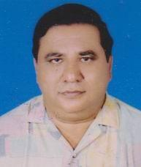 | PROF. DR. QAZI HAMEED ASGHAR  F/Name: Late: K.m.e. Subhan  M/Name: Late: Nasima Subhan  BM & DC Reg. No: 6133  NID:  Cell: 01711325600  Address: 3/2, Hazi Mohsin Road, Khulna-9000  Blood Group: O+
11 | Voter No  LM-2900010  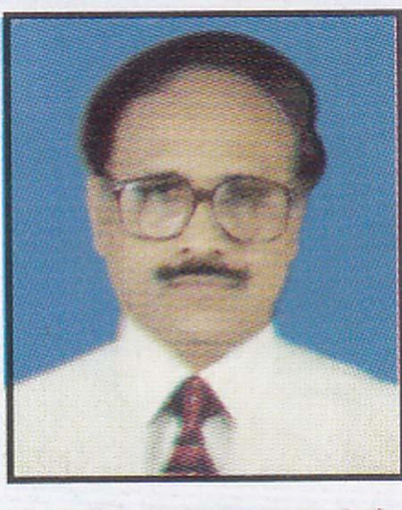 | DR. QUAZI ABDUL HAMID  F/Name: Quazi Lutfar Rahman  M/Name:  BM & DC Reg. No:  NID:  Cell:  Address: 59/1, Shamsur Rahman Road, Khulna  Blood Group: O+
12 | Voter No  LM-2900011  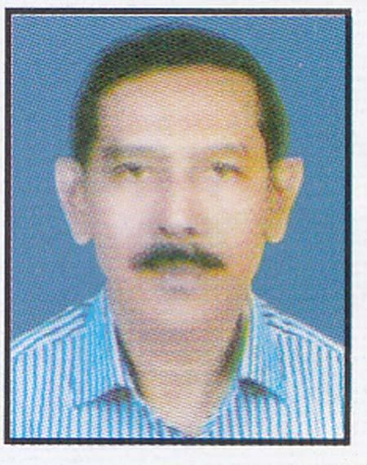 | DR. ASHISH KUMAR SAHA  F/Name: Sudhir Kumar Saha  M/Name:  BM & DC Reg. No: 13323  NID:  Cell: 01711535154  Address: Khan Valley, Flat-5D 23, South Central Road, Khulna  Blood Group: O+
13 | Voter No  LM-2900012  No Image | DR. MD. ABUL FAZAL  F/Name:  M/Name:  BM & DC Reg. No:  NID:  Cell:  Address:  Blood Group:  E X P I R E D
14 | Voter No  LM-2900013  No Image | DR. NIRANJAN MITRA  F/Name: Late Brojendra Nath Mitra  M/Name:  BM & DC Reg. No:  NID:  Cell:  Address: Cure Home KDA Avenue Khulna  Blood Group: O+
15 | Voter No  LM-2900014  No Image | DR. S.A. SATTAR  F/Name:  M/Name:  BM & DC Reg. No:  NID:  Cell:  Address: 273, West Agargaon Dhaka  Blood Group:
16 | Voter No  LM-2900015  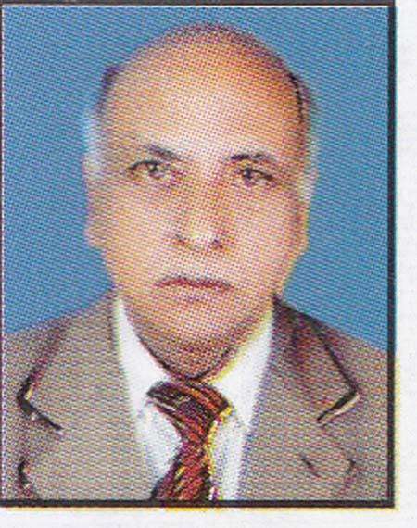 | DR. K.A. HALIM  F/Name: Alhaj Maulana Fazaluddin Khan  M/Name:  BM & DC Reg. No: 453  NID:  Cell: 01915767850  Address: Daulatpur Khulna  Blood Group: AB+
17 | Voter No  LM-2900016  No Image | DR. SYED MUNIR AHMED (DEIDON)  F/Name:  M/Name:  BM & DC Reg. No:  NID:  Cell:  Address:  Blood Group:  E X P I R E D
18 | Voter No  LM-2900017 | DR. RANJIT KUMAR NATH  F/Name: K.m. Nath  M/Name:  BM & DC Reg. No: 6620  NID:  Cell: 01711667997  Address: Road # 1, House # 185 Nirala Residential Area, Khulna  Blood Group: O+
19 | Voter No  LM-2900018  No Image | DR. MD. SERAJUL HOQUE  F/Name:  M/Name:  BM & DC Reg. No:  NID:  Cell:  Address:  Blood Group:  E X P I R E D
20 | Voter No  LM-2900019 | DR. GAZI MIZANUR RAHMAN  F/Name: Late Saker Mahmud  M/Name: 01714086827  BM & DC Reg. No: 16416  NID:  Cell: 01714086827  Address: A-19-21 Masjid Swarani Sonadanga Khulna-9100  Blood Group: O+
21 | Voter No  LM-2900020  No Image | DR. MD. ARIF KABIR  F/Name: Dr. M.a. Haye  M/Name:  BM & DC Reg. No:  NID:  Cell:  Address: House-1, Block-B Khalishpur R/A Khulna  Blood Group:
22 | Voter No  LM-2900021 | DR. MD. ASHRAFUZZAMAN  F/Name: Late S. Sarwar Ahmed  M/Name:  BM & DC Reg. No: 7233  NID:  Cell: 01711299166  Address: 2, Zaman Mahal Moulvi Para Khulna  Blood Group: O+
23 | Voter No  LM-2900022  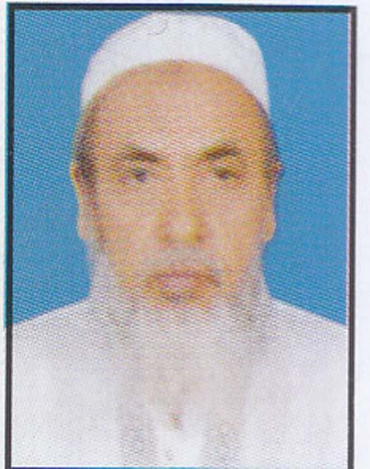 | DR. MD. TORAB ALI  F/Name: Alhaj Md. Osman Ali Sarder  M/Name:  BM & DC Reg. No: 7043  NID:  Cell: 01670715064  Address: 28, Sher-E-Bangla Road Khulna  Blood Group:
24 | Voter No  LM-2900023  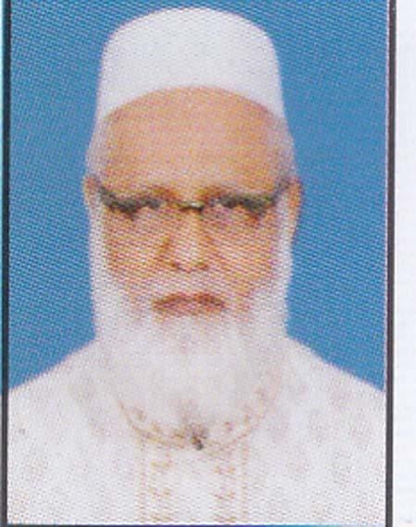 | DR. S.K. MAHFUZUL HOQUE  F/Name: Late Sk. Noor Ali  M/Name:  BM & DC Reg. No: 6727  NID:  Cell: 01715211722  Address: Momena Clinic Choto Boyra, Doctor’s Gole Khulna  Blood Group: B+
25 | Voter No  LM-2900024  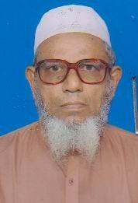 | DR. ALHAJ A.F.M. ABDUS SOBHAN  F/Name: Late Noor Mohammed Joarder  M/Name:  BM & DC Reg. No: 2313  NID:  Cell:  Address: 160, Haji Mohsin Road, Abu Khan Lane Khulna,  Blood Group: B+
26 | Voter No  LM-2900025  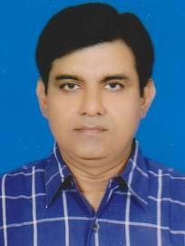 | DR. M.R. KHAN  F/Name: Dr. Habibullah Khan  M/Name:  BM & DC Reg. No: 13413  NID:  Cell: 01711428583  Address: House-45, Road-8 Nirala R/A, Khulna  Blood Group: AB+
27 | Voter No  LM-2900026 | DR. SHAIKH MOHAMMAD AKHTARUZZAMAN  F/Name: Abdul Khaleque Shaikh  M/Name:  BM & DC Reg. No: 13495  NID:  Cell: 01711187250  Address: 14, Munshipara 1st Lane, Khulna-9100  Blood Group: O+
28 | Voter No  LM-2900027  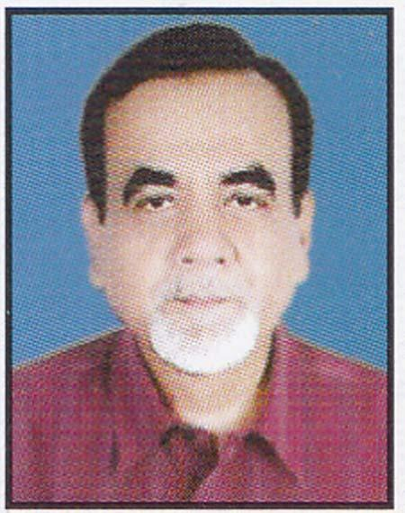 | PROF. DR. A.B.M. ALI AKBAR BISWAS  F/Name: Hazee Abdul Khaleque Biswas  M/Name:  BM & DC Reg. No: 9216  NID:  Cell: 01711123761  Address: Departmental Head (Surgery) Shahabuddin Medical College Dhaka.  Blood Group: B+  E X P I R E D
29 | Voter No  LM-2900028  No Image | DR. JALAL AHMED  F/Name:  M/Name:  BM & DC Reg. No:  NID:  Cell:  Address: Prof. Of Cataract  National Institute Of Opthalmology  Sher-E-Bangla Nagar, Dhaka.  Blood Group:  TRANSFERED to BMA Dhaka City  LM-1405543
30 | Voter No  LM-2900029  No Image | DR. MD. DELWAR HOSSAIN  F/Name:  M/Name:  BM & DC Reg. No:  NID:  Cell:  Address:  Blood Group:  E X P I R E D
31 | Voter No  LM-2900030  No Image | DR. MD. NURUL ISLAM  F/Name: Late Md. Abdul Aziz  M/Name:  BM & DC Reg. No:  NID:  Cell:  Address: 63, Mazid Swarani Sonadanga, Khulna  Blood Group:
32 | Voter No  LM-2900031  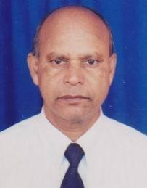 | DR. MD. SOLAIMAN  F/Name: Late Md. Abdul Latif  M/Name:  BM & DC Reg. No: 338  NID:  Cell: 01711482844  Address: 29, Shamsur Rahman Road Khulna  Blood Group: B+
33 | Voter No  LM-2900032  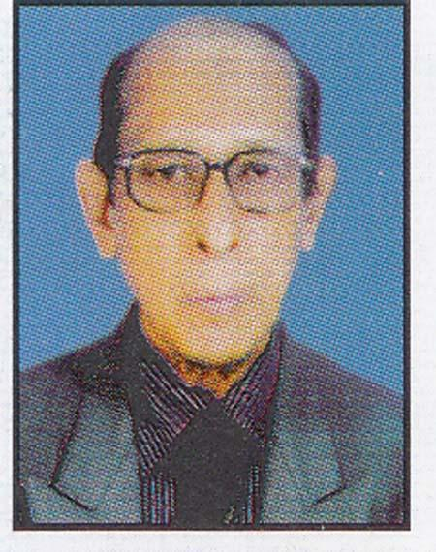 | DR. MD. MUZIBUR RAHMAN  F/Name: Alhaj Mozaher Uddin Ahmed  M/Name:  BM & DC Reg. No:  NID:  Cell: 01718550721  Address: 143, Boyra Main Road Khulna  Blood Group:
34 | Voter No  LM-2900033  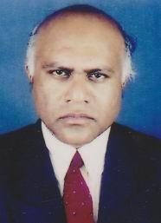 | DR. S.M. ABDUL MALEQUE  F/Name: Late Mohiuddin Ahmed  M/Name:  BM & DC Reg. No: 9088  NID:  Cell: 01711450244  Address: 19, Miapara Main Road Khulna-9100  Blood Group: O+
35 | Voter No  LM-2900034  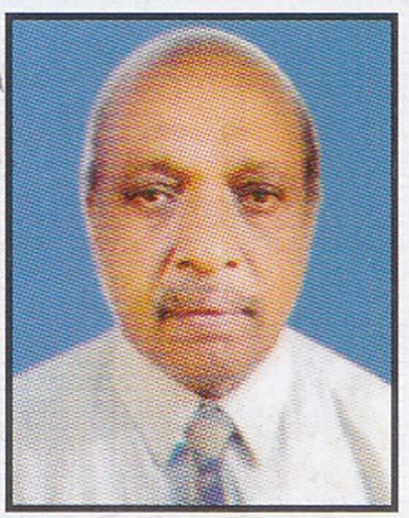 | DR. A.K.M. MUZIBUR RAHMAN  F/Name: Late Fazlur Rahman  M/Name:  BM & DC Reg. No: 161  NID:  Cell: 01711331286  Address: 125/8, Nirala R/A Khulna.  Blood Group: B+
36 | Voter No  LM-2900035  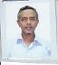 | DR. SYED REZAUL KARIM  F/Name: Syed Obaidul Kader  M/Name:  BM & DC Reg. No: 7143  NID:  Cell: 01711280323  Address: 7, Haji Mohsin Road Khulna  Blood Group: O+
37 | Voter No  LM-2900036  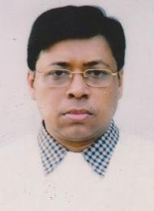 | DR. KAZI MUZAHIDUL ISLAM  F/Name: Late Kazi Nazrul Haque  M/Name:  BM & DC Reg. No: 17439  NID:  Cell: 01711297554  Address: Khalishpur Clinic Road-101, House-24, Khulna  Blood Group: AB+
38 | Voter No  LM-2900037  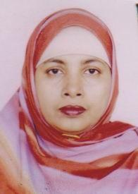 | DR. ISMAT ARA BINA  F/Name: Alhaj Azizur Rahman Khan  M/Name:  BM & DC Reg. No: 18093  NID:  Cell: 01711547554  Address: Khalishpur Clinic Road # 101, House # 41 Khalispur R/A, Khulna  Blood Group: AB+
39 | Voter No  LM-2900038  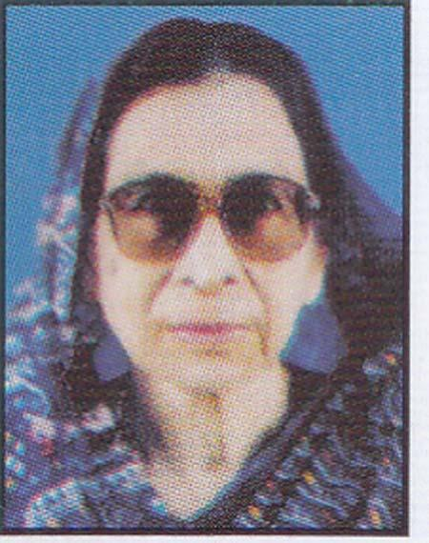 | DR. HOSNE ARA BEGUM  F/Name: Late Aftab Uddin Ahmed  M/Name:  BM & DC Reg. No:  NID:  Cell:  Address: Pabla Daulatpur Khulna  Blood Group: B+
40 | Voter No  LM-2900039  No Image | DR. SHAMIM ARA KHAN CHOWDHURY  F/Name: Khabir Uddin Khan Chowdhury  M/Name:  BM & DC Reg. No:  NID:  Cell:  Address: 1098, Shawrapara Mirpur Dhaka-1216  Blood Group:
41 | Voter No  LM-2900040  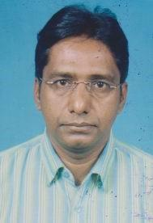 | DR. MD. ENAMUL HOQUE  F/Name: Ekhlasuddin Ahmed  M/Name:  BM & DC Reg. No: 21183  NID:  Cell: 01711953060  Address: 115, Islampur Road, Santidham More, Khulna  Blood Group: B+
42 | Voter No  LM-2900041  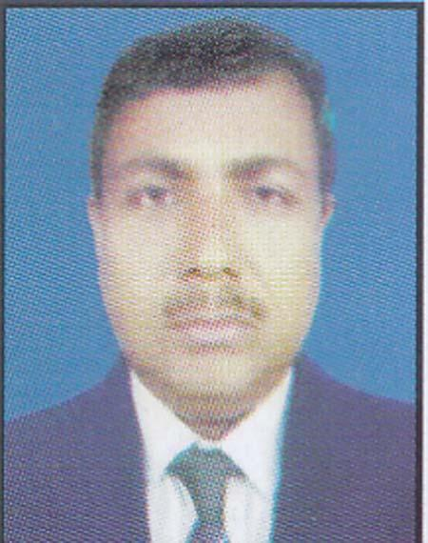 | DR. MD. SAYEDUR RAHMAN MIA  F/Name: Late Mozammel Haque Miah  M/Name:  BM & DC Reg. No: 15298  NID:  Cell: 01711404925  Address: South Parulia, Bayeshpur, Palash, Narsingdi.  Blood Group: A+
43 | Voter No  LM-2900042  No Image | DR. SYED AFZA IQBAL  F/Name: Syed Shamsuzzoha  M/Name:  BM & DC Reg. No:  NID:  Cell:  Address: Zia Manjil 83, South Centre Road Khulna  Blood Group:
44 | Voter No  LM-2900043  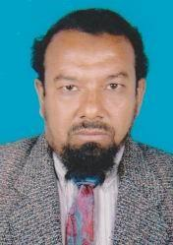 | DR. SHAHED RASHID MD. SAIFUL AZIZ  F/Name: Hafiz Md. Abdul Aziz  M/Name:  BM & DC Reg. No: 17676  NID:  Cell: 01716366077  Address: Asst. Professor, Resp. Medicine, KMC  Blood Group: A+
45 | Voter No  LM-2900044  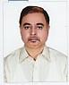 | DR. MD. ABUL HASSAN  F/Name: Md. Abdur Rouf Sarder  M/Name:  BM & DC Reg. No: 13853  NID:  Cell: 01920460188  Address: Professor (Paed) Gazi Medical College Khulna  Blood Group: AB+
46 | Voter No  LM-2900045  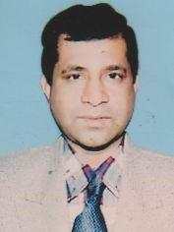 | DR. A.T.M. ABDULLAH  F/Name: Moulana Md. Amanat Ullah  M/Name:  BM & DC Reg. No: 158261  NID:  Cell: 01711299708  Address: Yousuf Roy 4, Mirzapur Road Khulna  Blood Group: O+
47 | Voter No  LM-2900046  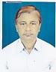 | DR. MD. SHADAT HOSSAIN  F/Name: Late Md. Majid Ali  M/Name:  BM & DC Reg. No:  NID:  Cell: 01711308796  Address: Asst. Director (Retd.) Karimnagar Boyra, Khulna.  Blood Group:
48 | Voter No  LM-2900047  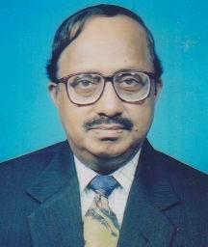 | DR. SARDER. HABIBUR RAHMAN  F/Name: Mvi.s. N. Ahmed  M/Name:  BM & DC Reg. No: 27  NID:  Cell: 01913568002  Address: 28, Sher-E-Bangla Road Khulna-9100  Blood Group: O+
49 | Voter No  LM-2900048  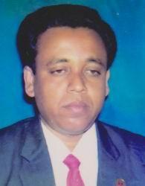 | DR. MD. ATAHAR HOSSAIN  F/Name: Mohammad Kader Mallick  M/Name:  BM & DC Reg. No: 13228  NID:  Cell: 01711321356  Address: 429, Hossain Complex, Guakhola, Noapara, Avaynagor jessore.  Blood Group: A+
50 | Voter No  LM-2900049  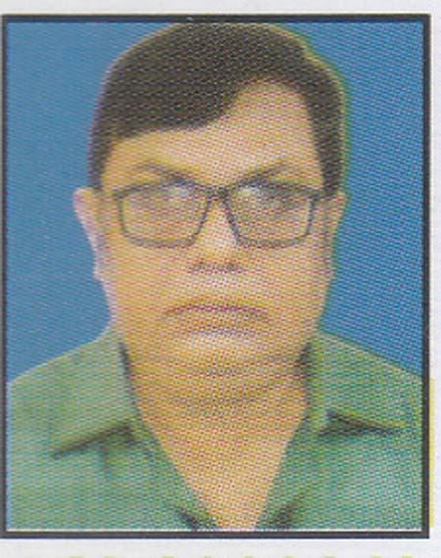 | PROF. DR. BISWAJIT BOSU  F/Name: Late Dr. Naresh Chandra Basu  M/Name:  BM & DC Reg. No: 8732  NID:  Cell: 01711950267  Address: 20/1, Shamsur Rahman Road Khulna.  Blood Group: B+
51 | Voter No  LM-2900050  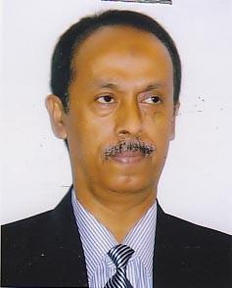 | PROF. DR. H.A.M. NAZMUL AHSAN  F/Name: Md. Hashmat Ali  M/Name:  BM & DC Reg. No: 10931  NID:  Cell: 01711343011  Address: Professor Popular Medical College, Dhanmondi-2, Dhaka.  Blood Group: A+
52 | Voter No  LM-2900051  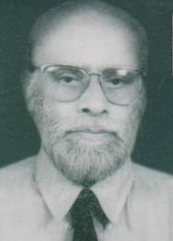 | DR. ALHAJ AFM. ANWAR UZZAMAN KHAN  F/Name: Late Md. Abul Hashem  M/Name:  BM & DC Reg. No:  NID:  Cell:  Address: Haji Meher Ali Road Iqbal Nagar, Khulna  Blood Group:  E X P I R E D
53 | Voter No  LM-2900052  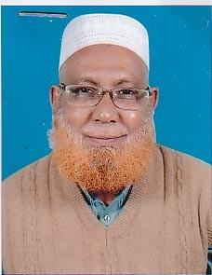 | DR. A.K.M. ABDUL HAMID  F/Name: Alhaj Torab Ali Gazi  M/Name:  BM & DC Reg. No: 4416  NID:  Cell: 01716214182  Address: Road # 11, House # 160 Sonadanga R/A Khulna  Blood Group: O+
54 | Voter No  LM-2900053  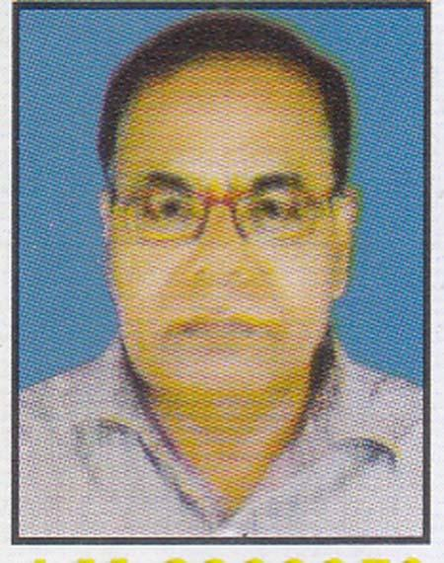 | DR. SUDHANSHU SHEKHER MALAKER  F/Name: Late Sarat Chandra Malakar  M/Name:  BM & DC Reg. No: 6707  NID:  Cell: 01711280065  Address: 48/2, Miapara Main Road, Khulna.  Blood Group: B+
55 | Voter No  LM-2900054  No Image | DR. MD. MIZANUR RAHMAN  F/Name:  M/Name:  BM & DC Reg. No:  NID:  Cell:  Address: Eye M.O. (Surgery-2)  Dhaka Medical College, Dhaka.  Blood Group:  TRANSFERED to BMA Dhaka City  LM-1405543
56 | Voter No  LM-2900055  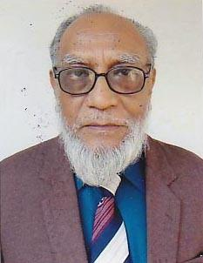 | DR. MA. LATIF MIA  F/Name: Late Md. Monsoor Ahmed  M/Name:  BM & DC Reg. No: 1538  NID:  Cell: 01711372999  Address: 66, Farazipara Main Road Khulna.  Blood Group: B+
57 | Voter No  LM-2900056  No Image | DR. MD. ABDUL MOJID  F/Name:  M/Name:  BM & DC Reg. No:  NID:  Cell:  Address:  Blood Group:  E X P I R E D
58 | Voter No  LM-2900057  No Image | DR. MIR NURUL ISLAM  F/Name:  M/Name:  BM & DC Reg. No:  NID:  Cell:  Address:  Blood Group:  E X P I R E D
59 | Voter No  LM-2900058  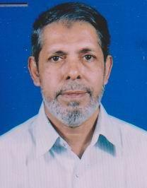 | DR. ALHAJ DR. SYED MASUDUN NABI  F/Name: Late Syed Abdul Bari  M/Name:  BM & DC Reg. No: 2228  NID:  Cell:  Address: 80, Miapara Road Khulna  Blood Group: A+
60 | Voter No  LM-2900059  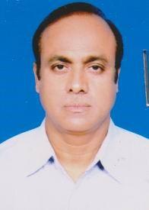 | DR. MD. SHAWKAT ALI LASKAR  F/Name: Late Shorab Ali Laskar  M/Name:  BM & DC Reg. No: 10090  NID:  Cell: 01711840710  Address: 86, Islampur Road Dolkhola, Khulna  Blood Group: B+
61 | Voter No  LM-2900060 | DR. MORSHED AHMED  F/Name: Late Mojlish Ahmed  M/Name:  BM & DC Reg. No: 10532  NID:  Cell: 01711218191  Address: Dilruba Manzil, 138 Khanjahan Ali Road Khulna  Blood Group: A+
62 | Voter No  LM-2900061  No Image | PROF. DR. A.B.M GOLAM ROBBANI  F/Name:  M/Name:  BM & DC Reg. No:  NID:  Cell:  Address: Asstt. Prof. (Urology) Rajshahi Medical College Rajshahi.  Blood Group:
63 | Voter No  LM-2900062  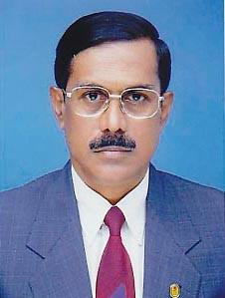 | DR. MD. BAHAUDDIN MALIK  F/Name: Mvi. Shahabuddin Malik  M/Name:  BM & DC Reg. No: 3701  NID:  Cell: 01715071622  Address: F-5/ H, Hal-Udayan Rokto Korobi P-J4, Mirpur-3, Dhaka-1203.  Blood Group: O+
64 | Voter No  LM-2900063  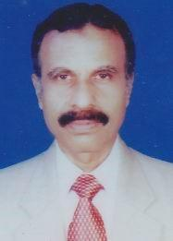 | DR. MD. ABDUR RAB  F/Name: Md. Golam Rahman  M/Name:  BM & DC Reg. No: 6123  NID:  Cell: 01712238910  Address: Mujfunni R/A, Muzgunni, Khulna.  Blood Group: O+
65 | Voter No  LM-2900064  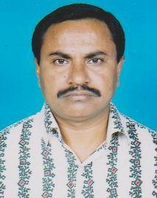 | DR. MD. SHAHJAHAN ALI  F/Name: Late Roychuddin Sarder  M/Name:  BM & DC Reg. No: 12185  NID:  Cell: 01715509647  Address: 29, Sher-E-Bangla Road Khulna  Blood Group: O+
66 | Voter No  LM-2900065  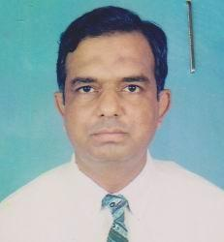 | DR. SYED ABU ASFAR  F/Name: Late Syed Abu Hamid  M/Name:  BM & DC Reg. No:  NID:  Cell: 01711826697  Address: National Sea Food 20/3, Fakirbari Lane, Hazi Mohsin Road, Khulna  Blood Group: O+
67 | Voter No  LM-2900066  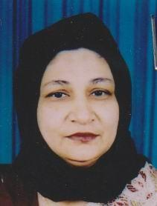 | DR. FOUZIA BEGUM  F/Name: Muhammad Bazlul Haque  M/Name:  BM & DC Reg. No: 13302  NID:  Cell: 01711250477  Address: National Sea Food 20/3, Fakirbari Lane, Hazi Mohsin Road, Khulna  Blood Group: O+
68 | Voter No  LM-2900067  No Image | DR. MD. MOHSIN MOLLA  F/Name: Molla Abdul Hamid  M/Name:  BM & DC Reg. No:  NID:  Cell:  Address: Ex-Medical Officer UHC, Rupsa, Khulna  Blood Group:
69 | Voter No  LM-2900068  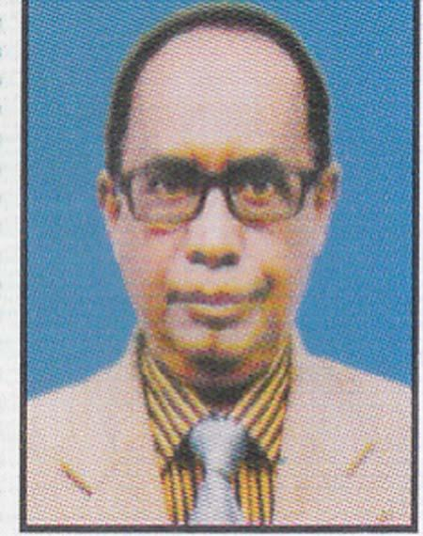 | PROF. DR. EASIN ALI GAZI  F/Name: Late Ahmed Ali Gazi  M/Name:  BM & DC Reg. No: 8581  NID:  Cell: 01711342229  Address: Prof. (Community Medicine) Gazi Medical College, Sonadanga Khulna.  Blood Group: A+
70 | Voter No  LM-2900069  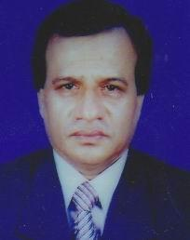 | DR. MOLLAH HARUN-AR-RASHID  F/Name: Late Md. Mominuddin Mollah  M/Name:  BM & DC Reg. No: 9243  NID:  Cell: 01718551893  Address: 54, Jalil Sawrani, Boyra, Khulna  Blood Group: B+
71 | Voter No  LM-2900070  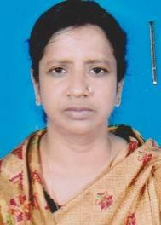 | DR. SALINA YASMIN  F/Name: Md. Rustom Ali Zomadder  M/Name:  BM & DC Reg. No: 12187  NID:  Cell: 01711841264  Address: 29, Sher-E-Bangla Road, Khulna  Blood Group: B+
72 | Voter No  LM-2900071 | DR. A.K.M. MAMUNUR RASHID  F/Name: A.k.m. Sultan Ahmed  M/Name:  BM & DC Reg. No: 5835  NID:  Cell: 01711814565  Address: 3/12, Baghbari Road, Mohammadpur Dhaka-1207.  Blood Group: A+
73 | Voter No  LM-2900072  No Image | DR. SHAH MD. EIAQUB-UL-AZAD  F/Name:  M/Name:  BM & DC Reg. No:  NID:  Cell:  Address: Director , Shahid WohrawaRoadi Hospital Sher-E-Bangla Nagor , Dhaka  Blood Group:  TRANSFERED to BMA Dhaka City  LM-1405543
74 | Voter No  LM-2900072  No Image | DR. SHAH MD. EAQUB-UL-AZAD  F/Name: Shah Md. Abdul Quader  M/Name: Rahima Khatun  BM & DC Reg. No: 6392  NID: 913 302 8069  Cell: 01711831024  Address: 62 Outer Bypass Road, Sonadanga, Khulna-9000.  Blood Group: O+
75 | Voter No  LM-2900073  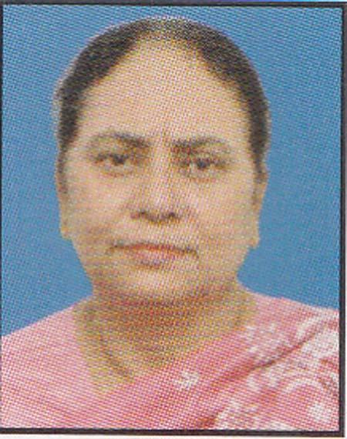 | PROF. DR. ROWSHAN ARA BEGUM  F/Name: Md. Jamir Uddin Munshi  M/Name:  BM & DC Reg. No: 6393  NID:  Cell: 01712110133  Address: Speacialist Hospital 62, Outer Bypass Road, Sonadanga, Khulna.  Blood Group: B+
76 | Voter No  LM-2900074  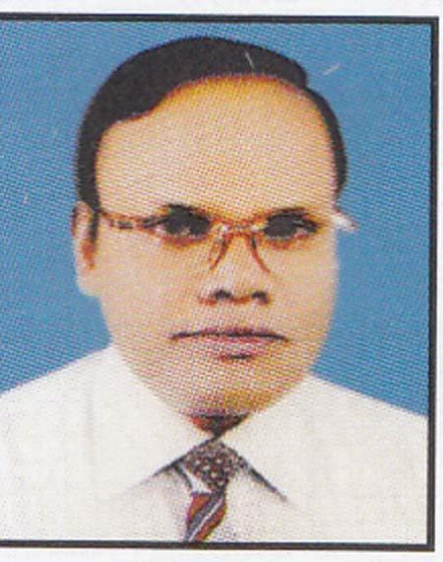 | PROF. DR. SAILENDRA NATH MISTRY  F/Name: Mahendra Nath Mistry  M/Name:  BM & DC Reg. No: 6615  NID:  Cell: 01711217521  Address: Ex-Sr. Consultant (Orth.) Khulna Medical College Hospital Khulna  Blood Group: O+
77 | Voter No  LM-2900075  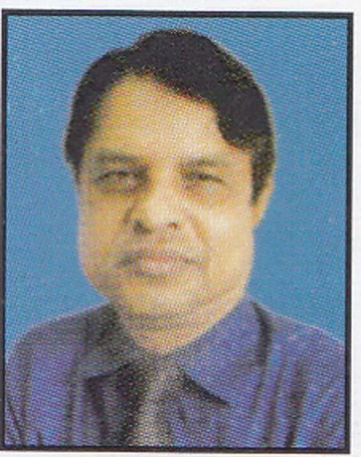 | PROF. DR. MD. MIZANUR RAHMAN  F/Name: Md. Golam Bari  M/Name:  BM & DC Reg. No: 11389  NID:  Cell: 01711161199  Address: 7/6, Block B, Lalmatia Dhaka.  Blood Group: B+
78 | Voter No  LM-2900076  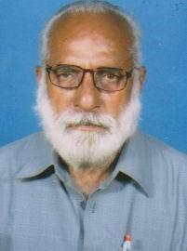 | DR. SHAMSUZZOHA QURISHI  F/Name: Late M.a. Jabbar Quraishi  M/Name:  BM & DC Reg. No:  NID:  Cell:  Address: Majila, Patikabari, Kushtia  Blood Group:  E X P I R E D
79 | Voter No  LM-2900077  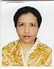 | DR. KAMRUN NAHAR  F/Name: Alhaj Taj Mahmud Sarder  M/Name:  BM & DC Reg. No:  NID:  Cell:  Address: 215, Sher-E-Bangla Road Khulna  Blood Group:
80 | Voter No  LM-2900078  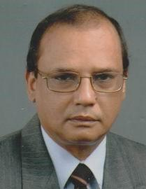 | PROF. DR. MOHAMMAD. MOHSIN  F/Name: Ebrahim Khalil  M/Name:  BM & DC Reg. No: 7087  NID: 23727225727  Cell: 01711840838  Address: 6, T.B. Boundary Road Moulvipara Road, Khulna  Blood Group: A+
81 | Voter No  LM-2900079  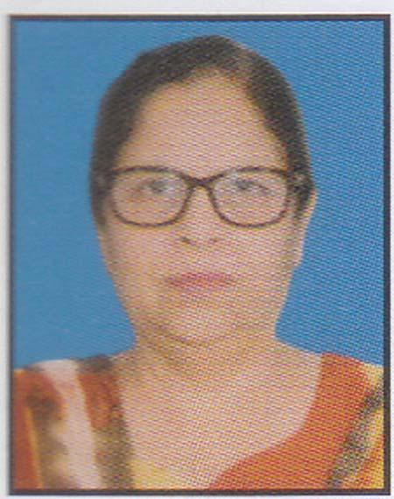 | DR. ARFA KHATUN  F/Name: Late Quazi Abdul Alim  M/Name:  BM & DC Reg. No: 15586  NID:  Cell: 01713337844  Address: 6, T.B. Boundary Road Moulvipara Road, Khulna.  Blood Group: A+
82 | Voter No  LM-2900080 | DR. MD. MASUD SATTAR  F/Name: M.a. Sattar  M/Name:  BM & DC Reg. No: 20056  NID:  Cell: 01911133545  Address: Taltala Hospital Road Tootpara, Khulna  Blood Group: O+
83 | Voter No  LM-2900081  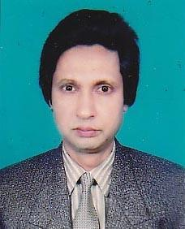 | DR. MD. ABDUL NASER  F/Name: Abdus Sattar  M/Name:  BM & DC Reg. No: 14109  NID:  Cell: 01715548388  Address: 15, Lower Jessore Road Infront Of Khulna Zilla School Khulna  Blood Group: AB+
84 | Voter No  LM-2900082  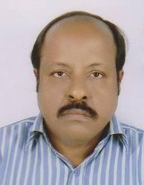 | DR. MD. TOZAMMEL HOSSAIN JOARDER  F/Name: Md. Mahatab Uddin Joarder  M/Name:  BM & DC Reg. No: 51792  NID:  Cell: 01711966397  Address: 28, B.K Roy Road, Dalmil More, Khulna.  Blood Group: B-
85 | Voter No  LM-2900083  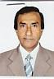 | DR. MD. MOSLEM ALI  F/Name: Md. Osman Ali Sarder  M/Name:  BM & DC Reg. No: 13587  NID:  Cell: 01715158501  Address: 215, Sher-E-Bangla Road Khulna  Blood Group: O+
86 | Voter No  LM-2900084  No Image | DR. M.A. ZAMAN  F/Name: Md. Azizur Rahman Khan  M/Name:  BM & DC Reg. No:  NID:  Cell:  Address: Medicare Hospital Charihata More Kushtia  Blood Group:
87 | Voter No  LM-2900085  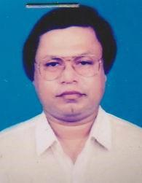 | DR. SK. BAHARUL ALAM  F/Name: Sk. Idris Alam  M/Name: Aysha Khatun  BM & DC Reg. No: 7635  NID: 9100315168  Cell: 01711217111  Address: 30, KDA Approach Road Khulna.  Blood Group: O+
88 | Voter No  LM-2900086 | DR. NAYEEMA KABIR  F/Name: Prof. Kabir Chowdhury  M/Name:  BM & DC Reg. No: 9712  NID:  Cell: 01713061226  Address: 41, Nayapalton, Gazi Bhaban, Dhaka.  Blood Group: B+
89 | Voter No  LM-2900087  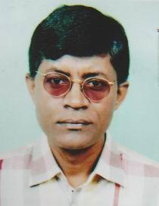 | DR. MD. ABDUR RAQUIB KHAN  F/Name: Md. Akhter Hossain Khan  M/Name:  BM & DC Reg. No: 17490  NID:  Cell: 01711109417  Address: Raysha Clinic, Gallamary Khulna  Blood Group: AB+
90 | Voter No  LM-2900088  No Image | DR. SALIM MD. ANSARI  F/Name:  M/Name:  BM & DC Reg. No:  NID:  Cell: 01711974845  Address: Director Necluar Medical Centre Bogra  Blood Group:  TRANSFERED to BMA Dhaka City  LM-1405543
91 | Voter No  LM-2900089  No Image | DR. ROWSHAN ARA BEGUM  F/Name: Md. Ruhul Amin Bhuiyan  M/Name:  BM & DC Reg. No:  NID:  Cell:  Address: Sughandha 61, Ahsan Ahmed Road Khulna  Blood Group:
92 | Voter No  LM-2900090  No Image | DR. ABUL MATLEB CHOWDHURY  F/Name:  M/Name:  BM & DC Reg. No:  NID:  Cell:  Address:  Blood Group:  E X P I R E D
93 | Voter No  LM-2900091  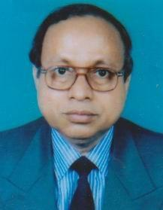 | DR. ISRAIL BISWAS  F/Name: Late Hatem Biswas  M/Name:  BM & DC Reg. No: 7334  NID:  Cell: 01711297560  Address: Samela Memorial Clinic Khanjahan Ali Road, Khulna  Blood Group: B+
94 | Voter No  LM-2900092  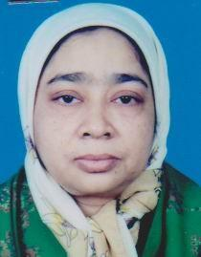 | DR. REHANA SULTANA  F/Name: A.k.m. Yaqub Ali  M/Name:  BM & DC Reg. No: 16615  NID:  Cell: 0171129560  Address: Samela Memorial Clinic Khanjahan Ali Road, Khulna  Blood Group: B+
95 | Voter No  LM-2900093  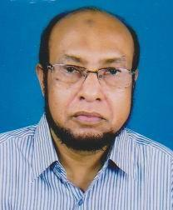 | DR. KAZI HAFIZUR RAHMAN  F/Name: Kazi Abu Akkas  M/Name: 100, Khanjahan Ali Road Khulna  BM & DC Reg. No: 6906  NID:  Cell: 01711280428  Address: 100, Khanjahan Ali Road, Jamatkhana, Khulna.  Blood Group: O+
96 | Voter No  LM-2900094  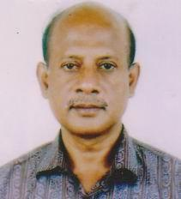 | DR. MD. SHAFIQUL ALAM  F/Name: Late Mohammad Toha  M/Name:  BM & DC Reg. No: 7731  NID:  Cell: 01711349154  Address: 4/B `` National Tower'' 56, Ahsan Ahmed Road, Khulna  Blood Group: O+
97 | Voter No  LM-2900095  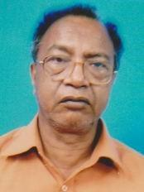 | DR. HOSSAIN SHAHID IQBAL  F/Name: A.b.m. Rokon Uddin  M/Name:  BM & DC Reg. No: 1655  NID:  Cell: 01191521952  Address: Khulna Clinic, Royal Morh Khulna  Blood Group: B+
98 | Voter No  LM-2900096  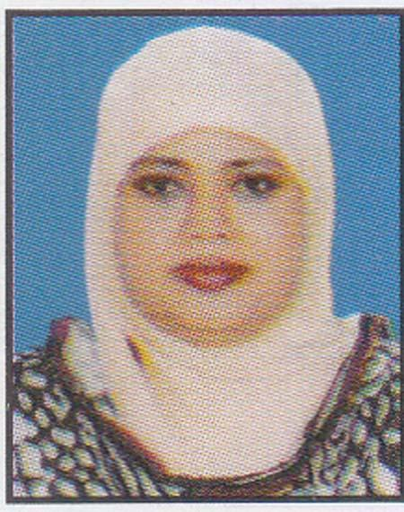 | DR. BEGUM ROWSAN ARA  F/Name: Late Mr. Aftabuddin  M/Name:  BM & DC Reg. No: 17555  NID:  Cell: 01711144187  Address: 368, Sher-E-Bangla Road Khulna  Blood Group: B+
99 | Voter No  LM-2900097  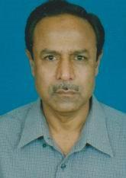 | DR. MD. ASADUL HAQUE  F/Name: Late Hazi Jafar Uddin Ahmed  M/Name:  BM & DC Reg. No: 7096  NID:  Cell: 01711398003  Address: 40, Gagon Babu Road Khulna  Blood Group: A+
100 | Voter No  LM-2900098  No Image | DR. A.K.M. WAHIDUZZAMAN  F/Name: Late Abdus Samad Shaikh  M/Name:  BM & DC Reg. No:  NID:  Cell:  Address: 14, Lower Jessore Road Khulna  Blood Group:
101 | Voter No  LM-2900099  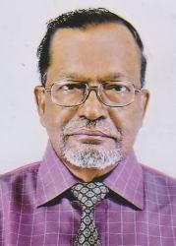 | DR. MD. MOZAMMEL HOQUE  F/Name: Late Md. P. Ullah  M/Name:  BM & DC Reg. No:  NID:  Cell: 01916568562  Address: 14, Lower Jessore Road Khulna  Blood Group: A+  E X P I R E D
102 | Voter No  LM-2900100  No Image | DR. RABINDRA NATH SARKAR  F/Name:  M/Name:  BM & DC Reg. No:  NID:  Cell:  Address: Monisha Nursing Home BIDC Road Khalispur Khulna.  Blood Group:  TRANSFERED to BMA Dhaka City  LM-1405543
103 | Voter No  LM-2900101  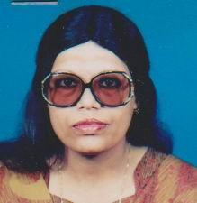 | DR. SHAHEEN ARA AKHTAR  F/Name: Sk. Md. Shahid Uddin  M/Name:  BM & DC Reg. No: 19265  NID:  Cell: 01714303013  Address: Khulna Shishu Hospital Ratan Sen Sarani, Khulna.  Blood Group: B+
104 | Voter No  LM-2900102  No Image | DR. MD. ABDUR ROUF  F/Name: Md. Mokshed Ali Biswas  M/Name:  BM & DC Reg. No: 13499  NID:  Cell: 01711735154  Address: M.O. 250 Bed Hospital, Jessore.  Blood Group: AB+
105 | Voter No  LM-2900103  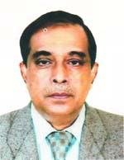 | DR. S. M. IDRIS ALI  F/Name:  M/Name:  BM & DC Reg. No: 12769  NID: 2690246960997  Cell: 01711155034  Address: House No-66, Rd-8-A, Flat-2A, Dhanmondi RA, Dhaka-1209  Blood Group: B-  TRANSFERED to BMA Dhaka City  LM-1405543
106 | Voter No  LM-2900104  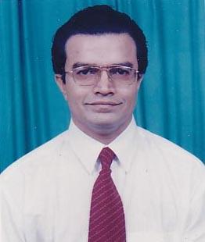 | DR. QUAZI ARIF UDDIN AHMED  F/Name: Quazi Ghias Uddin Ahmed  M/Name:  BM & DC Reg. No: 14313  NID:  Cell: 01711524755  Address: Nargis Memorial Clinic South Central Road Khulna  Blood Group: O+
107 | Voter No  LM-2900105  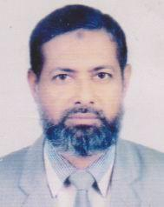 | DR. MD. ROFIQUL ISLAM  F/Name: Late Mosleh Uddin Sarder  M/Name:  BM & DC Reg. No: 4824  NID:  Cell: 01711965256  Address: House-367, Road-19 Nirala R/A Khulna-9100.  Blood Group: B+
108 | Voter No  LM-2900106  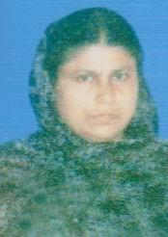 | DR. SITARA ISLAM  F/Name: Late Kazi Sahab Uddin Ahmed  M/Name:  BM & DC Reg. No: 4825  NID:  Cell: 01914751904  Address: House-367, Road-19 Nirala R/A Khulna  Blood Group: A+
109 | Voter No  LM-2900107  No Image | DR. SM. RAFIQUL ISLAM  F/Name:  M/Name:  BM & DC Reg. No:  NID:  Cell:  Address:  Blood Group:  E X P I R E D
110 | Voter No  LM-2900108  No Image | DR. MD. HAFIZUL ISLAM GOLDER  F/Name: Md. Abdul Wahab Golder  M/Name:  BM & DC Reg. No:  NID:  Cell:  Address: Army Medical Core Khulna  Blood Group:
111 | Voter No  LM-2900109  No Image | DR. MD. SADIQUL ISLAM  F/Name: Alhaj Dr. Md. Nazrul Islam  M/Name:  BM & DC Reg. No: 12118  NID:  Cell: 01713099875  Address: College Pharmacy Daulatpur, Khulna  Blood Group: B+
112 | Voter No  LM-2900110  No Image | DR. MST. FERDOUSI AKTAR  F/Name: Md. Atiar Rahman  M/Name:  BM & DC Reg. No:  NID:  Cell: 01711404989  Address: College Pharmacy Daulatpur, Khulna  Blood Group: A+
113 | Voter No  LM-2900111 | DR. SAHANA RAZZAQUE ALI  F/Name: Adv. Sk. Razzaque Ali  M/Name:  BM & DC Reg. No: 12778  NID:  Cell: 01713425503  Address: 9, Farazipara Road, Parijat Clinic Khulna  Blood Group: AB+
114 | Voter No  LM-2900112  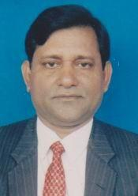 | DR. MATIAR RAHMAN KHAN  F/Name: Md. Abul Kashem Khan  M/Name:  BM & DC Reg. No:  NID:  Cell: 0171193935  Address: 12/2, Arjun Das Agarwala Road Courtpara, Kustia Khulna  Blood Group:
115 | Voter No  LM-2900113  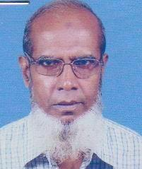 | DR. MD. SIRAZUL HAQUE  F/Name: Late Md. Abdul Zahid  M/Name:  BM & DC Reg. No: 258  NID:  Cell: 01715295096  Address: 24, B.K. Est Mosque Road Khulna  Blood Group: A+
116 | Voter No  LM-2900114 | DR. MD. SHAH ZAMAN  F/Name: Late Md. Amirul Haque  M/Name:  BM & DC Reg. No: 9818  NID:  Cell: 01712141420  Address: House # 204, 3r Floor, Road#8, Sonadanga, R/A, Khulna  Blood Group: AB+
117 | Voter No  LM-2900115  No Image | DR. GOURANGO CHANDRA DAS  F/Name:  M/Name:  BM & DC Reg. No:  NID:  Cell:  Address: Digholia, Khulna  Blood Group:  E X P I R E D
118 | Voter No  LM-2900116  No Image | DR. SUJIT KUMAR ROY  F/Name: Late Sudhir Kumar Roy  M/Name:  BM & DC Reg. No:  NID:  Cell:  Address: Ex-Asstt. Surgeon Railway Hospital Khulna  Blood Group:
119 | Voter No  LM-2900117  No Image | DR. DIPAL KRISHNA ADHIKARY  F/Name:  M/Name:  BM & DC Reg. No:  NID:  Cell:  Address:  Blood Group:  TRANSFERED to BMA Dhaka City  LM-1405543
120 | Voter No  LM-2900118  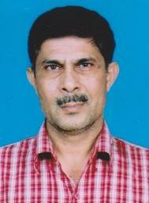 | DR. MD. MIZANUR RAHMAN  F/Name: Alhaj Yaqub Ali  M/Name:  BM & DC Reg. No: 9620  NID:  Cell: 01736560060  Address: Pyramid. Surgical Clinic Daulatpur, Khulna  Blood Group: O+
121 | Voter No  LM-2900119  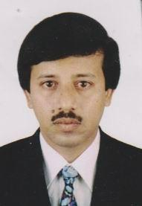 | DR. MD. MIZANUR RAHMAN  F/Name: Md. Siddiqur Rahman  M/Name:  BM & DC Reg. No: 15874  NID:  Cell: 01711298484  Address: RCC Hasan Tower, 35, Lower Jessore Road, Flat # 6A, Khulna  Blood Group: B+
122 | Voter No  LM-2900120 | DR. ZANNATUL FERDOUS JESMIN  F/Name: Late Syed Afsar Ali  M/Name:  BM & DC Reg. No: 22322  NID:  Cell: 01711814555  Address: RCC Hasan Tower 35, Lower Jessore Road, Flat # 6A, Khulna.  Blood Group: AB+
123 | Voter No  LM-2900121  No Image | DR. HARASIT KUMAR PAUL  F/Name:  M/Name:  BM & DC Reg. No:  NID:  Cell:  Address: Asstt. Registrar, Gastroinlogy Department  Bangabandu Shekh Muzib Medical University, Shahbagh  Dhaka.  Blood Group:  TRANSFERED to BMA Dhaka City  LM-1405543
124 | Voter No  LM-2900122  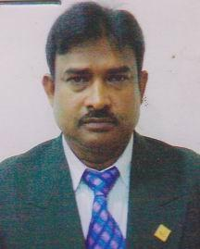 | DR. ATM. MONZUR MORSHED  F/Name: Late M.a. Gafur  M/Name:  BM & DC Reg. No: 15254  NID:  Cell: 01715468184  Address: A. Gafur Memorial Hospital, Fultala, Khulna.  Blood Group: B+
125 | Voter No  LM-2900123  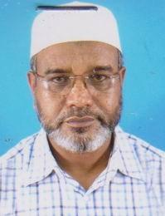 | DR. MUHAMMAD ABDUS SAMAD  F/Name: Dr. Muhammad Abdus Samad  M/Name:  BM & DC Reg. No: 14129  NID:  Cell: 01712195856  Address: 12, Islam Mission Road Noornagar, Biswapara, Khulna  Blood Group: B+
126 | Voter No  LM-2900124  No Image | DR. MD. NAZIMUDDIN KHAN  F/Name:  M/Name:  BM & DC Reg. No:  NID:  Cell:  Address:  Blood Group:  TRANSFERED to BMA Dhaka City  LM-1405543
127 | Voter No  LM-2900125  No Image | DR. B.M. ALI YOUSUF  F/Name:  M/Name:  BM & DC Reg. No:  NID:  Cell:  Address:  Blood Group:  TRANSFERED to BMA Dhaka City  LM-1405543
128 | Voter No  LM-2900126  No Image | DR. KAWSARA BEGUM  F/Name: Late Md. Abdul Aziz  M/Name:  BM & DC Reg. No:  NID:  Cell:  Address: Ex-Lecturer Physiology, Khulna Medical College, Khulna.  Blood Group: B+
129 | Voter No  LM-2900127  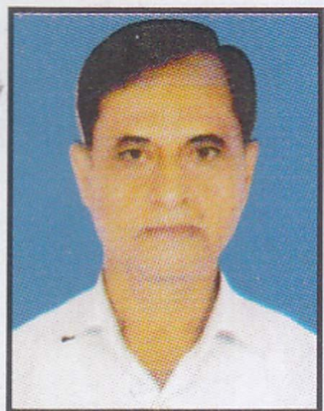 | PROF. DR. DULAL KRISHNA MONDOL  F/Name: Late Sarat Chandra Mondol  M/Name:  BM & DC Reg. No: 8614  NID:  Cell: 01715295085  Address: Prof. (Anatomy) Gazi Medical College, Sonadanga Khulna  Blood Group: O+
130 | Voter No  LM-2900128 | DR. CHITTA RANJAN BACHHAR  F/Name: Hemanto Kumar Bachhar  M/Name:  BM & DC Reg. No: 19608  NID:  Cell: 01711184690  Address: 88, Arambag, Banorgati Matepul, Khulna.  Blood Group: B+
131 | Voter No  LM-2900129  No Image | DR. DEB PRASAD BAIRAGI  F/Name: Late Santosh Kumar Bairagi  M/Name:  BM & DC Reg. No:  NID:  Cell:  Address: 45, Shamsur Rahman Road Khulna  Blood Group:
132 | Voter No  LM-2900130  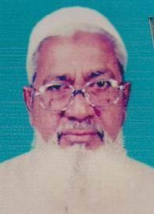 | DR. ALHAJ DR. SHAMSUR RAHMAN  F/Name: Late Ibrahim Hossain  M/Name:  BM & DC Reg. No: 2972  NID:  Cell: 01716953237  Address: Daulatpur Bus Stand Khulna.  Blood Group: O+
133 | Voter No  LM-2900131  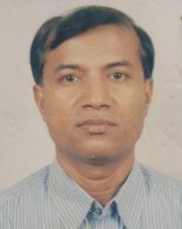 | DR. KAZI MOINUR RAHMAN  F/Name: Alhaj Dr. Shamsur Rahman  M/Name:  BM & DC Reg. No: 15430  NID:  Cell: 01716599722  Address: 17, Lower Jessore Road Khulna  Blood Group: B+
134 | Voter No  LM-2900132  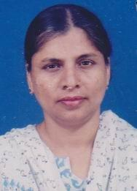 | DR. NILUFA AKHTER  F/Name: Abdul Latif  M/Name:  BM & DC Reg. No: 15431  NID:  Cell: 01715623029  Address: 17, Lower Jessore Road Khulna  Blood Group: O+
135 | Voter No  LM-2900133  No Image | DR. MD. REZAUL KARIM  F/Name: Md. Zamer Uddin Sarker  M/Name:  BM & DC Reg. No:  NID:  Cell:  Address: 153, B.K. Roy Road Shaikhpara Khulna.  Blood Group:
136 | Voter No  LM-2900134  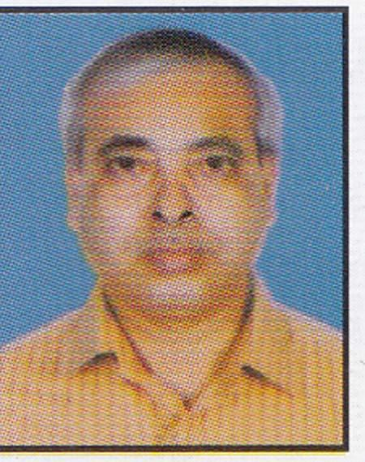 | DR. MADHUSUDAN SAHA  F/Name: Sudhir Kumar Saha  M/Name:  BM & DC Reg. No: 20343  NID:  Cell: 01711367847  Address: Basundia Jessore Sadar Jessore  Blood Group: B+
137 | Voter No  LM-2900135  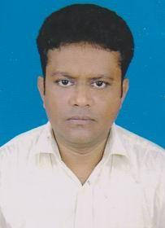 | DR. S.M. FARIDUZZAMAN  F/Name: Late Md. Abu Taleb Sikder  M/Name:  BM & DC Reg. No: 23959  NID:  Cell: 01712122915  Address: 29, B.K. Roy Road Khulna.  Blood Group: A+
138 | Voter No  LM-2900136  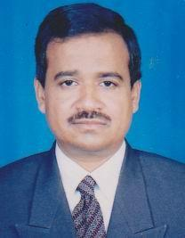 | DR. ZAHIDUL HASAN  F/Name: Md. Abdul Malek  M/Name:  BM & DC Reg. No: 19460  NID:  Cell: 01717312739  Address: Diabetic Samity 22, Sir Iqbal Road, Khulna  Blood Group: O+
139 | Voter No  LM-2900137  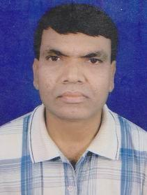 | DR. RABINDRA NATH MONDOL  F/Name: Ramani Mohan Mondol  M/Name:  BM & DC Reg. No: 23438  NID:  Cell: 01558317505  Address: Khulna Shishu Hospital Khulna  Blood Group: B+
140 | Voter No  LM-2900138  No Image | DR. ABDUR RAHMAN  F/Name:  M/Name:  BM & DC Reg. No:  NID:  Cell:  Address:  Blood Group:
141 | Voter No  LM-2900138  No Image | DR. ABDUR RAHMAN  F/Name:  M/Name:  BM & DC Reg. No:  NID:  Cell:  Address: Associate Professor, Institute of Health Technology, Mohakhali, Dhaka.  Blood Group:  TRANSFERED to BMA Dhaka City  LM-1405543
142 | Voter No  LM-2900139  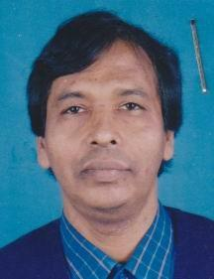 | DR. JAGABANDHU DAS  F/Name: Binod Bihari Das  M/Name:  BM & DC Reg. No: 20109  NID:  Cell: 01711973020  Address: 15/2, Ahsan Ahmed Road Khulna  Blood Group: A+
143 | Voter No  LM-2900140  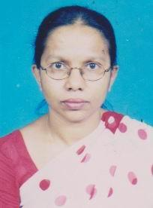 | DR. ETI SAHA  F/Name: Dhirendra Nath Saha  M/Name:  BM & DC Reg. No: 19714  NID:  Cell: 01715292641  Address: Ahsan Ahmed Road Khulna  Blood Group: AB+
144 | Voter No  LM-2900141  No Image | DR. S.M. ANWAR ALI  F/Name: Z.p. Ali  M/Name:  BM & DC Reg. No:  NID:  Cell:  Address: House # W/S-1, Road-172 Khalishpur R/A Khulna  Blood Group:
145 | Voter No  LM-2900142  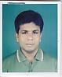 | DR. MONOJ KUMAR DAS  F/Name: Naline Kanti Das  M/Name:  BM & DC Reg. No: 21795  NID:  Cell: 01949227369  Address: 34, Ahsan Ahmed Road Khulna  Blood Group: AB+
146 | Voter No  LM-2900143 | DR. SK. MD. ZILLUR RAHMAN  F/Name: Abdul Khaleque Shaikh  M/Name:  BM & DC Reg. No: 7829  NID:  Cell: 01711840949  Address: 14, Munshipara, 1st Lane Khulna  Blood Group: A+
147 | Voter No  LM-2900144  No Image | DR. GANESH CHANDRA THANDER  F/Name:  M/Name:  BM & DC Reg. No:  NID:  Cell:  Address:  Blood Group:  E X P I R E D
148 | Voter No  LM-2900145 | DR. MD. MOSTAFA KAMAL  F/Name: Late Sk. Abdur Rashid  M/Name:  BM & DC Reg. No: 11828  NID:  Cell: 01713423050  Address: 31, Roypara Road Khulna  Blood Group: B+
149 | Voter No  LM-2900146  No Image | DR. MOSTAFA NURUZZAMAN  F/Name: Md. Solaiman Hossain  M/Name:  BM & DC Reg. No:  NID:  Cell:  Address: 23, Sher-E-Bangla Road Infront Of Balaka Club Khulna  Blood Group:
150 | Voter No  LM-2900147  No Image | DR. MST. NAZMUN NAHAR MINA  F/Name: Md. Omar Ali  M/Name:  BM & DC Reg. No:  NID:  Cell:  Address: 23, Sher-E-Bangla Road Infront Of Balaka Club Khulna  Blood Group:
151 | Voter No  LM-2900148  No Image | DR. SUSHIL KUMAR SAHA  F/Name:  M/Name:  BM & DC Reg. No:  NID:  Cell:  Address:  Blood Group:  E X P I R E D
152 | Voter No  LM-2900149  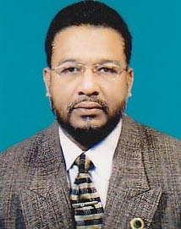 | DR. MD. JAHID HOSSAIN  F/Name: Abdul Hakim Molla  M/Name:  BM & DC Reg. No: 19097  NID:  Cell: 01711297531  Address: 101, Motiakhali, Shipyard Road, Khulna  Blood Group: B-
153 | Voter No  LM-2900150  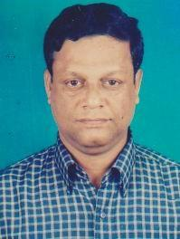 | DR. HARIDAS BISWAS  F/Name: Bhupendra Nath Biswas  M/Name:  BM & DC Reg. No: 9206  NID:  Cell: 01913813519  Address: 141/Ka, Boyra Main Road Choto Boyra, Khulna  Blood Group: B+
154 | Voter No  LM-2900151  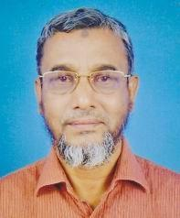 | DR. MD. RAFIQUL HAQUE BABLU  F/Name: Md. Habibor Rahman  M/Name:  BM & DC Reg. No: 10313  NID:  Cell: 01715229870  Address: H-35, Rd-5, Sonadanga R/A 1st Phase, Khulna  Blood Group: O+
155 | Voter No  LM-2900152  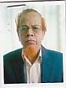 | DR. SM. MONIRUZZAMAN  F/Name: Late Sk. Ashraf Hossain  M/Name:  BM & DC Reg. No: 2792  NID:  Cell: 01755943338  Address: 51, KDA. Avenue Shailkhpara, Khulna  Blood Group: O+
156 | Voter No  LM-2900153  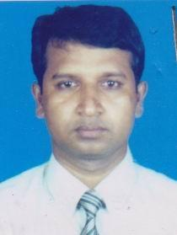 | DR. MD. WAZED ALI MRIDHA  F/Name: Md. Abul Qushem Mridha  M/Name:  BM & DC Reg. No: 22772  NID:  Cell: 01719261661  Address: House # 50, Road # 5, Sonadanga,Khulna.  Blood Group: A+
157 | Voter No  LM-2900154 | DR. MOST. DALIA AKHTER  F/Name: Late Kanchan Ali Sarder  M/Name: Mrs. Sahera Begum  BM & DC Reg. No: 22472  NID:  Cell: 01715166658  Address: 20/1, Shamsur Rahman Road, Khulna  Blood Group: B+
158 | Voter No  LM-2900155  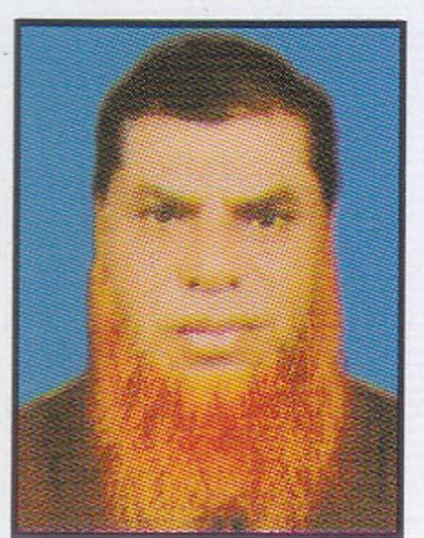 | DR. MD. MOTIAR RAHMAN  F/Name: Md. Wazed Ali Moral  M/Name:  BM & DC Reg. No: 461  NID: 9122753198  Cell: 01711310277  Address: 55/1, Ahan Ahmed Road Khulna  Blood Group: B+
159 | Voter No  LM-2900156  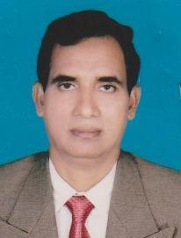 | DR. MD. MOSHARAF HOSSAIN  F/Name: Md. Waliar Rahman  M/Name:  BM & DC Reg. No: 19382  NID:  Cell: 01715634373  Address: 317/18, Nirala R/A Khulna  Blood Group: A+
160 | Voter No  LM-2900157  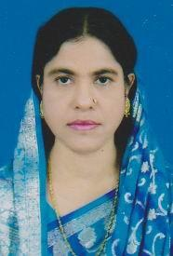 | DR. NOORJAHAN BEGUM  F/Name: Yunus Sheikh  M/Name:  BM & DC Reg. No: 12142  NID:  Cell: 01711297567  Address: Linda Clinic Shiromoni, Khulna.  Blood Group: O+
161 | Voter No  LM-2900158  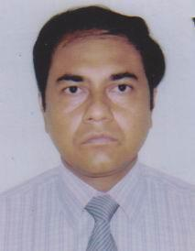 | DR. KAZAL KANTI DAM  F/Name: Porimal Kumar Dam  M/Name:  BM & DC Reg. No:  NID:  Cell: 041785484  Address: Vill & P.O. Madinabad Khulna  Blood Group:
162 | Voter No  LM-2900159  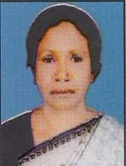 | DR. NASRIN SULTANA  F/Name: Rajab Ali  M/Name:  BM & DC Reg. No: 10486  NID:  Cell: 01728076346  Address: Hospital Road Nowapara, Avoynagor, Jessore.  Blood Group:
163 | Voter No  LM-2900160  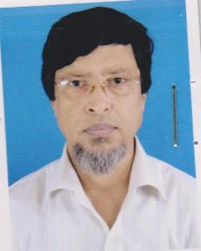 | DR. S.M. GOLAM MOSTOFA  F/Name: Md. Yakub Ali Sarder  M/Name:  BM & DC Reg. No:  NID:  Cell:  Address: Deputy Director (In-Charge) Family Planning, Pirojpur.  Blood Group:
164 | Voter No  LM-2900161  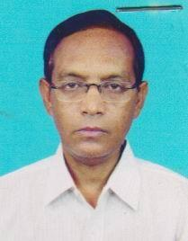 | DR. SUNIL KUMAR BISWAS  F/Name: Debendra Nath Biswas  M/Name:  BM & DC Reg. No: 13261  NID:  Cell: 01711377686  Address: 99/1C South Central Road, Khulna.  Blood Group: A+
165 | Voter No  LM-2900162  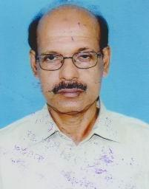 | DR. S.M. AKBAR HOSSAIN  F/Name: Late Abdul Hakim  M/Name:  BM & DC Reg. No: 10995  NID:  Cell: 01711246363  Address: 82, Boyra Bazar Mosjid Road, Boyra, Khulna.  Blood Group: B+
166 | Voter No  LM-2900163  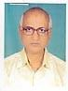 | DR. MD. MOAZZEM HOSSAIN  F/Name: Md. Sirajuddin  M/Name:  BM & DC Reg. No: 11340  NID:  Cell: 01721898486  Address: Imon Pharmacy, Biharypur Bazar, Noagaon  Blood Group: B+
167 | Voter No  LM-2900164  No Image | DR. MD. BAKER HOSSAIN  F/Name:  M/Name:  BM & DC Reg. No:  NID:  Cell:  Address:  Blood Group:  E X P I R E D
168 | Voter No  LM-2900165  No Image | DR. KHALED KABIR  F/Name: Nurul Haque Islam  M/Name:  BM & DC Reg. No:  NID:  Cell: 041721016  Address: 83, Gogon Babu Road Khulna  Blood Group:
169 | Voter No  LM-2900166  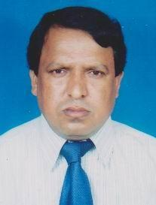 | DR. MD. ABDUS SABUR  F/Name: Md. Iman Ali Gazi  M/Name:  BM & DC Reg. No: 19545  NID:  Cell: 01712534404  Address: Diabetic Association Hospital, Sir Iqbal Road, Khulna.  Blood Group: B+
170 | Voter No  LM-2900167  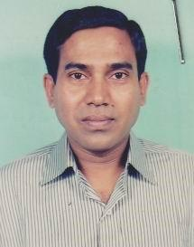 | DR. PROSANTA KUMAR BISWAS  F/Name: Dhirandro Nath Biswas  M/Name:  BM & DC Reg. No: 16760  NID:  Cell: 01711981678  Address: Khulna C.T. Clinic, 45/1, Bokshipara Road, Khulna.  Blood Group: A+
171 | Voter No  LM-2900168  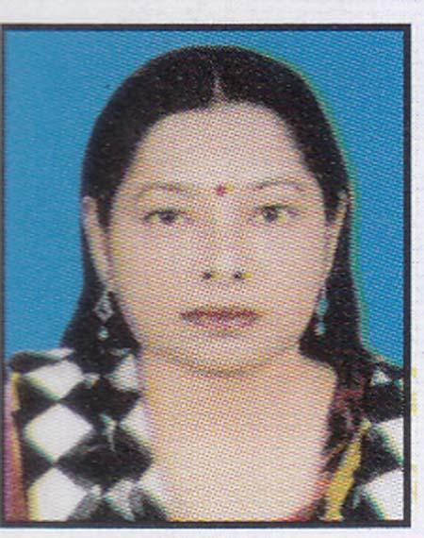 | DR. SUNITA RANI DAS  F/Name: Nagendra Nath Das  M/Name:  BM & DC Reg. No: 18542  NID:  Cell: 01711828871  Address: 9, Koylaghat Park Lane Khulna  Blood Group: O+
172 | Voter No  LM-2900169  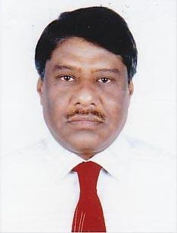 | DR. G. M. MONSUR HABIB  F/Name: Sukchan Gain  M/Name:  BM & DC Reg. No:  NID:  Cell: 01720685407  Address: 246, Hazi Ismail Road, Shaikhpara, Khulna.  Blood Group: A+
173 | Voter No  LM-2900170 | DR. M. A. HANNAN  F/Name: Md. Abdul Hamid Mollah  M/Name:  BM & DC Reg. No: 19425  NID:  Cell: 01711295460  Address: 34, Outer Bypas Road Sonadanga, Khulna.  Blood Group: B+
174 | Voter No  LM-2900171  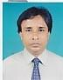 | DR. SHAIKH RAFIULLAH  F/Name: Shaikh Rahim Baksh  M/Name:  BM & DC Reg. No: 20982  NID:  Cell: 01711981673  Address: 85, KDA Outer Bypas Road Sonadanga, Khulna.  Blood Group: O+
175 | Voter No  LM-2900172  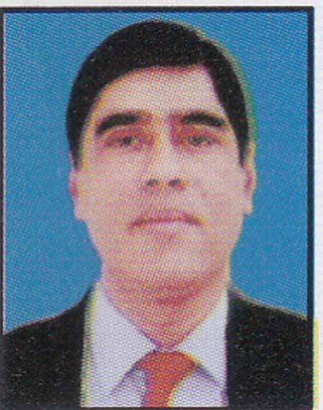 | DR. ASHOKE KUMAR PAUL  F/Name: Provat Kumar Paul  M/Name:  BM & DC Reg. No: 18733  NID:  Cell: 01752418742  Address: Nuclear Medicine & Ultrasound Khulna Medical College, Khulna  Blood Group: O+
176 | Voter No  LM-2900173 | PROF. DR. PORITOSH KUMAR CHOWDHURY  F/Name: Babu Rakhal Raj Chowdhury  M/Name:  BM & DC Reg. No: 14941  NID:  Cell: 01712522910  Address: 150/3, Boyra Main Road (Soto Boyra), Pujakhola, Khulna.  Blood Group: O+
177 | Voter No  LM-2900174  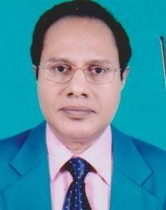 | DR. MD. SIRAJUL ALAM  F/Name: Rokonuddin Ahmed  M/Name:  BM & DC Reg. No: 13368  NID:  Cell: 01712057546  Address: 63, Ahsan Ahmed Road, Plot # 8A, Khulna-9100  Blood Group: A+
178 | Voter No  LM-2900175  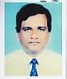 | DR. SHAIKH ABDUL KADIR  F/Name: Shaikh Adil Uddin  M/Name:  BM & DC Reg. No: 11673  NID:  Cell: 01711423001  Address: 113/3, Sher-E-Bangla Road Nirjon R/A, Khulna  Blood Group: B+
179 | Voter No  LM-2900176  No Image | DR. AKRAM ALI MOLLAH  F/Name:  M/Name:  BM & DC Reg. No:  NID:  Cell:  Address:  Blood Group:  E X P I R E D
180 | Voter No  LM-2900177  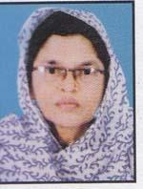 | DR. HOSNE ARA BEGUM  F/Name: Md. Kalimullah  M/Name:  BM & DC Reg. No: 18350  NID:  Cell: 01731987380  Address: Boyra Clinic Zalil Sawrani, Boyra, Khulna  Blood Group: AB+
181 | Voter No  LM-2900178  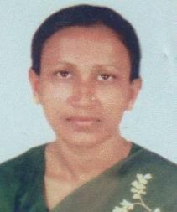 | DR. RUBY BEGUM  F/Name: Late Abdul Latif Miah  M/Name:  BM & DC Reg. No: 10648  NID:  Cell: 01711838786  Address: Flat # 03B, House # 66, Farazipara Main Road, Khulna.  Blood Group: O+
182 | Voter No  LM-2900179  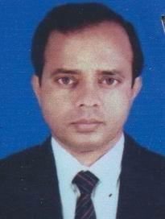 | DR. S. M. NAZRUL ISLAM  F/Name: Late Md. Rokonuddin Ahmed  M/Name:  BM & DC Reg. No: 8424  NID:  Cell: 01911838786  Address: Flat # 03B, House # 66, Farazipara Main Road, Khulna.  Blood Group: O+
183 | Voter No  LM-2900180  No Image | DR. TUHITUR RAHMAN BULU  F/Name: Md. Bazlur Rahman  M/Name:  BM & DC Reg. No:  NID:  Cell: 041730030  Address: 7, Cemetery Road Khulna  Blood Group:
184 | Voter No  LM-2900181  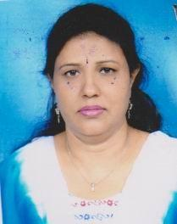 | DR. REBA MUZUMDER  F/Name: Sudhir Muzumder  M/Name:  BM & DC Reg. No: 20927  NID:  Cell: 01711308532  Address: 289/2, Khan jahan Ali Road, Khulna.  Blood Group: B+
185 | Voter No  LM-2900182  No Image | DR. MD. ABDUR RAHIM  F/Name: Md. Ismail Gazi  M/Name:  BM & DC Reg. No:  NID:  Cell:  Address: 67, Sir Iqbal Road, Khulna  Blood Group:  E X P I R E D
186 | Voter No  LM-2900183  No Image | DR. MUNSUR HABIB  F/Name:  M/Name:  BM & DC Reg. No:  NID:  Cell:  Address:  Blood Group:  TRANSFERED to BMA Dhaka City  LM-1405543
187 | Voter No  LM-2900184  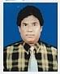 | DR. MD. MOAZZEM HOSSAIN  F/Name: Late Mvi. Abdul Wahed  M/Name:  BM & DC Reg. No:  NID:  Cell: 01711297595  Address: 38, South Central Road Khulna  Blood Group:
188 | Voter No  LM-2900185  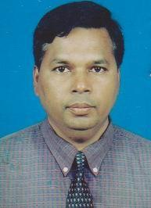 | DR. MD. ABDUL LATIF  F/Name: Alhaj Noor Muhammad  M/Name:  BM & DC Reg. No: 13566  NID:  Cell: 01711173340  Address: 292, Mujgunni R/A Road-20, Khalishpur, Khulna.  Blood Group: B+
189 | Voter No  LM-2900186 | DR. AFROZA KHANAM  F/Name: Abdul Quader  M/Name:  BM & DC Reg. No: 14122  NID:  Cell: 01944332879  Address: 19, Ahsan Ahmed Road Khulna  Blood Group: A+
190 | Voter No  LM-2900187  No Image | DR. MONOHAR CHANDRA MONDAL  F/Name: Profulla Kumar Mondol  M/Name:  BM & DC Reg. No:  NID:  Cell:  Address: Khulna M & H.C. 5, Islampur Road Khulna  Blood Group:
191 | Voter No  LM-2900188  No Image | DR. M.A. MAZED  F/Name:  M/Name:  BM & DC Reg. No:  NID:  Cell:  Address:  Blood Group:  E X P I R E D
192 | Voter No  LM-2900189  No Image | DR. M.A. JABBAR  F/Name: Late Abdul Gani Shaikh  M/Name:  BM & DC Reg. No:  NID:  Cell:  Address: 2, Musalman Para Road, Khulna  Blood Group:  E X P I R E D
193 | Voter No  LM-2900190  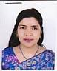 | DR. NISHAT SULTANA  F/Name: Shahidul Hoque  M/Name:  BM & DC Reg. No:  NID:  Cell: 01912077862  Address: Consultant (Gynae) 140, Taltala Hospital Road Tootpara, Khulna.  Blood Group: B+
194 | Voter No  LM-2900191  No Image | DR. MONIRUZZAMAN SHAHIN  F/Name:  M/Name:  BM & DC Reg. No:  NID:  Cell:  Address:  Blood Group:  TRANSFERED to BMA Dhaka City  LM-1405543
195 | Voter No  LM-2900192  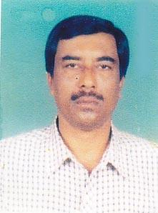 | PROF. DR. MONOJ KUMAR BOSE  F/Name: Late: Rampada Bosu  M/Name: Late: Madhabi Lata Bosu  BM & DC Reg. No: 7698  NID:  Cell: 01727588080  Address: Bangladesh Eye Hospital, 9-B Mojid Sharani, Shibbari, Khulna.  Blood Group: O+
196 | Voter No  LM-2900193 | DR. MOHD. BORHANUDDIN AHMED  F/Name: Late Alhaj Sarder Hemayet Uddin  M/Name:  BM & DC Reg. No: 6467  NID:  Cell: 01712179828  Address: 1, Miapara Primary School Khulna.  Blood Group: B+
197 | Voter No  LM-2900194  No Image | DR. M. SHAHAB UDDIN AHMED  F/Name:  M/Name:  BM & DC Reg. No:  NID:  Cell:  Address:  Blood Group:  TRANSFERED to BMA Dhaka City  LM-1405543
198 | Voter No  LM-2900195 | DR. NARGIS SULTANA  F/Name: Md. Abdul Hamid  M/Name:  BM & DC Reg. No: 14091  NID:  Cell: 01712744669  Address: House # E/28, Road # 29 Nirala Residential Area, Khulna  Blood Group: O+
199 | Voter No  LM-2900196  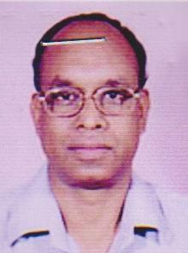 | DR. ZILLUR RAHMAN  F/Name: Habibur Rahman  M/Name:  BM & DC Reg. No: 9312  NID:  Cell: 01711482767  Address: House No.153, Road No.12 Mujgunni R/A, Khulna  Blood Group: A+
200 | Voter No  LM-2900197 | DR.S AHSAN AHMED  F/Name: Late Sarder Alauddin  M/Name: Hakima Khatun  BM & DC Reg. No: 24493  NID:  Cell: 01711881365  Address: 111 Islampur Road Khulna.--9100.  Blood Group: AB+
201 | Voter No  LM-2900198  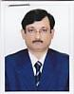 | DR. RAQIB UDDIN AHMED  F/Name: Rafi Uddin Ahmed  M/Name: Nurjahan Begum  BM & DC Reg. No: 11608  NID: 9100533885  Cell: 01711830940  Address: 82,outer bypass road,Sonadanga, Khulna  Blood Group: B+
202 | Voter No  LM-2900199  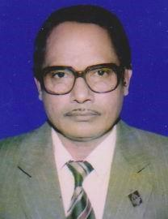 | DR. MD. HABIBUR RAHMAN  F/Name: Late Mvi. Dyem Ali Sarder  M/Name:  BM & DC Reg. No: 1107  NID:  Cell: 01726476800  Address: Road # 11, Plot-2 Khalishpur H/E, Khulna  Blood Group: B+
203 | Voter No  LM-2900200  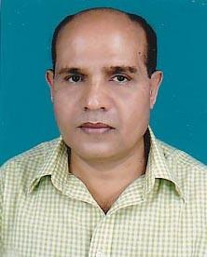 | DR. M. ASHRAF ALI  F/Name: Late Mohammad Nasir Uddin Molla  M/Name:  BM & DC Reg. No: 14960  NID:  Cell: 01711347875  Address: 282, ``Nashir Garden'' Khanjahan Ali Road, Khulna  Blood Group: O+
204 | Voter No  LM-2900201  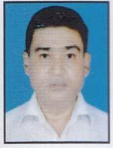 | DR. ASHIS KUMAR DEWAN  F/Name: Kanai Lal Dewan  M/Name:  BM & DC Reg. No:  NID:  Cell: 041-724275  Address: Hazra Bhaban, 19, Yusuf Row Mirzapur Khulna  Blood Group: O+
205 | Voter No  LM-2900202  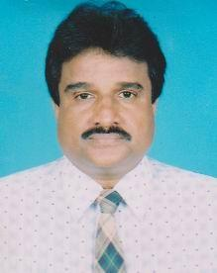 | DR. ANUP KUMAR DEY  F/Name: Pashu Pati Dey  M/Name:  BM & DC Reg. No: 80937  NID:  Cell: 01713400550  Address: Dupty Super, Khulna Shishu Hospital, Khulna  Blood Group: B+
206 | Voter No  LM-2900203  No Image | DR. HABIBUR RAHMAN SABUJ  F/Name: Late Ali Akbar  M/Name:  BM & DC Reg. No: 5772  NID:  Cell: 01711144250  Address: 3/2, Lalmatia, Dhaka.  Blood Group: A+
207 | Voter No  LM-2900204  No Image | DR. PROBHAT KUMAR DAS  F/Name: Monoranjan Das  M/Name:  BM & DC Reg. No:  NID:  Cell:  Address: Medical Officer, Thana Health Complex, Paikgacha, Khulna  Blood Group:
208 | Voter No  LM-2900205  No Image | DR. DAS PREETILATA  F/Name: Nagendra Nath Das  M/Name:  BM & DC Reg. No:  NID:  Cell:  Address: Ex-Medical Officer Thana Health Complex Phultala Khulna  Blood Group:
209 | Voter No  LM-2900206  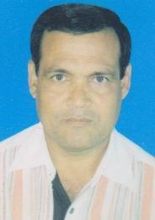 | DR. JATINDRA NATH MONDOL  F/Name: Late Dhirendra Nath Mondol  M/Name:  BM & DC Reg. No: 12258  NID:  Cell: 01711571300  Address: Vill-Kalabunia, P.O-Boyarbhanga Batiaghata, Khulna.  Blood Group: B+
210 | Voter No  LM-2900207  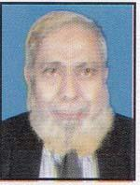 | DR. ALAMGIR KHAN  F/Name: Md. Siddique Ali Khan  M/Name:  BM & DC Reg. No: 8020  NID:  Cell: 01742101186  Address: Vill-& P.O-Sarajkathi Monirampur, Jessore.  Blood Group: AB+
211 | Voter No  LM-2900208  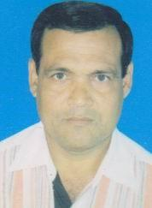 | DR. BIDHAN CHANDRA GHOSH  F/Name: Gour Pada Ghosh  M/Name:  BM & DC Reg. No: 25065  NID:  Cell: 01711703844  Address: Vill.: Bhadgati, P.O.: Amipur, Batiaghata, Khulna  Blood Group: A+
212 | Voter No  LM-2900209  No Image | DR. DILIP KUMAR ROY  F/Name:  M/Name:  BM & DC Reg. No:  NID:  Cell:  Address: Health Complex,Keshabpur, Jessore.  Blood Group:  TRANSFERED to BMA Dhaka City  LM-1405543
213 | Voter No  LM-2900210  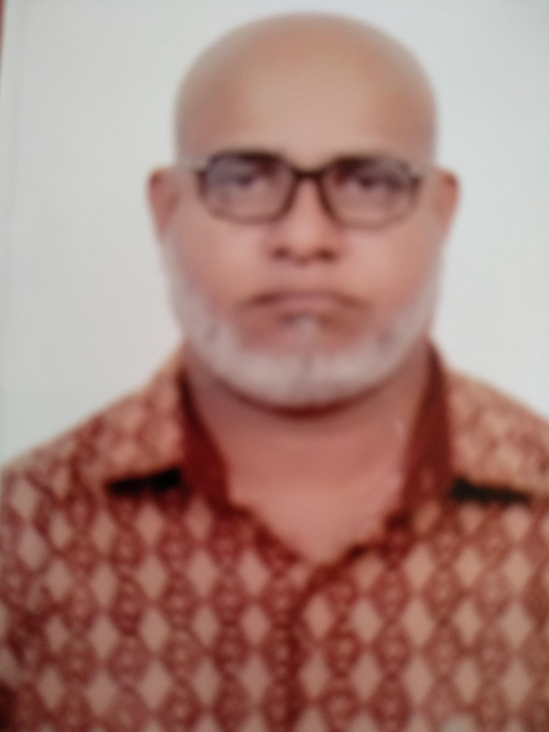 | DR MD MOINUDDIN MOLLA  F/Name: Late Md A.Aziz Mollah  M/Name: Late Rabeya Begum  BM & DC Reg. No: 15223  NID: 19584795131556967  Cell: 01713007053  Address: "PARAM TOWER" Holding Number:30P khan Bahadur Ahsanullah Road(Mujgunni Main Road-Boyra Part)Boyra Police Station:Sonadanga KCC,Khulna  Blood Group: O+
214 | Voter No  LM-2900211  No Image | DR. ANJOLI ROY  F/Name:  M/Name:  BM & DC Reg. No:  NID:  Cell:  Address: Abay Nagar Health Complex Jessore  Blood Group:  TRANSFERED to BMA Dhaka City  LM-1405543
215 | Voter No  LM-2900212  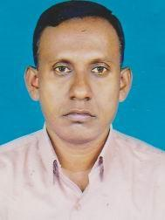 | DR. BISWAJIT KUMAR BAIN  F/Name: Sree Nimai Chancra Bain  M/Name:  BM & DC Reg. No: 20487  NID:  Cell: 01856472919  Address: 7, TB Boundary Road Moulvipara, Khulna.  Blood Group: O+
216 | Voter No  LM-2900213  No Image | DR. SAMINA BEGUM  F/Name: A.K.M. Alamgir  M/Name:  BM & DC Reg. No:  NID:  Cell:  Address: Ex-Medical Officer, MCWC, Sir Iqbal Road, Khulna  Blood Group:
217 | Voter No  LM-2900214  No Image | DR. FRANCIS ROZARIO  F/Name: Late Mr. Peter Rozario  M/Name:  BM & DC Reg. No:  NID:  Cell:  Address: Fatima Medicare, Mongla, Bagerhat  Blood Group:
218 | Voter No  LM-2900215  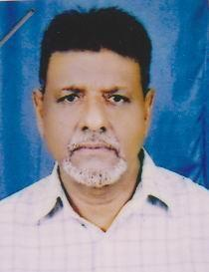 | DR. MD. BAZLUL HUQUE  F/Name: Late Alhaj Md. Fazlul Haque  M/Name:  BM & DC Reg. No: 3099  NID:  Cell: 01911016542  Address: Kinder Clinic 10, Dharmashava Cross Road, Khulna.  Blood Group: A+
219 | Voter No  LM-2900216  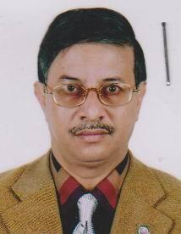 | DR. AMIRUL KHUSRU  F/Name: Late M.a. Hoque  M/Name:  BM & DC Reg. No: 14123  NID:  Cell: 01711826206  Address: “Shekor” Ahsan Ahmed Road, Khulna.  Blood Group: O+
220 | Voter No  LM-2900217  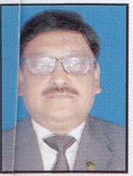 | DR. MD. MAHMUD HASAN LENIN  F/Name: M.a. Wahid  M/Name:  BM & DC Reg. No: 9951  NID:  Cell: 01711309933  Address: 32, Miapara 2nd Lane, Khulna.  Blood Group: AB+
221 | Voter No  LM-2900218  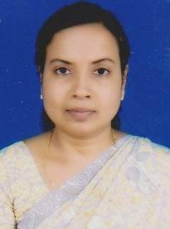 | DR. RITA BALA  F/Name: Late Profulla Kumar Bala  M/Name:  BM & DC Reg. No: 18678  NID:  Cell: 01711482995  Address: KBNSB Eye Hospital, Shiromoni, Khulna.  Blood Group: O+
222 | Voter No  LM-2900219  No Image | DR. MRINAL KANTI DAS  F/Name: Late Phani Bhusan Das  M/Name:  BM & DC Reg. No: 18678  NID:  Cell: 01711482995  Address: Ex-Medical Officer I.D. Hospital Mirrerdanga Khulna  Blood Group:
223 | Voter No  LM-2900220  No Image | DR. KAZI MAHBUBUR RAHMAN  F/Name: Kazi Abdul Hannan  M/Name:  BM & DC Reg. No:  NID:  Cell:  Address: Moheswarpasha Daulatpur Khulna  Blood Group:
224 | Voter No  LM-2900221  No Image | DR. DIPONGKAR KUMAR MONDOL  F/Name:  M/Name:  BM & DC Reg. No:  NID:  Cell:  Address:  Blood Group:  TRANSFERED to BMA Dhaka City  LM-1405543
225 | Voter No  LM-2900221  No Image | DR. DIPONGKAR KUMAR MONDOL  F/Name:  M/Name:  BM & DC Reg. No:  NID:  Cell:  Address:  Blood Group:  TRANSFERED to BMA Dhaka City  LM-1405543
226 | Voter No  LM-2900222  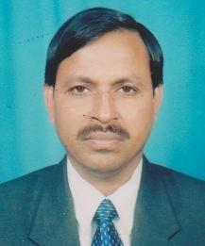 | DR. DINO BANDHU MONDOL  F/Name: Late Anukul Chandra Mondol  M/Name:  BM & DC Reg. No: 20003  NID:  Cell: 01914829980  Address: 55/1, Hazi Ismail Road Banorgati, Khulna.  Blood Group: B+
227 | Voter No  LM-2900223  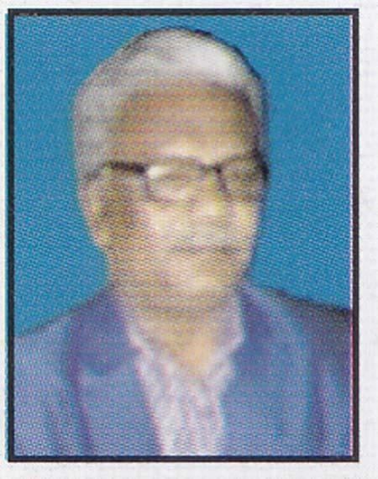 | DR. S.M. DIDARUL ALAM  F/Name: S.m. Abdul Hossain  M/Name:  BM & DC Reg. No: 24263  NID:  Cell: 01711981300  Address: 55/1, Golam Muktadir Sarok Nabopalli, Sonadanga, Khulna.  Blood Group: B+
228 | Voter No  LM-2900224  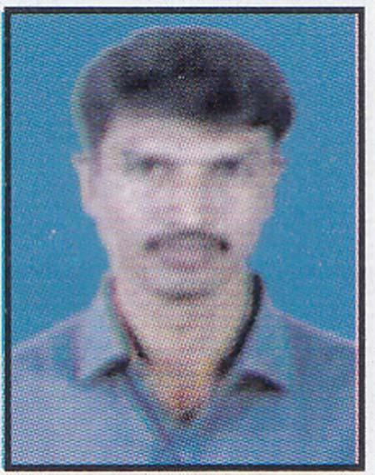 | DR. BIPUL KANTI HALDER  F/Name: Late Benode Behari Halder  M/Name:  BM & DC Reg. No: 24041  NID:  Cell: 01712172382  Address: Vill- Kanaidia, P.O. Kanaidia P.S- Tala, Satkhira  Blood Group: O+
229 | Voter No  LM-2900225  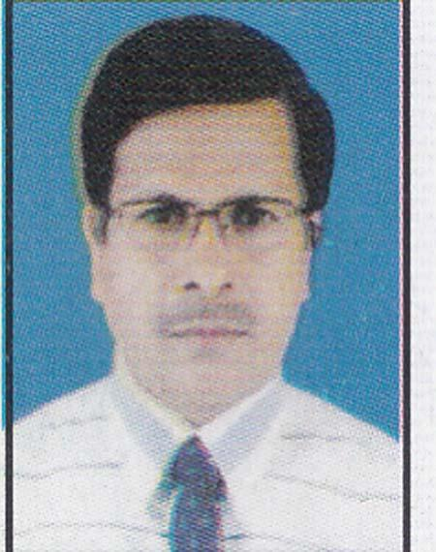 | DR. GOUTAM RAY  F/Name: Satish Ch. Roy  M/Name:  BM & DC Reg. No: 22992  NID:  Cell: 01711830942  Address: Ideal Nursing Home M A Bari Sarak, Gallamari Khulna.  Blood Group: O+
230 | Voter No  LM-2900226 | DR. KRISHNA PADA DAS  F/Name: Late Shanti Ranjan Das  M/Name:  BM & DC Reg. No: 22991  NID:  Cell: 01711450172  Address: 11/1, East Police Line Khulna.  Blood Group: B+
231 | Voter No  LM-2900227 | DR. ASHOKE KUMAR DAS  F/Name: Nishi Kanta Das  M/Name:  BM & DC Reg. No: 12254  NID:  Cell: 01711112284  Address: Baby Medical Hall Dolekhola Khulna  Blood Group: AB+
232 | Voter No  LM-2900228  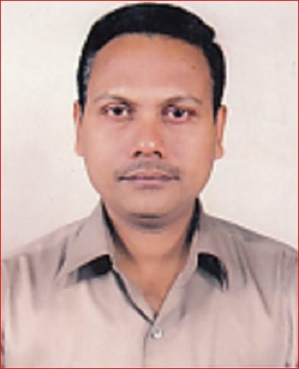 | DR. ASISH KUMAR DEB NATH  F/Name: Kalidas Deb Nath  M/Name:  BM & DC Reg. No:  NID:  Cell:  Address: Padma Diagnostic Centre Maylapota Khulna  Blood Group:
233 | Voter No  LM-2900229  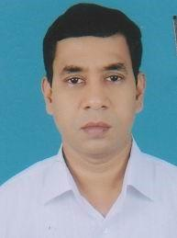 | DR. S.M. SHAMSUL AHSAN  F/Name: S.m. Abdul Gafur  M/Name:  BM & DC Reg. No: 22708  NID:  Cell: 01711877244  Address: Road-5, Plot-39, 3rd, Floor Sonadanga R/A, 1st Phase, Khulna.  Blood Group: B+
234 | Voter No  LM-2900230  No Image | DR. MD. NASIR UDDIN  F/Name:  M/Name:  BM & DC Reg. No:  NID:  Cell:  Address:  Blood Group:  TRANSFERED to BMA Dhaka City  LM-1405543
235 | Voter No  LM-2900231  No Image | DR. MURARI MOHAN MONDAL  F/Name: Satish Chandra Mondol  M/Name:  BM & DC Reg. No:  NID:  Cell:  Address: Khutakhali Bazar P.O.-Bajua P.S.-Dacope Khulna  Blood Group:
236 | Voter No  LM-2900232  No Image | DR. FARIDA YASMIN  F/Name: Shahab Uddin Chowdhury  M/Name:  BM & DC Reg. No:  NID:  Cell:  Address: House-14, Road-11 Khalishpur Khulna  Blood Group:
237 | Voter No  LM-2900233  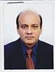 | DR. SK. MIZANUL HOQUE  F/Name: Late S.m. Fazlul Haque  M/Name:  BM & DC Reg. No:  NID:  Cell: 01717250773  Address: 76/1, Municipal Tank Road Khulna.  Blood Group: O+
238 | Voter No  LM-2900234  No Image | DR. F.D.M. KHAIRUL ANAM  F/Name:  M/Name:  BM & DC Reg. No:  NID:  Cell:  Address:  Blood Group:
239 | Voter No  LM-2900235  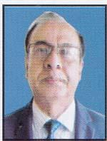 | PROF. DR. MUHAMMAD SHAHIDUZZAMAN  F/Name: Ahmed Hossain  M/Name:  BM & DC Reg. No: 10728  NID:  Cell: 01715475989  Address: House-27, Road-5, A-3/A, Dhanmondi R/A, Dhaka.  Blood Group: O+
240 | Voter No  LM-2900236  No Image | DR. S. M. ENAYETULLAH  F/Name:  M/Name:  BM & DC Reg. No:  NID:  Cell:  Address: Ex-Medical Officer Islami Health Centre Goalkhali Khulna  Blood Group:
241 | Voter No  LM-2900237  No Image | DR. MD. TOWHID-UZ-ZAMAN  F/Name:  M/Name:  BM & DC Reg. No:  NID:  Cell:  Address:  Blood Group:  TRANSFERED to BMA Dhaka City  LM-1405543
242 | Voter No  LM-2900238 | PROF. DR. SYED MOHAMMAD ELIAS  F/Name: Late Syed Shabuddin  M/Name:  BM & DC Reg. No: 6548  NID:  Cell: 01611323648  Address: House No.108, Road No.01 Sonadanga R/A, Khulna.  Blood Group: O+
243 | Voter No  LM-2900239  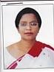 | PROF. DR. SHAMSUN NAHAR  F/Name: Md. Akram Hossain  M/Name:  BM & DC Reg. No: 15736  NID:  Cell: 01711430888  Address: 58/1, Ahsan Ahmed Road Khulna.  Blood Group: O+
244 | Voter No  LM-2900240  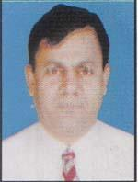 | DR. S.M. ABDUR RAHMAN  F/Name: Late S.m. Razzab Ali Sikder  M/Name:  BM & DC Reg. No: 23136  NID:  Cell: 01711836577  Address: Chowrangi Bus Stand, Satkhira  Blood Group:
245 | Voter No  LM-2900240  No Image | DR. S. M. ABDUR RAHMAN  F/Name:  M/Name:  BM & DC Reg. No:  NID:  Cell: 01711836577  Address: Chowrangi Bus Stand. Satkhira  Blood Group:  TRANSFERED to BMA Dhaka City  LM-1405543
246 | Voter No  LM-2900241 | PROF. DR. SUDHANGSHU KUMAR BALLAV  F/Name: Upendra Nath Ballav  M/Name:  BM & DC Reg. No: 13980  NID:  Cell: 01747085860  Address: 9/A, National Tower 26, Ahsan Ahmed Road, Khulna.  Blood Group: B+
247 | Voter No  LM-2900242  No Image | DR. DHIRAJ MOHAN BISWAS  F/Name: Ranajit Kumar Biswas  M/Name:  BM & DC Reg. No: 11007  NID:  Cell: 01711398210  Address: Prof Of Psychiatry (Retd) 154, Khanjahan Ali Road Khulna.  Blood Group: A+
248 | Voter No  LM-2900243  No Image | DR. SYED MD. BAQUI BILLAH TUTUL  F/Name: S.M. Saifuddin Ahmed  M/Name:  BM & DC Reg. No: 22654  NID:  Cell:  Address: Ex-Lecturer Khulna Medical College, Khulna.  Blood Group:
249 | Voter No  LM-2900244 | DR. SULTANA ZINAT FATEMA  F/Name: Late Dr. Kh. Mahfuzur Rahman  M/Name:  BM & DC Reg. No: 23080  NID:  Cell: 01714002120  Address: 12, Sultan Ahmed Road,Moulavipara Khulna.  Blood Group: B+
250 | Voter No  LM-2900245  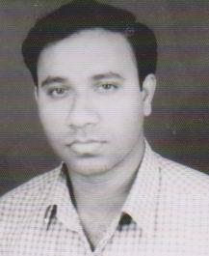 | DR. MRINAL KANTI MONDAL  F/Name:  M/Name:  BM & DC Reg. No:  NID:  Cell:  Address: Khulna Clinic 37/1 T.B. Boundry Road,Moulovipara Khulna.  Blood Group:
251 | Voter No  LM-2900246 | DR. A.B.M. GOLAM SARWAR FARUQUE  F/Name: Late Abul Quasem  M/Name:  BM & DC Reg. No: 15053  NID:  Cell: 01714002123  Address: 12, Sultan Ahmed Road Moulavipara. Khulna  Blood Group: AB+
252 | Voter No  LM-2900247  No Image | DR. MOHAMMAD BADRUDDOZA  F/Name: Janab M. A. Awal  M/Name:  BM & DC Reg. No:  NID:  Cell:  Address: 35/8 T.B. Cross Road Khulna.  Blood Group:
253 | Voter No  LM-2900248  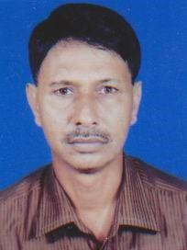 | DR. GULZAR RAHMAN  F/Name: Late Alhaj Taheruddin Gazi  M/Name:  BM & DC Reg. No: 11140  NID:  Cell: 01711953059  Address: Road # 6, House # 25 Sonadanga R/A. Khulna.  Blood Group: B+
254 | Voter No  LM-2900249  No Image | DR. RAZIA SULTANA  F/Name: Late Abdul Karim  M/Name:  BM & DC Reg. No:  NID:  Cell:  Address: a  Blood Group:  E X P I R E D
255 | Voter No  LM-2900250  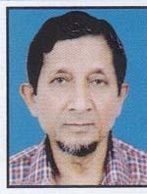 | DR. SALEMIR HOSSAIN CHOWDHURY  F/Name: Md. Farayez Hossain Chowdhury  M/Name:  BM & DC Reg. No: 8499  NID:  Cell: 01917117144  Address: H-19, Road-4, Abir Garden, Block-G, Banani, Dhaka-1213.  Blood Group: B+
256 | Voter No  LM-2900251  No Image | DR. MD. TABIBUL ISLAM  F/Name: Late Khorshedul Alam  M/Name:  BM & DC Reg. No:  NID:  Cell:  Address: Ex-Medical Officer Khulna Medical College Hospital.Khulna.  Blood Group:
257 | Voter No  LM-2900252 | DR. SURAJIT KUMAR BAIN  F/Name: Nirmal Kumar Bain  M/Name:  BM & DC Reg. No: 26573  NID:  Cell: 01712662799  Address: FM Tower, Flat-7, 17, Shamsur Rahman Road, Khulna.  Blood Group: A+
258 | Voter No  LM-2900253  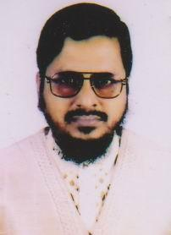 | S.M.JAFAR ULLAH  F/Name: Md.Shahid Ullah  M/Name: Sufia Khatun  BM & DC Reg. No: 11305  NID:  Cell: 01711331320  Address: 307, R-1 Sonadanga R/A, Khulna  Blood Group: O+
259 | Voter No  LM-2900254 | DR. MD. IBRAHIM KHALIL  F/Name: Late Mujibur Rahman  M/Name:  BM & DC Reg. No: 9288  NID:  Cell: 01711243008  Address: 26, Ahsan Ahmed Road National Tower, 5-D, Khulna  Blood Group: B+
260 | Voter No  LM-2900255  No Image | DR. MD. SHAHIDUR RAHMAN  F/Name: Md. Ishaque Sarder  M/Name:  BM & DC Reg. No: 14360  NID:  Cell:  Address: Ex-Medical Officer Kapilmoni,10 Bedded Hospital, Khulna.  Blood Group:
261 | Voter No  LM-2900256  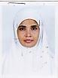 | DR. TAHMINA KHATUN  F/Name: Golam Mortoza  M/Name:  BM & DC Reg. No: 38868  NID:  Cell: 01815462617  Address: Hazi Hanif Complex, 12-13, Khan Jahan Ali Road, Khulna.  Blood Group: O+
262 | Voter No  LM-2900257  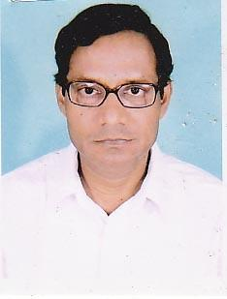 | DR. SK. ATAUR RAHMAN  F/Name: Late Sk. Subadar Ali  M/Name:  BM & DC Reg. No: 8665  NID:  Cell: 01711960609  Address: Road No.12, House No.153 Mujgunni R/A, Khulna  Blood Group: B+
263 | Voter No  LM-2900258  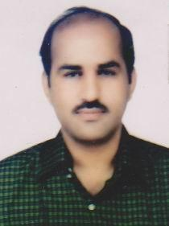 | DR. GIRINDRA NATH KUNDU  F/Name: Sri Monindra Nath Kundu  M/Name:  BM & DC Reg. No: 18326  NID:  Cell: 01611830944  Address: Patients Nursing Home KUET Gate, Fulbarigate Khulna  Blood Group: O-
264 | Voter No  LM-2900259  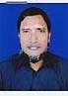 | DR. K.M. MUNIRUZZAMAN  F/Name: Md. Bayzid Ali Khan  M/Name:  BM & DC Reg. No: 21589  NID:  Cell: 01815462616  Address: 12-13, Khanjahan Ali Road Hazi Hanif Complex, Khulna.  Blood Group: A+
265 | Voter No  LM-2900260  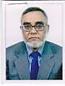 | DR. MD. NURUL ISLAM SARDER  F/Name: Late Sarder Md. Aftab Uddin Ahmed  M/Name:  BM & DC Reg. No:  NID:  Cell:  Address: Plot-396, Road-21, Nirala R/A, Khulna  Blood Group:  E X P I R E D
266 | Voter No  LM-2900261  No Image | DR. NAHIDA SULTANA  F/Name:  M/Name:  BM & DC Reg. No:  NID:  Cell:  Address:  Blood Group:  E X P I R E D
267 | Voter No  LM-2900262  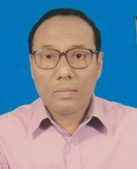 | DR. ANIL KRISHNA BISWAS  F/Name: Debendra Nath Biswas  M/Name:  BM & DC Reg. No: 15538  NID:  Cell: 01925491732  Address: 291, Khanjahan Ali Road, Khulna.  Blood Group: O+
268 | Voter No  LM-2900263  No Image | DR. SIPAR AHMED  F/Name:  M/Name:  BM & DC Reg. No:  NID:  Cell:  Address:  Blood Group:  E X P I R E D
269 | Voter No  LM-2900264  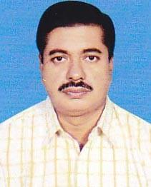 | DR. MD. ABDUL MAZID  F/Name: Late Md. Anis Uddin  M/Name:  BM & DC Reg. No:  NID:  Cell: 01715212134  Address: Managing Director Al Amin Clinic Paikgacha, Khulna  Blood Group:
270 | Voter No  LM-2900265  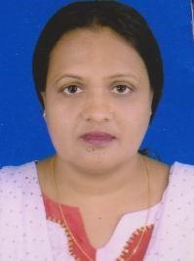 | DR. AREEFA AKTER  F/Name: Late Mohammed Ali  M/Name:  BM & DC Reg. No:  NID:  Cell:  Address: 2, Babu Khan Road Khulna  Blood Group:
271 | Voter No  LM-2900266 | DR. MD. MONIRUZZAMAN MOLLICK  F/Name: Md. Abdul Goni Mollick  M/Name:  BM & DC Reg. No: 31980  NID:  Cell: 01723350398  Address: Poygram, Phultala Khulna.  Blood Group: O+
272 | Voter No  LM-2900267  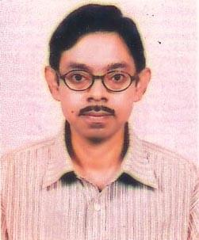 | DR. MD. SIRAJUM MUNIR  F/Name: Late Md. Maidul Islam  M/Name:  BM & DC Reg. No: 24032  NID:  Cell: 01914269747  Address: Asst. Prof. Cardiology Kushtia Medical College, Kushtia  Blood Group: O+
273 | Voter No  LM-2900268  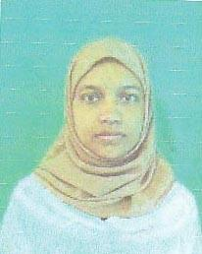 | DR. NAZMIN RAHMAN  F/Name: Md. Khalilur Rahman  M/Name:  BM & DC Reg. No: 35032  NID:  Cell: 01954848843  Address: 51, Basupara Lane Khulna  Blood Group: O+
274 | Voter No  LM-2900269  No Image | DR. GAZI EKRAMUL HAQUE  F/Name: Late Samir Uddin Gazi  M/Name:  BM & DC Reg. No:  NID:  Cell:  Address: Vill-Rahimnagar, P.O.-Rahimnagar PS- Digholia Khulna  Blood Group:
275 | Voter No  LM-2900270  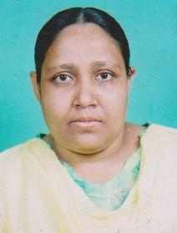 | DR. NILUFAR RAHMAN  F/Name: Late Md. Fazlur Rahman  M/Name:  BM & DC Reg. No: 30212  NID:  Cell: 01711109417  Address: Raysha Clinic Gallamari, Khulna  Blood Group: B+
276 | Voter No  LM-2900271 | DR. MAHBUBUL ALAM  F/Name: Mohammad Ali  M/Name:  BM & DC Reg. No:  NID:  Cell: 01712179639  Address: Vill-Senhati, P.O.-Senhati PS. Digholia Khulna  Blood Group:
277 | Voter No  LM-2900272 | DR. PROSANTA KUMAR BISWAS  F/Name: Chitta Ranjan Biswas  M/Name:  BM & DC Reg. No:  NID:  Cell: 01711571482  Address: Vill-Hadipur, P.O. Askarpur Upazilla. : Dehata, Dist. : Satkhira  Blood Group: B+
278 | Voter No  LM-2900273  No Image | DR. MIRAZUL HASSAN  F/Name:  M/Name:  BM & DC Reg. No:  NID:  Cell:  Address:  Blood Group:  E X P I R E D
279 | Voter No  LM-2900274  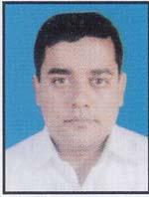 | DR. MD. MAHBUBUL HAQUE  F/Name: Md. Shamsuddin Ahmed  M/Name:  BM & DC Reg. No: 7823  NID:  Cell: 01711217445  Address: 28, Sher-E-Bangla Road Khulna  Blood Group: O+
280 | Voter No  LM-2900275  No Image | DR. S.M. MAHBUBUR RAHMAN  F/Name: Dr. SK.A. Rouf  M/Name:  BM & DC Reg. No:  NID:  Cell:  Address: Charerhat Main Road Khalishpur, Khulna  Blood Group:
281 | Voter No  LM-2900276  No Image | DR. KAZI ZAMIR HOSSAIN  F/Name: Kazi Neyamatullah  M/Name:  BM & DC Reg. No:  NID:  Cell:  Address: Khulna Medical College Hospital Khulna  Blood Group:
282 | Voter No  LM-2900277 | DR. S.M. MASUDUR RAHMAN  F/Name: S.m. Mostafizur Rahman  M/Name:  BM & DC Reg. No: 35313  NID:  Cell: 01712885110  Address: 99/1, South Central Road, Khulna.  Blood Group: B+
283 | Voter No  LM-2900278  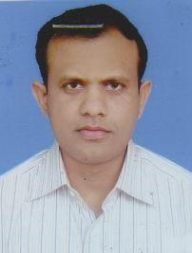 | DR. SOHEL MOHMUD KHAN  F/Name: Abdus Sattar Khan  M/Name:  BM & DC Reg. No:  NID:  Cell: 01914799685  Address: 28/6, Goalkhali Main Road Khalishpur Khulna  Blood Group:
284 | Voter No  LM-2900279 | DR. S.M. SHAHNEWAJ  F/Name: Md. Abdul Kader Sikder  M/Name:  BM & DC Reg. No: 35725  NID:  Cell: 01765696751  Address: 14, Mohila College Bagerhat.  Blood Group: B+
285 | Voter No  LM-2900280  No Image | DR. GAZI FARUQUE HOSSAIN  F/Name:  M/Name:  BM & DC Reg. No:  NID:  Cell:  Address:  Blood Group:  E X P I R E D
286 | Voter No  LM-2900281  No Image | DR. ZAMAN AHMED  F/Name: Late Md. Abul Hashem Sheikh  M/Name:  BM & DC Reg. No:  NID:  Cell:  Address: Opposite To Maszidul Kawsar Choto Boyra Khulna  Blood Group:
287 | Voter No  LM-2900282  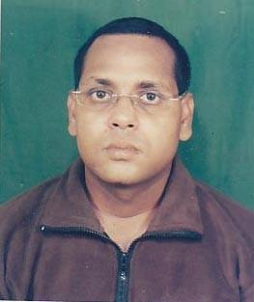 | DR. SAIFUZZAMAN  F/Name: Md. Abdul Hakim Sarder  M/Name:  BM & DC Reg. No:  NID:  Cell:  Address: 25, KD. Ghosh Road Khulna  Blood Group:
288 | Voter No  LM-2900283  No Image | DR. A.B.S.M. SIRAJUL HAQUE MIRAZ  F/Name:  M/Name:  BM & DC Reg. No:  NID:  Cell:  Address:  Blood Group:  TRANSFERED to BMA Dhaka City  LM-1405543
289 | Voter No  LM-2900284  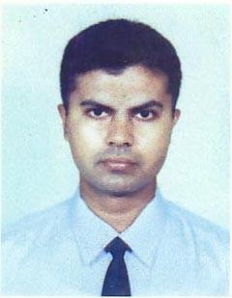 | DR. KHANDKAR ALI KAWSAR  F/Name: Khandkar Abul Hayat  M/Name:  BM & DC Reg. No:  NID:  Cell: 01911925287  Address: 48, Central Block Road # 150, Khalishpur Khulna.  Blood Group:
290 | Voter No  LM-2900285  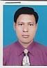 | DR. SYED MD. MUHSIN  F/Name: Late Asraf Ali  M/Name:  BM & DC Reg. No: 28574  NID:  Cell: 01711946412  Address: Sarospur, Naragati Pahardanga, Kalia, Narail.  Blood Group: O+
291 | Voter No  LM-2900286  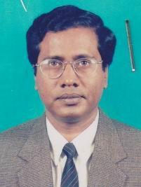 | DR. MD. ABDUL MALEQUE KHAN  F/Name: Alhaj Joynal Abedin Khan  M/Name:  BM & DC Reg. No: 15034  NID:  Cell: 01715296185  Address: House # 12, Road # 28. Nirala R/A Area, Khulna.  Blood Group: B+
292 | Voter No  LM-2900287  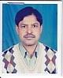 | PROF. DR. MD. SIRAJUL ISLAM  F/Name: Md. Abdus Samad Gazi  M/Name:  BM & DC Reg. No: 15933  NID:  Cell: 01714002468  Address: 29, Sher-E-Bangla Road, Shapla Clinic, Khulna.  Blood Group: B+
293 | Voter No  LM-2900288  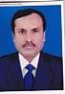 | DR. G.M. KHALILUR RAHMAN  F/Name: Late Jatton Ali Gazi  M/Name:  BM & DC Reg. No: 13515  NID:  Cell: 01716190400  Address: House # 142 Road# 12 Sonadanga, Khulna.  Blood Group: O+
294 | Voter No  LM-2900289  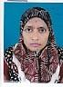 | DR. FERDOUSI AKTER  F/Name: Noor Ali Chowdhury  M/Name:  BM & DC Reg. No: 19755  NID:  Cell: 01711310303  Address: House # 142 Road# 12 Sonadanga, Khulna.  Blood Group: B+
295 | Voter No  LM-2900290  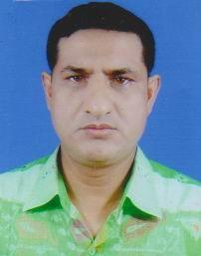 | DR. SONTOSH KUMAR MAJUMDER  F/Name: Late Nani Gopal Mojumder  M/Name:  BM & DC Reg. No: 11521  NID:  Cell: 01611988072  Address: Junior Consultant (Gynae) Upazilla Health Complex Dacope, Khulna.  Blood Group: A+
296 | Voter No  LM-2900291  No Image | DR. HOSHNE ARA LAIZU  F/Name: Md. Bayzid Ali Khan  M/Name:  BM & DC Reg. No:  NID:  Cell:  Address: Muzahid Para South Tutpara Khulna  Blood Group:
297 | Voter No  LM-2900292  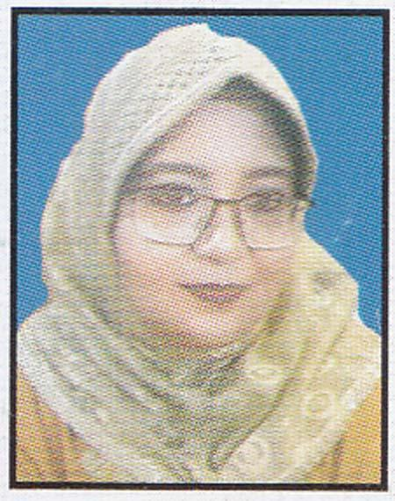 | DR. FARHANA AHMED  F/Name: M. Kamal Uddin Ahmed  M/Name:  BM & DC Reg. No: 28944  NID:  Cell: 01711274072  Address: 20/B, Road, # 11, Dhanmondi, Dhaka.  Blood Group: O+
298 | Voter No  LM-2900293  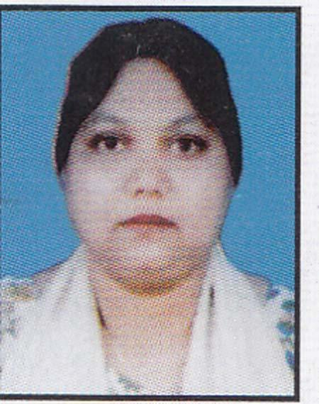 | DR. SURAIYA YASNOOR  F/Name: Md. Maksud Chowdhury  M/Name:  BM & DC Reg. No: 23770  NID:  Cell: 01712172334  Address: Khulna Shipyard Ltd. Bangladesh Navy, Khulna.  Blood Group: A+
299 | Voter No  LM-2900294  No Image | DR. DIPANKAR KUMAR SAHA  F/Name: Modon Mohon Saha  M/Name:  BM & DC Reg. No:  NID:  Cell:  Address: Ex-Asstt. Registrar (Surgery) Khulna Medical College Hospital Khulna  Blood Group:
300 | Voter No  LM-2900295  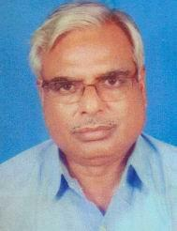 | DR. KHAN HABIBUR RAHMAN  F/Name: Md. Serajul Hoque Khan  M/Name:  BM & DC Reg. No: 8811  NID:  Cell: 01716916126  Address: Muzgunny R/A House-24, Road-7 Boyra, Khulna  Blood Group: AB+
301 | Voter No  LM-2900296  No Image | DR. NABILA HOSSAIN  F/Name: Late A.B.M. Saddat Ali  M/Name:  BM & DC Reg. No:  NID:  Cell:  Address: Road-6, House-71 Mujgunni R/A Khulna  Blood Group:
302 | Voter No  LM-2900297  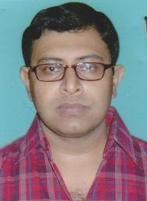 | DR. MOHD. ANOWERUL AZIM  F/Name: Md. Azizul Haque  M/Name:  BM & DC Reg. No: 34788  NID:  Cell: 01934985666  Address: Child Care Medical Center 42, Municipal Tank Road Khulna.  Blood Group: B+
303 | Voter No  LM-2900298  No Image | DR. MOHAMMAD HEDAYETUL ISLAM  F/Name: Late Md. Ebadullah  M/Name:  BM & DC Reg. No:  NID:  Cell:  Address: 30, B.K. East Maszid Lane Khulna  Blood Group:
304 | Voter No  LM-2900299  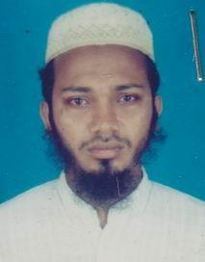 | DR. MD. BABY ZAMAN  F/Name: Late Amzed Ali  M/Name:  BM & DC Reg. No: 37396  NID:  Cell: 01714083796  Address: 18, Gagon Babu Road (Adarsa Bekary), Khulna.  Blood Group: B+
305 | Voter No  LM-2900300  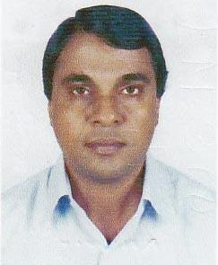 | DR. MD. SHAUKAT ALI KHAN  F/Name: Alhaz M.a. Latif  M/Name:  BM & DC Reg. No: 16295  NID:  Cell: 01911395238  Address: “Khan Manzil” Lower Jessore Road, Daulatpur, Khulna  Blood Group: O+
306 | Voter No  LM-2900301  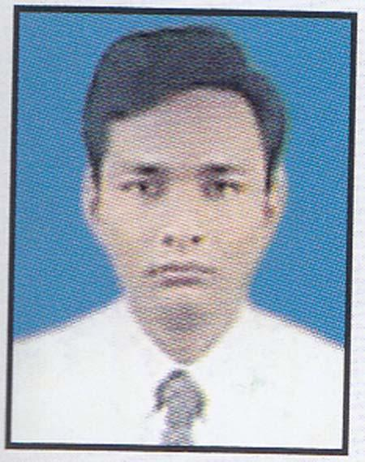 | DR. S. M. AKRAMUZZAMAN  F/Name: Md. Atiqur Rahman  M/Name:  BM & DC Reg. No: 29730  NID:  Cell: 01712582888  Address: Vill-Dhulgram, P.O-Siddipasha, Avaynagor, Jessore.  Blood Group: O+
307 | Voter No  LM-2900302  No Image | DR. SHAIKH LUTFAR RAHMAN  F/Name:  M/Name:  BM & DC Reg. No:  NID:  Cell:  Address:  Blood Group:  TRANSFERED to BMA Dhaka City  LM-1405543
308 | Voter No  LM-2900303  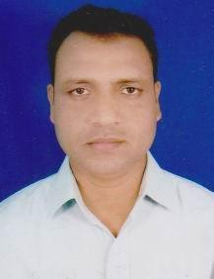 | DR. MD. MUSHFIQUR RAHMAN  F/Name: Md. Chad Miah  M/Name:  BM & DC Reg. No: 28484  NID:  Cell: 01711393190  Address: Road No. 20, House No. 227 Muggunni R/A, Khalishpur Khulna-9100.  Blood Group: A+
309 | Voter No  LM-2900304  No Image | DR. GAZI MD. NAZRUL ISLAM  F/Name: Gazi Md. Zahurul Haque  M/Name:  BM & DC Reg. No:  NID:  Cell:  Address: 5, South Central Road Khulna.  Blood Group:
310 | Voter No  LM-2900305 | DR. MD. SOFIUL ALAM  F/Name: Badrul Alam  M/Name:  BM & DC Reg. No: 43523  NID:  Cell: 01712110113  Address: Islamia College Road Boyra, Khulna.  Blood Group: A+
311 | Voter No  LM-2900306 | DR. MD. IBRAHIM KHALIL  F/Name: Md. Shamsuddin Morol  M/Name:  BM & DC Reg. No: 42293  NID:  Cell: 01712958604  Address: Consultant, Abu Naser Spacialist Hospital, Khulna.  Blood Group: B+
312 | Voter No  LM-2900307 | DR. MD. RIAZ SHAHID  F/Name: Late Advocate Md Shahiduzzaman  M/Name:  BM & DC Reg. No: 45182  NID:  Cell: 01711827069  Address: 100 Saltan Ahmed Road Moulovipara Khulna-9100  Blood Group: O+
313 | Voter No  LM-2900308 | DR. MD. NAFIS AREEFIN  F/Name: A K M Abdur Rab  M/Name:  BM & DC Reg. No: 43783  NID:  Cell: 01711112549  Address: Vill-Gholagari, P.O.-Khola Bogra Sadar, Bogra.  Blood Group: O-
314 | Voter No  LM-2900309  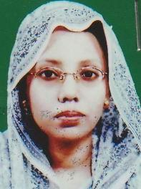 | DR. FARHANA YASMIN  F/Name: M A Rashid  M/Name:  BM & DC Reg. No: 43784  NID:  Cell: 01911776708  Address: 286/2, Aiub Ali Road Pabla Main Road Daulatpur, Khulna.  Blood Group: B+
315 | Voter No  LM-2900310  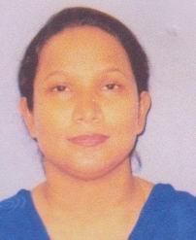 | DR. MOST SIRAJUM MUNIRA  F/Name: Shaik Lutfor Rahman  M/Name:  BM & DC Reg. No: 84202  NID:  Cell: 01912969470  Address: Kazi Place Old Laboratory School Road Daulatpur, Khulna.  Blood Group:
316 | Voter No  LM-2900311  No Image | DR. SYED QUAMRUZZAMAN  F/Name: Syed Abdul Quader  M/Name:  BM & DC Reg. No:  NID:  Cell:  Address: 19, Gagon Babu Road, 2nd Lane Nuton Bazar Khulna  Blood Group:
317 | Voter No  LM-2900312 | DR. MOSAMMAT ARFIA MUNNI  F/Name: K.m. Abu Yeakube  M/Name: Mrs. Asigunnahar  BM & DC Reg. No: 30664  NID: 479514177577  Cell: 01715001257  Address: Jonior Consultant, Eye BNSB Eye Hospital, Shiromoni, Khulna.  Blood Group: B+
318 | Voter No  LM-2900313 | DR. ABDUL KADER  F/Name: Late Dr. Abdul Bari  M/Name: Late Hasina Khatun  BM & DC Reg. No: 18823  NID: 4798517227197  Cell: 01715743237  Address: 3, Ibrahim Mia Road Palpara, Shibbari, Khulna.  Blood Group: B+
319 | Voter No  LM-2900314  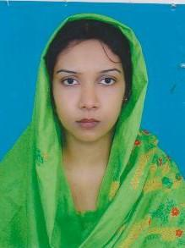 | DR. JAFRIN AJMIRA HOQUE  F/Name: Dr. Md. Sirajul Hoque  M/Name: Mrs. Noorjahan Hoque  BM & DC Reg. No: 31042  NID: 4798517227400  Cell: 01819132255  Address: 3, Ibrahim Mia Road Palpara, Shibbari, Khulna.  Blood Group: O+
320 | Voter No  LM-2900315 | DR. RAMESH CHANDRA SARKER  F/Name: Late Debendra Nath Sarker  M/Name: Subhadra Sarker  BM & DC Reg. No: 24311  NID: 4798516215133  Cell: 01711065406  Address: Shasanghat Road, Pujakhola, Choto Boyra, GPO Khulna- 9000, Thana: sonadanga, Dist: Khulna.  Blood Group: O+
321 | Voter No  LM-2900316 | DR. AMAR KUMAR SAHA  F/Name: Late Amulya Ratan Saha  M/Name: Late Giri Bala Saha  BM & DC Reg. No: 21808  NID: 4795122403871  Cell: 01711462679  Address: 3/299 Sonadanga R/A 2nd Phase, Khulna.  Blood Group: B+
322 | Voter No  LM-2900317 | DR. MD. ZAHID HUSSAIN  F/Name: Md. Taiab Ali Talukder  M/Name: Mst. Hosne Ara Begum  BM & DC Reg. No: 26011  NID: 4795129505222  Cell: 01711397280  Address: 86, Gagon Babu Road, Khulna.  Blood Group: O+
323 | Voter No  LM-2900318 | DR. S. M. KAMAL  F/Name: Mujibul Hoque  M/Name: Mamtaj Begum  BM & DC Reg. No: 15439  NID:  Cell: 01716208746  Address: House # 173, Road # 11, Sonadanga, R/A, 1st Phase, Khulna.  Blood Group: B+
324 | Voter No  LM-2900319 | DR. SANZIDA HUDA  F/Name: S.m. Nurul Huda  M/Name: Sajeda Huda  BM & DC Reg. No: 40385  NID: 4795129505087  Cell: 01711399065  Address: 11. No. Hazi Mohsin Road, Fakir Bari lane, Khulna.  Blood Group: A+
325 | Voter No  LM-2900320 | DR. ANZUMAN ARA  F/Name: Mohammad Asaduzzaman Khan  M/Name: Shahanara Zaman  BM & DC Reg. No: 40640  NID: 2650898250255  Cell: 01717880136  Address: House No: C/27, Road No: 123, Housing Estate, Khalishpur, Khulna.  Blood Group: A+
326 | Voter No  LM-2900321  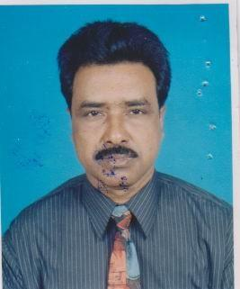 | DR. APU LAWRENCE BISWAS  F/Name: Lt. Mr. John Sachin Biswas  M/Name: Lt. Mrs. Margaret Purnima Biswas  BM & DC Reg. No: 14301  NID: 4795129497417  Cell: 01711841424  Address: ARK, 35/1(KA), House Building Area, Sonadanga Main Road, Khulna- 9000  Blood Group: O+
327 | Voter No  LM-2900322 | DR. CHANDAN KUMAR SAHA  F/Name: Dr. Champak Ranjan Saha  M/Name: Shikha Rani Saha  BM & DC Reg. No: 45777  NID: 4795123425438  Cell: 01717456929  Address: 17, KDA Avenue, JH Shanta Tower.  Blood Group: A+
328 | Voter No  LM-2900323  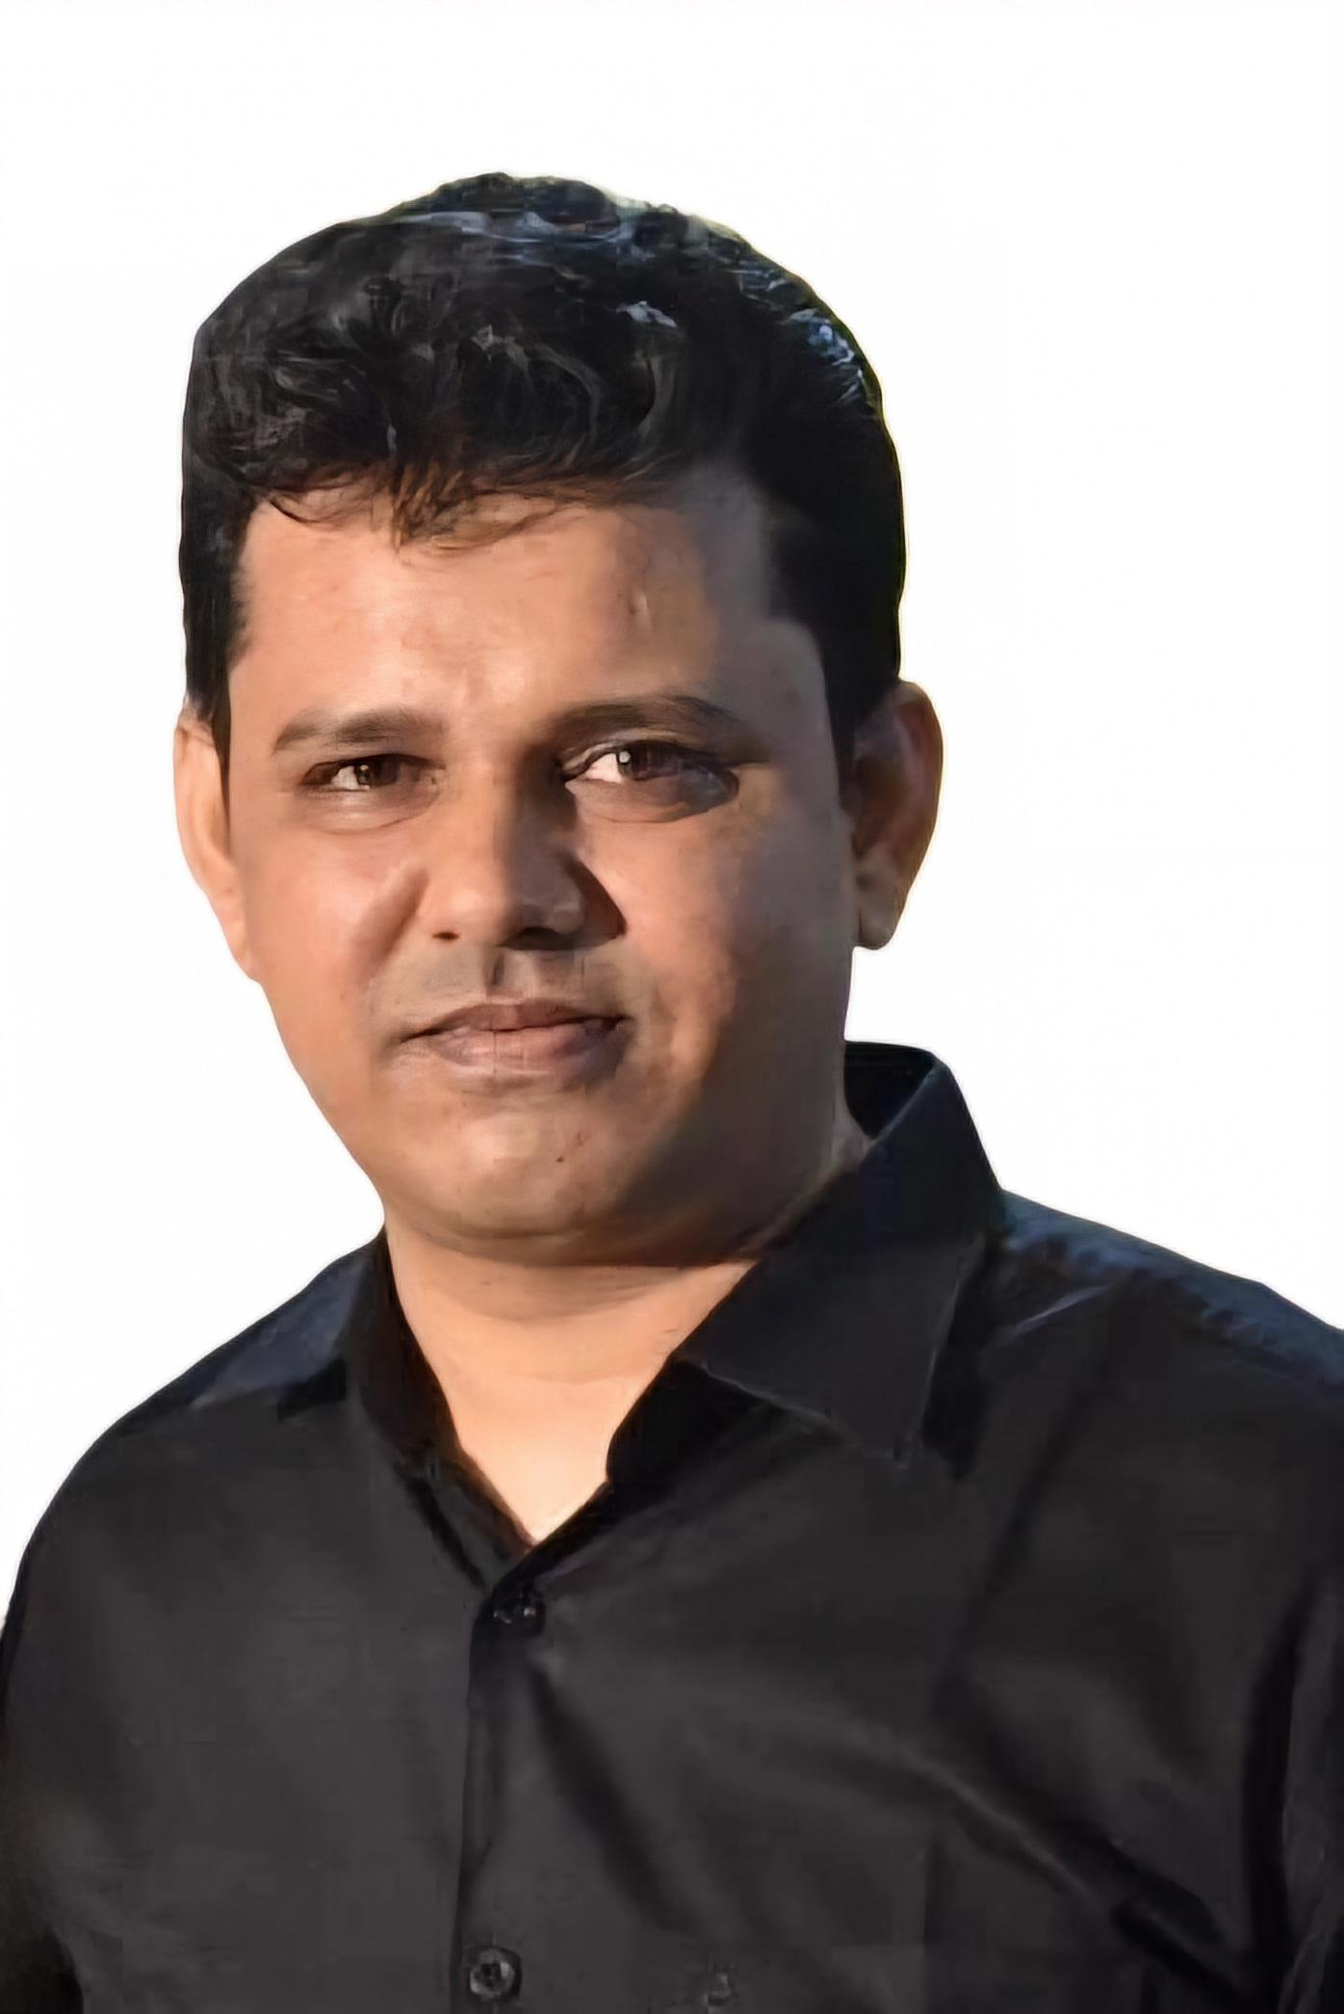 | DR. UZZAL KUMAR BISWAS  F/Name: Late Sridam Biswas  M/Name: Aroti Biswas  BM & DC Reg. No: 51593  NID: 4111194097129  Cell: 01719024147  Address: Upazilla Health Complex Shalikha, Magura.  Blood Group: B+
329 | Voter No  LM-2900324  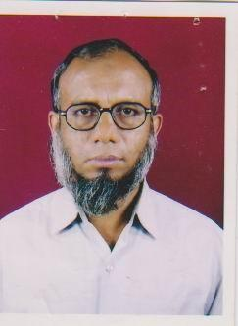 | DR. SHIKDAR ALI AKBAR  F/Name: Abdul Hakim Shikdar  M/Name: Mohitunnessa  BM & DC Reg. No: 13988  NID: 4795130518757  Cell: 01715144631  Address: Gopalganj Fazilatunnisa Eye Hospital & Training Center.  Blood Group: O+
330 | Voter No  LM-2900325  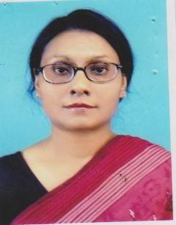 | DR. MERINA ARA  F/Name: Late Dr. Md. Rustom Miah  M/Name: Late Mst. Saheda Begum  BM & DC Reg. No: 12651  NID: 4795127468036  Cell: 01713068612  Address: 21, Prof. Rokon Uddin Road Tusher Lodge, Mistripara, Khulna.  Blood Group: A+
331 | Voter No  LM-2900326  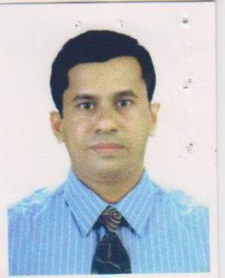 | DR. MD. MOHSIN ALI FARAZI  F/Name: Late Mobarak Ali Farazi  M/Name: Late Khadiza Khatun  BM & DC Reg. No: 25005  NID: 2696352214769  Cell: 01711964550  Address: SEL Rupsha, House # 50, Sonadanga R/A, Khulna.  Blood Group: A+
332 | Voter No  LM-2900327  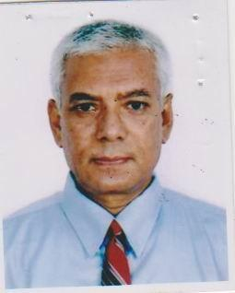 | DR.CHOUDHURY HABIBUR RASUL  F/Name: Late Chouhury Abul Hasnat  M/Name: Rasula Khatun  BM & DC Reg. No: 8056  NID:  Cell: 01710850351  Address: Flat 7B National Tower, 26, Ahsan Ahmed Road, Khulna.  Blood Group: A+
333 | Voter No  LM-2900328  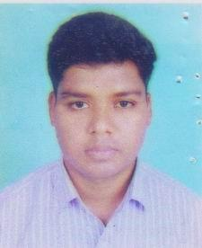 | DR. MD. RASHED HASAN  F/Name: Md Shahazzel Hossain  M/Name: Mrs. Sham Sunnahar  BM & DC Reg. No: 47381  NID: 4794510333929  Cell: 01711000744  Address: Plot # F7, Faisal Tower-22 47/1, R/A Khan Road, Kushtia.  Blood Group: B+
334 | Voter No  LM-2900329  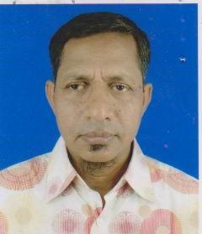 | DR. MD. ABDUS SAMAD  F/Name: Md. Abdul Mannan  M/Name: Mst. Amena Khatun  BM & DC Reg. No: 17904  NID:  Cell: 01712087431  Address: House: N-6, Road-143, Khalishpur Housing Estate, Khulna, Road: 143  Blood Group: O+
335 | Voter No  LM-2900330  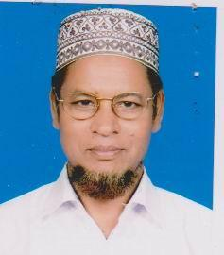 | DR. MD. NURUL HOQUE FAKIR  F/Name: Late Mr. Wazed Ali Fakir  M/Name: Mrs. Moyful Bibi  BM & DC Reg. No: 7609  NID: 4795129502397  Cell: 01710887663  Address: 142, Hoque Manzil, BK Roy Road, Shaikhpara, Khulna.  Blood Group: B+
336 | Voter No  LM-2900331  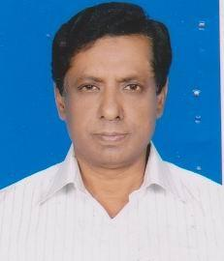 | DR. A.K.M. RABIUL IQBAL  F/Name: Md. Nurul Islam  M/Name: Mr. Nurunnessa  BM & DC Reg. No: 12089  NID:  Cell: 01711332634  Address: House No E/28 Road No: 29, Nirala Residential Area, Khulna.  Blood Group: O+
337 | Voter No  LM-2900332  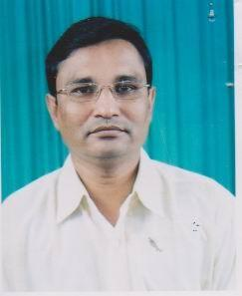 | DR. AICH LAKSHMON KUMAR  F/Name: Late Monmotha Aich  M/Name: Late Renu Bala Aich  BM & DC Reg. No: 18928  NID: 4795123417539  Cell: 01715448055  Address: 2/Kha, Gagon Babu Road Khulna.  Blood Group: B+
338 | Voter No  LM-2900333  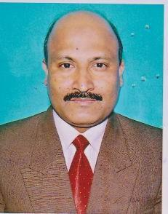 | DR. MD. RAFIQUL ISLAM  F/Name: Md. Abdul Gafur  M/Name: Mst Shahar Banu  BM & DC Reg. No: 17198  NID: 4798517242542  Cell: 01711838481  Address: P-2, Doctors Para Road, Chhata Boyra, Sonadanga, Khulna.  Blood Group: B+
339 | Voter No  LM-2900334 | DR. MST. TAHERA AMIN  F/Name: Ruhul Amin Patuary  M/Name: Rokeya Amin  BM & DC Reg. No: 41138  NID: 2696352219675  Cell: 01716438440  Address: Road-5, Plot-39 Sonadanga R/A, Khulna.  Blood Group: AB+
340 | Voter No  LM-2900335  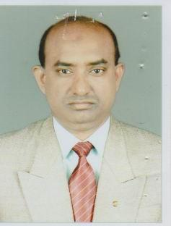 | DR. MD. A. MANNAN SHAIKH  F/Name: Md. Noor Ali Shaikh  M/Name: Late Rabeya Khatun  BM & DC Reg. No: 21145  NID: 4794512155485  Cell: 01712021725  Address: 4/1, Nazirghat main road, Khulna.  Blood Group: A+
341 | Voter No  LM-2900336 | DR. B.M DIN MOHAMMAD  F/Name: Late B.m. Khorshed Ali  M/Name: Jahanara Begum  BM & DC Reg. No:  NID:  Cell: 01716756275  Address: Vill+Post: Baruna, Ps: Dumuria Khulna.  Blood Group:
342 | Voter No  LM-2900337 | DR. MD. SYED ALI  F/Name: Late Md. Iumman Sarder  M/Name: Mst Sakina Khatun  BM & DC Reg. No: 23174  NID: 4798516214829  Cell: 01711981547  Address: 26, Ahsan Ahmed Road Khulna.  Blood Group: AB+
343 | Voter No  LM-2900338  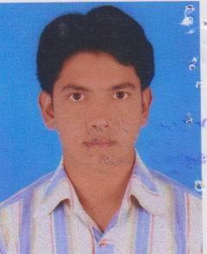 | DR. MANZURUL IBRAHIM MUSA  F/Name: S.m. Anowar Hossain  M/Name: Mrs. Monowara Begum  BM & DC Reg. No: 49771  NID: 4794509119145  Cell: 01818634635  Address: Hazar Duari, B/12, Boyra R/A Goolkhali, Khulna 9000.  Blood Group: AB+
344 | Voter No  LM-2900339  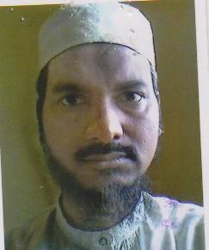 | DR. MD. MOKTER HOSSAIN  F/Name: Md. Montaz Ali  M/Name: Most Rizia Khatun  BM & DC Reg. No: 24336  NID: 4798520293803  Cell: 01711309067  Address: Holding No-32, Sayed Ali Hossain Road, Sonadanaga, Khulna.  Blood Group: B-
345 | Voter No  LM-2900340  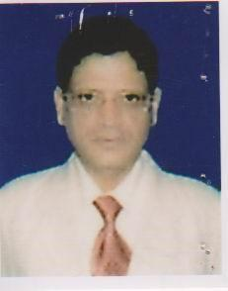 | DR. MD. SHAFIQUZZAMAN SIDDIQUI  F/Name: Late Md. Abdul Jabbar Siddiqui  M/Name: Late Nazatunnesa  BM & DC Reg. No: 16091  NID: 4795128480149  Cell: 01733700596  Address: Asst. Professor, Khulna Medical College Hospital, Khulna.  Blood Group: B+
346 | Voter No  LM-2900341  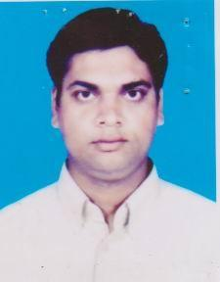 | DR. MD. MAMUN AL ROWSHON  F/Name: Md. Rowshon Ali  M/Name: Mrs. Mahamuda Rowshon  BM & DC Reg. No: 38895  NID: 4794515199766  Cell: 01711482868  Address: Nahar Manjil, 18 Gabtola Road, Khalishpur, Khulna-9000.  Blood Group: O+
347 | Voter No  LM-2900342  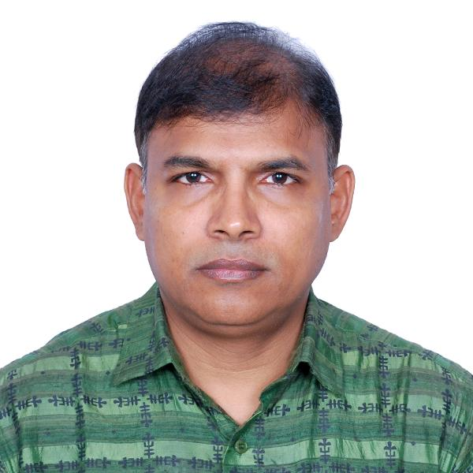 | DR. MD. KAMRUZZAMAN  F/Name: Late Hamijuddin Molla  M/Name: Kanchan Mala  BM & DC Reg. No: 22816  NID: 4798517230125  Cell: 01711155024  Address: House no-90, Road no-13, Sonadanga R/A, 2nd Phase, Khulna.  Blood Group: A+
348 | Voter No  LM-2900343  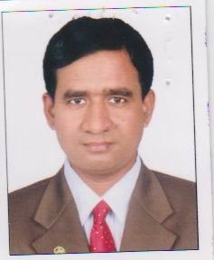 | DR. JIBITESH BISWAS  F/Name: Jiban Krishna Biswas  M/Name: Leela Bati Biswas  BM & DC Reg. No: 29329  NID: 6517654108568  Cell: 01715448257  Address: Upazilla Health Complex, Mongla, Bagerhat.  Blood Group: A+
349 | Voter No  LM-2900344  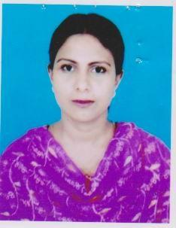 | DR. RUMA PARVIN  F/Name: Abdur Rashid Sardar  M/Name: Mrs. Shamsunnahar  BM & DC Reg. No: 35361  NID: 4794515199767  Cell: 01715351000  Address: Nahar Manjil, 18 Gabtola Road, Khalishpur, Khulna 9000  Blood Group: B+
350 | Voter No  LM-2900345  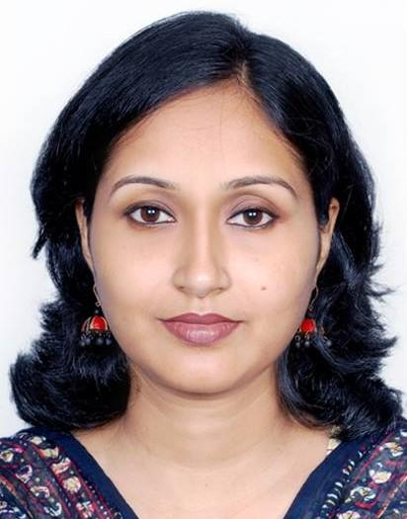 | DR. KAZI NURJAHAN  F/Name: Kazi Nuruddin  M/Name: Kazi Rosy Nur  BM & DC Reg. No: 36816  NID: 4798517230225  Cell: 01711476209  Address: House no-90, Road no-13, Sonadanga R/A, 2nd Phase, Khulna  Blood Group: AB+
351 | Voter No  LM-2900346  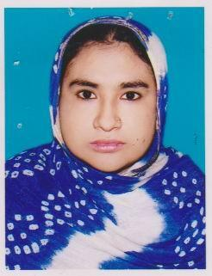 | DR. MOMOTAZ BEGUM  F/Name: Late Sk. Abul Hossain  M/Name: Late Zaheda Begum  BM & DC Reg. No: 31708  NID: 4714075147887  Cell: 01711365968  Address: Momota Clinic Fulbarigate, P.O: kuet, Dist: Khulna.  Blood Group: O+
352 | Voter No  LM-2900347  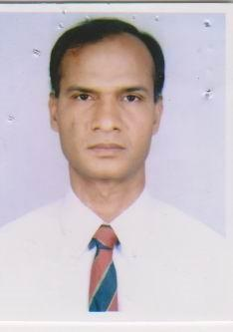 | DR. MD. RABIUL ALAM  F/Name: Late Shaikh Sajedur Rahman  M/Name: Banujan Begum  BM & DC Reg. No: 21745  NID: 4421906141410  Cell: 01711170787  Address: Asst. Prof. Dermatology, Khulna Medical College, Khulna.  Blood Group: O+
353 | Voter No  LM-2900348  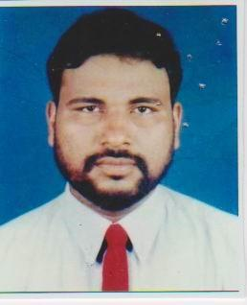 | DR S.M ABDUL WAHAB  F/Name: Late Md. Abul Kasem  M/Name: Late Mrs. Ovironnessa  BM & DC Reg. No: 16836  NID: 4798517230912  Cell: 01715166638  Address: Rd-03, H-316, Sonadanga R/A, 2nd Phase, Khulna.  Blood Group: O+
354 | Voter No  LM-2900349  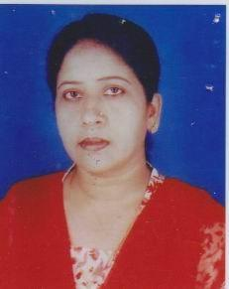 | DR. SHAMSUDA BEGUM  F/Name: Late Abdus Sattar  M/Name: Late Momena Khatun  BM & DC Reg. No: 21413  NID: 4794514189862  Cell: 01715849428  Address: Lecturer Community Medicine, Khulna Medical College, Khulna-9000  Blood Group: AB+
355 | Voter No  LM-2900350  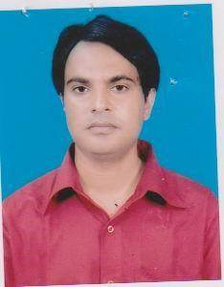 | DR. ABU ZAFAR MD SALEH  F/Name: Md Abdur Rob  M/Name: Late Mrs Razia Rob  BM & DC Reg. No: 37526  NID: 4798517243439  Cell: 01816702493  Address: Consultant ENT Dacope Upazilla Health Complex Dacope, Khulna.  Blood Group: A+
356 | Voter No  LM-2900351  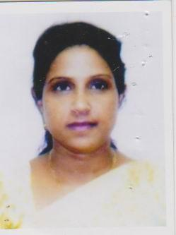 | DR. SABITA MALLICK  F/Name: Sunit Kumar Mallick  M/Name: Late Rukuma Mallick  BM & DC Reg. No: 21849  NID: 4798517248775  Cell: 01752573384  Address: 12/13, Hazi Hanif Complex Khanjahan Ali Road, Khulna.  Blood Group: O+
357 | Voter No  LM-2900352  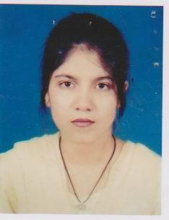 | DR. SABINA CHOWDHURY  F/Name: A. Azim Chowdhury  M/Name: Mrs. Nurbanu Chowdhury  BM & DC Reg. No: 36960  NID: 4798577234199  Cell: 01816702492  Address: 11.B. K. Roy Road, Shekh Para, Khulna.  Blood Group: A+
358 | Voter No  LM-2900353  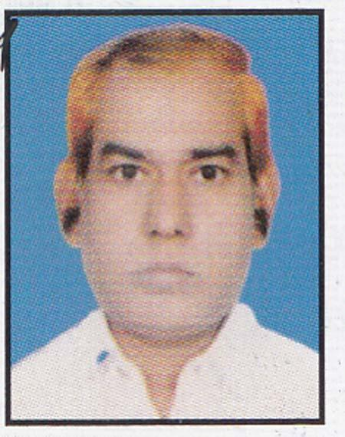 | DR.MD. ABUL KALAM AZAD  F/Name: Adv. Md. Abdul Quader  M/Name:  BM & DC Reg. No: 32517  NID: 9101401165  Cell: 01777159491  Address: 108,Al-Aksa Jame Mosque Lane, Mojid Saroni Road, Sonadanga. Khulna. 9000.  Blood Group: B+
359 | Voter No  LM-2900354  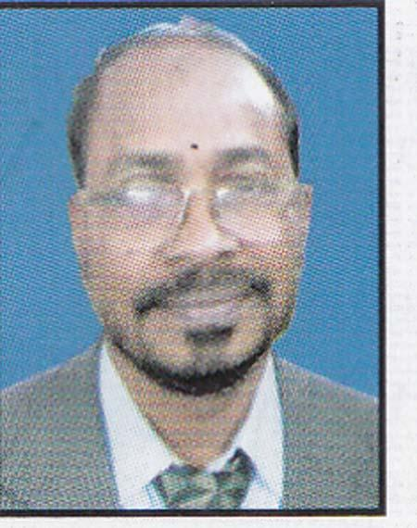 | DR. SYED MOZAMMEL HOSSAIN  F/Name: Syed Ali Akbar  M/Name:  BM & DC Reg. No: 14421  NID:  Cell: 01714136560  Address: House # 92, Road # 02, Sonadanga R/A, Khulna.  Blood Group: B+
360 | Voter No  LM-2900355  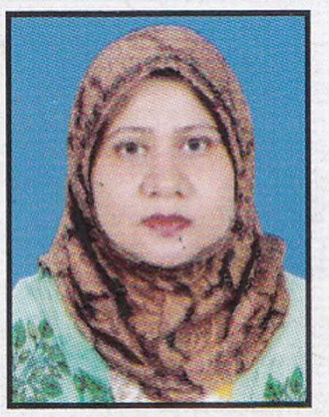 | DR. MOSLEMA PARVIN  F/Name: Mosle Uddin Ahamed  M/Name:  BM & DC Reg. No: 31326  NID:  Cell: 01711248280  Address: House # 92, Road # 02, Sonadanga R/A, Khulna.  Blood Group: A+
361 | Voter No  LM-2900356  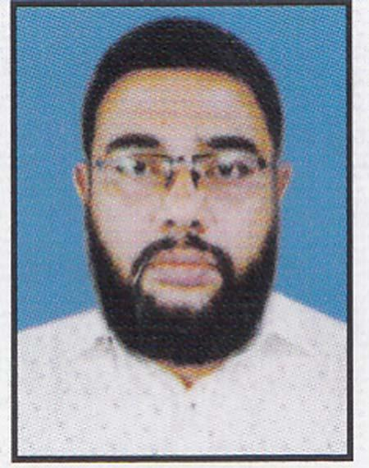 | DR. MD. MOSRAFUZZAMAN  F/Name: Md. Akramuzzaman  M/Name:  BM & DC Reg. No: 43689  NID:  Cell: 01715150942  Address: “Shaheen Monzil” 89, Basu Para, Bashtala More Khulna.  Blood Group: O+
362 | Voter No  LM-2900357  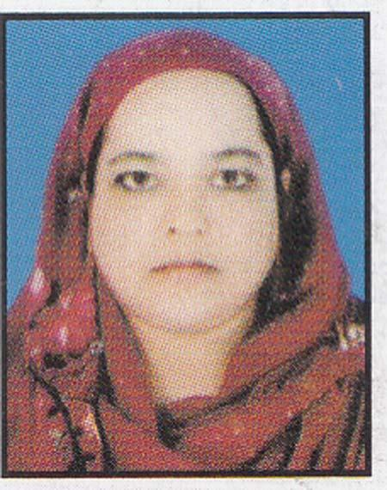 | DR. ROKEYA SULTANA  F/Name: Late Sk. Abdul Hannan  M/Name:  BM & DC Reg. No: 46489  NID:  Cell: 01717338237  Address: “Shaheen Monzil” 89, Basu Para, Bashtala More Khulna.  Blood Group: O-
363 | Voter No  LM-2900358  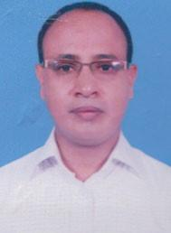 | DR. MD. ZAHIDUR RAHMAN  F/Name: Md. Tobibur Rahman  M/Name: Mrs. Lutfunnesa  BM & DC Reg. No: 29733  NID: 0695112191448  Cell: 01712799454  Address: RMO, Shahid Shekh Abu Naser, Specialized Hospital, Khulna.  Blood Group: B+
364 | Voter No  LM-2900359  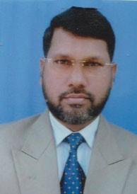 | DR. MD. MANZURUL ALAM  F/Name: Md. Asir Uddin Sana  M/Name: Sharbanu Begum  BM & DC Reg. No: 25493  NID:  Cell: 01191803451  Address: 119, Khan Jahan Ali Road, Khulna.  Blood Group: A+
365 | Voter No  LM-2900360 | DR. SADIA YEASMIN SAKI  F/Name: Dr. Md. Shahjahan Ali  M/Name: Dr. Selina Yeasmin  BM & DC Reg. No: 56454  NID: 4798520293789  Cell: 01717966478  Address: KA-1/E, Kuril, Dhaka-1929.  Blood Group: O+
366 | Voter No  LM-2900361  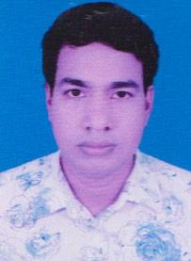 | DR. MD. ASADUZZAMAN  F/Name: Md. Adam Ali Howlader  M/Name: Mrs. Paritonnesa  BM & DC Reg. No: 35974  NID: 0117757545778  Cell: 01983654331  Address: 48/GA, 4B, Ahsan Ahmed Road, Khulna.  Blood Group: B+
367 | Voter No  LM-2900362  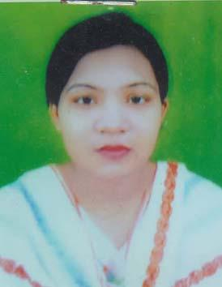 | DR. SHAMEEMA SULTANA  F/Name: Md. Nazrul Islam Sarder  M/Name: Mst. Rafia Begum  BM & DC Reg. No: 36497  NID: 4794511145740  Cell: 01766288284  Address: Plot no: 277, R/no: 20, Muzgunni, R/A, Khalishpur, Khulna-9000  Blood Group: O+
368 | Voter No  LM-2900363  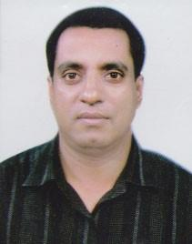 | DR. BANGA KAMAL BASU  F/Name: Mukunda Lal Basu  M/Name: Jyoti Kana Basu  BM & DC Reg. No: 36561  NID: 3275957482  Cell: 01712744736  Address: 4, Bakshipara Main Road, Sonadanga Sadar, Sonadanga, Khulna.  Blood Group: AB+
369 | Voter No  LM-2900364  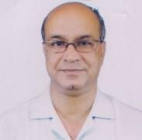 | DR. BISHNU PADA PAIK  F/Name: Kishore Behari Paik  M/Name: Binapani Paik  BM & DC Reg. No: 11551  NID:  Cell: 01558377562  Address: Garib Newaz Clinic KDA Avenue, Khulna.  Blood Group: O+
370 | Voter No  LM-2900365  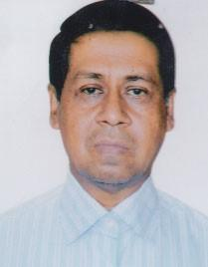 | DR. MRINAL KANTI SARKER  F/Name: Mr. Mukunda Lal Sarker  M/Name: Mrs. Radha Rani Sarker  BM & DC Reg. No: 14661  NID:  Cell: 01739243253  Address: 58/1, Ahsan Ahmed Road, Khulna.  Blood Group: O+
371 | Voter No  LM-2900366 | DR. MD MEHEDI NEWAZ  F/Name: Mosharaf Hossain  M/Name: Mrs Nasma Bilkis  BM & DC Reg. No: 26542  NID: 8728201153158  Cell: 01711680710  Address: Vice Principal Khulna Medical College, Khulna.  Blood Group: O+
372 | Voter No  LM-2900367 | DR. SK. TASNUVA ALAM  F/Name: Sheikh Baharul Alam  M/Name: Late Samsunnahar  BM & DC Reg. No: 52862  NID: 4798517240403  Cell: 01741065615  Address: 30. KDA. Approach Road, Snadanga, Khulna  Blood Group: O+
373 | Voter No  LM-2900368  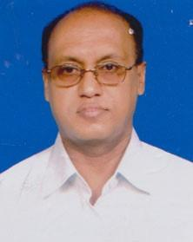 | DR. S.M. DELWAR HOSSAIN  F/Name: Mohammad Ali Sk  M/Name: Mrs. Rahila  BM & DC Reg. No: 19415  NID: 0117383665012  Cell: 01711352870  Address: Road-5, House-50, Sonadanga R/A, Khulna.  Blood Group: O+
374 | Voter No  LM-2900369  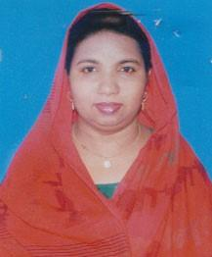 | DR. SHEIKH HOSNEARA  F/Name: Ismail Hossain Sheikh  M/Name: Mozida Ismail  BM & DC Reg. No: 40887  NID:  Cell: 01199406917  Address: General Hospital Khulna  Blood Group: B+
375 | Voter No  LM-290037  No Image | DR. ABDULLAH AL MAHBOOB (PROF.)  F/Name: Late Abdus Sobhan  M/Name: Mrs Anowara Khatun  BM & DC Reg. No: 13006  NID:  Cell: 01711352665  Address: Principal & Prof.(Pad), Khulna Medical College Khulna  Blood Group:
376 | Voter No  LM-2900370  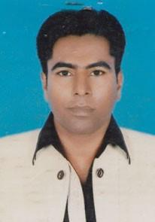 | DR. MD. MUSTAFIZUR RAHMAN  F/Name: Late Md. Abdus Sattar  M/Name: Mrs. Monowara Begum  BM & DC Reg. No: 42383  NID:  Cell: 01943217718  Address: 140, Tutpara Taltala Hospital Road, Khulna  Blood Group: O+
377 | Voter No  LM-2900371 | DR. MD. EHSANUL KABIR  F/Name: Md. Abedur Rahman  M/Name: Sultana Rahman  BM & DC Reg. No: 28010  NID: 2716469298963  Cell: 01718265080  Address: 4, Sonadanga Main Road, Khulna  Blood Group: O+
378 | Voter No  LM-2900372  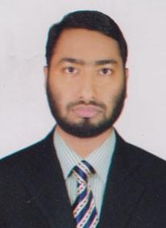 | DR. S. M. ABDUL AWAL  F/Name: Md. Quomar Uddin Sarder  M/Name: Mrs. Aklima Khatun  BM & DC Reg. No: 46293  NID: 1594308706869  Cell: 01713177802  Address: Pabla, Daulatpur, Khulna  Blood Group: O+
379 | Voter No  LM-2900373 | DR. MD. TAHERUL ISLAM  F/Name: Md. Abdul Wahab  M/Name: Nasima Akter Banu  BM & DC Reg. No: 35170  NID: 4798520294296  Cell: 01911176763  Address: 172 Sher-E-Bangla Road, Khulna-9100  Blood Group: O+
380 | Voter No  LM-2900374  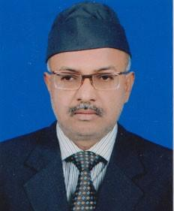 | PROF. DR. ABDULLAH AL MAHBOOB  F/Name: Late Abdus Sobhan  M/Name: Mrs. Anowara Khatun  BM & DC Reg. No: 13006  NID:  Cell: 01711352665  Address: 55,KDA, Avenue, Khulna.  Blood Group: AB+
381 | Voter No  LM-2900375  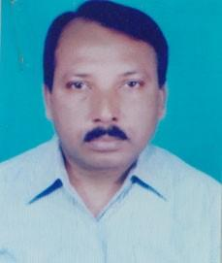 | DR. PARITOSH KUMAR KUNDU  F/Name: Late Aswini Kumar Kundu  M/Name: Late Sova Rani Kundu  BM & DC Reg. No: 8509  NID:  Cell: 01715144787  Address: 515/2, Golam Mostafa Rd. Central Road, Jessore.  Blood Group: O+
382 | Voter No  LM-2900376  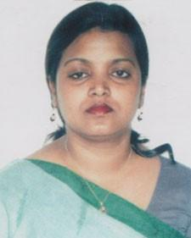 | DR. SALINA SHAHEEN PARUL  F/Name: Md. Asmat Ali Chowdhury  M/Name: Mrs. Salima Chowdhury  BM & DC Reg. No: 29518  NID: 9116295475488  Cell: 01911938774  Address: Sylhet Osmani Medical College, Sylhet  Blood Group: O+
383 | Voter No  LM-2900377 | DR. BEGUM NAZMA OBAYED  F/Name: Md. Lotafat Hossain  M/Name: Nurjahan Begum  BM & DC Reg. No: 45629  NID:  Cell: 01763744349  Address: G-9, KDA Avenue, Khanjahan Ali Road, Khulna.  Blood Group: B+
384 | Voter No  LM-2900378  No Image | DR. MOLLICK MONIRUZZAMAN  F/Name: Late Mollick Shahjahan  M/Name: Zohora Khatun  BM & DC Reg. No: 14293  NID:  Cell: 01715233388  Address: 31/13,Ka, Doctor Para Road, Chhoto Boyra, Khulna.  Blood Group: O+
385 | Voter No  LM-2900379 | DR. ISMAT ARA  F/Name: M.a. Aziz  M/Name: Mahbuba Aziz  BM & DC Reg. No: 28369  NID:  Cell: 01727670443  Address: House # 01, Bhybon Villa Tarer Pukur, Masjid Lane, Sanidham, Khulna.  Blood Group: O+
386 | Voter No  LM-2900380 | DR. KHAN OMAR FARUQUE  F/Name: Khan Altafur Rahman  M/Name: Momtaz Ara Begum  BM & DC Reg. No: 15920  NID:  Cell: 01712515217  Address: 39, Roy para Cross Road-2, Khulna.  Blood Group: O+
387 | Voter No  LM-2900381 | DR. QUAZI MAMUN HOSSAIN  F/Name: Late- Quazi Ghulam Hossain  M/Name: Syeda Mohmuda Khatun  BM & DC Reg. No: 27844  NID:  Cell: 01713400545  Address: 1/A, Ahsan Ahmed Road, Khulna.  Blood Group: A+
388 | Voter No  LM-2900382  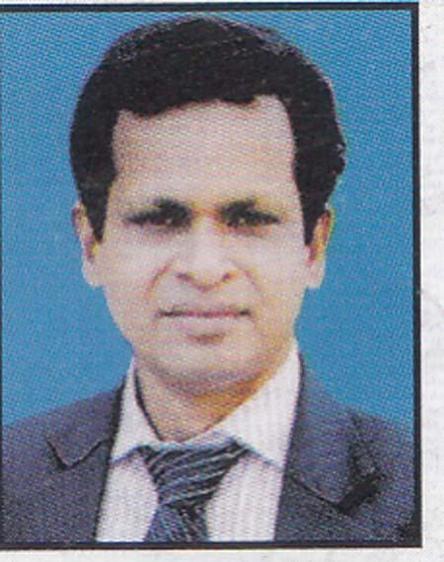 | DR. JAWHAR LAL SINGHA  F/Name: Late Sachindra Nath Singha  M/Name: Mrs. Hemprova Singha  BM & DC Reg. No: 24369  NID:  Cell: 01552320086  Address: Junior Consultant (Surgery) Khulna Medical College Hospital, Khulna.  Blood Group: A+
389 | Voter No  LM-2900383 | DR. MD. JAHIRUL ALAM AZAD  F/Name: Md. Abdul Quader  M/Name: Mrs. Momotaj Begum  BM & DC Reg. No: 33866  NID:  Cell: 01711-840875  Address: 108, Al-Aksa Jame Mosque Road, Sonadanga, Khulna.  Blood Group: B+
390 | Voter No  LM-2900384 | DR. SK. AKTHER HOSSSEN  F/Name: Sk. Nazrul Islam  M/Name: Khulsum Begum  BM & DC Reg. No:  NID:  Cell: 01912-941873  Address: 45, Khan Jahan Ali Road Faraji Para More, Khulna.  Blood Group: A+
391 | Voter No  LM-2900385  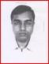 | DR. MD. MAHMUDUL HUQ  F/Name: Late Jobed Ali Sardar  M/Name: Mrs. Momena Khatun  BM & DC Reg. No: 30079  NID:  Cell: 01912-544807  Address: 3/D Doctors Quarter Khulna Medical College.  Blood Group: O+
392 | Voter No  LM-2900386  No Image | DR. KHAIRUN NAHAR  F/Name: Sk. Md. Khabir Uddin  M/Name: Samsun Nahar  BM & DC Reg. No: 49845  NID:  Cell: 01921-230956  Address: 3/D, Officer Quarter 2nd Floor, KMCH, Khulna.  Blood Group: A+
393 | Voter No  LM-2900387  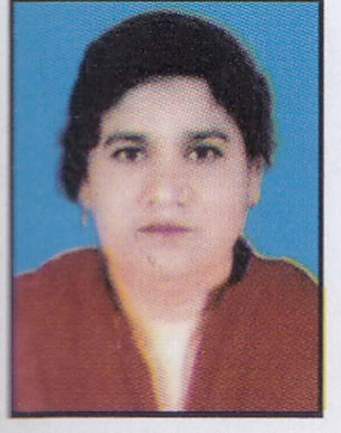 | DR. NASIMA BEGUM  F/Name: Abul Hashem Mridha  M/Name: Mrs. Belayetun Nessa  BM & DC Reg. No: 18488  NID:  Cell: 01712-149987  Address: Executive Engineer, DPHE Khanjahan Ali Rd, Khulna  Blood Group: A+
394 | Voter No  LM-2900388  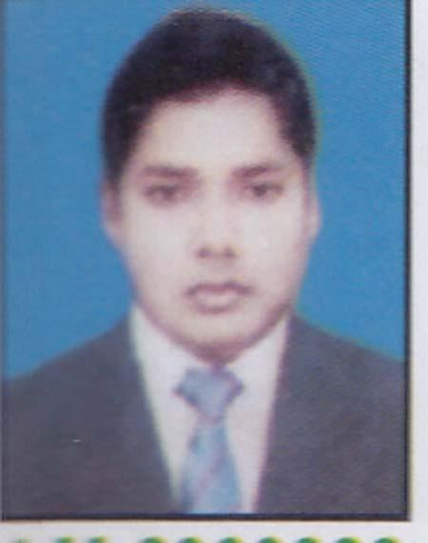 | DR. BIPLAB BISWAS  F/Name: Rabindra Nath Biswas  M/Name: Radha Rani Biswas  BM & DC Reg. No: 38968  NID:  Cell: 01712-087556  Address: Khulna Medical College Hospital, Khulna.  Blood Group: A+
395 | Voter No  LM-2900389  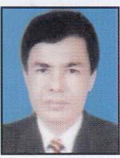 | PROF. DR. BIDHAN CHANDRA GOSWAMI  F/Name: Late Narod Chandra Goswami  M/Name: Mrs. Dhuni Bala Goswami  BM & DC Reg. No: 17471  NID:  Cell: 01716-169834  Address: Director & Professor Shahid Abu Naser Specialist Hospital, Khulna.  Blood Group: B+
396 | Voter No  LM-2900390  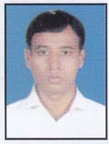 | DR. MD. JILHAJ UDDIN  F/Name: Shaikh Md. Imdadul Hoque  M/Name: Mrs. Jobeda Begum  BM & DC Reg. No: 43863  NID:  Cell: 01758-572140  Address: Upazila Health Complex, Dacope, Khulna.  Blood Group: A+
397 | Voter No  LM-2900391 | DR. MD. RAFID SHAHRIAR  F/Name: Dr. Md. Shahjahan Ali  M/Name: Dr. Salina Yeasmin  BM & DC Reg. No: 72698  NID:  Cell: 01725-954000  Address: 29,Sher-E-Bangla Road, Sonadanga, Khulna.  Blood Group: B+
398 | Voter No  LM-2900392  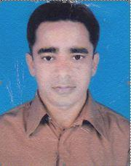 | DR. MD. ASHFAK AHMED  F/Name: Nazir Ahmed Mallick  M/Name: Anwara Begum  BM & DC Reg. No: 36565  NID:  Cell: 01711352952  Address: House No. NH-36, Road No. 26, Housing Estate, Khalishpur, Khulna-9000.  Blood Group: B+
399 | Voter No  LM-2900393  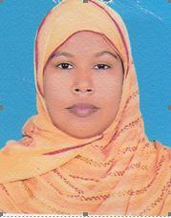 | DR. MAHFUZA KHANAM  F/Name: Md. Manik Shaik  M/Name: Monira Begum  BM & DC Reg. No: 37433  NID:  Cell: 01712-635677  Address: House No. NH-36, Road No. 26, Housing Estate, Khalishpur, Khulna-9000.  Blood Group: O+
400 | Voter No  LM-2900394  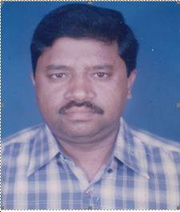 | DR. MD. MOSTAFIZUR RAHMAN  F/Name: Sk. Shahabuddin  M/Name: Msd. Sabura Khatun  BM & DC Reg. No: 23815  NID:  Cell: 01724-335664  Address: ‘Modern Tower’ 4th Floor, 6, Moulovi Para TB Boundary Road, Khulna.  Blood Group: B+
401 | Voter No  LM-2900395  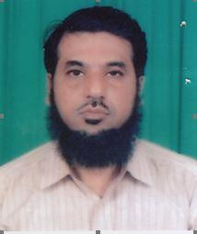 | DR. G.M. ABU ZAFAR  F/Name: Late G.m. Abu Bakar  M/Name: Mrs. Zohura Khatun  BM & DC Reg. No: 16279  NID:  Cell: 01772-093593  Address: ‘House No. 26, Road No. 29 Nirala Residential Area, Khulna.  Blood Group:
402 | Voter No  LM-2900396 | DR. QUAZI MEHRANUDDIN AHMED  F/Name: Quazi Arifuddin Ahmed  M/Name: Kaniz Ahmed  BM & DC Reg. No: 61359  NID: 19874795129501378  Cell: 01673-530130  Address: 28, Lower Jessore Road Khulna.  Blood Group: O+
403 | Voter No  LM-2900397  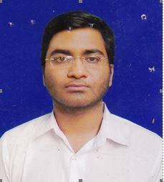 | DR. TOWSEEF HASNAIN KHAN  F/Name: Dr. Matiar Rahman Khan  M/Name: Jobeda Nasrin  BM & DC Reg. No: 69111  NID:  Cell: 01758-014928  Address: 12/2, Arjun Das Agarwala Road Courtpara, Kustia.,  Blood Group: A+
404 | Voter No  LM-2900398  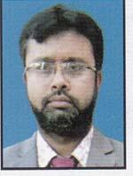 | DR. MD. IMRAN  F/Name: Md. Emdadul Haque  M/Name:  BM & DC Reg. No: 52465  NID:  Cell: 01712659761  Address: Vill+Po: Rampal, P.S:Rampal, Dist: Bagerhat.  Blood Group: B+
405 | Voter No  LM-2900399  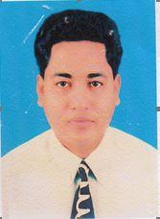 | DR. SHAIKH MOHAMMAD KAMAL HOSSAIN  F/Name: Md. Younus Shaikh  M/Name: Hasina Begum  BM & DC Reg. No: 26697  NID:  Cell: 01711298281  Address: Linda Clinic, Shiromoni, Khulna.  Blood Group: A+
406 | Voter No  LM-2900400  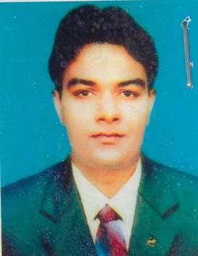 | DR. PRODIP DEBNATH  F/Name: Mrinal Debnath  M/Name: Krishna Debnath  BM & DC Reg. No: 49627  NID:  Cell: 01717417215  Address: Consultant, Khulna Shishu Hospital, Khulna  Blood Group: B-
407 | Voter No  LM-2900401 | DR. SYED MOHAMMAD AL-AMIN  F/Name: Syed Mohammad Rafiq  M/Name: Syeda Lutfunnesa  BM & DC Reg. No: 22781  NID: 4795129502147  Cell: 01711339032  Address: \'Bakul Villa\' 102/2 South Central Road, Khulna-9100  Blood Group: A+
408 | Voter No  LM-2900402  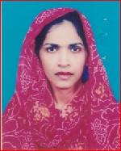 | DR. DIL SHAD JAHAN  F/Name: Late Abdur Rahman  M/Name: Late Selina Rahman  BM & DC Reg. No: 23127  NID:  Cell: 01711-339043  Address: “Bakul Villa” 102/2, South Central Road, Khulna-9100  Blood Group: B+
409 | Voter No  LM-2900403 | DR. AYSHA HAQUE  F/Name: Md. Rafique-ul Haque  M/Name: Anjura Khatun  BM & DC Reg. No: 27238  NID: 4795130517561  Cell: 01556630511  Address: 32, Sarkarpara, Toofpara, Khulna  Blood Group: O+
410 | Voter No  LM-2900404  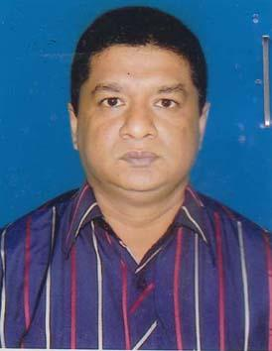 | DR. A.K.M. MORSHADUR RAHMAN  F/Name: Late. A.K.M. Habibur Rahman  M/Name: Late. Monuara Begum  BM & DC Reg. No: 36279  NID: 4798516217025  Cell: 01711361619  Address: 36, Choto Boyra Market Cross Road, Khulna-9000  Blood Group: A+
411 | Voter No  LM-2900405 | DR. MD. SHAHIDUL ISLAM  F/Name: Md. Sohrab Hossain  M/Name: Mst. Rizia Begum  BM & DC Reg. No: 27918  NID: 2694810969625  Cell: 01711175279  Address: 65, Anandamohan Bagchi Lane, Kushtia-7000.  Blood Group: O+
412 | Voter No  LM-2900406  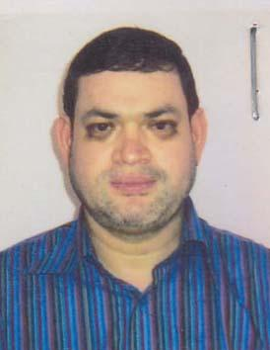 | DR. SHAIKH HUMAYUN KABIR  F/Name: Shaikh Abdul Mutalib  M/Name: Sufia Begum  BM & DC Reg. No: 23351  NID: 4716919757851  Cell: 01717071920  Address: Vill+PO: Shiromoni, PS: Khan Jahan Ali, Dist: Khulna, Bangladesh  Blood Group: A+
413 | Voter No  LM-2900407  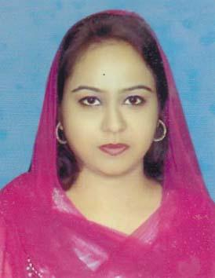 | DR. ROMANA AFROJ  F/Name: Dr. Daud Ali Meer  M/Name: Dr. Sufia Khatun  BM & DC Reg. No: 70117  NID: 4716919755584  Cell: 01730449273  Address: House#2, Road#6, Sonadanga R/A, 1st Phase, Khulna GPO-9000.  Blood Group: A+
414 | Voter No  LM-2900408  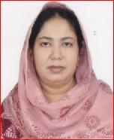 | DR. SHAMIMA AKHTER  F/Name: Sk. Mostafizur Rahman  M/Name: Firoza Begum  BM & DC Reg. No: 24193  NID: 5027905126506  Cell: 01711398810  Address: 173, Road-11 Sonadanga R/A 1st Pahse, Khulna.  Blood Group: B+
415 | Voter No  LM-2900409 | DR. M. REAZUL ALAM (RUSSEL)  F/Name: Md. Selimul Alam  M/Name: Mrs. Yesmin Begum  BM & DC Reg. No: 42271  NID: 4792106077925  Cell: 01743753639  Address: Pabla Kabir-Battala, Khasoblal Road, House no # 22, Ward # 06, Daulatpur, Khulna  Blood Group: AB-
416 | Voter No  LM-2900410  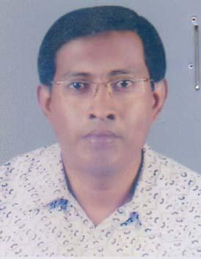 | DR. MD. RAFIQUL ISLAM GAZI  F/Name: Nur Mohammad Gazi  M/Name: Aklima Begum  BM & DC Reg. No: 34485  NID: 0113410098726  Cell: 01711067821  Address: Gazi Cottage 1, Koyla Ghat Park Lane, Khulna.  Blood Group: A+
417 | Voter No  LM-2900411  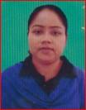 | DR. DALIA HALDER  F/Name: Mr. Elias S. Halder  M/Name: Mrs. Mira Halder  BM & DC Reg. No: 34345  NID: 2695042759712  Cell: 01721057721  Address: \"Somarponaloy\" 49/3, 1st Floor, Ispahani 2nd Lane, Rupsha, Strand Road, Khulna  Blood Group: B+
418 | Voter No  LM-2900412 | DR. MD. WAHIDUZZAMAN  F/Name: Md. Nurul Islam  M/Name: Begum Jasmin Akhter  BM & DC Reg. No: 61275  NID: 19874798516226957  Cell: 01717962125  Address: 7D, National Tower Ahsan Ahmed Road, Khulna.  Blood Group: O+
419 | Voter No  LM-2900413  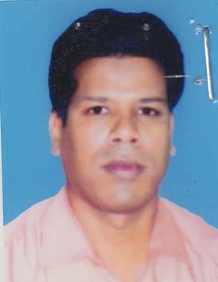 | DR. S.M. NAZMUL HUQUE  F/Name: Md. Osman Gani  M/Name: Nurjahan Begam  BM & DC Reg. No: 29239  NID: 2697557397801  Cell: 01711397284  Address: Nazir Shandarpur Jessore Sadar, Jessore.  Blood Group: B+
420 | Voter No  LM-2900414 | DR. SAIFUL ISLAM  F/Name: Dr. Mizanur Rahman  M/Name: Nasima Khatun  BM & DC Reg. No: 57508  NID: 9196202120237  Cell: 01717584137  Address: Pyramid Surgical Clinic Pabla, Daulatpur, Khulna  Blood Group: A+
421 | Voter No  LM-2900415  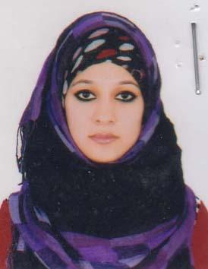 | DR. NASTARAN LASKER  F/Name: Dr. Md. Shawkat Ali Lasker  M/Name: Farzana Begum  BM & DC Reg. No: 66331  NID: 4795124432607  Cell: 01797092826  Address: 86, Islampur Road, Khulna  Blood Group: AB+
422 | Voter No  LM-2900416  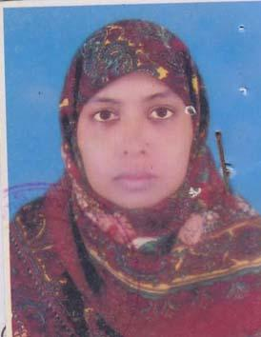 | DR. TAHIRA KHATUN  F/Name: Md. shakhawat Hossain  M/Name: Mrs. Noorjahan Begum  BM & DC Reg. No: 33942  NID:  Cell: 01711065497  Address: Opposite to Masjidul Kawsar Mosque, 55, Boyra Main Rd, Choto Boyra, Khulna-9000  Blood Group: B+
423 | Voter No  LM-2900417 | DR. SK. MUNIR AHMED  F/Name: Late Sk. Siddique Ahmed  M/Name: Mrs. Hamida Begum  BM & DC Reg. No: 31565  NID: 4795129504592  Cell: 01748520404  Address: 39, M. T. Road, Khulna  Blood Group: B+
424 | Voter No  LM-2900418 | DR. SANCHAY KUMAR BISWAS  F/Name: Kshirod Chandra Biswas  M/Name: Sulekha Biswas  BM & DC Reg. No: 24960  NID: 4798516226656  Cell: 01819054459  Address: 138, Karim Nagor Khulna.  Blood Group: A+
425 | Voter No  LM-2900419 | DR. IMTIAZ HASAN  F/Name: Mollah Harun-ar-rashid  M/Name: Hosneara Begum  BM & DC Reg. No: 68237  NID: 19904798516000036  Cell: 01711824135  Address: 54, Jalil Sarani, Boyra, Thana- Sonadanga, Khulna.  Blood Group: B+
426 | Voter No  LM-2900420  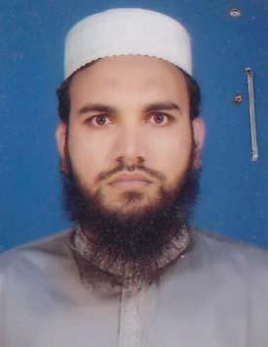 | DR. FERDOUS BIN HABIB  F/Name: Md. Habibur Rahman  M/Name: Most. Laila Firoza  BM & DC Reg. No: 36872  NID: 2697556418103  Cell: 01912949915  Address: House No. LP-26, Housing State, Khalishpur, Post: Daulatpur, Khulna-9202  Blood Group: O+
427 | Voter No  LM-2900421 | DR.ARCHISMAN DEBNATH  F/Name: Ramproshad Debnath  M/Name: Depali Debnath  BM & DC Reg. No: 35253  NID: 4798518267863  Cell: 01716153901  Address: Ghonoshyampur, Chulkati Fokirhat, Bagerhat.  Blood Group: O+
428 | Voter No  LM-2900422  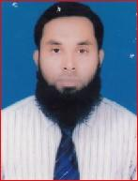 | DR. MD. BELAL UDDIN  F/Name: Md. Yusuf Ali  M/Name: Sahinur Begum  BM & DC Reg. No: 42959  NID: 2690601921774  Cell: 01711453557  Address: House # I-5, Road # 105, Housing Estate, Khalishpur, Khulna.  Blood Group: B+
429 | Voter No  LM-2900423  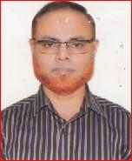 | DR. MIZANUR RAHMAN  F/Name: A. Malek Bakhtiar  M/Name: Mahua Khatun  BM & DC Reg. No: 20894  NID: 4795123421206  Cell: 01712260060  Address: 72, Lower Jessore Road, Khulna.  Blood Group: O+
430 | Voter No  LM-2900424 | DR. KAZI ABU RASHED  F/Name: Kazi Abdul Khaleque  M/Name: Rokeya Begum  BM & DC Reg. No: 32277  NID: 0695112193110  Cell: 01716862687  Address: 48/1 Farazi Para Road, Khulna, Consultant, ENT, General Hospital, Khulna  Blood Group: O+
431 | Voter No  LM-2900425  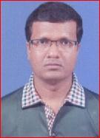 | DR. PROKASH CHANDRA DEBNATH  F/Name: Kalipado Debnath  M/Name: Anurupa Debnath  BM & DC Reg. No: 36326  NID: 0113431113084  Cell: 01714026809  Address: 95, Outer Bypass Road Sonadanga, Khulna.  Blood Group: O+
432 | Voter No  LM-2900426 | DR. MD. QUMRUZZAMAN  F/Name: Late Md. Mobarok Hossain  M/Name: Late Mrs. Akramun Nessa  BM & DC Reg. No: 10714  NID: 4798517242496  Cell: 01711643745  Address: House # 45, Road-5, Sonadanga, R/A, Khulna.  Blood Group: O+
433 | Voter No  LM-2900427  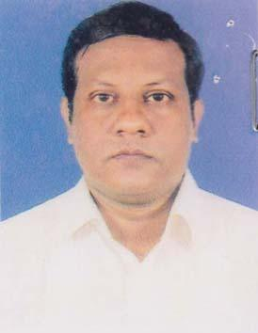 | DR. MD. ARIFULL KAMAL  F/Name: Md. Kamal Sharif  M/Name: Shamsunnahar  BM & DC Reg. No: 40117  NID:  Cell: 01717059565  Address: Road-11, House-166, Sonadanga R/A, Khulna.  Blood Group: A+
434 | Voter No  LM-2900428 | DR. MD. MOSADDEQ HOSSAIN  F/Name: Md. Mosharraf Hossain  M/Name: Shabnam Sultana  BM & DC Reg. No: 38580  NID:  Cell: 01713062645  Address: Meheshwar, Pasha Kartic, P.O. Kuet, Khulna.  Blood Group: A+
435 | Voter No  LM-2900429 | DR. MD. SALAHUDDIN RAHMATULLAH  F/Name: Shamsuddin Ahmed  M/Name: Shamsun Naher Ahmed  BM & DC Reg. No: 27099  NID: 4795124435092  Cell: 01711170747  Address: 246, Haji Ismail Road, Sheikh Para, Khulna.  Blood Group: B+
436 | Voter No  LM-2900430  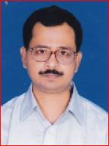 | DR. SUBRATA KUMAR BISWAS  F/Name: Nityananda Biswas  M/Name: Champale Lata Biswas  BM & DC Reg. No: 20288  NID: 2694814934447  Cell: 01732700290  Address: 53. KDA Avenue, Shaik Para, Khulna.  Blood Group: B+
437 | Voter No  LM-2900431  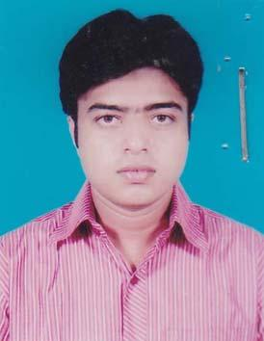 | DR. MD. KUDRAT-E-HAQUE  F/Name: Late-S.M. Fazlul Haque  M/Name: Begum Rahima Haque  BM & DC Reg. No: 50378  NID: 4798516214461  Cell: 01711443295  Address: House no # 136/12 (KA), Road no# 2, Kashemnagar R/A, Sher-E-Bangla Road, Khulna  Blood Group: O+
438 | Voter No  LM-2900432  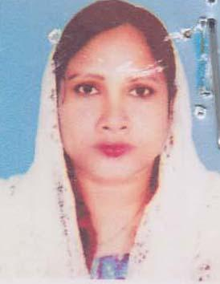 | DR. KHANAM SHAWKATARA BAYZID  F/Name: Md. Bayzid Ali Khan  M/Name: Mafuza Begum  BM & DC Reg. No: 38901  NID: 2694263701963  Cell:  Address: Paikgacha Hospital Quater Khulna.  Blood Group: A+
439 | Voter No  LM-2900433 | DR. PARTHA PRATIM DEBNATH  F/Name: Niranjan Debnath  M/Name: Rama Rani Nath  BM & DC Reg. No: 54071  NID: 4798516214995  Cell: 01716166175  Address: Vill+Post- Banka Bhowanipur, Upazilla- Paikgacha, Zilla- Khulna  Blood Group: B+
440 | Voter No  LM-2900434  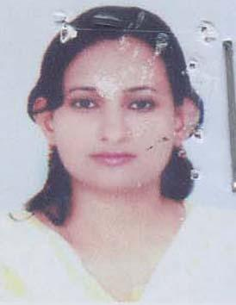 | DR. SHORMISTHA SAHA  F/Name: B.d. Saha  M/Name: Shima Saha  BM & DC Reg. No: 62579  NID: 2691649103014  Cell: 01620538677  Address: Vill+Post- Banka Bhowanipur, Upzilla- Paikgacha, Zilla- Khulna  Blood Group: B+
441 | Voter No  LM-2900435  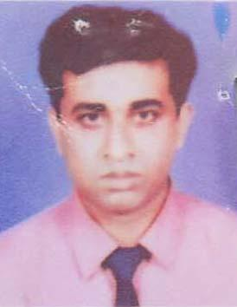 | DR. SHAFIQUL ISLAM SIKDER  F/Name: Late Uzir Ahmed Sikder  M/Name: Saleha Begum  BM & DC Reg. No: 29401  NID: 2694263701962  Cell: 01725640677  Address: Hospital Quarter UHC, Paikgacha, Khulna.  Blood Group: O+
442 | Voter No  LM-2900436  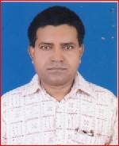 | DR. NITYANANDA BARURI  F/Name: Late- Kali Pada Baruri  M/Name: Sreemoti-vhanu Moti Baruri  BM & DC Reg. No: 18223  NID: 0120805120945  Cell: 01711951947  Address: Khulna Medical College, Hospital, Khulna.  Blood Group: B+
443 | Voter No  LM-2900437  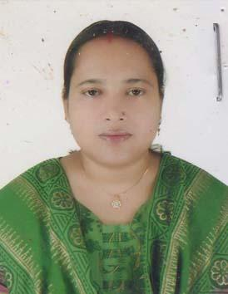 | DR. LIPI RANI ROY  F/Name: Makhan Lal Roy  M/Name: Ranu Mazumder  BM & DC Reg. No: 28626  NID: 2694814934389  Cell: 01711944781  Address: Tarerpukur, Khulna.  Blood Group: B+
444 | Voter No  LM-2900438 | DR. SHAHNAJ AKTHER  F/Name: Abdul Jabber  M/Name: Hamida Begum  BM & DC Reg. No: 34337  NID: 8728201153161  Cell: 01711450675  Address: House-307, Road-1, Phase-2, Sonadanga R/A, Khulna.  Blood Group: A+
445 | Voter No  LM-2900439  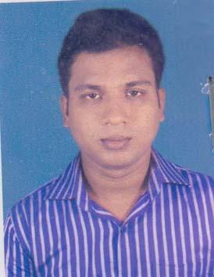 | DR. MD. FORHADUL ISLAM  F/Name: Md. Elias Sardar  M/Name: Farida Khatun  BM & DC Reg. No: 56605  NID: 6125217227382  Cell: 01913793549  Address: 368/A, Alo Chasa Frce Steet School, Helel Paul, Dhaka.  Blood Group: A+
446 | Voter No  LM-2900440 | DR. MD.SHWKAT ALI  F/Name: Md. Sekendar Ali  M/Name: Mrs. Akhter Banu  BM & DC Reg. No: 33369  NID: 4798518258948  Cell: 01711233017  Address: Ju. Consultant (Sirgery) Digholia UHC, Digholia, Khulna.  Blood Group: AB+
447 | Voter No  LM-2900441  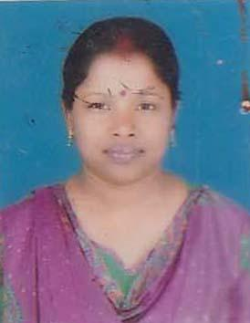 | DR. MOUSUMI SAHA  F/Name: Suvash Chandra Saha  M/Name: Late, Mongola Rani Saha  BM & DC Reg. No: 42522  NID: 4794509118270  Cell: 01710873339  Address: 11/1 Swapnachura, East Police Line, Khulna.  Blood Group: A+
448 | Voter No  LM-2900442 | PROF. DR. MONI MOHAN SAHA  F/Name: Late Dr. Dwijendra Nath Saha  M/Name: Late Sneha Lata Saha  BM & DC Reg. No: 17718  NID: 4795123416040  Cell: 01712249769  Address: RCC Hasan Tower-4B, 35 Khan-A-Sabur Road, Khulna-9100  Blood Group: O+
449 | Voter No  LM-2900443  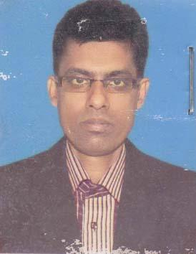 | DR. GAZI SALAHUDDIN  F/Name: G.m. Iman Ali  M/Name: Fajila Khatun  BM & DC Reg. No: 28896  NID:  Cell: 01711162654  Address: Vill+Post-Ratanpur, P.S Kaliganj, Satkhira.  Blood Group: A+
450 | Voter No  LM-2900444  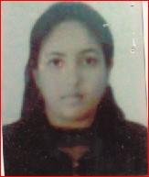 | DR. SALMA BINTEA GOLAM RAZZAQ RANU  F/Name: Golam Razzaq Chowdhury  M/Name: Nazma Ara Begum  BM & DC Reg. No: 62149  NID: 19869196216280193  Cell: 01778409036  Address: Boyra R/A, Soburar More, Central Road, H# 12, Khulna.  Blood Group: O+
451 | Voter No  LM-2900445 | DR. SHAHEEN SHAHNOWAZ AKHTER  F/Name: A.n. Minhaj Uddin Ahmed  M/Name: Mrs. Lily Ahmed  BM & DC Reg. No: 16811  NID: 19614795123425105  Cell: 01712057547  Address: 63, Ahsan Ahmed Road, Flat No-8A, Khulna.  Blood Group: B+
452 | Voter No  LM-2900446 | DR. SUHASH RANJAN HALDER  F/Name: Suresh Chandra Halder  M/Name: Hiran Kana Halder  BM & DC Reg. No: 51159  NID: 19829196212239703  Cell: 01711903881  Address: Assistant Registrar Anaesthesiology Department, KMCH, Khulna.  Blood Group: B+
453 | Voter No  LM-2900447  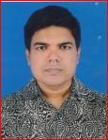 | DR. BIPLOB KUMAR DAS  F/Name: Manotosh Kumar Das  M/Name: Basanti Das  BM & DC Reg. No: 28886  NID:  Cell: 01712-124361  Address: 116/2, Islampur Road, Madhumati Press Building, Khulna.  Blood Group: B+
454 | Voter No  LM-2900448 | DR. KAZI KARIM NEWAZ  F/Name: Kazi Quader Newas  M/Name: Sazeda Parvin  BM & DC Reg. No: 63126  NID:  Cell: 01617-456476  Address: 6, Miapara Central Mosque Lane, Khulna.  Blood Group: B+
455 | Voter No  LM-2900449 | DR. MD. ISHTIAK MAHMOOD  F/Name: Md. Kawser Ali  M/Name: Nasima Begum  BM & DC Reg. No: 70797  NID:  Cell: 01712-690195  Address: 4/3, Goborchaka Cross Road-2, Sonadanga, Khulna  Blood Group:
456 | Voter No  LM-2900450  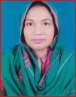 | DR. ANJUMAN ARA  F/Name: Ramjan Ali  M/Name: Ashrafun Nahar  BM & DC Reg. No: 22371  NID:  Cell: 01556-322501  Address: 3/D, Khulna Medical College Hospital Quarter, Khulna.  Blood Group: O-
457 | Voter No  LM-2900451 | DR. S. M. MURAD HOSSAIN  F/Name: S.m. Akber Hossain  M/Name: Selina Akther  BM & DC Reg. No: 35274  NID:  Cell: 01711-346999.  Address: 58, Sir Iqbal Road, Baitipara, Khulna-9100  Blood Group: O+
458 | Voter No  LM-2900452  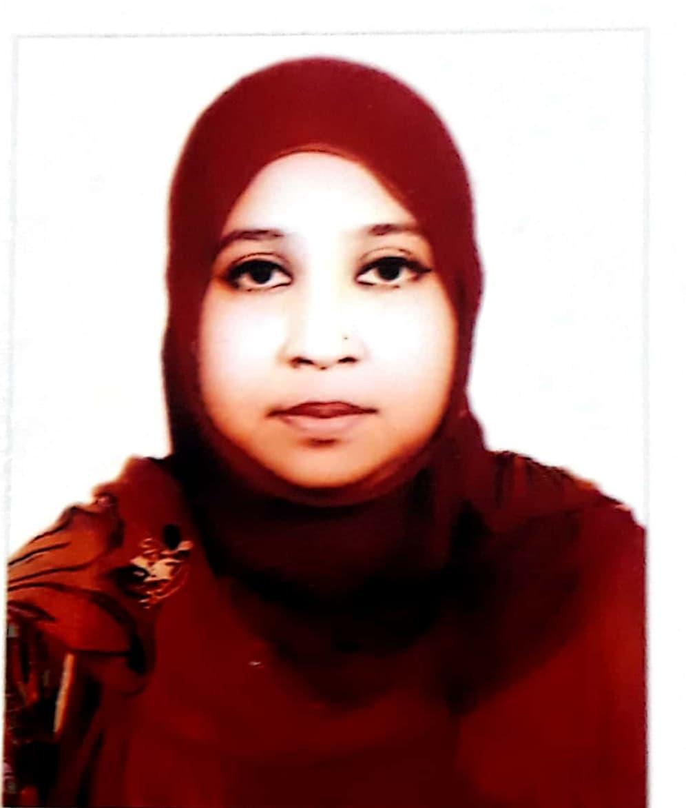 | DR. FARZANA HOSSAIN  F/Name: S.M.Akbar Hossain  M/Name: Selima Akhter  BM & DC Reg. No: 48401  NID:  Cell: 01920-517150  Address: 58, Sir Iqbal Road, Baitipara, Khulna-9100.  Blood Group: O+
459 | Voter No  LM-2900453  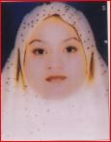 | DR. FARHANA RAHMAN  F/Name: Md. Fazlur Rahman Sharif  M/Name: Mrs. Payara Rahman  BM & DC Reg. No: 58078  NID:  Cell: 01717-156189  Address: Sharif Bhaban, Moeshwar pasha, Kedernath Cross Road, Doulapur, Khulna.  Blood Group: B-
460 | Voter No  LM-2900454  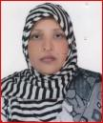 | DR. MST. DILRUBA PARVIN  F/Name: Late Motiar Rahman Biswas  M/Name: Late Amena Khatun  BM & DC Reg. No: 26920  NID:  Cell: 01712-203595  Address: Doctorpara, Plot-2, Chhotoboyra, Sonadanga Khulna.  Blood Group: A+
461 | Voter No  LM-2900455  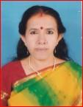 | DR. PROVA BAIRAGI  F/Name: Manindra Nath Bairagi  M/Name: Late Nirulola Bairagi  BM & DC Reg. No: 20348  NID:  Cell: 01710-963004  Address: 65/1, Sir Iqbal Road Road , 2A, Iddris Vhaban, Khulna.  Blood Group: B+
462 | Voter No  LM-2900456 | DR. MD. GOLAM MARTUZA SIKDER  F/Name: Late Abdul Khaleque Sikder  M/Name: Late Hamida Khatun  BM & DC Reg. No: 10566  NID:  Cell: 01711-430969  Address: House No # Ex-4, Road No # 28 Nirala R/A, Khulna.  Blood Group: B+
463 | Voter No  LM-2900457 | DR. S.M ARIF EFTAKHAR  F/Name: S.m. Bellal  M/Name: Nasrin Aktar  BM & DC Reg. No: 45344  NID:  Cell: 01711-454004  Address: 110/1, Islamia College Road, Choto Bayra Sonadanga, Khulna.  Blood Group: B+
464 | Voter No  LM-2900458 | DR. PALASH BISWAS  F/Name: Bimal Biswas  M/Name: Rasmoni Biswas  BM & DC Reg. No: 48547  NID:  Cell: 01784-614838  Address: Utsob Place, House-150/2KA Boyra Main Road, Choto Boyra, Khulna.  Blood Group: O+
465 | Voter No  LM-2900459 | DR. URMI CHOWDHURY  F/Name: Dr. Popitosh Kumar Chowdhury  M/Name: Aruna Biswas  BM & DC Reg. No: 56081  NID:  Cell: 01780-232059  Address: Utsob Place, House-150/2KA Boyra Main Road, Choto Boyra, Khulna.  Blood Group: O+
466 | Voter No  LM-2900460 | DR. PARITOSH KUMAR ROY  F/Name: Late Nanda Dulal Roy  M/Name: Late Radha Rani Roy  BM & DC Reg. No: 8990  NID:  Cell: 01711-299635  Address: 6/A, National Towar, 26, Ahsan Ahmed Road Khulna.  Blood Group: AB+
467 | Voter No  LM-2900461  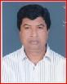 | DR. MD. RUHUL AMIN  F/Name: Late Md. Azizur Rahman  M/Name: Mrs. Kokeya Begum  BM & DC Reg. No: 24105  NID:  Cell: 01712-562434  Address: Amin View, House-335/1, Road-5, Sonadanga R/A, Khulna.  Blood Group: B-
468 | Voter No  LM-2900462 | DR. MD. BELLAL HOSSAIN  F/Name: Md. Soleman Biswas  M/Name: Begum Sharifunnessa  BM & DC Reg. No: 39209  NID:  Cell: 01716-084374  Address: Dakshindi, Fultala Khulna.  Blood Group: A+
469 | Voter No  LM-2900463  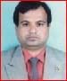 | DR. MD. AKTARUZZAMAN  F/Name: Md. Abu Taleb Sardar  M/Name: Mrs. Jamila Khatun  BM & DC Reg. No: 29335  NID:  Cell: 01715-275087  Address: 53/14, West Bania Khamar, Jabbar Sarak, Sonadanga Khulna.  Blood Group: A+
470 | Voter No  LM-2900464 | PROF. DR. MD. ABDUL AHAD  F/Name: Md. Namder Ali Moral  M/Name: Mrs. Zohra Begum  BM & DC Reg. No: 17356  NID:  Cell: 01711-184343  Address: 80, Outer Bypass Road, 1st Phase, Sonadanga, Khulna.  Blood Group: O+
471 | Voter No  LM-2900465  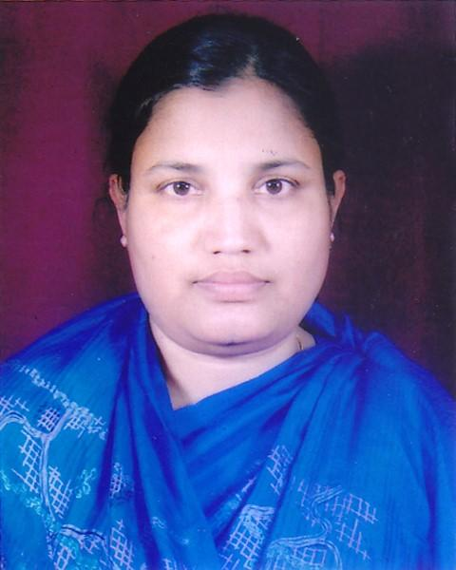 | DR. FERDOUSI BEGUM  F/Name: Kamruzzaman Khan  M/Name: Mrs. Lutfun Nahar  BM & DC Reg. No: 28908  NID:  Cell: 01711-964943  Address: 80, Outer Bypass Road, 1st Phase, Sonadanga, Khulna.  Blood Group: B+
472 | Voter No  LM-2900466 | DR. SUKUMAR SAHA  F/Name: Late Sushil Kumar Saha  M/Name: Suchitra Saha  BM & DC Reg. No: 25790  NID:  Cell: 01712-522726  Address: City Palace, 16, Hazi Mohsin Road, Khulna.  Blood Group: A+
473 | Voter No  LM-2900467  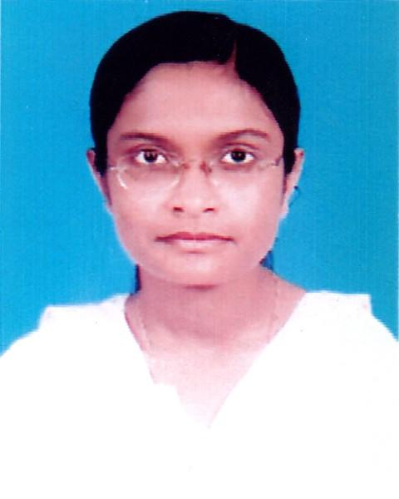 | DR. FALGUNI SIKDER  F/Name: Kalinga Bihari Sikder  M/Name: Latika Sikder  BM & DC Reg. No: 48526  NID:  Cell: 01928-846123  Address: House No. 251, Road No. 16 Nirala R/A, Khulna.  Blood Group: O+
474 | Voter No  LM-2900468 | DR. SHEIKH SUFIAN RUSTOM  F/Name: Sheikh Siddiqur Rahman  M/Name: Mrs. Salma Parvin  BM & DC Reg. No: 30231  NID:  Cell: 01930788933  Address: “Jharna, House” 21, Maddah Para Road, Alamnagar, Khalishpur, Khulna.  Blood Group: AB+
475 | Voter No  LM-2900469  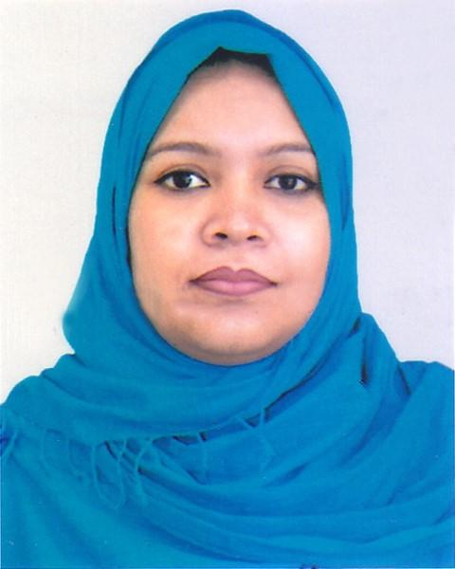 | DR. RESHMA PARVIN SAMPA  F/Name: Md. Rejaul Khayer  M/Name: Late Farida Khayer  BM & DC Reg. No: 33499  NID:  Cell: 01743-433355  Address: “Jharna, House” 21, Maddah Para Road, Alamnagar, Khalishpur, Khulna.  Blood Group: A+
476 | Voter No  LM-2900470 | DR. AMIT CHATTERJEE  F/Name: Amiya Chatterjee  M/Name: Manju Sree Chattarjee  BM & DC Reg. No: 59787  NID:  Cell: 01717-946119  Address: Plot-302, Gita Kunjo, Protapaditto Road, Pabla, Daulatpur, Khulna.  Blood Group: B+
477 | Voter No  LM-2900471  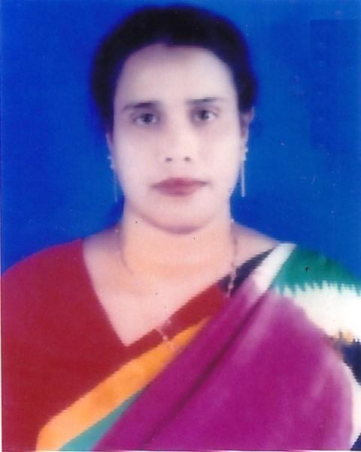 | DR. AFROZA AKHTER  F/Name: S.k. Mansuruddin Ahmed  M/Name: Mrs. Sufiia Khatun  BM & DC Reg. No: 19026  NID:  Cell: 01711-067511  Address: 105, Hazi Mohsin Road, Khulna.  Blood Group: B+
478 | Voter No  LM-2900472  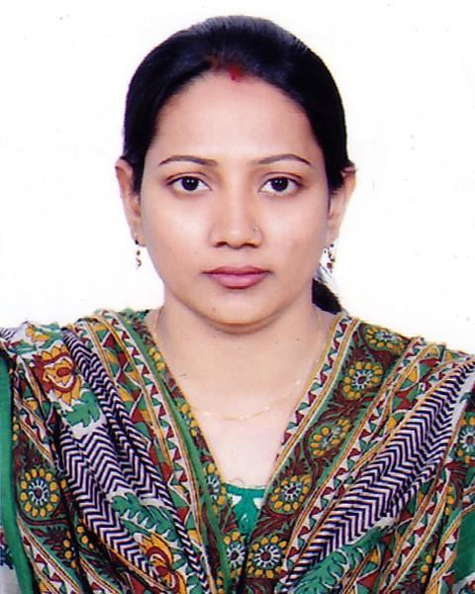 | DR. DIPA DAS RONY  F/Name: Haripada Das  M/Name: Nilima Das  BM & DC Reg. No: 51821  NID:  Cell: 01719-075233  Address: 60/2, Roypara, Khulna Sadar, Khulna.  Blood Group: O+
479 | Voter No  LM-2900473  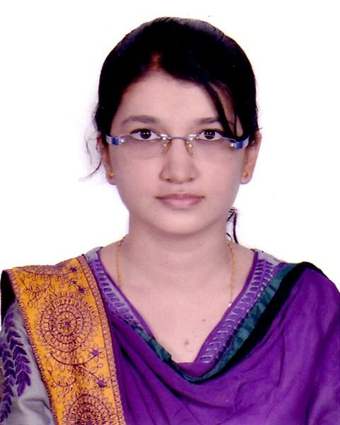 | DR. MAHNAZ TABASSUM RAISA  F/Name: Sk. Mahbubul Haque  M/Name: Nasrin Haque  BM & DC Reg. No: 67505  NID:  Cell: 01732-268945  Address: 28, Lower Jessore Road, Khulna.  Blood Group: B+
480 | Voter No  LM-2900474 | DR. MD. MUZAHIDUL ISLAM  F/Name: Prof. Dr. Israil Biswas  M/Name: Dr. Rehana Sultana  BM & DC Reg. No: 63251  NID:  Cell: 01782-317370  Address: 348/2, Khan Jahan Ali Road, Khulna.  Blood Group: B+
481 | Voter No  LM-2900475 | DR. ABDUL HALIM SARDAR  F/Name: Yakub Ali Sardar  M/Name: Rahima Khatun  BM & DC Reg. No: 24426  NID: 8719087892106  Cell: 01711348426  Address: 322, Sonadanga R/A, Road-03 2nd Phase, Sonadanga, Khulna.  Blood Group: B+
482 | Voter No  LM-2900476  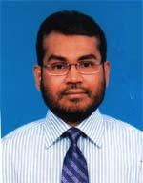 | PROF. DR. SHAIKH AMIR HOSSAIN  F/Name: Sk. Abul Hossain  M/Name: Zayeda Khatun  BM & DC Reg. No: 20616  NID: 4792101001115  Cell: 01711224427  Address: 54, Hazi Mohsin Road, Khulna.  Blood Group: B+
483 | Voter No  LM-2900477  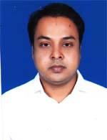 | DR. MOHAMMED WAHEDUJJAMAN MASUM  F/Name: Late Md. Haowar Hossain  M/Name: Late Mrs. Rokeya Hossain  BM & DC Reg. No: 34927  NID: 19756125218237201  Cell: 01717057498  Address: 168, Road-11, Sonadanga R/A, Khulna.  Blood Group: O+
484 | Voter No  LM-2900478  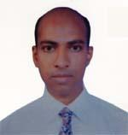 | DR. FORRUKH AHAMMAD  F/Name: Helal Uddin Ahmed  M/Name: Firoza Ahmed  BM & DC Reg. No: 27126  NID: 4798517244740  Cell: 01711979262  Address: 20/4, Karim Nagar, Sonadanga, Khulna.  Blood Group: O+
485 | Voter No  LM-2900479  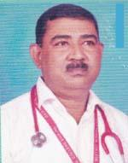 | DR. MD. BARKOT ALI  F/Name: Late Al Haj Md. Shaheb Ali Miah  M/Name: Late Mrs. Khadiza Khatun  BM & DC Reg. No: 25803  NID: 4792105057257  Cell: 01712050951  Address: Asso. Prof. Dept. of Peacliatric Gazi Medical College, Hospital, Khulna  Blood Group: A+
486 | Voter No  LM-2900480 | DR. DIPIKA RANI MONDAL  F/Name: Late Rajendra Nath Mondal  M/Name: Shova Rani Mondal  BM & DC Reg. No: 14779  NID:  Cell: 01711191833  Address: 18/357, Prime Clinic, Nirala R/A, Khulna.  Blood Group: B+
487 | Voter No  LM-2900481  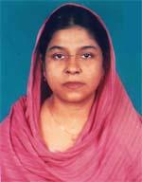 | DR. NARGIS JAHAN  F/Name: Late Dr. Md. Nowsher Ali  M/Name: Dr. Jahanara Ali  BM & DC Reg. No: 19102  NID: 4798520293792  Cell: 01715950975  Address: 9, Shere Bangla Road, Khulna  Blood Group: A+
488 | Voter No  LM-2900482 | DR. DIPANKAR NAG  F/Name: Nirod Behari Nag  M/Name: Dushpa Rani Nag  BM & DC Reg. No: 29284  NID: 4795124433199  Cell: 01711131066  Address: 65, Islampur Road, Shantidhan More, Khulna  Blood Group: B+
489 | Voter No  LM-2900483 | DR. MD. NOOR -A-ALAM SIDDIQUE  F/Name: Md. Abdur Noor  M/Name: Mrs. Shamsun Nahar  BM & DC Reg. No: 35770  NID: 4795124441431  Cell: 01711489958  Address: 22/1, Musolman para Rayhan Monjil 2nd Floor, Khulna  Blood Group: B+
490 | Voter No  LM-2900484  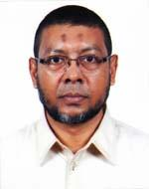 | DR. ABUL QUAUM SHAIKH  F/Name: Late Dr. A. F. S. Badsha Mia  M/Name: Mrs. Raziatun Maleka Banu  BM & DC Reg. No: 33535  NID: 1471634053  Cell: 01914325111  Address: No. 1 Faraji Para Road, Khulna  Blood Group: B+
491 | Voter No  LM-2900485 | DR. SRABONI QUAUM  F/Name: Late Nabin Kumar Tripura  M/Name: Mrs. Sujita Tripura  BM & DC Reg. No: 33536  NID: 3721662090  Cell: 01914325444  Address: No. 1, Farazi para road, Khulna  Blood Group: B+
492 | Voter No  LM-2900486 | DR. SK. MOAZZEM HOSSAIN  F/Name: Sk Aitaf Hossain  M/Name: Morium Begum  BM & DC Reg. No: 29035  NID: 19724716919745788  Cell: 01711966110  Address: Vill-Mattom Danga, Post-Jahanabad Cant. , Khulna  Blood Group: O+
493 | Voter No  LM-2900487 | DR. FARJANA KABIR  F/Name: Late Dr. Shaikh Md. Anwarul Kabir  M/Name: Hamida Kabir  BM & DC Reg. No: 33380  NID:  Cell: 01712122615  Address: c/o Dr. SK Moazzem Hossain Vill-Mattomdanga, post-Jahanabad, Cantonment, Khulna  Blood Group: B+
494 | Voter No  LM-2900488 | DR. SUDIPTO SAHA  F/Name: Dhirendro Nath Saha  M/Name: Lila Saha  BM & DC Reg. No: 28535  NID: 4798516214883  Cell: 01711818250  Address: Nasima House, Choto Boyra Khulna.  Blood Group: O+
495 | Voter No  LM-2900489 | DR. JHARNA DAS  F/Name: Sukharangan Das  M/Name: Laxmi Das  BM & DC Reg. No: 41197  NID: 4798516214884  Cell: 01712183658  Address: Nasima House, Choto Boyra, Khulna  Blood Group: O+
496 | Voter No  LM-2900490 | DR. BISWAJIT SARKAR  F/Name: Rajkrishna Sarkar  M/Name: Lalita Sarkar  BM & DC Reg. No: 35670  NID:  Cell: 01716495566  Address: New Life Nursing Home, Agrani Bank Town Gollamari, Khulna  Blood Group: B+
497 | Voter No  LM-2900491  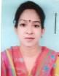 | DR. DOLLY HALDER  F/Name: Subhash Chandra Halder  M/Name: Maya Rani Halder  BM & DC Reg. No: 42905  NID: 4798517235423  Cell: 01712100697  Address: ``Mayanir' 38, Korim Nogor, Choto Boyra Khulna.  Blood Group: B+
498 | Voter No  LM-2900492 | DR. UTTAM KUMAR DEWAN  F/Name: Joy Gopal Dewan  M/Name: Durga Rani Dewan  BM & DC Reg. No: 35461  NID: 6525201420671  Cell: 01722257285  Address: 8/5, Choto Mirzapur Nargis Tower, Khulna.  Blood Group: AB+
499 | Voter No  LM-2900493 | DR. ZILLUR RAHMAN TORUN  F/Name: Late A. Jalil Mia  M/Name: Saleha Begum  BM & DC Reg. No: 65088  NID: 4794508105972  Cell: 01711364799  Address: Holding-712, Crescent Gate, Khakinhpur, Khulna  Blood Group: B+
500 | Voter No  LM-2900494 | DR. MD. YUNUS UZZAMAN KHAN  F/Name: Late Md. Jamir Ali Khan  M/Name: Zinnatunnasha  BM & DC Reg. No: 49393  NID: 19824716450077588  Cell: 01711950459  Address: 51, Sir Iqbal Road, Khulna  Blood Group: AB+
501 | Voter No  LM-2900495  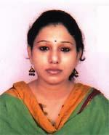 | DR. SHIRIN SULTANA  F/Name: Dr. Abu Jafor Md. Salah  M/Name: Mrs. Rashida Jafor  BM & DC Reg. No: 59167  NID: 4795123417063  Cell: 01717178940  Address: 51, Sir Iqbal Road, Khulna  Blood Group: A+
502 | Voter No  LM-2900496 | DR. FARIA FARUQUE  F/Name: Md. Faruque  M/Name: Nurun Naher  BM & DC Reg. No: 44436  NID: 4798516216588  Cell: 01717005901  Address: Choto Boyra, Khulna, Obosor Vangapol, MT road, Chotoboyra, Khulna  Blood Group: O+
503 | Voter No  LM-2900497 | DR. AVIJIT KUMAR SIKDER  F/Name: Fani Vuson Sikder  M/Name: Charu Bala Halder  BM & DC Reg. No: 39085  NID: 2696352211748  Cell: 01716169133  Address: 3B, 3rd Floor, Khana Medical College Quater  Blood Group: O+
504 | Voter No  LM-2900498  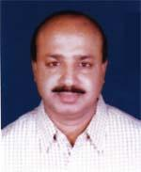 | DR. MD. MOSTAFIZUR RAHMAN  F/Name: Taibur Rahman  M/Name: Saleh Begum  BM & DC Reg. No: 12006  NID:  Cell: 01711979449  Address: H # 16, Rd # 03, Nirala R/A, Khulna  Blood Group: A+
505 | Voter No  LM-2900499  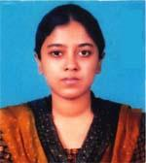 | DR. NAZIA NASIR  F/Name: Md. Nasir Khasru  M/Name: Mrs. Nasima Mariam  BM & DC Reg. No: 58949  NID: 1822303132900  Cell: 01765947064  Address: 8/1, KDA Approach Road, Sonadanga, Khulna  Blood Group: O+
506 | Voter No  LM-2900500 | DR. MD. ANISUR RAHMAN  F/Name: Md. Aminur Rahman  M/Name: Shamsunnahar  BM & DC Reg. No: 59205  NID: 4795123420890  Cell: 01732373716  Address: 74/1, M. T. road, Khulna  Blood Group: A+
507 | Voter No  LM-2900501 | DR. S.M GOLAM AZAM  F/Name: Md. Wazed Ali Sardar  M/Name: Mrs. Rahima Khatun  BM & DC Reg. No: 22432  NID: 8719031566571  Cell: 01711468682  Address: House-153, Road-12, Mujgunni R/A Khalispur, Khulna  Blood Group: A+
508 | Voter No  LM-2900502  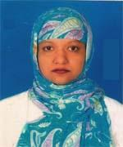 | DR. SUHANA NAZMIN  F/Name: Mirza Md. Shawkat Hussain  M/Name: Begum Sharifa Akter  BM & DC Reg. No: 33451  NID: 4756998751196  Cell: 01553218541  Address: 33/3 Mujgunni Uttar para, Baitur Ruhai, Khulna  Blood Group: O+
509 | Voter No  LM-2900503 | DR. BANI SAHA  F/Name: Niranjan Saha  M/Name: Mrs. Malati Saha  BM & DC Reg. No: 24293  NID: 4124705071063  Cell: 01711879090  Address: 25, Bagmara Govt. Primary School Road, Bagmara, Khulna  Blood Group: O+
510 | Voter No  LM-2900504 | DR. MD. ANWAR SHAHADAT  F/Name: Md. Sirajul Islam  M/Name: Tajia Islam  BM & DC Reg. No: 41675  NID: 0125808349238  Cell: 01717520369  Address: Buildings No. 3D (2nd Floor), Doctors Quater, Khulna Medical College, Khulna.  Blood Group: B+
511 | Voter No  LM-2900505 | DR. SUMON ROY  F/Name: Hiranmoy Krishna Roy  M/Name: Doli Rani Das  BM & DC Reg. No: 46604  NID: 4795127478673  Cell: 01816307142  Address: 133/4, Baghmara, Bankers Lane-1, Bagmara Main Road, Khulna  Blood Group: B+
512 | Voter No  LM-2900506 | DR. CHAMPAK ROY  F/Name: Manoyit Kumar Roy  M/Name: Hiya Roy  BM & DC Reg. No: 49455  NID: 19844798516214900  Cell: 01716821505  Address: 31/3, Doctorpara Lane, Sonadanga, Khulna.  Blood Group: O+
513 | Voter No  LM-2900507 | DR. NABILA HASSAN  F/Name: Md. Abu Hassan  M/Name: Momotaj Hassan  BM & DC Reg. No: 67536  NID: 19924795127000100  Cell: 01732033965  Address: 41, Mia Para Main Road Khulna.  Blood Group: B+
514 | Voter No  LM-2900508  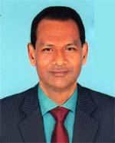 | DR. A. H. S. M. KAMRUZZAMAN  F/Name: Late Sheikh Munsur Ali  M/Name: Late Asia Khatun  BM & DC Reg. No: 18371  NID: 19634795122403167  Cell: 01747458527  Address: 26, Ahsan Ahmed Road, Khulna  Blood Group: A+
515 | Voter No  LM-2900509  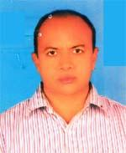 | DR. MD. MOZAMMEL HAQUE  F/Name: Md. Kamal Uddin (late)  M/Name: Mrs. Amina Begum  BM & DC Reg. No: 18672  NID: 4121708406640  Cell: 01711131472  Address: Dacope Health Complex Dacope, Khulna.  Blood Group: A+
516 | Voter No  LM-2900510  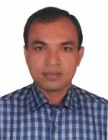 | DR. SATTYAJIT MONDAL  F/Name: Binoy Krishna Mondal  M/Name: Promila Mondal  BM & DC Reg. No: 38667  NID: 4716957021851  Cell: 01712523196  Address: 72/2,Hazi Ismail Road, Banorgati, Khulna.  Blood Group: A+
517 | Voter No  LM-2900511  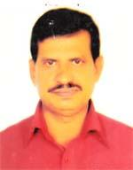 | DR. DILIP KUMAR BRAHMA  F/Name: Late Kali Pada Brahma  M/Name: Late Bina Pani Brahma  BM & DC Reg. No: 10993  NID: 4795123425178  Cell: 01711267566  Address: 7/2, Sir Iqbal Road, By-lane, Khulna.  Blood Group: A+
518 | Voter No  LM-2900512 | PROF. DR. MD. ABU BAKAR  F/Name: Md. Mahashin Uddin Howlader  M/Name: Mrs. Shaheda Begum  BM & DC Reg. No: 9670  NID: 19554795123425493  Cell: 01711328254  Address: National Tower, 26, Ahsan Ahmed Road, Khulna, Flat -9/B  Blood Group: B+
519 | Voter No  LM-2900513  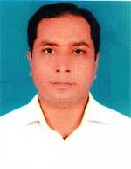 | DR. MD. TARIKUL ISLAM  F/Name: Md. Golam Mostafa  M/Name: Monowara Begum  BM & DC Reg. No: 30603  NID: 4714057522950  Cell: 01711311137  Address: Assistant prof. Burr & Plastic Surgery, Khulna Medical College  Blood Group: A+
520 | Voter No  LM-2900514  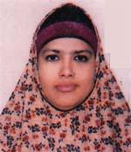 | DR. RIFAT SULTANA SHELLY  F/Name: Late S. M. Abdul Hoque Chowdhury  M/Name: Late Most. Roison Nessa  BM & DC Reg. No: 20712  NID: 4795123419994  Cell: 01714087286  Address: 4, Mirzapur Road Sadar Khulna.  Blood Group: O+
521 | Voter No  LM-2900515 | DR. MD. KHALED MAHMUD  F/Name: Md. Abdur Rashid  M/Name: Monjuara Begum  BM & DC Reg. No: 63121  NID: 4794509127692  Cell: 01725958183  Address: Flat No.-0222-0223, B/W GPO & Pumlic Library, Khalishpur, Khulna.  Blood Group: O+
522 | Voter No  LM-2900516  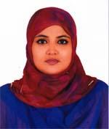 | DR. NAZIA NAZNEEN  F/Name: S. M. Nurul Islam  M/Name: Mahfuja Begum  BM & DC Reg. No: 52101  NID: 6125215214698  Cell: 01720818581  Address: Associate Professor, Gazi Medical College, Khulna.  Blood Group: B+
523 | Voter No  LM-2900517 | DR. NASREEN AKHTER  F/Name: Khondoker Atiur Rahman  M/Name: Shahida Rahman  BM & DC Reg. No: 15730  NID:  Cell: 01712248062  Address: House- 84, Road No.02 Sonadanga R/A, Khulna  Blood Group: O+
524 | Voter No  LM-2900518  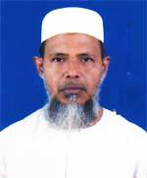 | DR. MD. HABIBUR RAHMAN  F/Name: Md. A. Kader  M/Name: Amina Khatun  BM & DC Reg. No: 19426  NID: 0695119238704  Cell: 01738688720  Address: 35/A, Babu Khan Road Khulna.  Blood Group: O+
525 | Voter No  LM-2900519  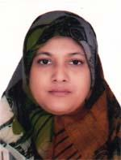 | DR. FARHANA ISLAM  F/Name: Dr. Md. Rafiqul Islam  M/Name: Dr. Sitara Islam  BM & DC Reg. No: 34659  NID: 2695041753684  Cell: 01717615418  Address: 26, Basupara Lane Sonadanga, Khulna-9100.  Blood Group: AB+
526 | Voter No  LM-2900520 | DR. UPANANDA RAY  F/Name: Narayan Chandra Ray  M/Name: Pravabati Ray  BM & DC Reg. No: 60196  NID: 4798516214754  Cell: 01717560194  Address: 21/15, Sahana Manjil Choto Boyra, Khulna.  Blood Group: O+
527 | Voter No  LM-2900521  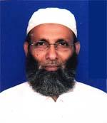 | DR. SHAHABUDDIN MD. MUJTABA  F/Name: Md. Sadaruddin  M/Name: Mst. Morjina Khatun  BM & DC Reg. No: 11796  NID: 4798516214290  Cell: 01711482492  Address: Islami Bank Hospital Khulna.  Blood Group: B+
528 | Voter No  LM-2900522  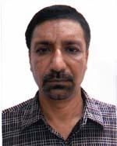 | DR. AKM MAMUNUR RASHID  F/Name: Abul Basher  M/Name: Mrs. Salema Khatun  BM & DC Reg. No: 16887  NID: 4798517241614  Cell: 01711299188  Address: Mithisha House, Choto Boyra, Khulna.  Blood Group: O+
529 | Voter No  LM-2900523 | DR. S. M. MONIR HOSSAIN  F/Name: Dr. Md. Moazzem Hossain  M/Name: Kaniz Sultana  BM & DC Reg. No: 63522  NID: 19884798516214695  Cell: 01710886280  Address: 38/1, South Central Road, Khulna  Blood Group: B+
530 | Voter No  LM-2900524  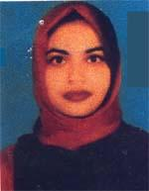 | DR. FAHMIDA HASAN  F/Name: T. S. M. Ali Hasan  M/Name: Kohinoor Begum  BM & DC Reg. No: 64571  NID:  Cell: 01731790966  Address: 38/1, South Central Road, Khulna  Blood Group: B+
531 | Voter No  LM-2900525  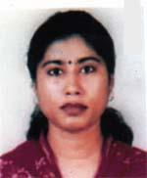 | DR. AFROZA BEGUM LUBNA  F/Name: Dr. Harun Ar Rashid  M/Name: Mrs. Shamima Begum  BM & DC Reg. No: 47853  NID: 2698878414713  Cell: 01915902396  Address: Flat-3B, Castle Noor, Nurnagar, Munshipara Road, Khalispur, Khulna.  Blood Group: O+
532 | Voter No  LM-2900526  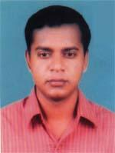 | DR. MD. JASIM UDDIN  F/Name: Md. Oliar Rahaman Fakir  M/Name: Jubria Begum  BM & DC Reg. No: 33563  NID: 4798517243428  Cell: 01743753775  Address: Flat-3B, Castle Noor, Nurnagar, Munshipara Road, Khalispur, Khulna.  Blood Group: A+
533 | Voter No  LM-2900527  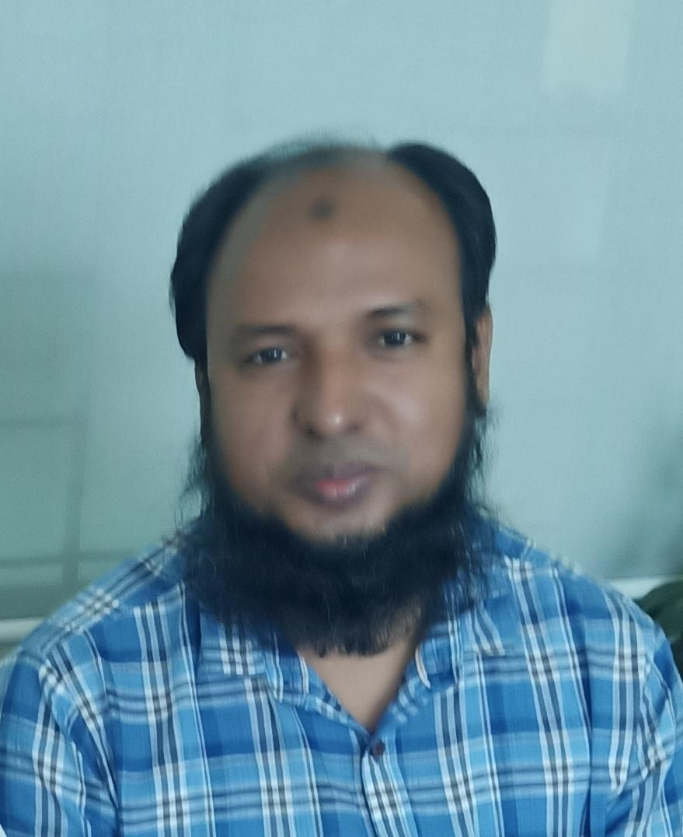 | DR. MD. ABU BAKAR SIDDIQUE  F/Name: Md. Nizam Uddin  M/Name: Sufia Begum  BM & DC Reg. No: 36648  NID: 4795128485505  Cell: 01914923033  Address: H-24/2, Ka, Noor Mosque Cross Road, Alifbagh, West Tootpara, Khulna  Blood Group: B+
534 | Voter No  LM-2900528 | DR. MD. KUTUB UDDIN MOLLICK  F/Name: Md. Jillur Rahman Mollick  M/Name: Mrs. Khadiza Khanoom  BM & DC Reg. No: 27016  NID: 2696352226843  Cell: 01711979084  Address: Nilfa, 169 B.k. main lane, Purbo Bania, Khamar, Khulna-9100  Blood Group: B+
535 | Voter No  LM-2900529 | DR. MD. SAYEDUR RAHMAN SHEIKH  F/Name: Late Dabiruddin Sheikh  M/Name: Noor Jahan  BM & DC Reg. No: 27907  NID: 0113421159218  Cell: 01711971091  Address: Registar, Nearomedicine, Shahid Sheikh abu Naser Specialized Hospital, Khulna.  Blood Group: A+
536 | Voter No  LM-2900530  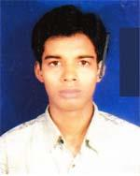 | DR. MD. ASHIK UZZAMAN SHAIKH  F/Name: Md. Pizir Uddin Shaikh  M/Name: Rokeya Begum  BM & DC Reg. No: 58520  NID: 19854716976005330  Cell: N/A  Address: Vill-Poygram, Post+P.s-Phultala, Dist-Khulna  Blood Group: O+
537 | Voter No  LM-2900531  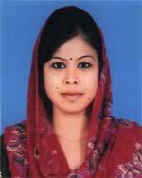 | DR. WAHIDA SULTANA  F/Name: Anwar Hossain  M/Name: Mst. Afroza Begum  BM & DC Reg. No: 63125  NID: 4798516216656  Cell: 01729541107  Address: Goborchaka Cross Road Sonadanga, Khulna.  Blood Group: B+
538 | Voter No  LM-2900532  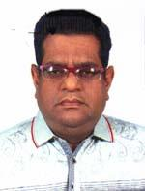 | DR. KHAN AHMED HILALY  F/Name: Shams Uddin Ahmed  M/Name: Halima Ahmed  BM & DC Reg. No: 25718  NID: 4795129507386  Cell: 01919585111  Address: 81, Gagon Babu Road, Khulna  Blood Group: B+
539 | Voter No  LM-2900533  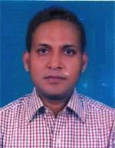 | DR. SYED AMANUL ISLAM  F/Name: Syed A. N. Md. Shaheed  M/Name: Begum Ayesha Shaheed  BM & DC Reg. No: 29944  NID: 4794514189626  Cell: 01716360452  Address: 1/5, Karimnagar Colony, Farazipara Main Road, Khulna.  Blood Group: A+
540 | Voter No  LM-2900534 | DR. MAHFUZA FERDOUS  F/Name: Md. Jamshed Ali  M/Name: Mrs. Shahida Khatun  BM & DC Reg. No: 29943  NID: 4794514189611  Cell: 01711930597  Address: Islami Bank Hospital, Khulna  Blood Group: B+
541 | Voter No  LM-2900535 | DR. NASRIN AKHTER  F/Name: Late Sk Abu Bakar  M/Name: Late Anowara Begum  BM & DC Reg. No: 17864  NID:  Cell: 01716070737  Address: Boyra Nursing Home, E14 Jalil Sarani, Boyra, Khunlna.  Blood Group: B+
542 | Voter No  LM-2900536  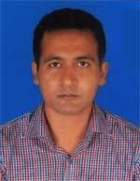 | DR. KANAK JYOTI MONDAL  F/Name: Jatindra Nath Mondal  M/Name: Tuku Rani Mondal  BM & DC Reg. No: 58324  NID: 19864711235842067  Cell: 01717666781  Address: Vill-Balabunia , Post-Bayarbhanga, P.s-Batiaghata, Khulna  Blood Group: B+
543 | Voter No  LM-2900537 | DR. BAPPA RAJ DUTTA  F/Name: Ram Chandra Dutta  M/Name: Bina Rani Dutta  BM & DC Reg. No: 60175  NID: 4798516214990  Cell: 01721803775  Address: 87, Kundupara Road Choto Boyra, Sonadanga, Khulna.  Blood Group: A+
544 | Voter No  LM-2900538 | DR. MILAN KUMAR SAHA  F/Name: Late Mahadeb Saha  M/Name: Shipra Saha  BM & DC Reg. No: 47051  NID: 19839587416220876  Cell: 01912660112  Address: 87, Kundupara Road Choto Boyra, Khulna.  Blood Group: A+
545 | Voter No  LM-2900539 | DR. GOUR PRIYA MAJUMDER  F/Name: Late Krishna Prosad Majumder  M/Name: Late Purnima Majumder  BM & DC Reg. No: 8810  NID: 4798517243425  Cell: 01711239993  Address: 4/Ka, Sashanghot Rd, Chota Boyra, Khulna  Blood Group: O+
546 | Voter No  LM-2900540  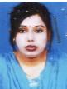 | DR. CHANDRA RANI NAG  F/Name: Narayan Chandra Nag  M/Name: Shankari Rani Nag  BM & DC Reg. No: 49021  NID: 8198510364137  Cell: 01913352377  Address: 20 # Boro Boyra, Daspara Road, Khulna-9000  Blood Group: B+
547 | Voter No  LM-2900541 | DR. KHAN AHMED ISHTIAK  F/Name: Khan Akhter Hossain  M/Name: Umme Asma  BM & DC Reg. No: 72527  NID: 19914794512000049  Cell: 01826611062  Address: House No.-19, Road No.-154, Central Block R/A, Khalishpur, Khulna  Blood Group: A+
548 | Voter No  LM-2900542 | DR. MD. TOFAZZALE HOSAIN  F/Name: Gazi Tafsir Ahmed  M/Name: Mrs. Rekha Ahmed  BM & DC Reg. No: 52584  NID: 3720278062  Cell: 01717025359  Address: 2/7, Babu Khan Road, Khulna  Blood Group: A+
549 | Voter No  LM-2900543 | DR. SHAIKH SYEED AFTAB  F/Name: Shaikh Anwaruzzaman  M/Name: Wahida Hosneara  BM & DC Reg. No: 63697  NID: 4795122402650  Cell: 01687771375  Address: 65, Hazi Mohasin road, Khulna  Blood Group: O+
550 | Voter No  LM-2900544 | DR. SHYAMOL CHANDRA BARAL  F/Name: Late Kiron Chandra Baral  M/Name: Sabitri Rani Baral  BM & DC Reg. No: 39498  NID: 2697557398059  Cell: 01712991155  Address: 38, Karim Nagar, Choto Boyra, Post-G.p.o, P.s-Sonadanga, Khulna  Blood Group: A+
551 | Voter No  LM-2900545  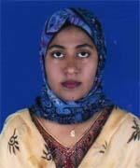 | DR. MUSFIQA IFFAT  F/Name: Late S. M. Hafizur Rahman  M/Name: Syeda Nadira Pervin  BM & DC Reg. No: 42900  NID: 4795129503980  Cell: 01717725653  Address: 39/3, Municipal Tank Road, Khulna  Blood Group: O+
552 | Voter No  LM-2900546 | DR. NAYER ISLAM  F/Name: Kamrul Islam  M/Name: Taslima Islam  BM & DC Reg. No: 43846  NID: 376948110188717  Cell: 01712984990  Address: Asst. Registrar, Khulna Medical College Hospital, Khulna.  Blood Group: A+
553 | Voter No  LM-2900547  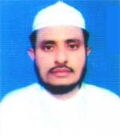 | DR. KOWSAR ALI  F/Name: Md. Amin Sheik  M/Name: Rokeya Begum  BM & DC Reg. No: 26851  NID: 4798525309429  Cell: 01980448645  Address: 7/1, B.k.m.t. Road, Tarer Pukur, Khulna  Blood Group: B+
554 | Voter No  LM-2900548 | DR. SK. ENAMUL KABIR  F/Name: Md. Layek Uddin Shaikh  M/Name: Momena Khatun  BM & DC Reg. No: 17304  NID: 4795123416400  Cell: 01711943887  Address: 2, Agrani Bank Town Gallamary, Khulna.  Blood Group: A+
555 | Voter No  LM-2900549  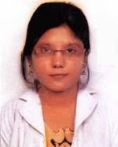 | DR. SUMANA DAS  F/Name: Biswanath Das  M/Name: Debika Das  BM & DC Reg. No: 67034  NID: 19904794515000007  Cell: 01762938598  Address: 27, Halder Para Rd, South Khalishipur, G.P.O.-Khulna, 9000, P.s-Khalishipur, Dist-Khulna  Blood Group: B+
556 | Voter No  LM-2900550 | DR. HIMEL SAHA  F/Name: Arabinda Saha  M/Name: Uma Saha  BM & DC Reg. No: 45575  NID: 4795122401274  Cell: 01711267631  Address: House-Godhulia, Holding No.-40, Sultan Ahmed Road, Moulavipara, Khulna  Blood Group: O+
557 | Voter No  LM-2900551  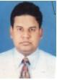 | DR. MD. MAMUNUR RASHID  F/Name: Abdur Razzak Molla  M/Name: Farida Begum  BM & DC Reg. No: 41341  NID: 4798526325155  Cell: 01712753375  Address: 28/1, Shahid Swarardi College Road Sonadanga, Khulna.  Blood Group: A+
558 | Voter No  LM-2900552  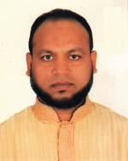 | DR. MD. NAZMUL HAQUE  F/Name: Md. Iman Ali Sarder  M/Name: Mrs. Mahfuza Begum  BM & DC Reg. No: 27543  NID: 19722697556416853  Cell: 01711274156  Address: h-90, R-13, Sonadanga R/A (2nd Phase) Khulna  Blood Group: B+
559 | Voter No  LM-2900553  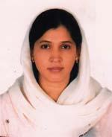 | MD. SAMIA NARGIS  F/Name: Mohammad Abdul Jabber  M/Name: Jahanara Begum  BM & DC Reg. No: 44107  NID: 2694263699629  Cell: 01712763536  Address: H-90, R-13, Sonadanga R/A 2nd Phase, Khulna  Blood Group: A+
560 | Voter No  LM-2900554  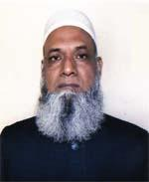 | PROF. DR. MD. ABU SAYEED  F/Name: Late Abdus Sattar  M/Name: Late Noorjahan Begum  BM & DC Reg. No: 13627  NID: 4798516214507  Cell: 01711157073  Address: 99/2, South Central Road Khulna.  Blood Group: AB+
561 | Voter No  LM-2900555  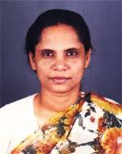 | DR. RAZIA SULTANA  F/Name: Late Olayet Ali Mridha  M/Name: Lutfun Nessa  BM & DC Reg. No: 13628  NID: 4798516214503  Cell: 01779947573  Address: 99/2, South Central Road Khulna.  Blood Group: B+
562 | Voter No  LM-2900556 | DR. MD. ABDULLAH AL MASUM  F/Name: Md. Ayub Ali Khan Bangali  M/Name: Mrs. Monowara Bangali  BM & DC Reg. No: 52018  NID: 19824795123422143  Cell: 01711355991  Address: Divesional Polic Hospital Khulna.  Blood Group: O+
563 | Voter No  LM-2900557 | DR. ABU HENA MUSTOFA KAMAL  F/Name: M.m. Sufid Ali  M/Name: Saleha Begum  BM & DC Reg. No: 35766  NID:  Cell: 01716337975  Address: 205 Hazi Ismail Road, P.s-Sonadanga, Khulna  Blood Group: A-
564 | Voter No  LM-2900558 | DR. SYED MAHBUBE KIBRIA  F/Name: Syed Jahangir Ali  M/Name: Hosne Banu  BM & DC Reg. No: 39369  NID: 4798517243437  Cell: 01199464393  Address: Lecturer Anatomy, Khulna Medical College, Khulna.  Blood Group: O+
565 | Voter No  LM-2900559  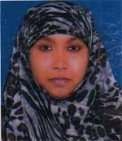 | DR. TAMANNA-E-NUR  F/Name: Dr. S.m. Eaqub Ali  M/Name: Selima Pervin  BM & DC Reg. No: 48806  NID: 4798526319640  Cell: 01670672248  Address: 40, Nazirghat road, West Baniakhamar, khulna  Blood Group: B+
566 | Voter No  LM-2900560 | DR. SARDER MD. SAIFUL AREFIN  F/Name: Sarder Ashraf Ali  M/Name: Safia Khanam  BM & DC Reg. No: 30080  NID: 4794509132233  Cell: 01714002490  Address: House-254, Road-19, Mazgunri R/A, Khulna  Blood Group: B+
567 | Voter No  LM-2900561 | DR. MUNIR HOSSAIN  F/Name: Md. Abdus Sattar  M/Name: Hosneara Begum  BM & DC Reg. No: 47682  NID: 4794514192831  Cell: 01717528923  Address: Plot No.02, Central Road, Mujgunni R/A, Boyra, Khulna  Blood Group: O+
568 | Voter No  LM-2900562  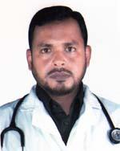 | DR. ASADULLAHIL GALIB  F/Name: Abul Hossen  M/Name: Rokea Hossen  BM & DC Reg. No: 35688  NID: 4798517241089  Cell: 01711152203  Address: Mujgunni Mohasarok Bilane, Boira, Khulna  Blood Group: B+
569 | Voter No  LM-2900563  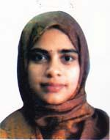 | DR. MAKSUDA KHANAM  F/Name: Mohammad Muslim Khan  M/Name: Jahanara Khanam  BM & DC Reg. No: 47766  NID: 4798517241090  Cell: 01785902393  Address: 49, KDA Avenue, Dortors Point, Khulna.  Blood Group: O+
570 | Voter No  LM-2900564  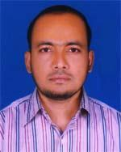 | DR. MD. ALAUDDIN SIKDER  F/Name: Md. Abu Bakar Sikder  M/Name: Gamila Begum  BM & DC Reg. No: 36884  NID: 4714017148120  Cell: 01712278749  Address: Lakhohati, Barakpur Degholia, Khulna  Blood Group: A+
571 | Voter No  LM-2900565  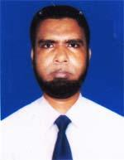 | A. B.M. ZAFAR SADEQUE  F/Name: Md. Abul Kashem  M/Name: Mahmuda Khatun  BM & DC Reg. No: 38377  NID: 19774795124455788  Cell: 01711121616  Address: House-87, Road-01, Nirala R/A, Khulna  Blood Group: O+
572 | Voter No  LM-2900566 | DR. SK. ABDULLAH AL MAMUN  F/Name: Sk. Samsul Alom  M/Name: Hosnae Ara Begum  BM & DC Reg. No: 41807  NID: 4716444055395  Cell: 01711000856  Address: 39/3, Tank Road, Khulna  Blood Group: O+
573 | Voter No  LM-2900567  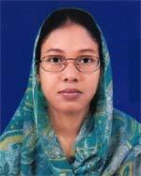 | DR. EVANA NASRIN  F/Name: Liaquat Ali Khokon  M/Name: Amina Khatun  BM & DC Reg. No: 37051  NID: 4798517235572  Cell: 01715012356  Address: 20/4, Kasimnagar, GPO-9000, Sonadanga, Khulna  Blood Group: O+
574 | Voter No  LM-2900568  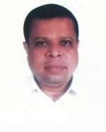 | DR. MD. ALI HASSAN  F/Name: Late Md. Eshaque  M/Name: Late Siddika Banu  BM & DC Reg. No: 23051  NID: 9196211230176  Cell: 01711709460  Address: K/12, Khalishpur Housing Society, Khalishpur, Khulna.  Blood Group: B+
575 | Voter No  LM-2900569  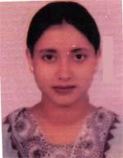 | DR. SALINA AKTER  F/Name: Md. Azahar Ali  M/Name: Mrs. Hazera Begom  BM & DC Reg. No: 36152  NID: 4798517230209  Cell: 01715286331  Address: House No.-108, Road No.-1, Sonadanga R/A (1st Phase), Khulna  Blood Group: O+
576 | Voter No  LM-2900570  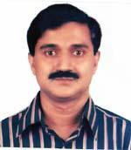 | DR. S.M. QUAMRUL HUQ  F/Name: Mr S N Huq  M/Name: Halima Huq  BM & DC Reg. No: 23339  NID: 4795129508079  Cell: 01745436386  Address: 6/1, Gagon Babu Road By lane Old M.Tank Road, Khulna-9100  Blood Group: O+
577 | Voter No  LM-2900571 | DR. KANIJ FAHMIDA  F/Name: Dr. M. A. Majid  M/Name: Shamsunnahar  BM & DC Reg. No: 23763  NID: 4795129508078  Cell: 01711458184  Address: 6/1, Gagon Babu Road By Lane (old M. Tand Road) Khulna-9100  Blood Group: B-
578 | Voter No  LM-2900572  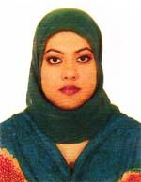 | DR. LILA-TUZZOHA MITHUN  F/Name: Liquat Ali  M/Name: Mahfuza Begum  BM & DC Reg. No: 65787  NID: 4124702015749  Cell: 01728049015  Address: 2/7 Babu Khan Road, Khulna  Blood Group: B+
579 | Voter No  LM-2900573 | DR. MD. SHAMIMUL HAQUE  F/Name: Late Shamsul Haque  M/Name: Mrs. Shamsun Nahar  BM & DC Reg. No: 45177  NID: 4798525309662  Cell: 01798467062  Address: Prince Altra Scan 285, Khanjahan Ali Road, Khulna.  Blood Group: B+
580 | Voter No  LM-2900574  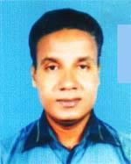 | DR. ASHISH KUMAR HALDER  F/Name: Sudhir Ranjan Halder  M/Name: Akul Bala Halder  BM & DC Reg. No: 34721  NID: 4794512164638  Cell: 01712626010  Address: Sr. MO (Eye Unit), Lions Eye Hospital, Khulna.  Blood Group: O+
581 | Voter No  LM-2900575 | DR. MD. SADDAMUL HAQUE  F/Name: Late Shamsul Haque  M/Name: Mst. Shamsun Nahar  BM & DC Reg. No: 44789  NID: 4717513646656  Cell: 01711141534  Address: 190, Hazi Ismail Road, Banorgat Bazar, Sonadanga, Khulna  Blood Group: B+
582 | Voter No  LM-2900576  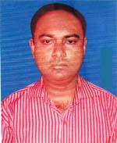 | DR. ABDULLAH AL ZAFOR  F/Name: Md. Golam Mustafa  M/Name: Mrs. Sanjida Sitara Bari  BM & DC Reg. No: 73930  NID: 4794509132223  Cell: 01717728519  Address: Solaiman Monjil, Rd-22, Hs no.389, Mujgunni R/A, Khulna  Blood Group: B+
583 | Voter No  LM-2900577  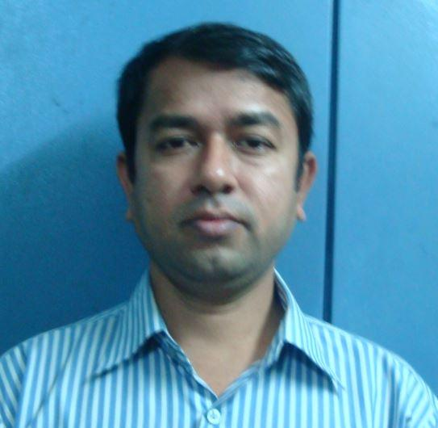 | DR.MD.MAHABUBUR ROSHED  F/Name: Md. A. Rahman  M/Name: Mrs. Rahima Khatun  BM & DC Reg. No: 26655  NID: 2691557397325  Cell: 01912446064  Address: 131/Kha, Mojid Sarani Sonadanga, Khulna.  Blood Group: O+
584 | Voter No  LM-2900578 | DR. KAZI MOFIZUR RAHMAN  F/Name: Kazi Abubakkar  M/Name: Begum Rokeya  BM & DC Reg. No: 76687  NID: 19904798519000004  Cell: 01914092818  Address: 125, B.K. Roy Road Dalmil More, Khulna  Blood Group: O+
585 | Voter No  LM-2900579  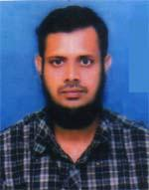 | DR. GOLAM MASHUD  F/Name: Golam Mortuza  M/Name: Rowshan Ara Begum (late)  BM & DC Reg. No: 24884  NID: 479512444070  Cell: 01818695423  Address: 26, Muslman Para Road. Khulna.  Blood Group: B+
586 | Voter No  LM-2900580 | DR. SUBRATA KUMAR MONDAL  F/Name: Shiba Pada Mondal  M/Name: Nani Bala Mondal  BM & DC Reg. No: 41562  NID: 4798518253758  Cell: 01716952927  Address: House No-350/1, Road-2, Phase-2, Sonadanga Residential Area, Khulna.  Blood Group: O-
587 | Voter No  LM-2900581 | DR. MD. SALMAN HOSSAIN  F/Name: Md. Abubakar Siddque  M/Name: Mst. Kamrun Nahar  BM & DC Reg. No: 56609  NID: 6125217227404  Cell: 01718773071  Address: Bardem Hospital,  Blood Group: A+
588 | Voter No  LM-2900582 | DR. MONORANJAN MONDAL  F/Name: Late Gopal Chandra Mondal  M/Name: Late Kokila Mondal  BM & DC Reg. No: 10456  NID: 4795124456181  Cell: 01714083898  Address: 357/18, Nirala R/A Khulna  Blood Group: B+
589 | Voter No  LM-2900583  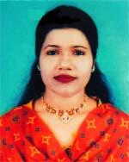 | DR. APARNA BISWAS  F/Name: Amal Kanti Biswas  M/Name: Mrs. Priti Kana Biswas  BM & DC Reg. No: 32490  NID: 4224002107764  Cell: 01919336662  Address: 32, Shamsur Rahman Road, Khulna  Blood Group: B+
590 | Voter No  LM-2900584  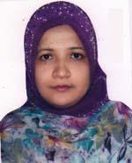 | DR. SABIHA KHATUN CHHABI  F/Name: Md. Abdus Satter Talukder  M/Name: Begum Mamata Yasmin  BM & DC Reg. No: 50956  NID: 2694066782344  Cell: 01717523583  Address: Sagorik 1/D, Officers Quarter BAF-Bas E Motiur, Jessore Cant.  Blood Group: O+
591 | Voter No  LM-2900585  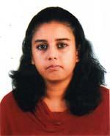 | DR. RAFSANA ROUF  F/Name: Sk. Abdur Rouf  M/Name: Tahamina Rouf  BM & DC Reg. No: 61774  NID: 19882698878414851  Cell: 01712632668  Address: 119/1, West Tutpara Main Road, Khulna  Blood Group: O+
592 | Voter No  LM-2900586 | DR. MANAS SAHA  F/Name: Prof. Dr. Moni Mohan Saha  M/Name: Bina Rani Saha  BM & DC Reg. No: 72484  NID: 19912697556000245  Cell: 01746042084  Address: 4B Rcc Hasan Tower 35 Lower Jessore Road, Khulna-9100  Blood Group: O+
593 | Voter No  LM-2900587  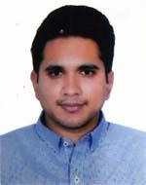 | DR. KAZI IRFAN SUBHAN  F/Name: Prof. Dr. Qazi Hameed Asghar  M/Name: Late Tahmina Tanin Asghar  BM & DC Reg. No: 63119  NID: 4795124433258  Cell: 01711280366  Address: 3/2, Hazi Mohsin Road Khulna.  Blood Group: O+
594 | Voter No  LM-2900588  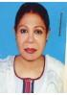 | DR. SHAHEEN NOWROSY  F/Name: Late Shamsur Rahman  M/Name: Late Rashida Begum  BM & DC Reg. No: 4588  NID: 4795128489799  Cell: 01711806637  Address: Dewdrop 21, A.N Das Lane Tutpara, Khulna.  Blood Group: B+
595 | Voter No  LM-2900589  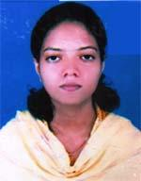 | DR. KALPO SIKDER  F/Name: Nikhil Ranjan Sikder  M/Name: Santwana Rani Mistry  BM & DC Reg. No: 60183  NID: 4798525308502  Cell: 01716620356  Address: 131, Hazi Ismail Road, Banargati, Sonadanga, Khulna  Blood Group: B+
596 | Voter No  LM-2900590  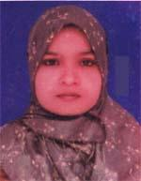 | DR. UMME FATEMA  F/Name: Md. Waliar Rahman Sarder  M/Name: Rehena Pervin  BM & DC Reg. No: 60199  NID: 4798517244160  Cell: 01678748928  Address: Fultala Health Complex, Fultala, Khulna  Blood Group: B+
597 | Voter No  LM-2900591  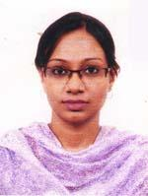 | DR. NAHIN SHAKURUN  F/Name: Md. Nazrul Islam  M/Name: Nasima Islam  BM & DC Reg. No: 60153  NID: 2692848472358  Cell: 01717962918  Address: House-06, Road-08, Block-C, Mirpur, Dhaka.  Blood Group: O+
598 | Voter No  LM-2900592 | DR. DEBNATH TALUKDER  F/Name: Jagunnath Talukder  M/Name: Anjana Talukder  BM & DC Reg. No: 48312  NID: 8198510364767  Cell: 01711972506  Address: 16/B, Modhubag, Moghbazar, Dhaka.  Blood Group: B+
599 | Voter No  LM-2900593 | DR. S. M. TUSHAR ALOM  F/Name: S.m. Tobibur Rahman  M/Name: Rashida Khatun  BM & DC Reg. No: 48364  NID: 19834798516214831  Cell: 01716257552  Address: 32/6, Gramin R/A, Sonadanga, Khulna.  Blood Group: B+
600 | Voter No  LM-2900594 | DR. BISWANATH KUMAR MONDAL  F/Name: Gobinda Lal Mondal  M/Name: Jamuna Rani Mondal  BM & DC Reg. No: 42421  NID: 8710434598057  Cell: 01816889688  Address: Khulna Medical College Hospital, Khulna.  Blood Group: O+
601 | Voter No  LM-2900595  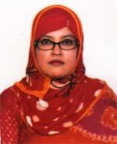 | DR. SHOHANA SELIM  F/Name: Sk. Abu Selim  M/Name: Taslima Selim  BM & DC Reg. No: 50799  NID: 19834798516000035  Cell: 01777888499  Address: 22/1, Choto Boyra Masjid Bari Road, Khulna  Blood Group: A+
602 | Voter No  LM-2900596  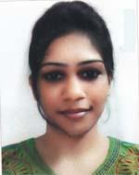 | DR. MST. NAZNEEN NAHAR RINA  F/Name: Md. Golam Sarwar Mia  M/Name: Hasina Khatun  BM & DC Reg. No: 61314  NID: 4798517233101  Cell: 01747821333  Address: Brittee Debi Rajnagor Kacherkol, Soilkupa, Jhenaidah.  Blood Group: O+
603 | Voter No  LM-2900597 | DR. RONY KUMAR BRAHMA  F/Name: Dr. Dilip Kumar Brahma  M/Name: Anima Rani Dey  BM & DC Reg. No: 72944  NID: 6872724809  Cell: 01716108800  Address: 7/2 Sir Iqbal Road, Bi Lane, Khulna-9100  Blood Group: A+
604 | Voter No  LM-2900598  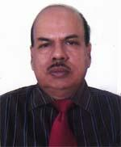 | DR. ARABINDA KUMAR DEY  F/Name: Late Bisweswar Dey  M/Name: Late Hazari Bala Dey  BM & DC Reg. No: 8722  NID: 4794514191733  Cell: 01715448399  Address: Rd No.-13, House No. -161, Boyra, Khulna  Blood Group: A+
605 | Voter No  LM-2900599  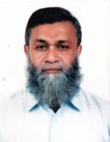 | DR. MD. ABDUL HANNAN  F/Name: Late Alhaj Monsur Ahmed  M/Name: Late Most. Hamida Begum  BM & DC Reg. No: 9237  NID: 4795129496736  Cell: 01717007887  Address: 47/4, Toot Para Central Road, Khulna.  Blood Group: O+
606 | Voter No  LM-2900600  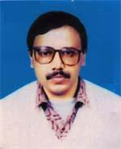 | DR. RAMENDRA NATH BISWAS  F/Name: Late Gurudas Biswas  M/Name: Late Amala Rani Biswas  BM & DC Reg. No: 14535  NID: 4798518267943  Cell: 01914840196  Address: Associate Professor Gazi Medical College, Khulna.  Blood Group: O+
607 | Voter No  LM-2900601 | DR. S. M. TASLIM YUSUF TAMAL  F/Name: S. M. Yusuf Ali  M/Name: Mrs. Rowshan Akhter  BM & DC Reg. No: 64258  NID: 19874798517000025  Cell: 01717527983  Address: 8/1, KDA Approach Road, Sonadanga, Khulna  Blood Group: O+
608 | Voter No  LM-2900602  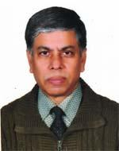 | DR. MD. ABDUL LATIF KHAN  F/Name: Late Abdur Rashid Khan  M/Name: Mst. Shamsun Nahar  BM & DC Reg. No: 13441  NID: 9196209197178  Cell: 01969752317  Address: Pharmacology Dept. Gazi Medical College, Sonadanga, Dhaka.  Blood Group: B+
609 | Voter No  LM-2900603 | DR. MD. LASKAR SHAWKATUZZAMAN  F/Name: Menajaddin Laskar  M/Name: Shaheda Khatum  BM & DC Reg. No: 22759  NID: 2695431008310  Cell: 01714208781  Address: Flat No.-5, Neerchayagithi, Gopibagh, Dhaka-1203  Blood Group: O+
610 | Voter No  LM-2900604  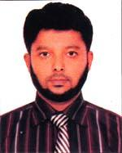 | DR. MD. ROKONUZZAMAN  F/Name: Md. Abdur Razzak  M/Name: Mrs. Rizia Begum  BM & DC Reg. No: 42160  NID: 4716938768200  Cell: 01711149479  Address: Vill+Post-Damodar, Thana-Phultala, Dist-khulna  Blood Group: B+
611 | Voter No  LM-2900605  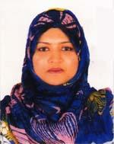 | DR. AMINA JANNAT PEEA  F/Name: Md. Abul Hossain Khan  M/Name: Mrs. Jahanara Hossain  BM & DC Reg. No: 50981  NID: 19852694066782324  Cell: 01949204474  Address: House No. 395, Road No. 03, Athoy, 1st Floor Sonadaga R/A, Phase 2, Khulna  Blood Group: AB+
612 | Voter No  LM-2900606 | DR. NILUFA AKTER  F/Name: Md. Lokman Hossain  M/Name: Rahima Begum  BM & DC Reg. No: 61070  NID: 2613894255575  Cell: 01719991693  Address: 121/1, Hazi Iman Ali Lane Basupara, Khulna.  Blood Group: B+
613 | Voter No  LM-2900607  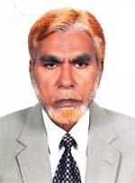 | DR. MD. SHARAFAT HOSSAIN  F/Name: Late Alhay Motizuddin  M/Name: Sharbanu  BM & DC Reg. No: 1577  NID: 4798525312450  Cell: 01711070506  Address: 315, Sher E Bangla Road, Solaiman Nagar, Khulna  Blood Group: O+
614 | Voter No  LM-2900608  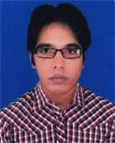 | DR. MD. ABUL HASANAT  F/Name: Md. Munirul Islam  M/Name: Fatema Asma  BM & DC Reg. No: 58832  NID: 3323012538449  Cell: 01965397011  Address: 181, Jinna Road, Islambag, Moheshwarpasha, Daulatpur, Khulna  Blood Group: B+
615 | Voter No  LM-2900609 | DR. FARHANA KARIM  F/Name: Md. Abdul Karim  M/Name: Mrs. Rehana Karim  BM & DC Reg. No: 39684  NID: 2695045913858  Cell: 01711447702  Address: House-179, Road-6,Phase-2, Sonadanga, Khulna.  Blood Group: O+
616 | Voter No  LM-2900610  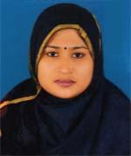 | DR. ISRAT JAHAN  F/Name: Late Khalilur Rahman  M/Name: Mrs. Razia Rahman  BM & DC Reg. No: 50855  NID: 2611038744293  Cell: 01914677111  Address: R-06, H-74, Mosgunni R/A, Boyra, Khalishpur, Khulna-9000  Blood Group: B-
617 | Voter No  LM-2900611  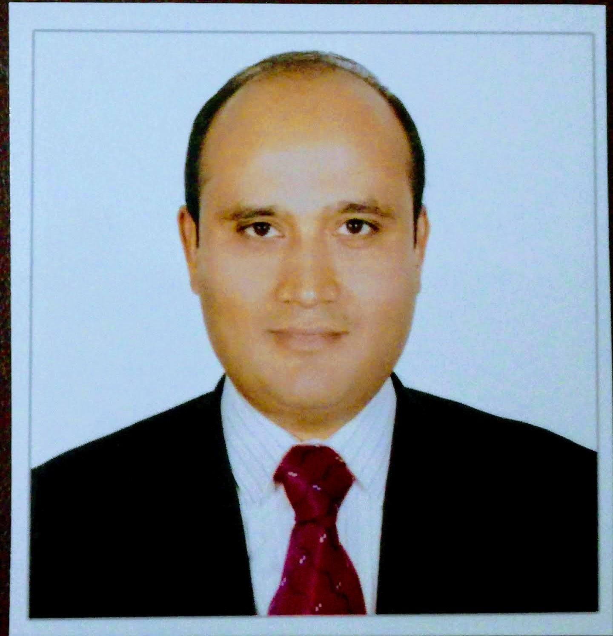 | DR. MD.MUNJUR HOSSAIN  F/Name: Md. Abul Kalam Azad  M/Name: Mrs. Salina Azad  BM & DC Reg. No: 40151  NID: 2611038744292  Cell: 01955916015  Address: R-06, H-74, Mosgunni R/A, Boyra, Khalishpur, Khulna-9000  Blood Group: B+
618 | Voter No  LM-2900612  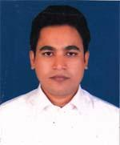 | DR. MD. MIJANUR RAHMAN  F/Name: Md. Sukur Ali Biswas  M/Name: Aleya Begum  BM & DC Reg. No: 48974  NID: 4798516214906  Cell: 01715299443  Address: Zahra Health Point, Fultala Bus Stand, Fultala, Khulna  Blood Group: A+
619 | Voter No  LM-2900613 | DR. MD. AHSANUL HAQUE  F/Name: Md. Tozammel Haque  M/Name: Mrs. Aklima Begum  BM & DC Reg. No: 66078  NID: 19825027906000014  Cell: 01770428092  Address: Army Medical College Jessore.  Blood Group: AB+
620 | Voter No  LM-2900614  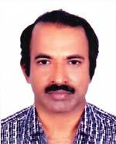 | DR. DIPOK KUMAR SUNYAL  F/Name: Late.dejendro Nath Sunyal  M/Name: Maya Sunayal  BM & DC Reg. No: 19328  NID: 2694812105013  Cell: 01710828796  Address: Flat-127, Meghna Bhaban Mirpur-1, Dhaka-1216  Blood Group: A+
621 | Voter No  LM-2900615  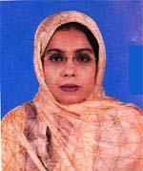 | DR. DILRUBA BULBUL  F/Name: Sk. Sirajur Rahman  M/Name: Sakina Begum  BM & DC Reg. No: 36182  NID: 0120806126073  Cell: 01915797158  Address: 154, Hazi, Inmail road, Metepool, Banorgati, Khulna  Blood Group: B+
622 | Voter No  LM-2900616  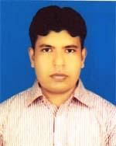 | DR., CHANDAN KUMAR SAHA  F/Name: Manindra Nath Saha  M/Name: Sabita Saha  BM & DC Reg. No: 40365  NID: 2696352214370  Cell: 01712813487  Address: Nasir Garden, 282, Khan Jahan Ali Road, Khuln.  Blood Group: O+
623 | Voter No  LM-2900617  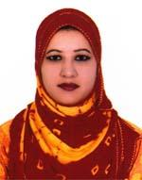 | DR. SADIA AFRIN LOPA  F/Name: Abu Bakar Siddique  M/Name: Rawshon Ara Siddique  BM & DC Reg. No: 68281  NID: 19904798517000384  Cell: 01737984897  Address: 30/9, Suborna mansion, main rosd, Garmeen R/AKDA outer Bipass Road, Sonadanga, Khulna  Blood Group: B+
624 | Voter No  LM-2900618  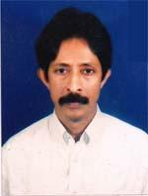 | DR. SK. FARID UDDIN AHMED  F/Name: Sk. Shamsuddin Ahmed  M/Name: Asia Khatun  BM & DC Reg. No: 19468  NID: 4798520287086  Cell: 01711295957  Address: 337, Khan Jahan Ali Road, Khulna  Blood Group: O+
625 | Voter No  LM-2900619 | DR. MD. ROKIBUL ISLAM  F/Name: Md. Iran Ali Sarder  M/Name: Ripa Begum  BM & DC Reg. No: 77233  NID: 3257101240  Cell: 01737956780  Address: 133/5, Khanjahan Ali Road, Khulna.  Blood Group: O+
626 | Voter No  LM-2900620  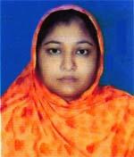 | DR. MORJINA KHANAM  F/Name: Md. Masum Billah  M/Name: Sanoara Begum  BM & DC Reg. No: 64363  NID: 2924703122719  Cell: 01737208003  Address: 133/5, Khanjahan Ali Road, Khulna.  Blood Group: B+
627 | Voter No  LM-2900621 | DR. MD.ABUL KALAM AZAD  F/Name: Mr.abdul Bari Moral  M/Name: Mrs.sokhina Khatun  BM & DC Reg. No: 33088  NID: 8728209246375  Cell: 01715248618  Address: Sir Solimulla Medical College, Dhaka.  Blood Group: A+
628 | Voter No  LM-2900622  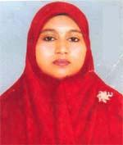 | DR. TASNUVA ISLAM  F/Name: Mohinur Islam  M/Name: Tanjuman Ara Islam  BM & DC Reg. No: 49545  NID: 4798525313271  Cell: 01816454882  Address: 1B, S/S College Link Road, Banargati, Khulna.  Blood Group: B+
629 | Voter No  LM-2900623 | DR. K.M. SHAIFUL ISLAM  F/Name: Late K. M. Rofiquil Islam  M/Name: Sahida Begum  BM & DC Reg. No: 43488  NID: 479852318531  Cell: 01712145269  Address: 119/9 Nirala R/A, Khulna  Blood Group: B+
630 | Voter No  LM-2900624 | DR. SYEDA TAMANNA TANJIL  F/Name: Syed Iqbal Ali  M/Name: Rehana Yasmin  BM & DC Reg. No: 72480  NID: 4795129501328  Cell: 01674731484  Address: 39/1 Hazi Mohsin Road Khulna.  Blood Group: O+
631 | Voter No  LM-2900625  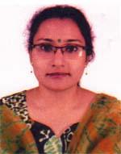 | DR. JOYATI DEVI  F/Name: Kalikinkar Saha  M/Name: Julu Rani Saha  BM & DC Reg. No: 42887  NID: 1325803452995  Cell: 01711476217  Address: 6 No. Fire Brigade Road, Khulna  Blood Group: O+
632 | Voter No  LM-2900626  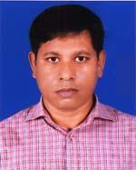 | DR. AJOY KUMAR SAHA  F/Name: Jogesh Chandra Saha  M/Name: Suniti Saha  BM & DC Reg. No: 29005  NID: 1325803452994  Cell: 01711132454  Address: 7, Police Line Passim Goli Khulna.  Blood Group: B+
633 | Voter No  LM-2900627  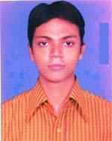 | DR. PALASH KUMAR DEY  F/Name: Sailendra Nath Dey  M/Name: Jharna Dey  BM & DC Reg. No: 51059  NID:  Cell: 01711953385  Address: Khulna Medical College hospital, Surgary Dept, Khulna.  Blood Group: O+
634 | Voter No  LM-2900628  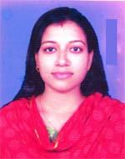 | DR. APARNA ADDYA  F/Name: Robindra Nath Addya  M/Name: Maya Addya  BM & DC Reg. No: 60678  NID:  Cell: 01710615652  Address: A/R, Respiratory Redicere, Khulna Medical College, Hospital  Blood Group: B+
635 | Voter No  LM-2900629  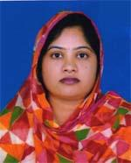 | DR. UMME SALMA  F/Name: Dr. Md. Moksed Ali  M/Name: Anawara Ali  BM & DC Reg. No: 69322  NID: 3323011306039  Cell: 01796581220  Address: 181, Jinna Road, Islambag, Moheshwarpasha, Daulatpur, Khulna  Blood Group: O+
636 | Voter No  LM-2900630  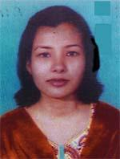 | DR. DILJAHAN NIPA  F/Name: Md. Pizir Uddin Shaikh  M/Name: Rokeya Begum  BM & DC Reg. No: 50196  NID: 19834716976005304  Cell: 01717863048  Address: Vill-Poyaram, post+p.s-Phultala, Dist-Khulna  Blood Group: O+
637 | Voter No  LM-2900631  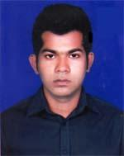 | DR. MOHAMMAD HASAN  F/Name: Late Mohd. Mujibur Rahman  M/Name: Mrs. Salma Khanam  BM & DC Reg. No: 63122  NID: 4794510346410  Cell: 01723095625  Address: Jamatkhana, Ferryghat Khulna.  Blood Group: B+
638 | Voter No  LM-2900632 | DR. GAZI SAFIQUR RAHMAN  F/Name: Gazi Kutub Uddin  M/Name: Mrs. Kulsum Begum  BM & DC Reg. No: 63118  NID: 4798516214705  Cell: 01717418619  Address: 47/2, Gobarchaka 1 No. Cross Road, Khulna  Blood Group: B-
639 | Voter No  LM-2900633 | DR. MD. AL AMINUR ISLAM  F/Name: Md. Monwarul Islam  M/Name: Farida Islam  BM & DC Reg. No: 60198  NID: 4792103038467  Cell: 01912984706  Address: Vill-Maheswarpasha, Deypara, Holding No.-40, Post-Kuet, P.s-Daulatpur, Dist-Khulna  Blood Group: O+
640 | Voter No  LM-2900634 | DR. SHAIKH ABDUL HAMID  F/Name: Late Shawkat Ali  M/Name: Tofa Bibi  BM & DC Reg. No: 77235  NID: 19914798516000277  Cell: 01716779034  Address: 31/22, Doctor Para, Chotoboyra, Sonadanga, Khulna.  Blood Group: O+
641 | Voter No  LM-2900635  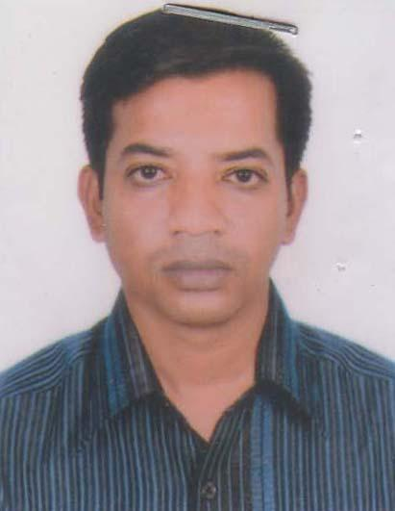 | DR. RAZIB KRISHNA MANDAL  F/Name: Nirmal Chandra Mandal  M/Name: Samita Rani Mandal  BM & DC Reg. No: 47466  NID: 19820126005698232  Cell: 01722-888965  Address: 62/2, A/R Complex Specialised Hospital, Sonadanga, Khulna.  Blood Group: B+
642 | Voter No  LM-2900636  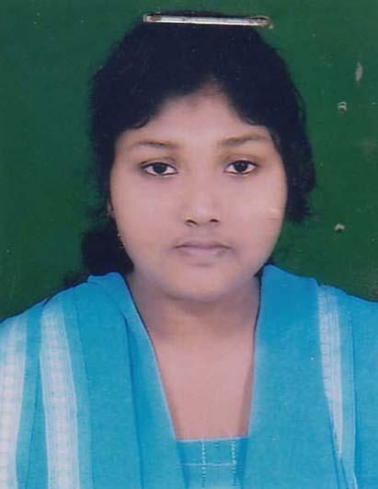 | DR. MAITRY BISWAS  F/Name: Dr. Anil Krishna Biswas  M/Name: Suparna Biswas  BM & DC Reg. No: 79941  NID: 19914795127000161  Cell: 01725351572  Address: 291, Khan Jahan Ali Road, Khulna.  Blood Group: O+
643 | Voter No  LM-2900637  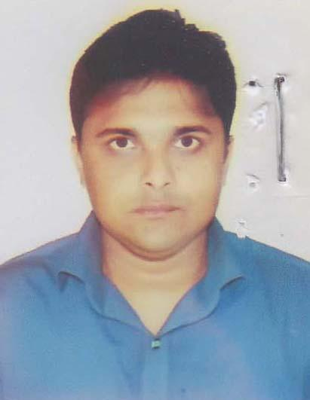 | DR. MITUN KUMAR PAUL  F/Name: Jitendra Nath Paul  M/Name: Minu Rani Paul  BM & DC Reg. No: 59003  NID: 881274710026  Cell: 01689377594  Address: GMC, Sonadanga, Khulna.  Blood Group: B+
644 | Voter No  LM-2900638 | DR. MD. MEHDI HASAN  F/Name: Md. Bazlur Rahman  M/Name: Sadeka Nazneen  BM & DC Reg. No: 70003  NID: 19904795124447445  Cell: 01926694004  Address: 194/ Bagmara Main Road, Khulna.  Blood Group: B+
645 | Voter No  LM-2900639  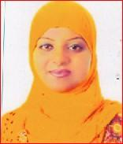 | DR. SUMAYA FARJAN  F/Name: Dr. Md. Lutfur Rahman  M/Name: Yesmina Begum  BM & DC Reg. No: 53864  NID: 8524904042252  Cell: 01816528669  Address: 332, No House, Road - 03, Sonadanga, Phase-2, Khulna.  Blood Group: B+
646 | Voter No  LM-2900640 | DR. NASRIN AKHTER  F/Name: Late Ziaul Hoque  M/Name: Sufia Akhter  BM & DC Reg. No: 42895  NID: 2693624617656  Cell: 01911088996  Address: Assistant Professor, Dept Of Biomedical Engineering, KUET, Khulna.  Blood Group: B+
647 | Voter No  LM-2900641  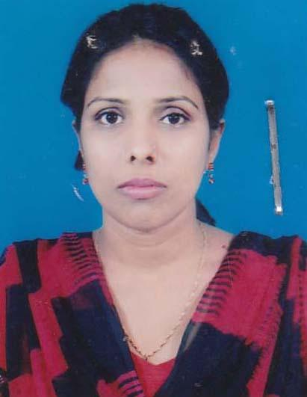 | DR. MUKTA PARVEEN  F/Name: Late Abdur Rashid Sarder  M/Name: Shamsun Nahar  BM & DC Reg. No: 56273  NID: 4794515199768  Cell: 01732220947  Address: Nahar Monjil, 18/Gabtola Road, Khalishpur, Khulna.  Blood Group: B+
648 | Voter No  LM-2900642 | DR. TANIA RAHMAN  F/Name: Md. Tayabur Rahman  M/Name: Taslina Rahman  BM & DC Reg. No: 53298  NID: 4798517227670  Cell: 01717125362  Address: 25, B, K, East Lane, Khulna.  Blood Group: O+
649 | Voter No  LM-2900643 | DR. ROZINA AFROZ  F/Name: J.m.a. Razzak  M/Name: Rebeka Sultana  BM & DC Reg. No: 51819  NID: 19844794512151527  Cell: 01717-721005  Address: R-21, Housing Estate, Khalishpur, Khulna.  Blood Group: B+
650 | Voter No  LM-2900644  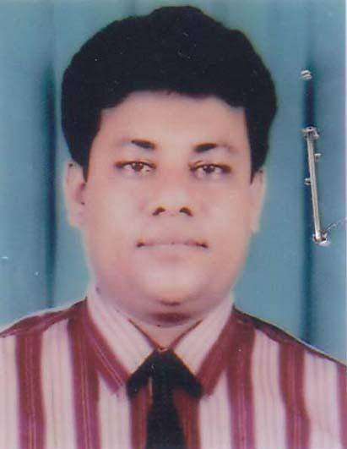 | DR. SWAPAN KUMAR HALDER  F/Name: Pijush Kanti Halder  M/Name: Suhashini Chakroborty  BM & DC Reg. No: 18335  NID: 4795124435108  Cell: 01720002147  Address: 38, Iqbal Nagar Mosjid Road, Iqbal Nagar, Khulna.  Blood Group: O+
651 | Voter No  LM-2900645  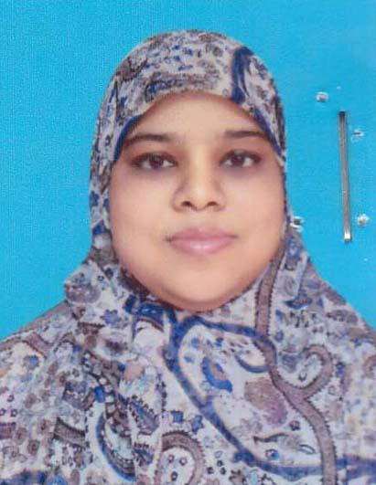 | DR. BADRUN NESSA  F/Name: Md. Abdul Jabber  M/Name: Khadiza Jabber  BM & DC Reg. No: 49740  NID: 4795130528703  Cell: 01715182567  Address: 70/3 Dabir Uddin Lane, Rupsha, Stran Road, Khulna.  Blood Group: O+
652 | Voter No  LM-2900646  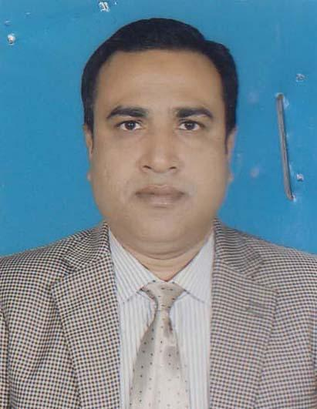 | DR. S.M MAINUL HAQUE  F/Name: M. Abdul Gapur  M/Name: Mrs Momena Khatun  BM & DC Reg. No: 27313  NID: 8728202121331  Cell: 01711170805  Address: Road No. 01, House No: 06, Prantika R/A, Nirala Khulna.  Blood Group: O+
653 | Voter No  LM-2900647  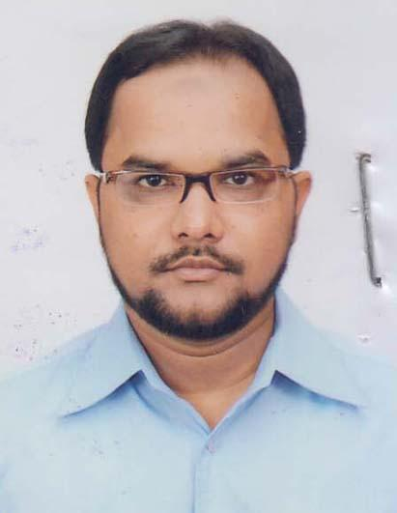 | DR. KAZI SAMIM PARVEZ  F/Name: Kazi Abdur Rakib  M/Name: Shams E Ara  BM & DC Reg. No: 41271  NID: 4716976007949  Cell: 01913198751  Address: Assistant Registar, Gastroaterology, Khulna Medical College Hospital.  Blood Group: O+
654 | Voter No  LM-2900648 | DR. S.M MAHMUDUR RAHMAN RISVI  F/Name: Md. Mizanur Rahman  M/Name: Shahanara Begum  BM & DC Reg. No: 49371  NID: 4110410248408  Cell: 01717582244  Address: Taz House: 4, KDA Approach Road, Shouadanga, Khulna.  Blood Group: B+
655 | Voter No  LM-2900649 | DR. ROWSHON ARA SHAMMI  F/Name: Abdur Rashid Jamader  M/Name: Mrs Momotaz Begum  BM & DC Reg. No: 49370  NID: 4110410248407  Cell: 01710390861  Address: Taz House: 4, KDA Approach Road, Shonadanga, Khulna.  Blood Group: B+
656 | Voter No  LM-2900650  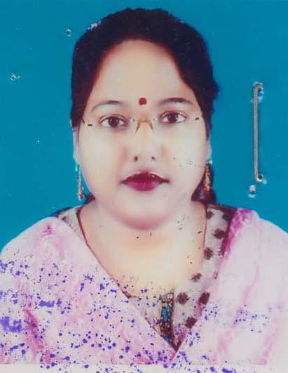 | DR. SABIKUN NAHAR CHOWDHURY  F/Name: A.k.m. Maksudur Rahman Chowdhury  M/Name: Khairul Begum  BM & DC Reg. No: 40774  NID: 19824798516216294  Cell: 01712963614  Address: Khan Tower, 4D South Central Road, Sadar, Khulna.  Blood Group: A+
657 | Voter No  LM-2900651 | DR. MD. NAZRUL ISLAM  F/Name: Anwar Hossain  M/Name: Monoara Begum  BM & DC Reg. No: 40775  NID: 4798526216293  Cell: 01725-497947  Address: Khan Tower, 4D South Central Road, Sadar, Khulna.  Blood Group: O+
658 | Voter No  LM-2900652 | DR. MD. ZAHIRUL HUQ  F/Name: Md. Dabir Uddin Shaikh  M/Name: Motiunnesa  BM & DC Reg. No: 36005  NID: 0110851215733  Cell: 01711006081  Address: 31/4, Doctor Para, Choto Boyra, Khulna.  Blood Group:
659 | Voter No  LM-2900653  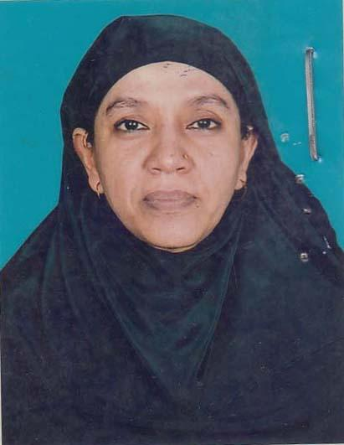 | DR. MOMENA KHATUN  F/Name: M.a. Jalil  M/Name: Sattanun Nahar  BM & DC Reg. No: 15572  NID: 4795129502128  Cell: 01911686838  Address: House No. 474, Road No. 20, Mujgunni Resdential Area, Khulna-9000.  Blood Group:
660 | Voter No  LM-2900654 | DR. ABUL KALAM AZAD  F/Name: S.m. Abdul Wadud  M/Name: Rokeya Begum  BM & DC Reg. No: 8707  NID: 4795129502127  Cell: 01712159150  Address: House No. 474, Road No. 20, Mujgunni Resdential Area, Khulna-9000.  Blood Group: B+
661 | Voter No  LM-2900655  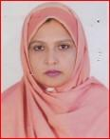 | DR. SADIKA PARVIN  F/Name: Ain Uddin Ahmed  M/Name: Ayesha Khatun  BM & DC Reg. No: 24064  NID: 19694795129000010  Cell: 01767981518  Address: 29, Hazi Muhsin Road, Khulna.  Blood Group: O+
662 | Voter No  LM-2900656 | DR. MD. KHOSRUL ALAM MOLLICK  F/Name: Abdur Razzak Mollick  M/Name: Suraya Begum  BM & DC Reg. No: 22796  NID: 10165479512900007  Cell: 01838458953  Address: 29, Hazi Mohsen Road, Khulna.  Blood Group: O+
663 | Voter No  LM-2900657 | DR. F.M. KHALIDUZZAMAN  F/Name: Fakir Ashraf Uddin  M/Name: Fatema Begum  BM & DC Reg. No: 50688  NID: 19840110886288321  Cell: 01715717968  Address: Vill-Sayedpur, Chulkati Bagerhat  Blood Group: B+
664 | Voter No  LM-2900658 | DR. TANIA AKHTER  F/Name: Ak. Abdur Razzak  M/Name: Rokshana Akhter  BM & DC Reg. No: 45291  NID: 4794519190333  Cell: 01728844879  Address: 110/9 Mugunni R/A, GPO Khulna.  Blood Group: B+
665 | Voter No  LM-2900659 | DR. SADIA AFRIN NITOL  F/Name: Md. Mahfuzur Rahman  M/Name: Mrs. Marzia Akter  BM & DC Reg. No: 69679  NID: 0120801100423  Cell: 01717528114  Address: Vill-Rajapur, R.K. Bari Sadar, Bagerhat  Blood Group: B+
666 | Voter No  LM-2900660 | DR. SHAMPA ROY  F/Name: Hiranmoy Krishna Roy  M/Name: Dali Rani Das  BM & DC Reg. No: 75778  NID: 4795127477384  Cell: 01683787303  Address: 133/4, Bagmara Main Road, Banker\'s Lane, Khulna.  Blood Group: O+
667 | Voter No  LM-2900661 | DR. JAHANARA NAZNIN  F/Name: Shakh Aminuzzaman  M/Name: Alyea Begum  BM & DC Reg. No: 48807  NID: 4122307795080  Cell: 01724716178  Address: 587/1 Showhan Tower, Khanjahan Ali Road, 5th Floor, Maniktola Bus Stand, Khulna.  Blood Group: O+
668 | Voter No  LM-2900662 | DR. SYED TAHERUL ISLAM  F/Name: Syed Mahamad Ali  M/Name: Taslima Begum  BM & DC Reg. No: 44170  NID: 4716919750285  Cell: 01756565786  Address: Gilatola Road, Jahanabad Cantonment, Phultala, Khulna.  Blood Group: B+
669 | Voter No  LM-2900663 | DR. S.M. KAMRUZZAMAN  F/Name: Alhajj A.k.m. Shahjahan Miah  M/Name: Alhajj Mosammat Saleha Khatun  BM & DC Reg. No: 49089  NID: 4798518263960  Cell: 01823887688  Address: 23/6, Hazi Tamij Uddin Road, Banorgati, Sonadanga, Khulna.  Blood Group: B+
670 | Voter No  LM-2900664 | DR. MEHEDI ALAM  F/Name: Jahangir Alam  M/Name: Zabeda Nahar  BM & DC Reg. No: 47525  NID: 9196203121480  Cell: 01749189187  Address: Road-03, House-382, Sonadanga, Khulna.  Blood Group: O+
671 | Voter No  LM-2900665 | DR. ANIRUDHA SARDAR  F/Name: Late Gour Pada Sardar  M/Name: Koushalla Rani Sardar  BM & DC Reg. No: 44642  NID: 19804711784478763  Cell: 01710350450  Address: Vill: Nishan Khali, Post: Batbunia, P.S: Dacope, Dist: Khulna.  Blood Group: B+
672 | Voter No  LM-2900666  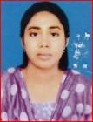 | DR. NIPA RAY  F/Name: Guna Sindhu Ray  M/Name: Kanan Ray  BM & DC Reg. No: 67388  NID: 4711235837589  Cell: 01788656644  Address: Vill: Hatalbunia, Post: Bahaghata Bazar, Thana: Batiaghata, Dist: Khulna.  Blood Group: B+
673 | Voter No  LM-2900667 | DR. BIPPLAB KUMAR DEY  F/Name: Kalipada Dey  M/Name: Sumona Dey  BM & DC Reg. No: 71979  NID: 8714723622039  Cell: 01737957724  Address: House No. 220, RoadNo. 15, Sonadanga Residential (Phase-2), Khulna.  Blood Group: O+
674 | Voter No  LM-2900668 | DR. MD. NURUL HUDA  F/Name: Md. Ali Akbar  M/Name: Most. Mhoshina  BM & DC Reg. No: 62817  NID: 4795127472161  Cell: 01719000407  Address: 31/19, Doctorspara, Chotoboyra, GPO-9000, Sonadanga, Khulna.  Blood Group: O+
675 | Voter No  LM-2900669 | DR. MD. GOLAM MOSTOFA  F/Name: Md. Abdul Barik Sardar  M/Name: Amena Khatun  BM & DC Reg. No: 30787  NID: 1594116380900  Cell: 01732573857  Address: 3/12, Nirala Abasik Khulna.  Blood Group: B+
676 | Voter No  LM-2900670 | DR. MD. SHAHRIAR SHAMIM  F/Name: Md. Shamim Akhter  M/Name: Shahan Ara Begum  BM & DC Reg. No: 63724  NID: 4795124440860  Cell: 01717417190  Address: 5/1, Roy Para Cross Road, Khulna.  Blood Group: B+
677 | Voter No  LM-2900671 | DR. RAMKRISHNA DAS  F/Name: Niranjan Das  M/Name: Mina Das  BM & DC Reg. No: 42134  NID: 2691650475308  Cell: 01712720905  Address: Ortho Surgery Dept. Khulna, Medical College Hospital.  Blood Group: AB+
678 | Voter No  LM-2900672 | DR. MD. NAZRUL ISLAM  F/Name: Munsi Md. Abdus Samad  M/Name: Mrs Sokina Begum  BM & DC Reg. No: 46786  NID: 8524904042482  Cell: 01786213667  Address: R.K. Mission Road Sadar Jessore.  Blood Group: B+
679 | Voter No  LM-2900673  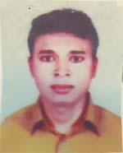 | DR.MANOJ KUMAR MALAKAR  F/Name: Modusudan Malakar  M/Name: Kaushalya Malakar  BM & DC Reg. No: 38785  NID: 2694810975990  Cell: 01715296167  Address: 74, Choto Boyra Main Road, Khulna.  Blood Group: O-
680 | Voter No  LM-2900674  No Image | DR. MAHMUD HOSSAIN KHAN  F/Name: Dr. Ashraf Hossain Khan  M/Name:  BM & DC Reg. No: 14748  NID:  Cell: 01917542827  Address: Senior Consaltant, Chest Clinic, Khulna.  Blood Group: O+
681 | Voter No  LM-2900675  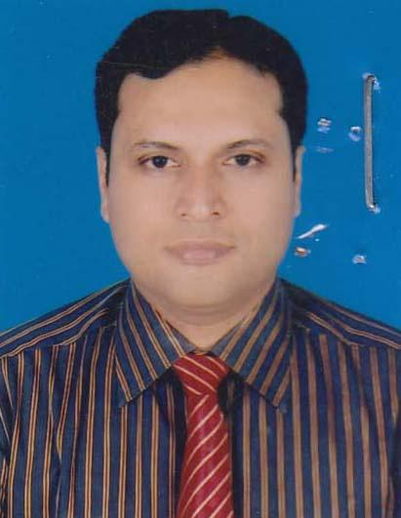 | DR. BISWAJIT MONDAL  F/Name: Sarojit Mondal  M/Name: Anjali Rani Mondal  BM & DC Reg. No: 46821  NID: 4798516214911  Cell: 01743376711  Address: 34, Sonadanga East Lane Khulna.  Blood Group: O+
682 | Voter No  LM-2900676  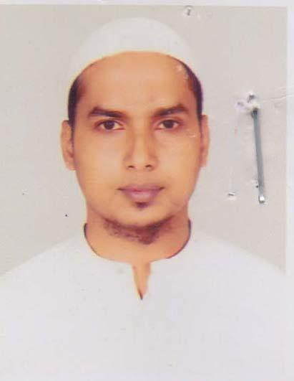 | DR. S.M MOSTOFA QAILYUM  F/Name: S.m Mokbul Hossain  M/Name: Parvin Hossain  BM & DC Reg. No: 58066  NID: 0696111184820  Cell: 01716624197  Address: Mohir Bari Boro Khalpar, South Tootpara, Khulna Sadar, Khulna.  Blood Group: B+
683 | Voter No  LM-2900677  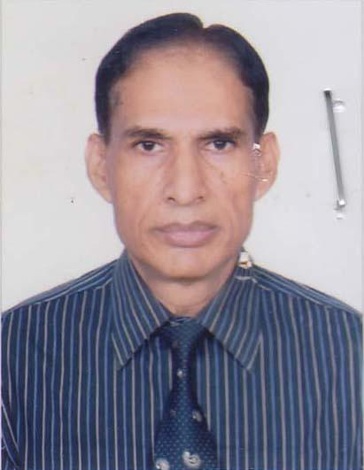 | DR. SK. ANISUR RAHMAN  F/Name: Late Sk Atahar Rahman  M/Name: Late Mst Arfatun Nessa  BM & DC Reg. No: 10037  NID: 19544745124435080  Cell: 01711868467  Address: 33, Iqbal Nagar Mosjid Road, Khulna: 9100.  Blood Group: A+
684 | Voter No  LM-2900678 | DR. SHAIKH MD. JAKARIA  F/Name: Shaikh Md. Siddique Ali  M/Name: Salma Parvin  BM & DC Reg. No: 37716  NID: 0113484143381  Cell: 01913-821368  Address: Khulna Medical College Hospital, Khulna.  Blood Group: A+
685 | Voter No  LM-2900679  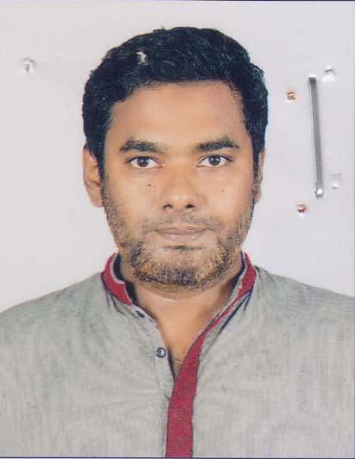 | DR. SHAH MURADUR RAHMAN  F/Name: Late Shah Fazlar Rahman  M/Name: Late Habiba Begum  BM & DC Reg. No: 35382  NID: 4795121396990  Cell: 01711279461  Address: 660, Khan-A Sabur Road, Charabati, Upper Jessore Road, Khulna.  Blood Group: A+
686 | Voter No  LM-2900680 | MD MAKSUDE MOWLA  F/Name: Abul Fatah Md Abdur Rob  M/Name: Farida Begum  BM & DC Reg. No: 73089  NID: 4798516226919  Cell: 01941234070  Address: 92/3, West Baniakhamar, sonadanga, Khulna.  Blood Group: A+
687 | Voter No  LM-2900681  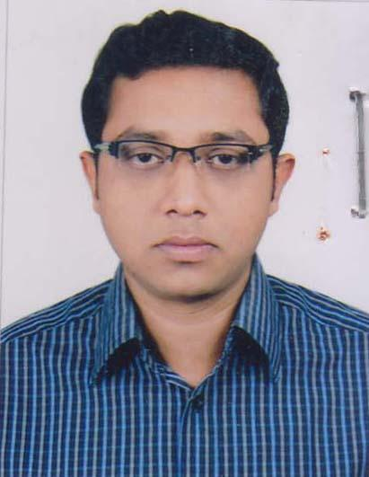 | DR. A.M FOYSAL MOSTOFA  F/Name: A.m. Mostofa Zaman  M/Name: Jesmin Ara Khanom  BM & DC Reg. No: 73569  NID: 19904795127000182  Cell: 01779610615  Address: 290/3, Venous Tower, Sher-E-Bangla Road, Khulna.  Blood Group: B+
688 | Voter No  LM-2900682  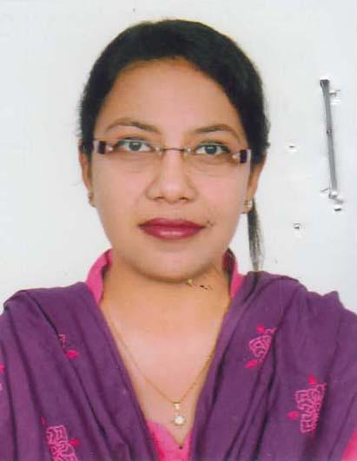 | DR. MEHNAZ HAQUE  F/Name: Md. Jahurul Haque  M/Name: Arifun Nahar  BM & DC Reg. No: 71659  NID: 19914795124000150  Cell: 01725459207  Address: Road No.1, House No: 179, Nirala, R/A,Khulna.  Blood Group: A+
689 | Voter No  LM-2900683  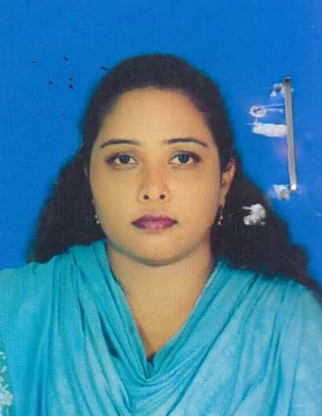 | DR. MOUMITA DUTTA  F/Name: Dutta Chittaranjan  M/Name: Rita Dutta  BM & DC Reg. No: 76365  NID: 19904716483000089  Cell: 01739966997  Address: Vill: Bowanipur, Post: Banka Bhowanipur, Upz: Paikgacha, Dist: Khulna.  Blood Group: B+
690 | Voter No  LM-2900684  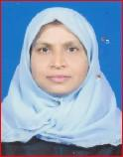 | DR. JIBAN NESA  F/Name: A. Rab  M/Name: Anowara Begum  BM & DC Reg. No: 29454  NID: 4798517239060  Cell: 01711954020  Address: 155, M.A Bari Sarak, Gollamali, Khulna.  Blood Group: A+
691 | Voter No  LM-2900685 | DR. SHAMOL KUMAR PAUL  F/Name: Haripada Paul  M/Name: Juthaika Rani Paul  BM & DC Reg. No: 37202  NID: 6850161784  Cell: 01712102423  Address: 115/6, Thana Road, Sonadanga, Khulna.  Blood Group: O+
692 | Voter No  LM-2900686 | DR. S.M. MANOARUL ISLAM  F/Name: Abdul Aziz Sarder  M/Name: Rabeya Begum  BM & DC Reg. No: 36567  NID: 4713013278910  Cell: 01716232665  Address: 7/E Jalil Saroni, Intron 7 PMG Office Boyra, Khulna.  Blood Group: B+
693 | Voter No  LM-2900687  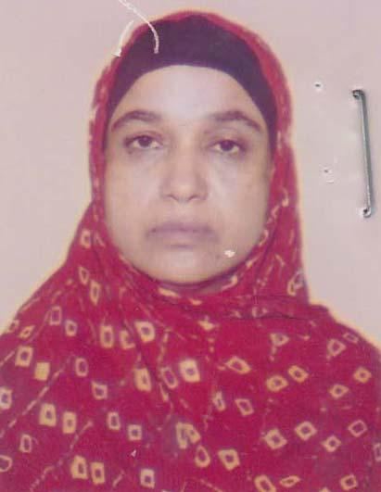 | DR. SUFIA KHATUN  F/Name: Late S.k. Younus Ali  M/Name: Late Hasina Begum  BM & DC Reg. No: 14202  NID: 4714075283671  Cell: 01716495799  Address: Post Health Officer, Khalishpur Mongla (Chalua), Khulna.  Blood Group: O+
694 | Voter No  LM-2900688  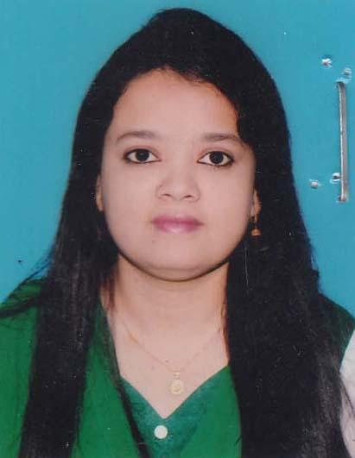 | DR. TONIMA RAHMAN  F/Name: Md. Kohinur Rahman  M/Name: Monoara Begum  BM & DC Reg. No: 79306  NID: 19916527606000044  Cell: 01741420072  Address: 44/3 Shamsur Rahman Road, Khulna.  Blood Group: B+
695 | Voter No  LM-2900689  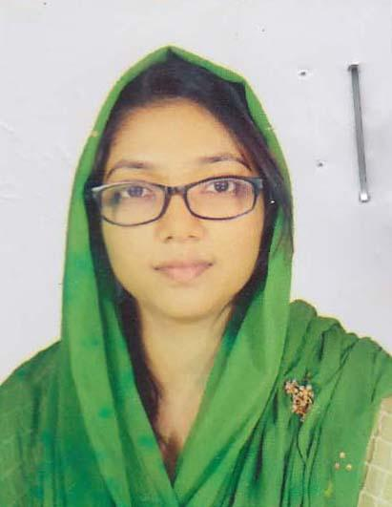 | DR. JANNATUN NAYM  F/Name: Manjur Ashraf  M/Name: Sharmin Ashraf  BM & DC Reg. No: 78995  NID:  Cell: 01758004323  Address: House No: 27, Road No: 102, Khalishpur, Khulna.  Blood Group: O+
696 | Voter No  LM-2900690 | DR. MITHUN BAHADUR  F/Name: Ram Pada Bahadur  M/Name: Rina Rani Bahadur  BM & DC Reg. No: 70740  NID: 19904715311000284  Cell: 01915948871  Address: A. 19-21, Mazid Sarani, Sonadanga, Khulna Gazi Medical College.  Blood Group: O+
697 | Voter No  LM-2900691  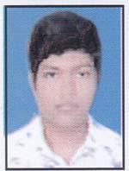 | DR. MD. RAKIB HASAN  F/Name: S.m. Ruhul Amin  M/Name: Mrs. Karimun Nesa  BM & DC Reg. No: 82181  NID: 19934798516000216  Cell: 01924333303  Address: 12/5(Ka) Boro Mirzapur, Yousuf row Road, Khulna.  Blood Group: A+
698 | Voter No  LM-2900692 | DR. JANNATUL MYMONA ALI  F/Name: Md. Moslem Ali  M/Name: Afroza Ali  BM & DC Reg. No: 71445  NID: 19904795124000223  Cell: 01712850993  Address: 161, Balimara Main Road, Khulna.  Blood Group: O+
699 | Voter No  LM-2900693  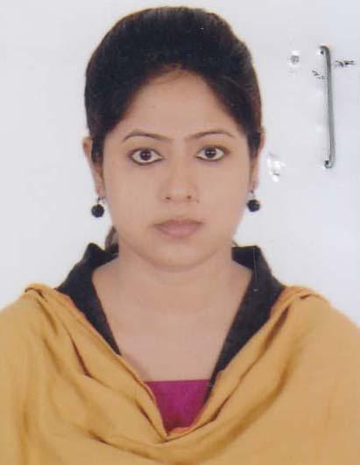 | DR. SUMSAD SULTANA  F/Name: Md. Hasan UZ Zaman  M/Name: Monnujan  BM & DC Reg. No: 59293  NID: 8198510364105  Cell: 01752506987  Address: 171/11(Gha), 4No Kasem Nagar Sarok, Gollamari, Khulna.  Blood Group: O+
700 | Voter No  LM-2900694  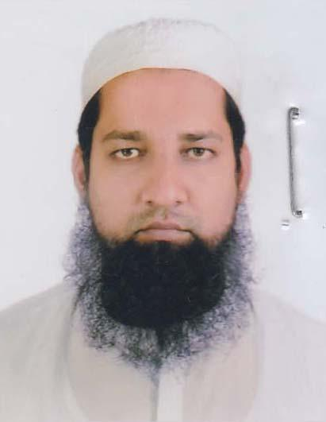 | DR. FAISAL MOHAMMAD ARIFUL ISLAM  F/Name: Mohammad Rafiqul Islam  M/Name: Feroza Parvin  BM & DC Reg. No: 50341  NID: 4600448551  Cell: 01915200144  Address: Jabdipur, KUET School Pocket Gate, Khulna.  Blood Group: O+
701 | Voter No  LM-2900695  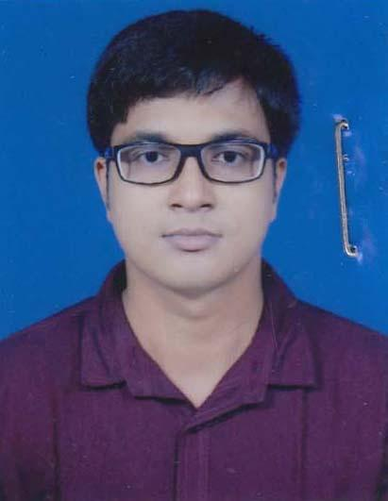 | DR. S.M. MASUM BILLAH  F/Name: S.m. Abdus Salam  M/Name: Mokunda Salam  BM & DC Reg. No: 75267  NID: 3738536030  Cell: 01917601020  Address: 44/13, Hazi Tmij Uddin Lane, Sonadanga, Khulna.  Blood Group: O+
702 | Voter No  LM-2900696  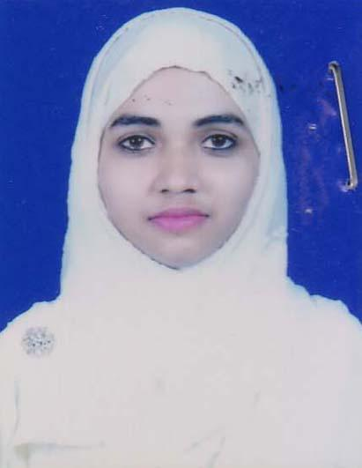 | DR. REHNUMA TABASSUM TIMU  F/Name: Md. Mas U Dur Rahman  M/Name: Kaniz Fatima  BM & DC Reg. No: 75269  NID: 19904798517000377  Cell: 01675723400  Address: 44/13, Haji Tamij Uddin Lane, Sonadanga, Khulna.  Blood Group: AB+
703 | Voter No  LM-2900697  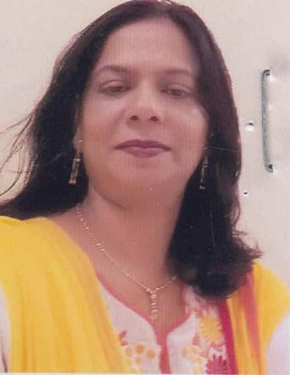 | DR. NARGIS MONJURA AFROZ  F/Name: Noor Mohammad Zamader  M/Name: Soyeba Begum  BM & DC Reg. No: 33113  NID: 4794507100819  Cell: 01724537310  Address: 32, Sahapara, Moheshwaspasha, Daulatar, Khulna.  Blood Group: O+
704 | Voter No  LM-2900698 | DR. SARBOJIT ANWAR KAMAL  F/Name: Md. Mawla Baksh  M/Name: Mrs. Rashida Begum  BM & DC Reg. No: 23340  NID: 3271620878  Cell: 01718180926  Address: Jhorvanga, sachibunia Batiaghata, Khulna.  Blood Group: A+
705 | Voter No  LM-2900699  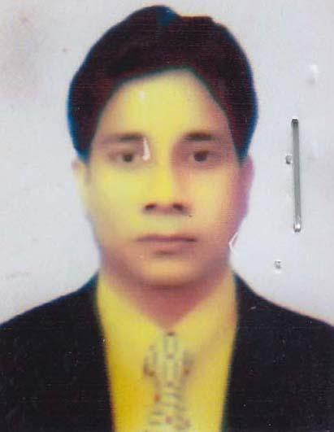 | DR. NAWSHAD MUHAMMAD WAHIDUR RAHMAN  F/Name: Md. Altafur Rahman  M/Name: Nazma Begum  BM & DC Reg. No: 39787  NID: 2696352224716  Cell: 01816736995  Address: 25/1, Kadir Khan Road, Banarghat, Khulna.  Blood Group: A+
706 | Voter No  LM-2900700  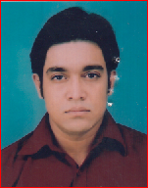 | DR. ZOBAIR RIAL  F/Name: Md. Abdul Aziz  M/Name: Mrs. Shahana Parvin  BM & DC Reg. No: 69922  NID: 19934798516000216  Cell: 01717-386477  Address: Mirerdanga, K.D.A.Residential Area, Robsaruni Road, Mirerdanga, Khulna.  Blood Group: B+
707 | Voter No  LM-2900701  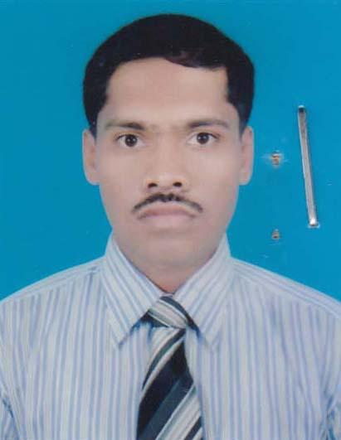 | DR. ANANDA DYUTI HIRA  F/Name: Kanu Krishna Hira  M/Name: Juthika Hira  BM & DC Reg. No: 52433  NID: 4711235838006  Cell: 01715146145  Address: Vill: Hetalbunia P.O&Thana: Batiaghata, Dist: Khulna.  Blood Group: O+
708 | Voter No  LM-2900702  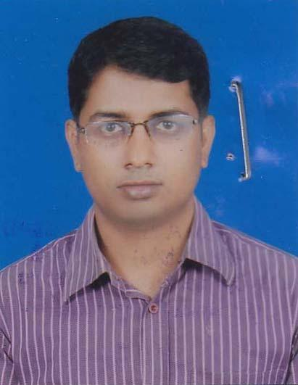 | DR. MD. JIAUR RAHMAN  F/Name: Md. Ruhul Amin  M/Name: Soburunnesa  BM & DC Reg. No: 63124  NID: 4798516214515  Cell: 01717893595  Address: Road : 12, House: 149, Muzgunni R/A, Khauspur, Khulna.  Blood Group: B+
709 | Voter No  LM-2900703  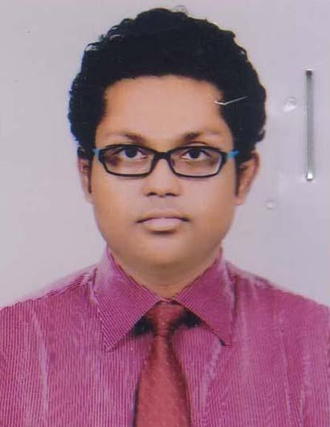 | DR. MD ASHEKULLAH  F/Name: A.m. Ahmedullah  M/Name: Rowshon Ara Khatun  BM & DC Reg. No: 62601  NID: 7324299986  Cell: 01714003737  Address: 28/1, Hazibag Maszid Lane, Tootpara, Khulna.  Blood Group: B+
710 | Voter No  LM-2900704  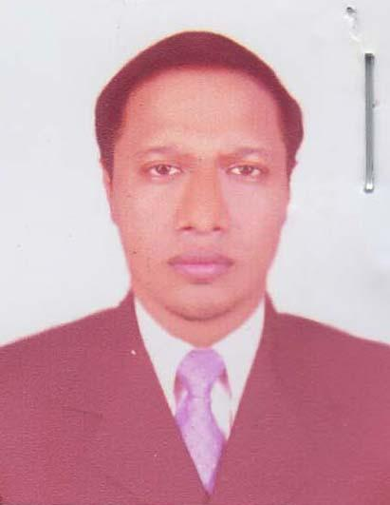 | DR. MD. MOSTOFA AL MAMUN  F/Name: Md. Abdul Jabber  M/Name: Mrs. Rizia Khatun  BM & DC Reg. No: 30676  NID: 19748728201000002  Cell: 01926737790  Address: House 307, Road 1, Sonadanga, Abesikfse , Khulna  Blood Group: O+
711 | Voter No  LM-2900705  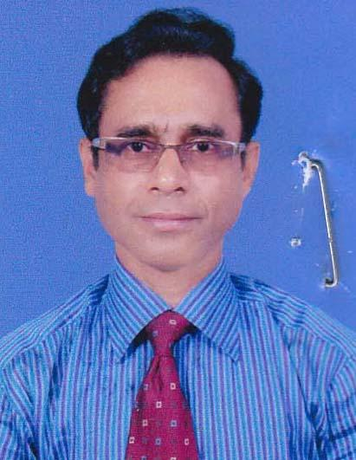 | DR. SUTANU KUMAR MONDAL  F/Name: Late Hazari Lal Mondal  M/Name: Late Urmila Mondal  BM & DC Reg. No: 25542  NID: 4798516214879  Cell: 01711144213  Address: Associate Professole, ENT Khulna Medical College.  Blood Group: O+
712 | Voter No  LM-2900706  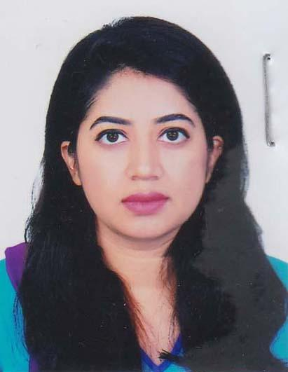 | DR. GAZI TANZINA MEHNAZ  F/Name: DR. Gazi Mizanur Rahman  M/Name: Tania Rahman  BM & DC Reg. No: 82084  NID: 1989-08-16  Cell: 01713403052  Address: A 19-21 Mazid Sarani Sonadanga,Khulna-9100.  Blood Group: O+
713 | Voter No  LM-2900707  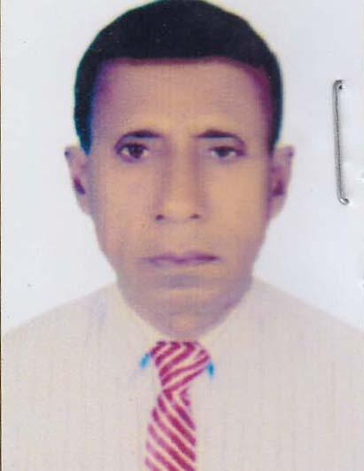 | DR. MANOSANTOSH MALLICK  F/Name: Late Anil Kumar Mallick  M/Name: Late Nilima Rani Mallick  BM & DC Reg. No: 9351  NID: 6527605110054  Cell: 01725991714  Address: Gazi Medical College, Khulna.  Blood Group: B+
714 | Voter No  LM-2900708 | DR. MD. KAMAL UDDIN  F/Name: Md. Abdul Quddus  M/Name: Late Johora Begum  BM & DC Reg. No: 61048  NID: 8235515288  Cell: 01777-638307  Address: KUET Medical Centre, KUET, Khulna.  Blood Group: O+
715 | Voter No  LM-2900709  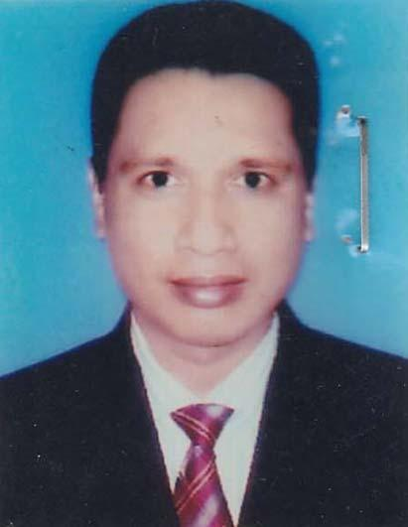 | DR. SM. MONIRUL ISLAM  F/Name: Md. Takim Uddin  M/Name: Mrs. Amonwara Begum  BM & DC Reg. No: 25311  NID: 6421763571  Cell: 01684514041  Address: Khulna Shishu Hospital.  Blood Group: O+
716 | Voter No  LM-2900710  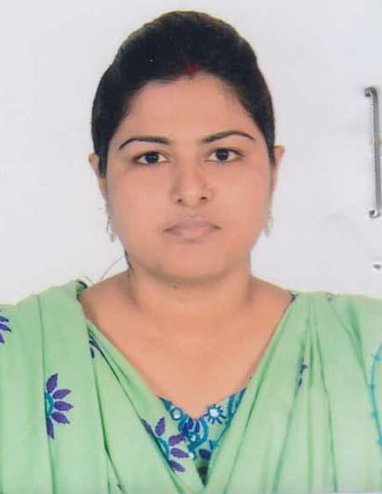 | DR. SATABDI SEN  F/Name: Milon Kumar Sen  M/Name: Rekha Sen  BM & DC Reg. No: 70300  NID: 7331302229  Cell: 01715285220  Address: Gazi Medical College, Khulna.  Blood Group: AB+
717 | Voter No  LM-2900711  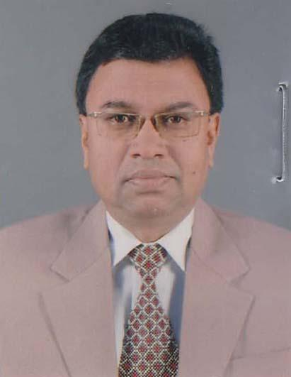 | DR. SULTAN HAFIZ SELIM  F/Name: Shamsur Rahman  M/Name: Rashida Begum  BM & DC Reg. No: 9441  NID: 4798519174971  Cell: 01711299444  Address: 53, KDA Avenue Khulna..  Blood Group: B+
718 | Voter No  LM-2900712  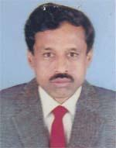 | DR. UDAY BARAN MONDAL  F/Name: Sannyashi Kumar Mondal  M/Name: Hemlate Mondal  BM & DC Reg. No: 15960  NID: 0117377653530  Cell: 01820-531188  Address: Choto-Bayra-Sasanghat, Khulna.  Blood Group: B+
719 | Voter No  LM-2900713  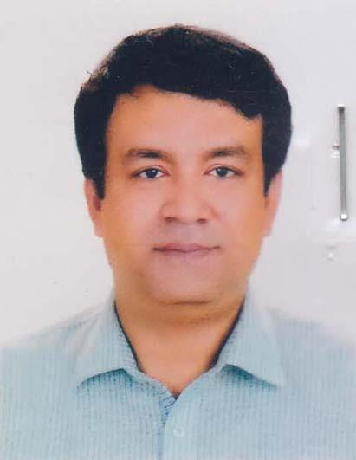 | DR. SYED AHSAN REZVI  F/Name: A.k.m Ahsanul Haque  M/Name: Mrs. Rehana Haque  BM & DC Reg. No: 35123  NID: 1935259984  Cell: 01715002700  Address: 69/1, Baro Boyra, Madhapara, Masjid Road, Thana: Khalishpur, Khulna-9000.  Blood Group: O+
720 | Voter No  LM-2900714  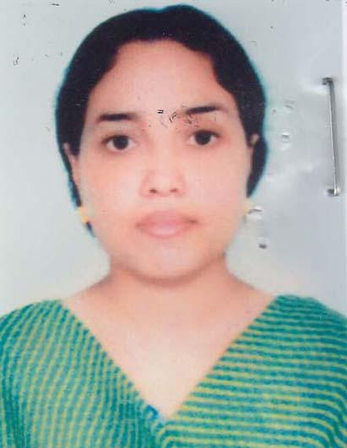 | DR. FARHANA PERVIN  F/Name: Md. Monowarul Islam  M/Name: Shahanima Khanam  BM & DC Reg. No: 37747  NID: 4124704049944  Cell: 01912195845  Address: Asst. Prof. Pharmacology Dept. Khulna Medical College.  Blood Group: B+
721 | Voter No  LM-2900715  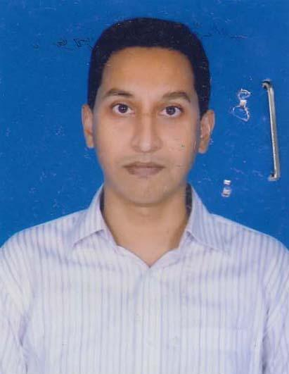 | DR. MIJANUR RAHMAN SARDAR  F/Name: Nazimuddin Sadar  M/Name: Shahaniona Khanam  BM & DC Reg. No: 35929  NID: 41247040499453  Cell: 01912195844  Address: Asst. Prof. Physiology Dept, Khulna Medical College.  Blood Group: B+
722 | Voter No  LM-2900716  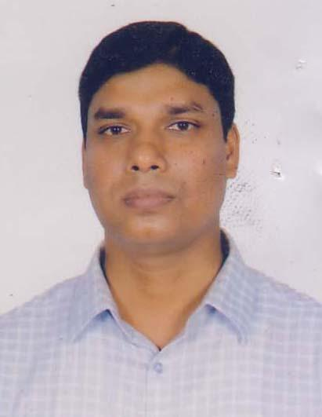 | DR. PRITISH TARAFDER  F/Name: Dayal Chandra Tarafder  M/Name: Sadhona Rani Tarafder  BM & DC Reg. No: 36784  NID: 1976471128387766  Cell: 01712154015  Address: 115/4, Sonadanga Thana Road, Khulna.  Blood Group: B+
723 | Voter No  LM-2900717  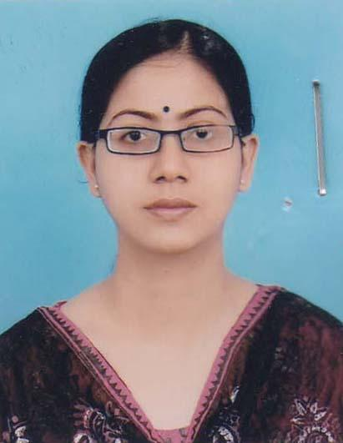 | DR. MOUTUSI SOROWAR  F/Name: Gazi Golam Sorowar  M/Name: Jahanara Sorowar  BM & DC Reg. No: 43288  NID: 2695041731500  Cell: 01717001819  Address: \"Gazi Bari\" 12, Gollamari North Khal Bank Road, Bosupara, Khulna.  Blood Group: B+
724 | Voter No  LM-2900718  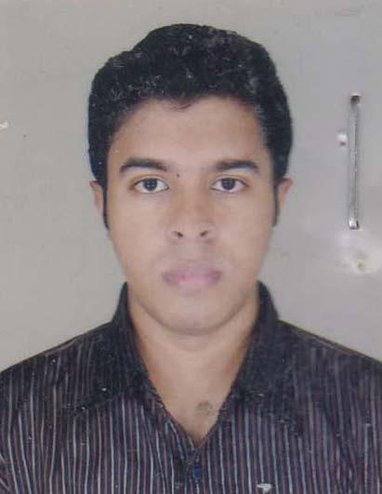 | DR. MITHUN KUMAR PAUL  F/Name: Narayan Chandra Paul  M/Name: Nilima Rani Paulo  BM & DC Reg. No: 63120  NID: 19894795124454570  Cell: 01772473424  Address: 15/1 Zahidur Rahman Cross Road, Bhagmara, Tetultola, Khulna.  Blood Group: O+
725 | Voter No  LM-2900719  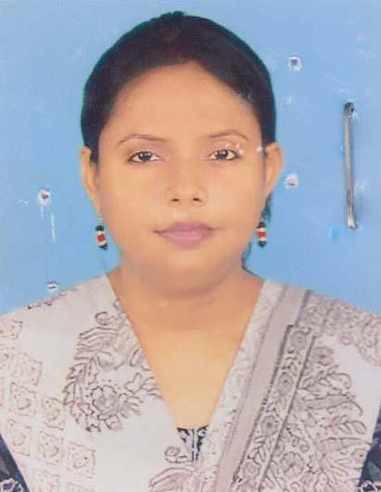 | DR. MANIKA RANI SAHA  F/Name: Nagendra Nath Saha  M/Name: Bina Pani Saha  BM & DC Reg. No: 38474  NID: 4150176909  Cell: 01711488125  Address: Sonadanga R/A, H/No. 358, R/No. 02, Sonadanga, Khulna.  Blood Group: O+
726 | Voter No  LM-2900720 | DR. PUJA PRIANKA DUTTA  F/Name: Pijush Kanti Dutta  M/Name: Lily Biswas  BM & DC Reg. No: 73368  NID: 19912691615000313  Cell: 01756995736  Address: 20, Kader Khan Road, Banorgati, Khulna.  Blood Group: O+
727 | Voter No  LM-2900721  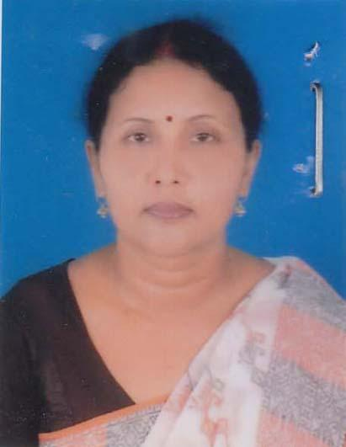 | DR. CHHABI RANI DAS  F/Name: Late Anil Kumar Das  M/Name: Mukul Rani Das  BM & DC Reg. No: 20333  NID: 8192214344860  Cell: 01711810804  Address: Koyra 1, Madinabad Koyra, Khulna.  Blood Group: B+
728 | Voter No  LM-2900722  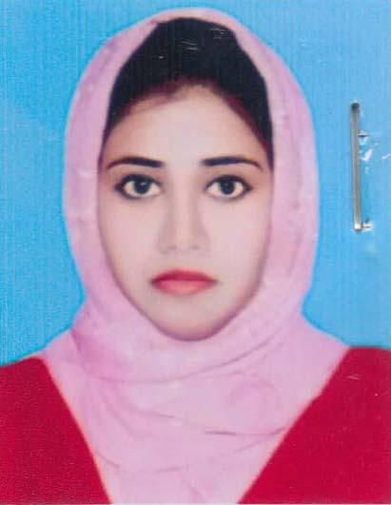 | DR. FAHREEN FATMEE JAHAN  F/Name: Salahuddin Ahmed  M/Name: Rowshnara Ahmed  BM & DC Reg. No: 83854  NID: 8215870175  Cell: 017389654562  Address: 3/5, Hazi Ismail Road, Basupara, Khulna.  Blood Group: A+
729 | Voter No  LM-2900723  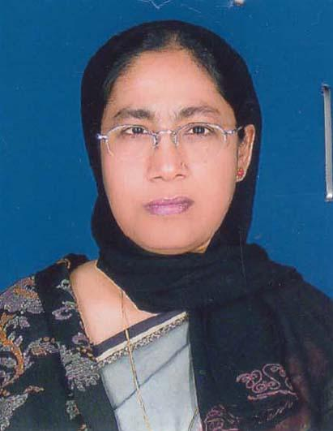 | DR. SHELINA KHATUN  F/Name: Late Gazi Golam Sarwar  M/Name: Jahanara Begum  BM & DC Reg. No: 17200  NID: 4621564253  Cell: 01717251150  Address: House No: H-E4, Road No. 28, Nirala R/A, Khulna.  Blood Group: O+
730 | Voter No  LM-2900724  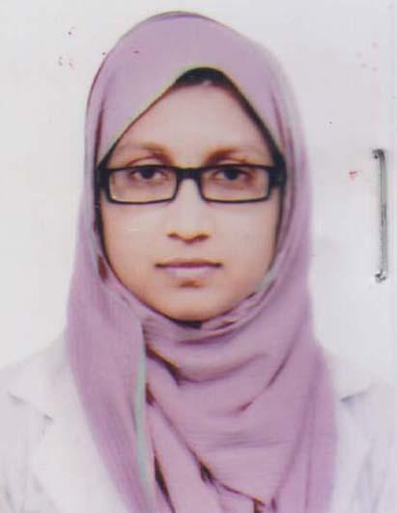 | DR. RUBYA AKTHER  F/Name: Rajib Ali Sardar  M/Name: Salina Akther  BM & DC Reg. No: 85848  NID: 5953233037  Cell: 01784212337  Address: 106, Sultan Ahmed Road, Khulna.  Blood Group: B+
731 | Voter No  LM-2900725  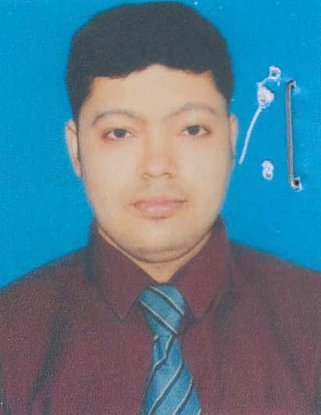 | DR. MOLOY MOLLICK  F/Name: Shibu Pada Mollick  M/Name: Protima Mollick  BM & DC Reg. No: 71437  NID: 19904798516000312  Cell: 01753016803  Address: Room-203, Building-3c, Staff Quarter, Khulna Medical College, Sonadanga, Khulna.  Blood Group: AB+
732 | Voter No  LM-2900726  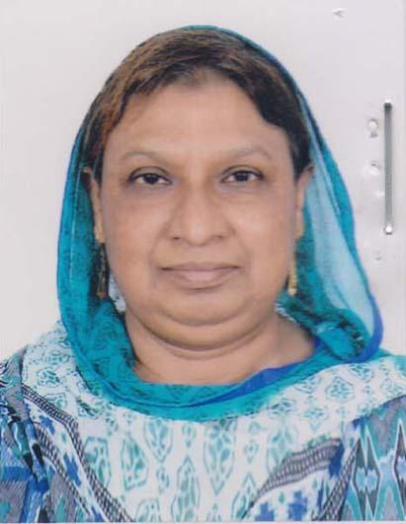 | DR. ROWSHON ARA KHATUN  F/Name: Md. Yousuf Ali Sardar  M/Name: Mrs Morium Begum  BM & DC Reg. No: 12668  NID: 7355381182  Cell: 01960019006  Address: 348/5, Khanjahan Ali Road, Khulna, Akij Medical Hospital, Khulna.  Blood Group: B+
733 | Voter No  LM-2900727  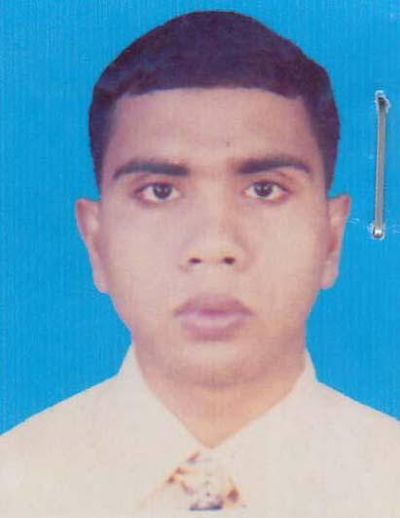 | DR. SIKDER MAHFUZUR RAHMAN  F/Name: Sikder Hafizur Rahman  M/Name: Rahila Khatun  BM & DC Reg. No: 71473  NID: 19852690815000029  Cell: 01966630030  Address: Vill: Rajpat, Post&Thana: Fakirhat, Bagerhat.  Blood Group: B+
734 | Voter No  LM-2900728  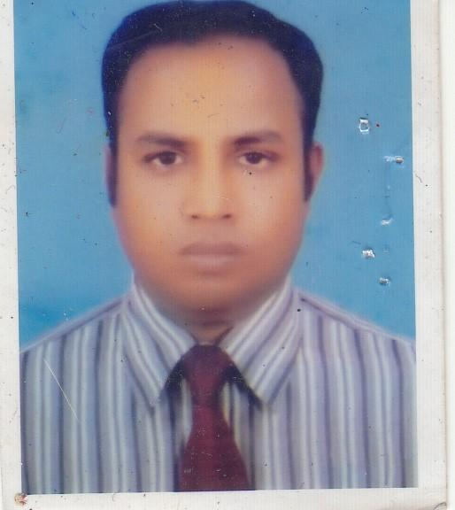 | DR. MD. SHAHIDUL ISLAM  F/Name: Shfidduin Ahmed  M/Name: Mrs. Monowara Khatun  BM & DC Reg. No: 34461  NID:  Cell: 01711-787624  Address: Junior Consultant (Surgery) Shahid Sheikh Abu Naser Hospitaal Khulna.  Blood Group: O+
735 | Voter No  LM-2900729  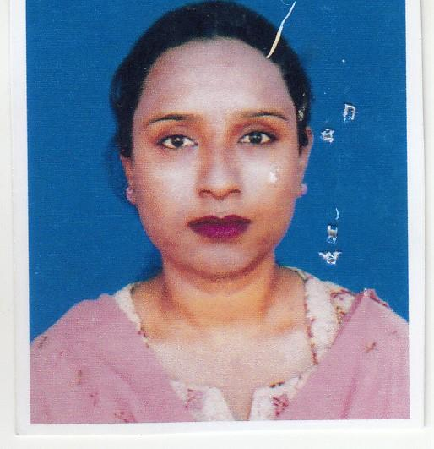 | DR. MITHEEL IBNA ISLAM  F/Name: Md.rafiqul Islam  M/Name: Mrs. Farida Yeasmin  BM & DC Reg. No: 42130  NID:  Cell: 01711-054371  Address: 189/8, Soburer Mor, Mujgunni Boyra, Khulna  Blood Group: O-
736 | Voter No  LM-2900730  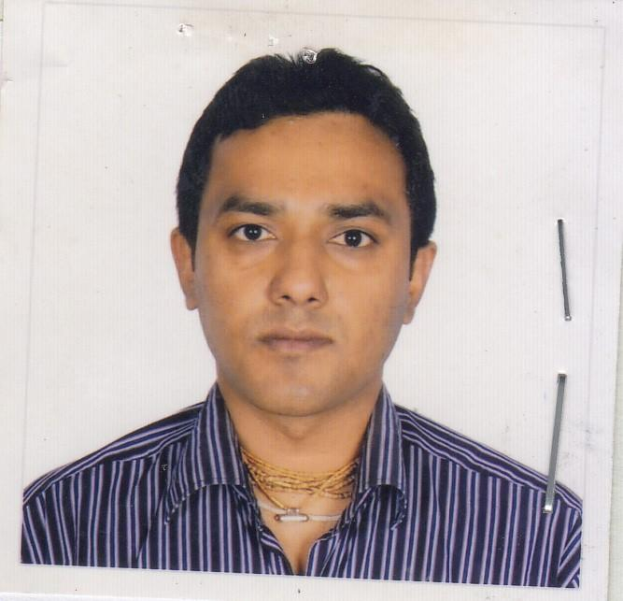 | DR. LITON DHALI  F/Name: Lolit Mohan Dhali  M/Name: Basanti Rani Dhali  BM & DC Reg. No: 55003  NID:  Cell: 01717-527879  Address: Vill-Moubhoge, Po-Mansha Ps-Fakirhat, Bagerhat.  Blood Group: B+
737 | Voter No  LM-2900731  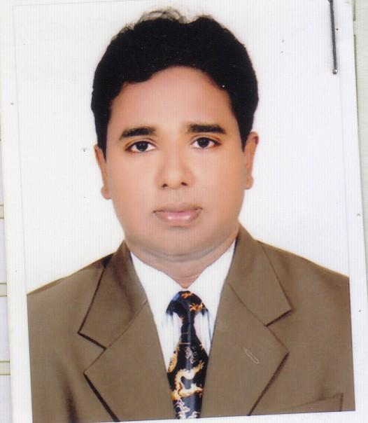 | DR. SHEIKH MOHAMMAD SOHELUL ALAM  F/Name: Sheikh Md. Shamsher Ali  M/Name: Jahura Begum  BM & DC Reg. No: 1306  NID:  Cell: 01711-340408  Address: Medical Center Khulna University, Khulna.  Blood Group: B+
738 | Voter No  LM-2900732  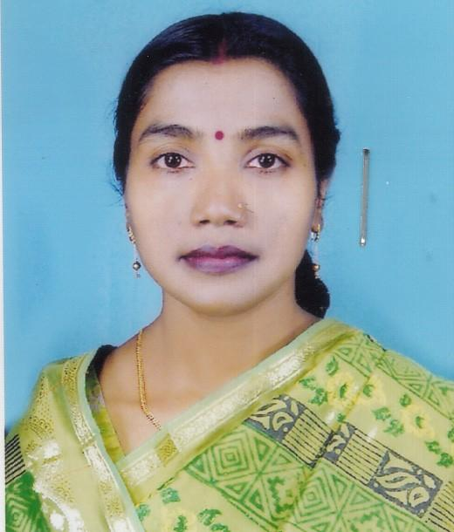 | DR. ANAMIKA BISWAS  F/Name: Kalipada Biswas  M/Name: Shandha Rani Biswas  BM & DC Reg. No: 43273  NID: 4711271833417  Cell: 01727-022904  Address: 47, South Central Road (P.D.S), Khulna.  Blood Group: B+
739 | Voter No  LM-2900733  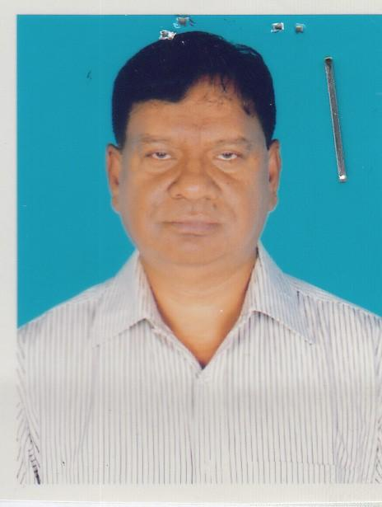 | DR. SK. AMZED HOSSAIN  F/Name: Sk. Akram Hossain  M/Name: Late- Asia Begum  BM & DC Reg. No: 16946  NID:  Cell: 01751-941002  Address: House-33, Old jessore Road Khalishpur, Khulna.  Blood Group: A+
740 | Voter No  LM-2900734  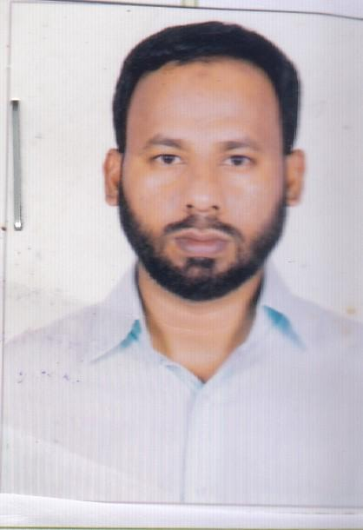 | DR. SM. IKBAL KABIR ( RAJU )  F/Name: S. M. Shahiduzzaman  M/Name: Rema Sultani  BM & DC Reg. No: 57935  NID:  Cell: 01722-018036  Address: Vill-Baruna, Po-Baruna Bazar PS-Dumuria, Khulna.  Blood Group: O-
741 | Voter No  LM-2900735  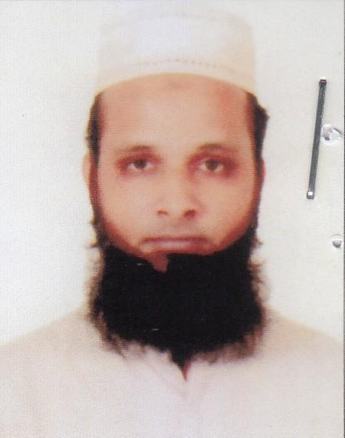 | DR. MD. ABDULLAH AL MAMUN  F/Name: Md. Abdul Latif  M/Name: Mrs. Mariam Begum  BM & DC Reg. No: 58749  NID:  Cell: 01710-779498  Address: Vill-Kazirchr, PO-Char Commissioner, Muladi, Barisal.  Blood Group: B+
742 | Voter No  LM-2900736 | DR. MD. MISQATUS SALEHEEN  F/Name: M.m.anisur Rahman  M/Name: Begum Nurun Nahar  BM & DC Reg. No: 59400  NID:  Cell: 01681-249917  Address: 64, Shamsur Rahaman Road, Khulna.  Blood Group: O+
743 | Voter No  LM-2900737  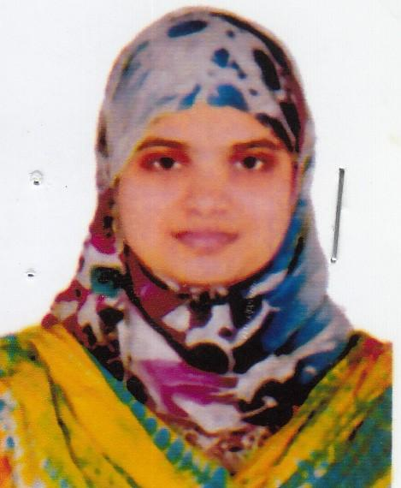 | DR. REHENA AKHTER  F/Name: Md. Idrish Miah  M/Name: Jahanara Begum  BM & DC Reg. No: 59401  NID:  Cell: 01671-407954  Address: 220/02, Free School Street, Kathalbagan Bazer, Dhaka.  Blood Group: O+
744 | Voter No  LM-2900738  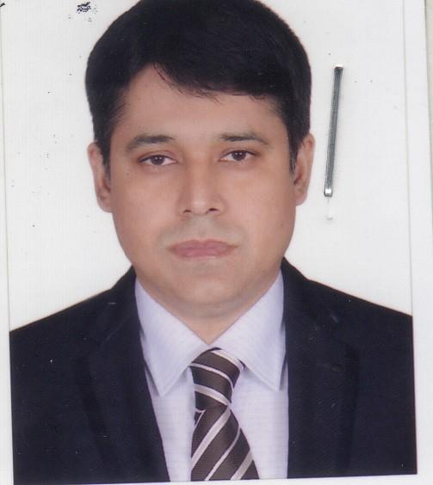 | DR. SAWDESH KUMAR CHAKROVORTTY  F/Name: Swapon Kumar Chakrovortty  M/Name:  BM & DC Reg. No: 31121  NID:  Cell: 01712-600505  Address: Flat-4A, RCC Hasan Tower 35, Lower Jessore Road, Khulna.  Blood Group: O+
745 | Voter No  LM-2900739  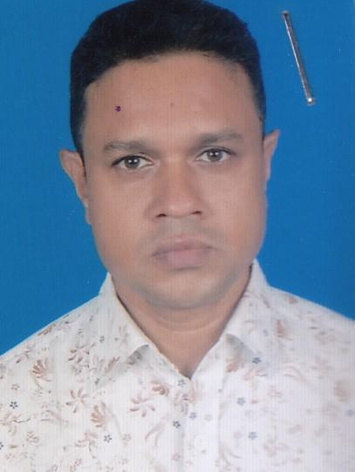 | DR. MD. FAISAL ABEDIN  F/Name: Sheikh Joynal Abedin  M/Name: Momena Khatun  BM & DC Reg. No: 41265  NID:  Cell: 01795-222677  Address: Sattar Mansion, 39 Lower Jessore Road, Khulna.  Blood Group: O+
746 | Voter No  LM-2900740  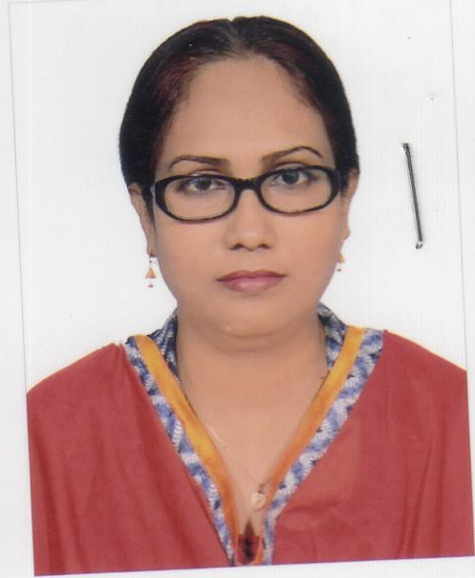 | DR. SYEDA FARZANA YESMIN  F/Name: Mir Ashraf Uddin Ahmed  M/Name: Dilruba Ashraf  BM & DC Reg. No: 37427  NID:  Cell: 01915-453977  Address: 6, Cemetery Road, Khulna.  Blood Group: O+
747 | Voter No  LM-2900741  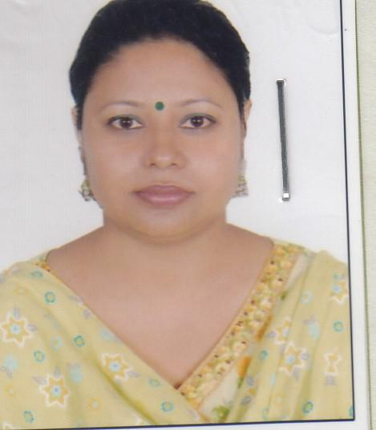 | DR. OHIDA SULTANA  F/Name: Habibur Rahaman  M/Name: Anowara Begum  BM & DC Reg. No: 42888  NID:  Cell: 01711-285843  Address: House-445, Road-7, Sonadanga R/A, 2nd Phase, Khulna.  Blood Group: B+
748 | Voter No  LM-2900742  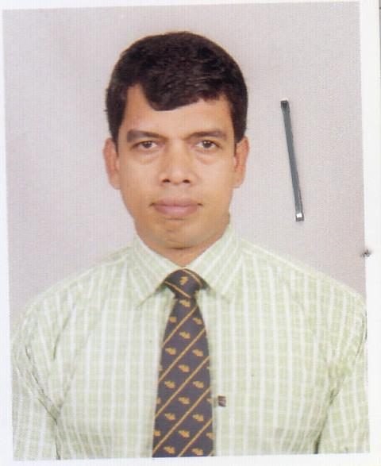 | DR. SAHADEV KUMAR ADHIKAY  F/Name: Bishanath Adhikary  M/Name: Anima Rani Adhikary  BM & DC Reg. No: 46054  NID:  Cell: 01739-321650  Address: Vill-Dumuria, PO-Sajiara Dumuria, Khulna.  Blood Group: B+
749 | Voter No  LM-2900743  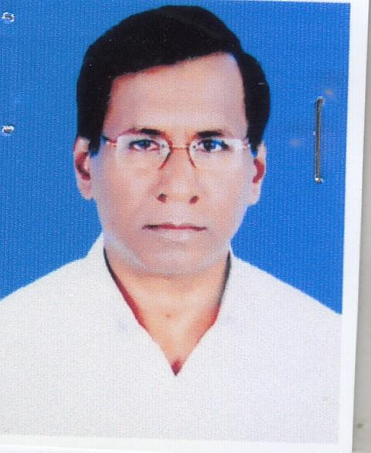 | DR. ANANDA MOHAN SAHA  F/Name: Nishikanta Saha  M/Name: Nihar Bala Saha  BM & DC Reg. No: 11451  NID:  Cell: 01712-740553  Address: 7, Bokshipara Road Sonadanga, Khulna Metro.  Blood Group: B+
750 | Voter No  LM-2900744 | DR. SM. NAHID KAMAL  F/Name: Md. Nashir Uddin  M/Name: Saleha Khatun  BM & DC Reg. No: 52716  NID:  Cell: 01723-355385  Address: 86/1, KA Godhuli, 2 No Cross Road, Boiragipara, Pabla, Daulatpur, Khulna.  Blood Group: B+
751 | Voter No  LM-2900745  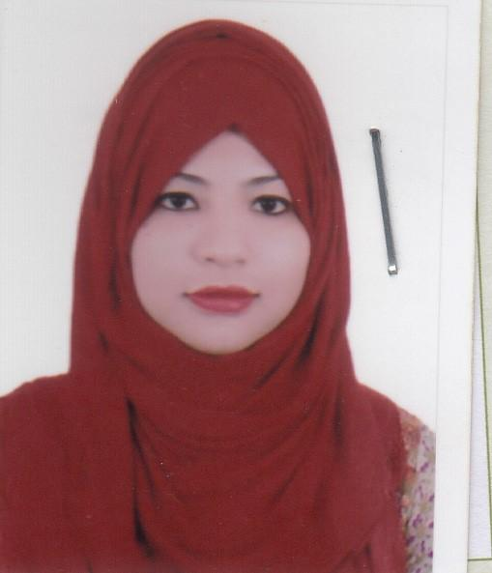 | DR. ISRAT JAHAN  F/Name: Md. Daud Ali  M/Name: Halima Khatun  BM & DC Reg. No: 90036  NID:  Cell: 01762-476168  Address: 23/1, Tootpara, Main Road, Khulna.  Blood Group: O+
752 | Voter No  LM-2900746  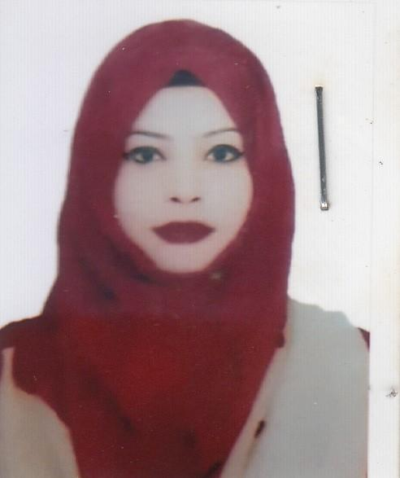 | DR. KANIJ FATEMA  F/Name: Md. Daud Ali  M/Name: Helima Khatun  BM & DC Reg. No: 84588  NID:  Cell: 01775-901344  Address: 23/1, Tootpara Main Road, Khulna.  Blood Group: O+
753 | Voter No  LM-2900747  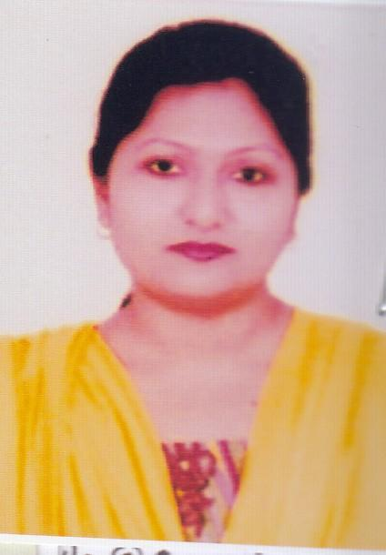 | DR. BAISHAKHI ISLAM  F/Name: Sirajul Islam  M/Name: Nurun Nahar  BM & DC Reg. No: 56666  NID:  Cell: 01715-113346  Address: Associate Professor, Dep. Pharmacology, Gazi Medical College, Sonadanga, Khulna.  Blood Group: B+
754 | Voter No  LM-2900748  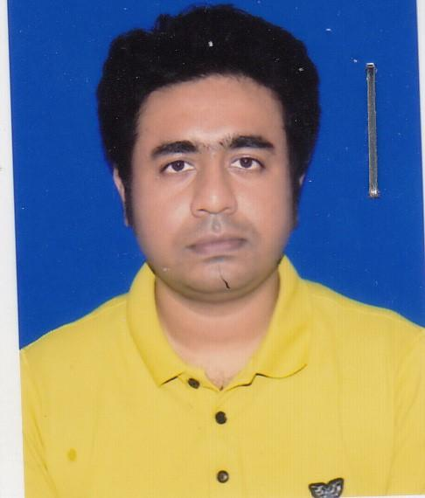 | DR. A. N. M FERDOUS  F/Name: Late Dr. Md. Akram Ali Mollah  M/Name: Dr. Nasrin Sultana  BM & DC Reg. No: 59048  NID:  Cell: 01711-010904  Address: Khulna Medical College, Khulna  Blood Group:
755 | Voter No  LM-2900749  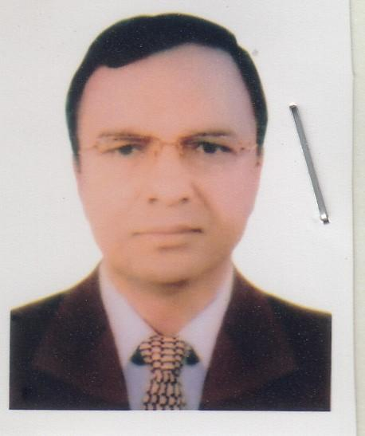 | DR. SHAHIDUL HASSAN MOLLICK  F/Name: Late Abdur Razzaque Mollick  M/Name: Mis. Suraiya Begum  BM & DC Reg. No: 22332  NID:  Cell: 01711-181625  Address: Gastroenterlogy Dep. Khulna Medical College, Khulna.  Blood Group:
756 | Voter No  LM-2900750  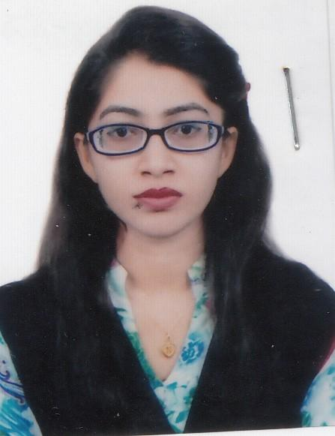 | DR. NAIMA RAHMAN  F/Name: Md. Hafizur Rahman  M/Name: Rebeka Rahaman  BM & DC Reg. No: 83684  NID:  Cell: 01793-000153  Address: Address: 3, Islampur Road, Tarer Pukur, Khulna.  Blood Group:
757 | Voter No  LM-2900751  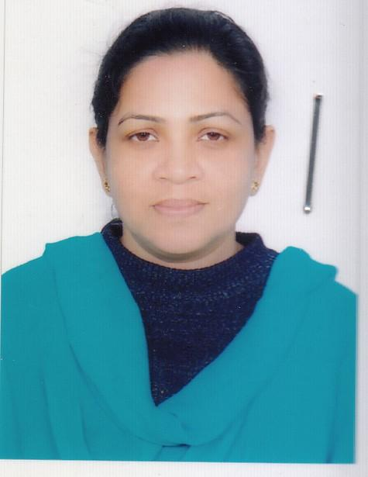 | DR. AFSIA MONSUR  F/Name: Late Dr. Monsur Ali  M/Name: Mrs. Marzina Khatun  BM & DC Reg. No: 52079  NID:  Cell: 01949-225449  Address: 10, Hejee Meher Ali Road, Iqbalnagar, Khulna.  Blood Group:
758 | Voter No  LM-2900752  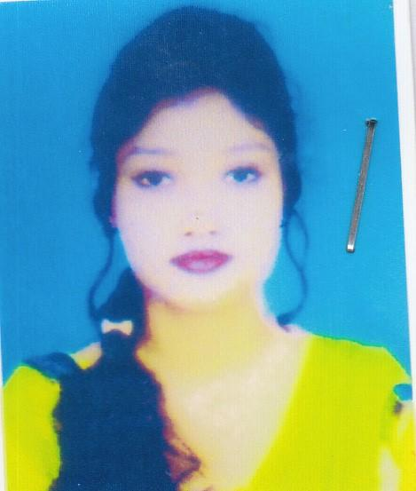 | DR. HRITU BISWAS  F/Name: Dr. Anil Krisna Biswas  M/Name: Superna Biswas  BM & DC Reg. No: 94570  NID:  Cell: 01317-401031  Address: 291, Khan jahan Ali Road, Khulna.  Blood Group:
759 | Voter No  LM-2900753  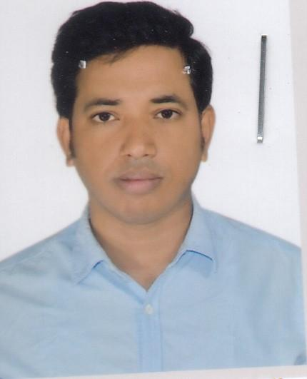 | DR. MD. OBAIDUL HUQ  F/Name: Md. Sirajul Huq  M/Name: Moshammat Mohshena Khatun  BM & DC Reg. No: 49621  NID:  Cell: 01913-249495  Address: M-8, Road-142, Old Houseing Estate, Ward No-12, Khalispur, Khulna.  Blood Group:
760 | Voter No  LM-2900754  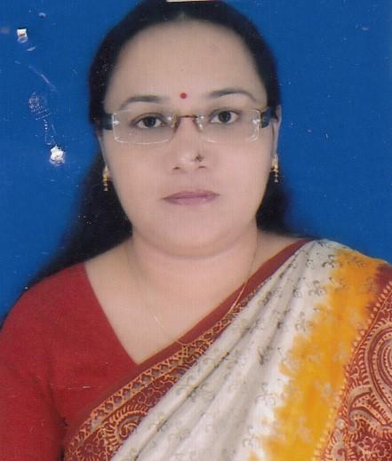 | DR. SILVIA PAROI  F/Name: Bivash Paroi  M/Name: Manolina Paroi  BM & DC Reg. No: 42116  NID:  Cell: 01711-972415  Address: 174/58, Khan jahan Ali Road, Khulna.  Blood Group:
761 | Voter No  LM-2900755  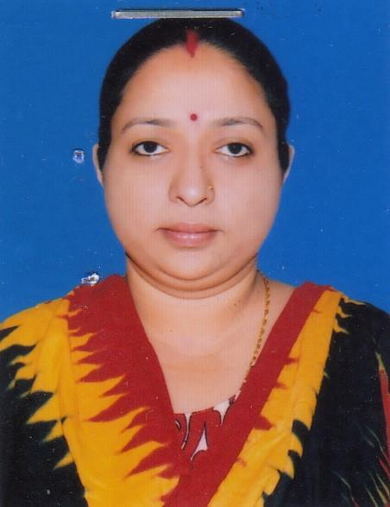 | DR. PRAJNAMITA BHATTACHARJEE  F/Name: Ajit Kumar Bhattacharjee  M/Name: Tripti Chakrobarty  BM & DC Reg. No: 54845  NID:  Cell: 01912-055279  Address: 59, Tutpara Main Road, Jorakol Bazar, Khulna.  Blood Group:
762 | Voter No  LM-2900756  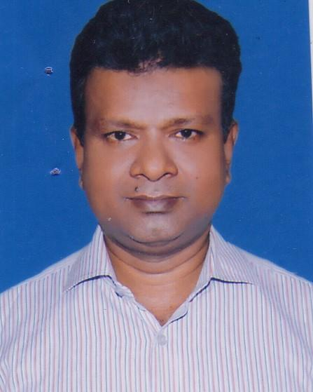 | DR. ANJAN KUMAR CHAKROBARTTY  F/Name: Late- Ajoy Kumar Chakrobartty  M/Name: Late- Joba Rani Chakrobartty  BM & DC Reg. No: 24914  NID:  Cell: 01711888525  Address: 59, Tutpara Main Roa, Jorakol Bazar, Khulna.  Blood Group:
763 | Voter No  LM-2900757  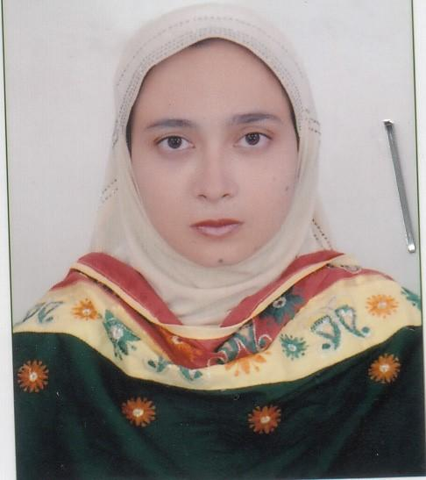 | DR. SAMINA AZAD  F/Name: Abdus Samad Azad  M/Name: Mahamuda Begum  BM & DC Reg. No: 52012  NID:  Cell: 01816198006  Address: 46/01, Choto Boyra, Market Road, Khulna.  Blood Group:
764 | Voter No  LM-2900758  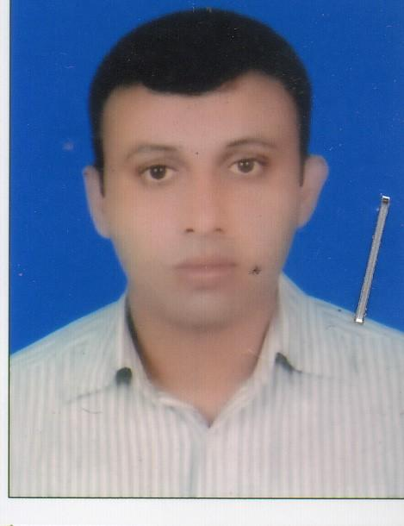 | DR. MD. MOHIBUL HASAN KHAN  F/Name: Md. Mohidur Rahaman Khan  M/Name: Mrs. Masuda Khanom  BM & DC Reg. No: 52013  NID:  Cell: 01816-198007  Address: 46/1, Chotoboyra, Market Road, Sonadanga, Khulna  Blood Group:
765 | Voter No  LM-2900759  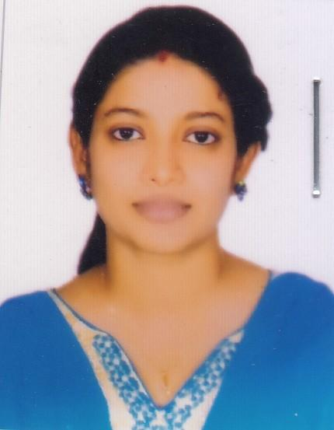 | DR. MOUSUMI MONDAL  F/Name: Profulla Chandra Mondal  M/Name: Basanti Rani Mondal  BM & DC Reg. No: 67820  NID:  Cell: 01921-109888  Address: 115/4, Sonadanga Thana Road, Khulna.  Blood Group:
766 | Voter No  LM-2900760  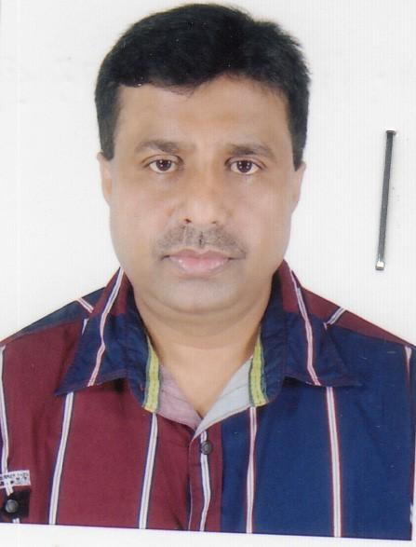 | DR. DELIP KUMAR KUNDU  F/Name: Adhir Kumar Kundu  M/Name: Rekha Rani Kundu  BM & DC Reg. No: 21543  NID:  Cell: 01716-082735  Address: Hasan Tower, 35 jashore Road, Khulna  Blood Group:
767 | Voter No  LM-2900761  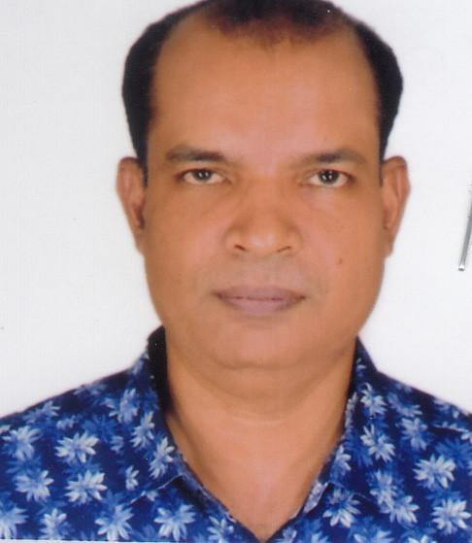 | DR. TULSHI RANJAN DAS  F/Name: Amal Krishna Das  M/Name: Padma Rani Das  BM & DC Reg. No: 25591  NID:  Cell: 01715-761899  Address: Gita Kunjo' Shaikh Ayub Ali Road, Pabla, Daulotpur, Khulna.  Blood Group:
768 | Voter No  LM-2900762  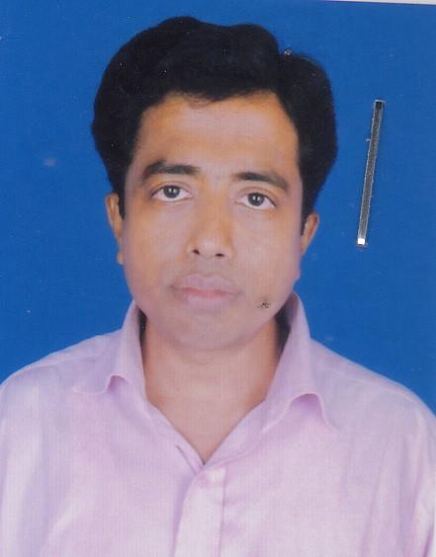 | DR. MOHAMMAD MUFTI MAHMUD  F/Name: Mohammad Lutfor Rahaman  M/Name: Mrs. Sabina Rahaman  BM & DC Reg. No: 30223  NID:  Cell: 01915-093726  Address: Archid Tower, House No- S-17, Mujgunni Main road, Khulna GPO, Khulna.  Blood Group:
769 | Voter No  LM-2900763  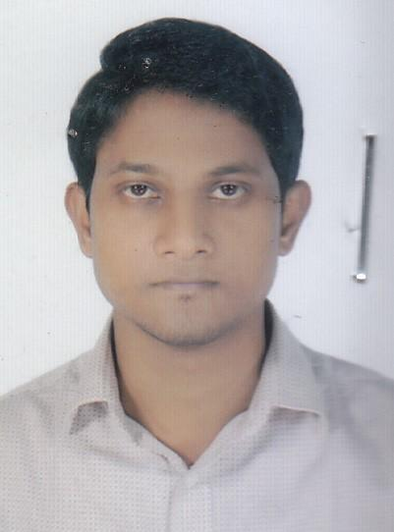 | DR SAIFULLAH MANSUR  F/Name: Md. Faizul Haque  M/Name: Most. Sufia Haque  BM & DC Reg. No: 90940  NID:  Cell: 01717-514551  Address: Building No:3/F(4th Floor),Khulna Medical College Quarter,Khulna.  Blood Group:
770 | Voter No  LM-2900764  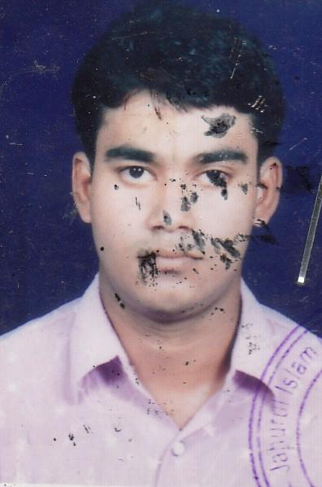 | DR. MD. MOSTAFIZUR RAHAMAN  F/Name: Md. Zahid Hossain  M/Name: Hosne Ara Begum  BM & DC Reg. No:  NID:  Cell:  Address: Khulna Health Care Hospital, Sonadanaga, Khulna  Blood Group:
771 | Voter No  LM-2900765  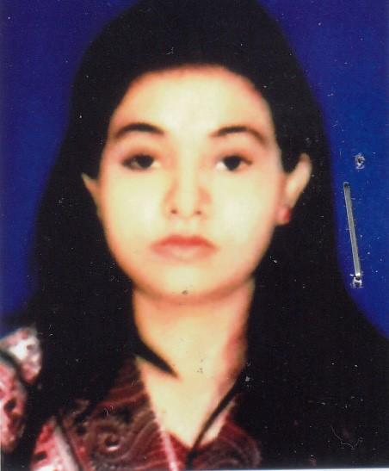 | DR. TASHNOVA TASHRIN RAHMAN  F/Name: Dr. Bodiur Rahaman  M/Name: Hosne Ara Begum  BM & DC Reg. No: 75585  NID:  Cell: 01775-776811  Address: Khulna Health Care Hospital, Sonadanaga, Khulna  Blood Group:
772 | Voter No  LM-2900766  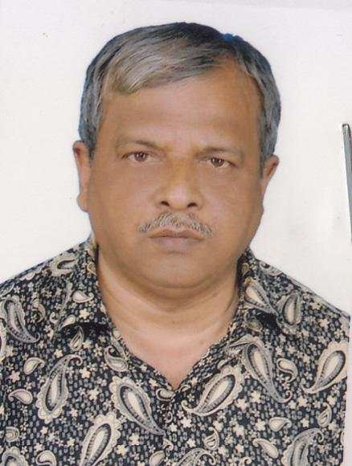 | DR. MAHBUBUR RAHMAN MUKUL  F/Name: Late NC Ghosal  M/Name: Late Monorama Ghosal  BM & DC Reg. No: 16626  NID: 4792104053335  Cell: 01711947220  Address: 250 Bed General Hospital, Kulna  Blood Group: B+
773 | Voter No  LM-2900767  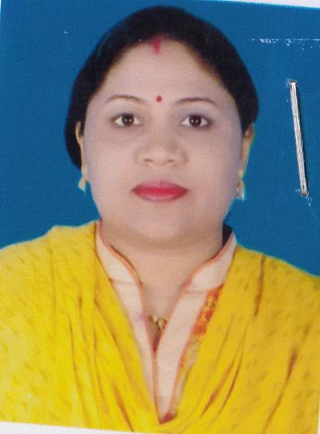 | DR. RAMA RANI KUMDU  F/Name: Ruhi Das Kundu  M/Name: Ratna Rani Kundu  BM & DC Reg. No: 52002  NID: 4798517233176  Cell: 01711449053  Address: Vill: Choto Boyra , PO: GPO Khulna, Sonadanga, Khulna.  Blood Group: A+
774 | Voter No  LM-2900768  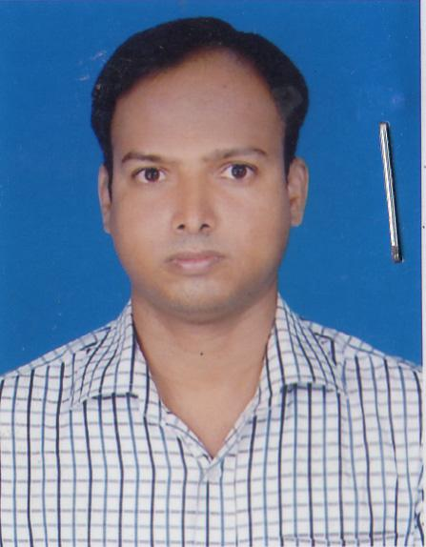 | DR. DHRUBO KUMAR MONDAL  F/Name: Sunil Mondal  M/Name: Nivasha Mondal  BM & DC Reg. No: 40864  NID: 4713067801284  Cell: 01716694874  Address: 300/3, Nasreen Palace, Royal More, Kulna  Blood Group: O+
775 | Voter No  LM-2900769  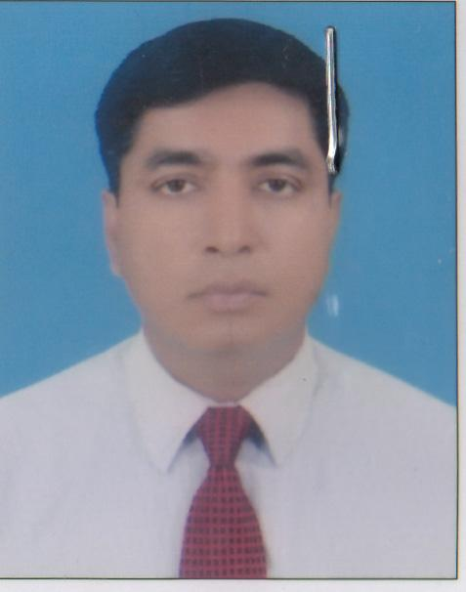 | DR. MD. ABDUS SOBHAN  F/Name: Mohammad Ali  M/Name: Mst. Monowara Khatun  BM & DC Reg. No: 36089  NID: 2694066784666  Cell: 01711574477  Address: Shahid Sheikh Abu Naser Specialized Hospital, Khulna.  Blood Group: A+
776 | Voter No  LM-2900770  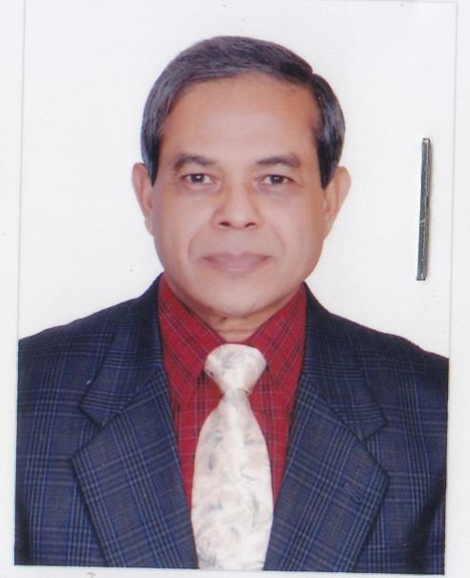 | DR. SHAMSUL ALAM  F/Name: Late Dr. M. A. Quader  M/Name: Late Mrs. Rabeya Khatun  BM & DC Reg. No: 12805  NID: 2373579073  Cell: 01718553425  Address: 30(old 110), Khanjahan Ali Road, Khulna-9100.  Blood Group: B+
777 | Voter No  LM-2900771 | DR. KHAN NAHID MURAD  F/Name: Khan A. Salim  M/Name: Mrs. Rekha Khan  BM & DC Reg. No: 93934  NID: 1915116196  Cell: 07119656873  Address: 13/7, Boyra Farukia Msjid Cross Road, Choto Boyra, Sonadnaga, Khulna-9000  Blood Group: AB+
778 | Voter No  LM-2900772  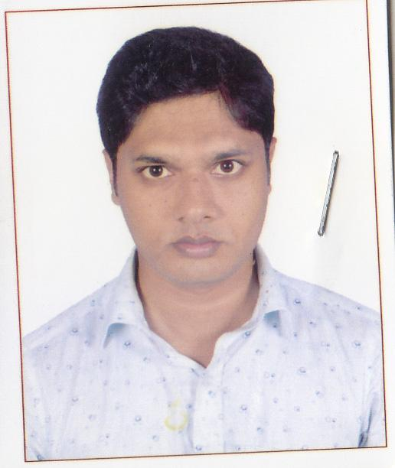 | DR. MD. ABUL KALAM AZAD  F/Name: Md. Aminul Islam  M/Name: Most. Rahela Begom  BM & DC Reg. No: 85126  NID: 5081419508  Cell: 01737837774  Address: 3/C Staff Quarter, Khulna Medical College, Sonadanga, Khulna.  Blood Group: O+
779 | Voter No  LM-2900773  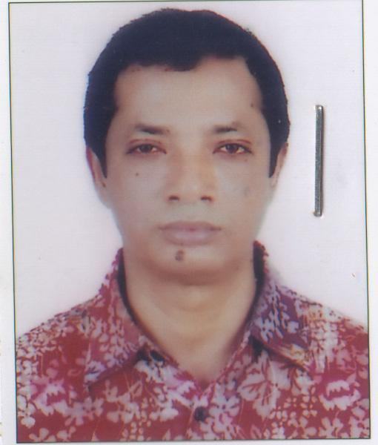 | DR. MD. MIZANUR RAHMAN NASIM  F/Name: Late Abdul Kader Howlader  M/Name: Ambia Khatun  BM & DC Reg. No: 21565  NID: 7318502239  Cell: 01728-299731  Address: House No: 30, 4A, Syed Ali Hossain Sarak, (KDA outer bypass road), Ward No:17, Sonadanga, Khulna.  Blood Group: B+
780 | Voter No  LM-2900774  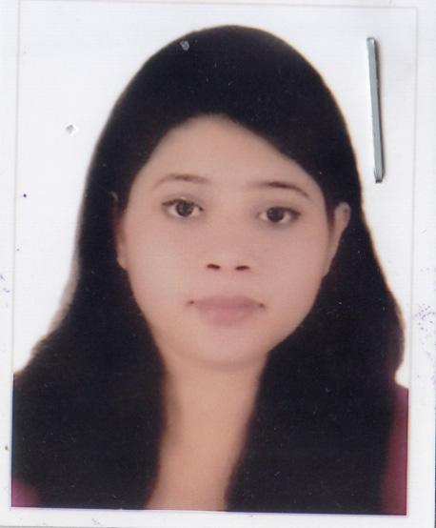 | DR. IFFAT TASNIM  F/Name: Dr. Md. Shafiqul Alam  M/Name: Mrs. Tahmina Yasmin  BM & DC Reg. No: 81262  NID: 19934795123000118  Cell: 01780200042  Address: 26, Ahsan Ahmed Road, 4B National Tower, Khulana  Blood Group: B+
781 | Voter No  LM-2900775  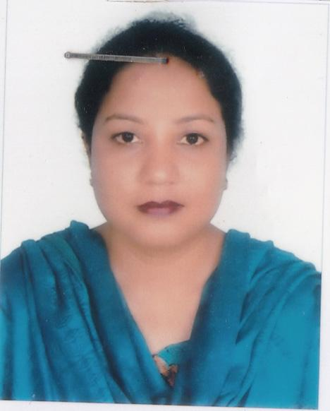 | DR. KAKALI RANI GHOSH  F/Name: Ajit Kumar Ghosh  M/Name: Santi Rani Ghosh  BM & DC Reg. No: 44587  NID: 4795123419062  Cell: 01716325797  Address: 11, Mirjapur Road, Khulna.  Blood Group: B+
782 | Voter No  LM-2900776  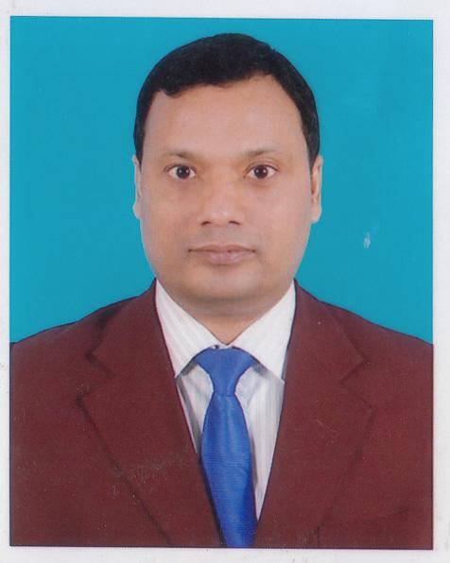 | DR. UTPAL KUMAR CHANDA  F/Name: Sunil Kumar Chanda  M/Name: Usha Rani Chanda  BM & DC Reg. No:  NID: 6423692570  Cell: 01712261769  Address: Asst. Prof. Medicine, Khulna Medical College.  Blood Group: B+
783 | Voter No  LM-2900777  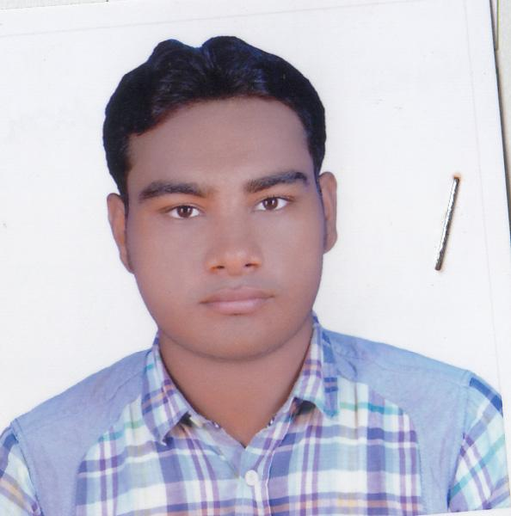 | DR. SYED RAKIBUL ISLAM  F/Name: Syed Rafiqul Islam  M/Name: Momotaz Rafiq  BM & DC Reg. No: 95350  NID:  Cell: 01914832512  Address: Fulbarigate, P/O-KUET-9203, P/S-Khanajahan Ali, Dist-Khulna.  Blood Group: B+
784 | Voter No  LM-2900778  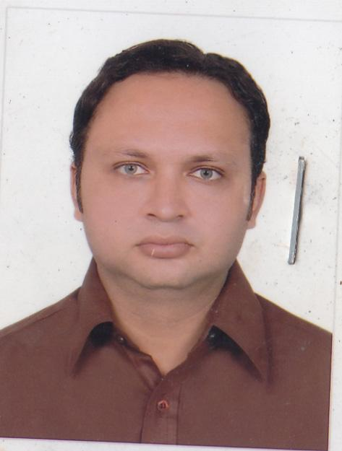 | DR. MD. IFTIKHAR ALAM  F/Name: Dr. Mahabub Alam Foraji  M/Name: Jebunnessa Begum  BM & DC Reg. No: 75171  NID: 4640069342  Cell: 01995613708  Address: R-156, House-90, Housing Estate, Khalishpur, Khulna.  Blood Group: B+
785 | Voter No  LM-2900779  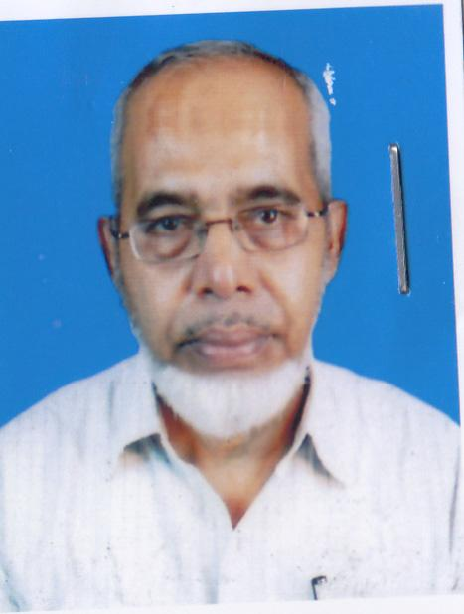 | DR. MD. DAUD ALI MEER  F/Name: Late Abu Bakar Meer  M/Name: Late Fatema Begum  BM & DC Reg. No:  NID: 6879756697  Cell: 01921777721  Address: Fresh Health Clinic, KUET road, Fulbarigate, Khulna.  Blood Group: AB+
786 | Voter No  LM-2900780  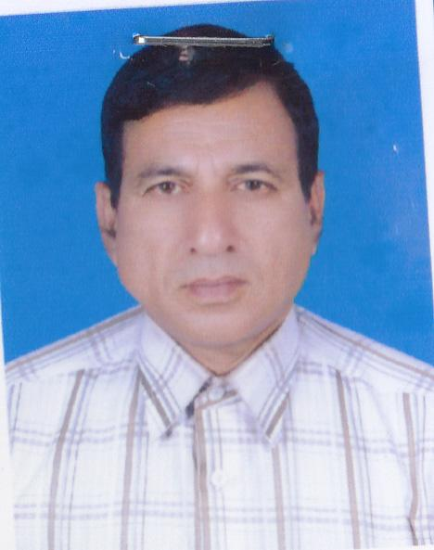 | DR. MD. RAFIQUL ISLAM  F/Name: Sk. Abdul Goni  M/Name: Amena Begum  BM & DC Reg. No: 45732  NID: 4714075398823  Cell: 01714087252  Address: Deputy Chief Medical Officer, Khulna University of Engineering & Technology.  Blood Group: B+
787 | Voter No  LM-2900781  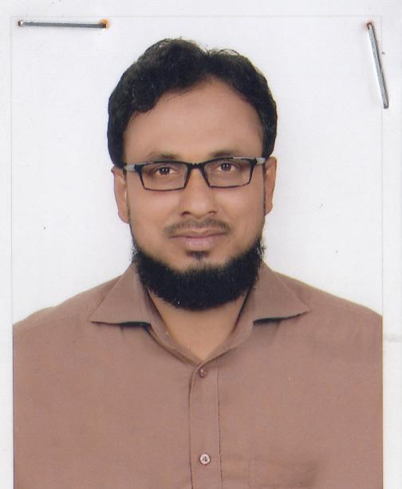 | A.K.M. ASADUZZAMAN  F/Name: Md. Kamrul Huda  M/Name: Sufia Khatun  BM & DC Reg. No: 48002  NID: 19822619551183794  Cell: 01711015652  Address: 45 Bakshipara Lane, Moylpota, Sonadanga, Khulna.  Blood Group: O+
788 | Voter No  LM-2900782  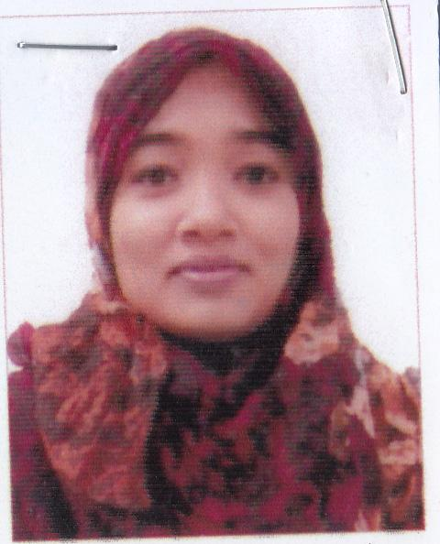 | DR. AFSANA AMIN  F/Name: Dr. Ruhul Amin  M/Name: Hosneara Begum  BM & DC Reg. No: 59773  NID: 2619551195475  Cell: 017194876920  Address: 45, Bakshipara Lane, Moylapota, Sonadanga, Khulna  Blood Group: O+
789 | Voter No  LM-2900783  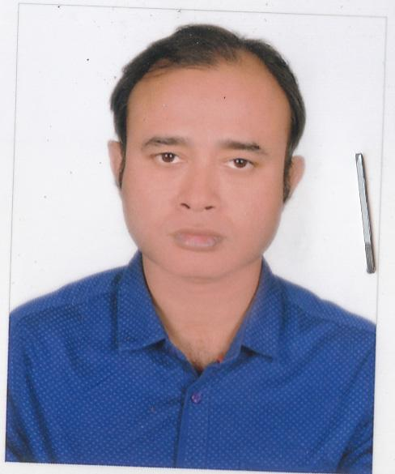 | DR. SHITESH CHANDRA BANARJEE  F/Name: Shankar Banarjee  M/Name: Shanti Banarjee  BM & DC Reg. No: 32432  NID:  Cell: 01711972739  Address: Khulna BNSB Eye Hospital, Shiromoni, Khulna.  Blood Group: B+
790 | Voter No  LM-2900784  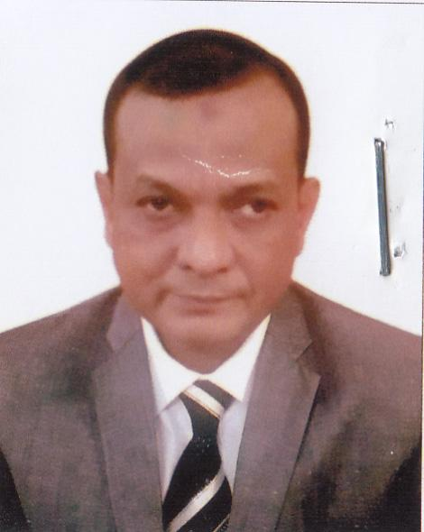 | DR. SUJAT AHMED  F/Name: Sahbuddin Ahmed  M/Name: Rawshan Ara Begum  BM & DC Reg. No: 24484  NID: 4715310275804  Cell: 01789356483  Address: Civil Surgeon Khulna  Blood Group: A+
791 | Voter No  LM-2900785 | DR. ARUP RATAN ADHIKARY  F/Name: Madhu Sudan Adhikary  M/Name: Niharika Adhikary  BM & DC Reg. No: 90522  NID: 6440366059  Cell: 01710503351  Address: 279/20, Mujgunni R/A, Khalishpur, Khulna  Blood Group: AB+
792 | Voter No  LM-2900786  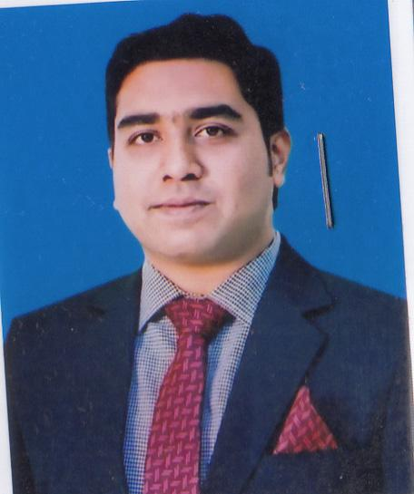 | DR. MOHD. FAYSAL ALAM  F/Name: Md. Shahjahan Alam  M/Name: Nazma Alam  BM & DC Reg. No: 65330  NID: 7785867750  Cell: 01717997460  Address: House-14, Flat-B1, Road-172, Housing Estate R/A, Khalishpur, Khulna.  Blood Group: AB+
793 | Voter No  LM-2900787  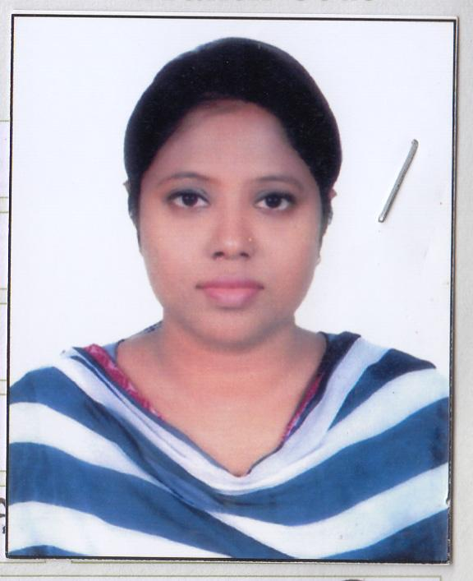 | DR. RABEYA KHATUN MOURY  F/Name: Ali Azam Khan  M/Name: Rexona Azam  BM & DC Reg. No: 93572  NID: 19944795124000134  Cell: 01679503005  Address: Prottasha(Nirala), Road No: 04, Thana: Lononchora, Zilla: Khulna.  Blood Group: A-
794 | Voter No  LM-2900788  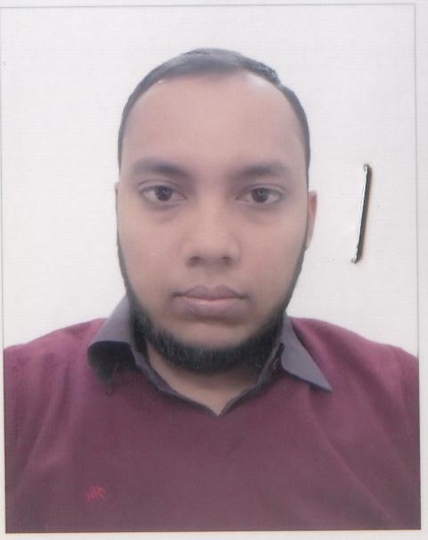 | DR. MD. MEHEDI HASAN  F/Name: Md. Daud Hossain  M/Name: Salma Daud  BM & DC Reg. No: 62181  NID: 8237234078  Cell: 01717456769  Address: Jakaria Road, Tootpara, Khulna.  Blood Group: AB+
795 | Voter No  LM-2900789  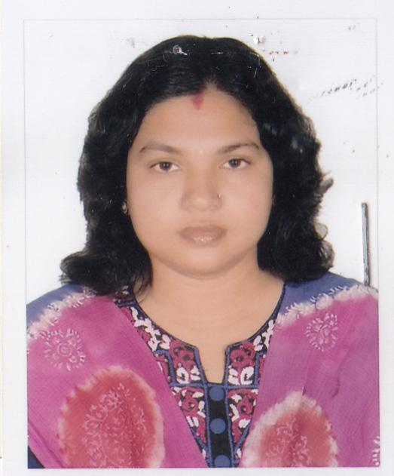 | DR. LIPIKA RAY  F/Name: Susen Kumar Roy  M/Name: Kalpana Rani Das  BM & DC Reg. No: 37170  NID: 19784798525307086  Cell: 01711189099  Address: 77/1, Banorgati Hazi Ismail Road, Thana: Sonadnaga, Post: Khulna City, Khulna.  Blood Group: O+
796 | Voter No  LM-2900790 | DR. JOYANATA KUMAR DAS  F/Name: Dhirendra Nath Das  M/Name: Promila Rani Das  BM & DC Reg. No: 30279  NID: 19734798525307085  Cell: 01717409917  Address: 77/1, Banorgati Hazi Ismail Road, Banorgati, Sonadanga, Khulna.  Blood Group: O+
797 | Voter No  LM-2900791  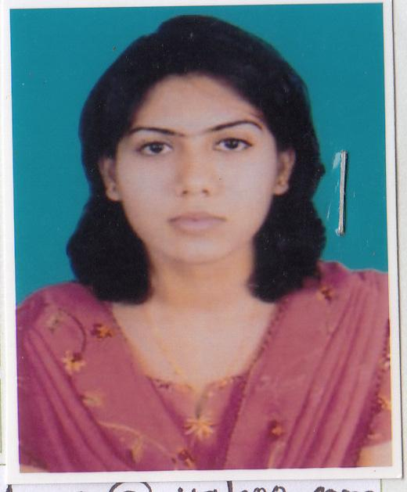 | DR. HAPPY SAHA  F/Name: Bidyoot Kumar Saha  M/Name: Protima Rani Saha  BM & DC Reg. No: 58239  NID: 9100613281  Cell: 01720510010  Address: 60/2, Roy Para Main Road, Khulna  Blood Group: O+
798 | Voter No  LM-2900792  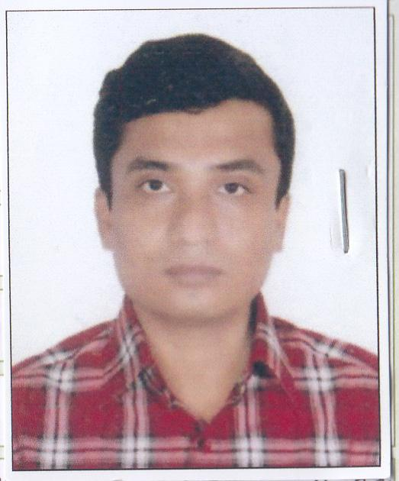 | DR. DIP KUMAR DAS  F/Name: Shyama Pada Das  M/Name: Suprava Das  BM & DC Reg. No: 51441  NID: 4795127469580  Cell: 01779099336  Address: 60/2, Roypara Main Road, Khulna  Blood Group:
799 | Voter No  LM-2900793  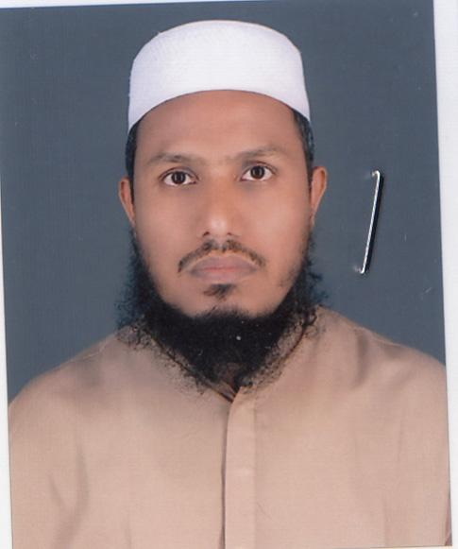 | DR. MD. HOSSAIN ALI  F/Name: Late Chaen Ali  M/Name: Late Rahima Khatun  BM & DC Reg. No: 39155  NID: 1461371435  Cell: 01819966700  Address: 65, Sheikh Para Main Road, Sonadanga, Khulna.  Blood Group: B+
800 | Voter No  LM-2900794 | DR. PULAK DEBNATH  F/Name: Prof. Subhash Chandra Debnath  M/Name: Amita Debnath  BM & DC Reg. No: 42424  NID: 9131351273  Cell: 01671459012  Address: ASSISTANT DIRECTOR , DIRECTORATE GENERAL OF MEDICAL EDUCATION , MOHAKHALI , DHAKA - 1212  Blood Group: A+
801 | Voter No  LM-2900795  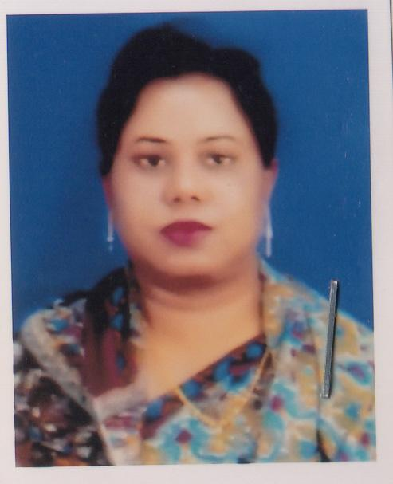 | DR. SHAHELA AKTHER  F/Name: Sheikh Mostafizur Rahman  M/Name: Mrs. Firoza Begum  BM & DC Reg. No:  NID: 4798516214933  Cell: 01712023550  Address: House-50, Road-5, Sonadanga Residential Area, Area-1, Sonadanga, Khulna-9000.  Blood Group: B+
802 | Voter No  LM-2900796  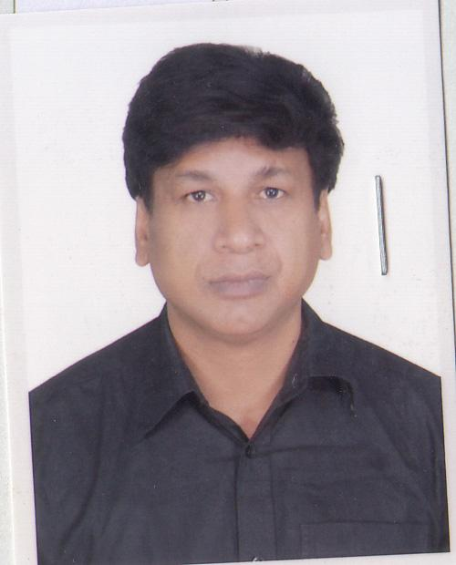 | DR. ABHIJIT GUHO  F/Name: Paritose Guho  M/Name: Mangulika Guho  BM & DC Reg. No: 26615  NID: 19708198508262087  Cell: 01711018769  Address: 209/4, Ayub Ali Road, Pabla Bonik Para, PS+PO: Daulatpur, Khulna.  Blood Group: O+
803 | Voter No  LM-2900797  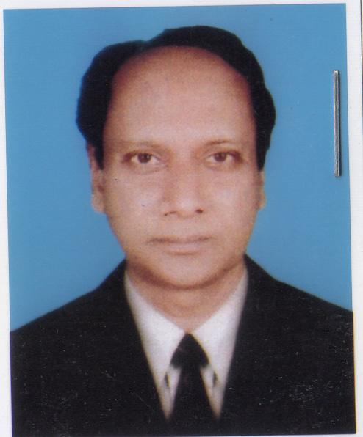 | DR. BAPPA GAUTAM  F/Name: Late H. Mondal  M/Name: Anima Chakravarty  BM & DC Reg. No: 22377  NID: 2383576861  Cell: 01715165970  Address: Associate Professor, Department of Biochemistry, Khulna Medical College, Khulna.  Blood Group: O+
804 | Voter No  LM-2900798  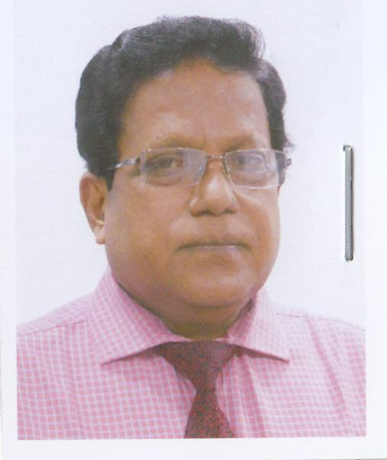 | DR. MD. ABDUL ALI  F/Name: Late Sk. Md. Waqqas Ali  M/Name: Late Dilrawsan Begum  BM & DC Reg. No: 11244  NID: 9100809897  Cell: 01917740903  Address: House No: 358, Road No: 22, Muggunni Housing, Khalispur, Khulna.  Blood Group: A+
805 | Voter No  LM-2900799  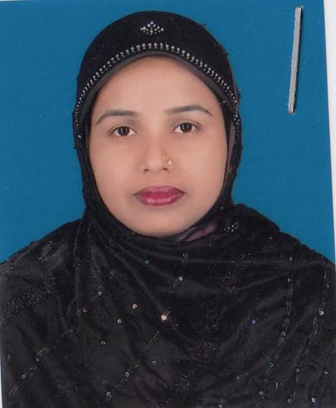 | DR. REHANA SULTANA  F/Name: Md.badsha Hawlader  M/Name: Monowara Begum  BM & DC Reg. No: 42547  NID: 19804798520295356  Cell: 01712050758  Address: 65, Shaikpara Main Road, Khulna, Lecturer, Pathology Department, Khulna Medical College.  Blood Group: O+
806 | Voter No  LM-2900800  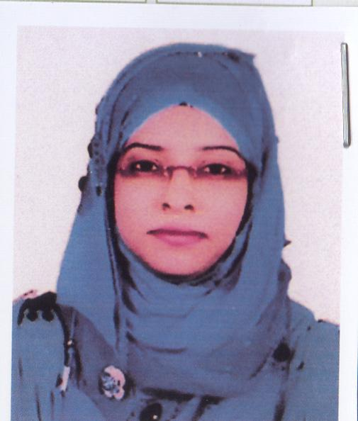 | DR. NUSRAT TAMANNA  F/Name: Md. Abdun Noor  M/Name: Samsun Nahar  BM & DC Reg. No: 46950  NID: 4795124440888  Cell: 01717250731  Address: 22/1, Musolmanpara, Raihan Manjil (2nd Floor), Khulna.  Blood Group: B+
807 | Voter No  LM-2900801  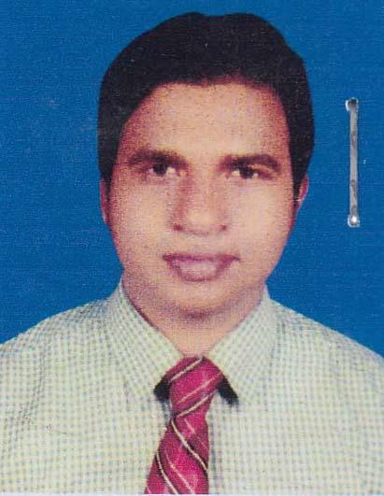 | DR. SHEIKH AURANGZEB PRINCE  F/Name: Sheikh Abdul Hannan  M/Name: Ozifa Khatun  BM & DC Reg. No: 64972  NID: 19894726404038805  Cell: 01916373684  Address: Vill: Soical, Post: Paikgacha, Dist: Khulna.  Blood Group: O+
808 | Voter No  LM-2900802 | DR. MD NEAZ MUSTAFI CHOWDHURY  F/Name: Md. Mahbubur Rahman Chowdhury  M/Name: Rowshan Ara Begum  BM & DC Reg. No: 54885  NID: 4798526325239  Cell: 01717665110  Address: 53/1, West Bania Khamar Main Road, Khulna.  Blood Group: AB+
809 | Voter No  LM-2900803  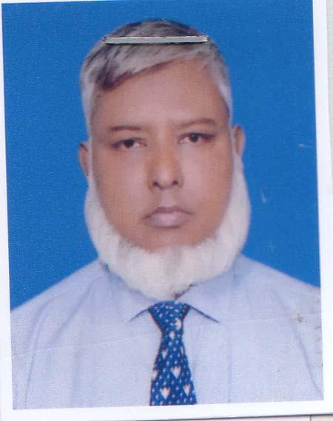 | DR. MD. SH AMSUL ALAM  F/Name: Late: Dr. A.khaleque  M/Name: Late: Ferdousi Begum  BM & DC Reg. No: 19431  NID: 19634795131562729  Cell: 01711066021  Address: SoF 3, Khulna Shipyard Ltd, BN, Khulna.  Blood Group: AB+
810 | Voter No  LM-2900804  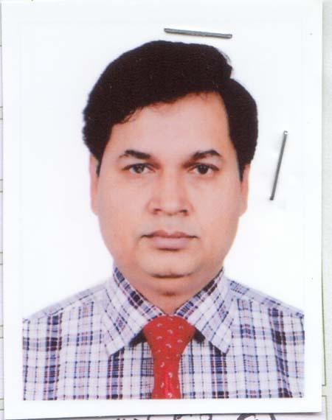 | DR. MD. YOUNUS ALI  F/Name: Ruhul Amin  M/Name: Murshida Begum  BM & DC Reg. No: 31310  NID: 1950673010  Cell: 01710772308  Address: House 0/14, Housing Estate, Khalishpur, Khulna.  Blood Group: A+
811 | Voter No  LM-2900805 | DR. MD. SAZID REZWAN  F/Name: Rof. Dr. Md. Abu Sayeed  M/Name: Dr. Razia Sultana  BM & DC Reg. No: 78814  NID: 6855904733  Cell: 01715144444  Address: 3A. Professor's Quarter, KMCH  Blood Group: A+
812 | Voter No  LM-2900806  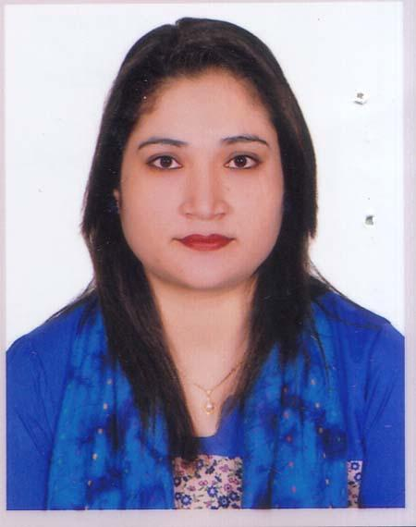 | DR. MST. SHAMMY AKHTER  F/Name: Md. Mizanur Rahman  M/Name: Mrs. Khoushmuda Rahman  BM & DC Reg. No: 53536  NID: 2722104807272  Cell: 01715411806  Address: Dept. Of Psychiatruy, Gazi Medical College and Hospital, Khulna.  Blood Group: O+
813 | Voter No  LM-2900807 | DR. SHARIF ASHRAFUL HABIB  F/Name: Sharif Habibur Rahman  M/Name: Sharif Hosne Ara Habib  BM & DC Reg. No: 55498  NID: 9553252728  Cell: 01913050327  Address: House No: 63, (3rd Floor North), Road No: 14 Sonadaga R/A, Phase-2.  Blood Group: O+
814 | Voter No  LM-2900808  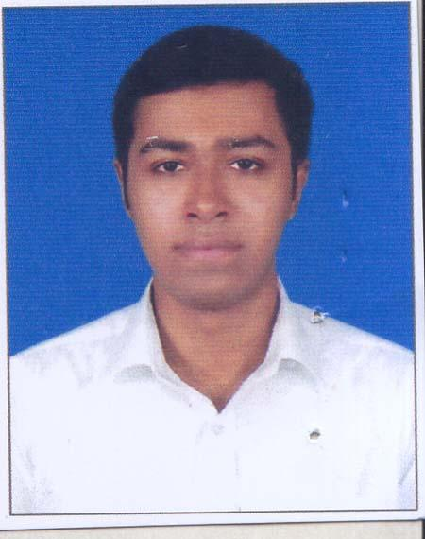 | DR.SK. TANVEER HASAN  F/Name: Sk. Khalilur Rahman  M/Name: Most: Rahima Khatun  BM & DC Reg. No: 81442  NID: 19924795130000106  Cell: 01711203908  Address: 9/2 Tutpara Dilkhola Road, khulna.  Blood Group: A-
815 | Voter No  LM-2900809  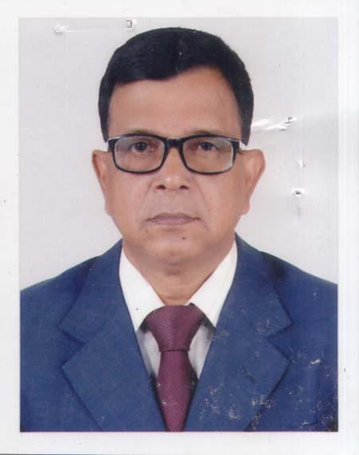 | DR. MD. YASIN ALI SARDAR  F/Name: Late: Md. Sakayet Ali Sardar  M/Name: Late: Mrs. Moiful Begum  BM & DC Reg. No: 10673  NID: 5072909160  Cell: 01756206069  Address: 29/1, Khan Jahan Ali Road, Khulna.  Blood Group: A+
816 | Voter No  LM-2900810  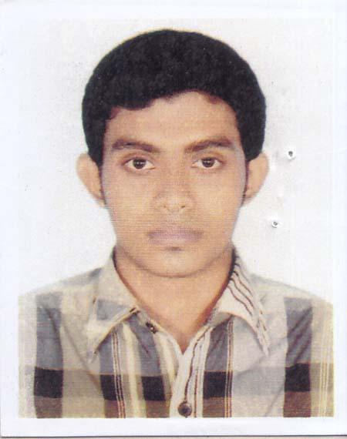 | DR. RUPOL BRAHMA  F/Name: Dr. Dilip Kumar Brahma  M/Name: Anima Rani Dey  BM & DC Reg. No: 102844  NID:  Cell: 01734555505  Address: 7/2, Sir Iqbal bi lane, Khulna.  Blood Group: A+
817 | Voter No  LM-2900811  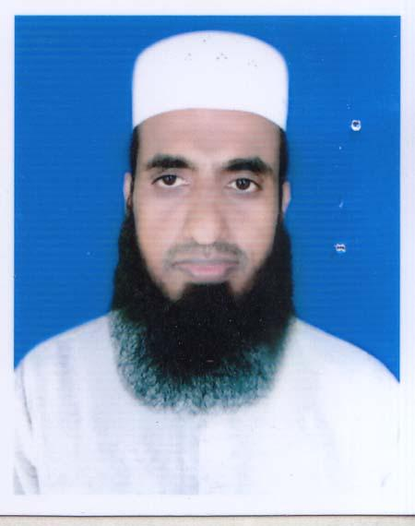 | DR. G.M MAHMUDUR RAHMAN  F/Name: Md. Abdul Mannan  M/Name: Rahima Khatun  BM & DC Reg. No: 44339  NID: 19824126103625144  Cell: 01716585030  Address: Department Of Biomedical Engineering. KUET, Khulna.  Blood Group: B+
818 | Voter No  LM-2900812  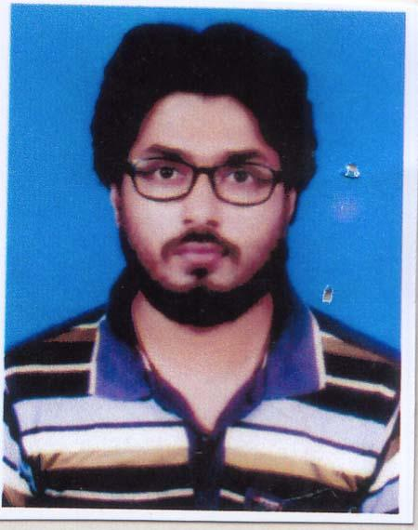 | DR. MD. BELAL HOSSAIN  F/Name: Late. Md. Akkas Ali  M/Name: Mrs. Bilkis Begum  BM & DC Reg. No: 61656  NID: 19870695111184834  Cell: 01710724642  Address: Glayo Mor, Khanjahan Ali Road, Rupsha Khulna.  Blood Group: AB+
819 | Voter No  LM-2900813  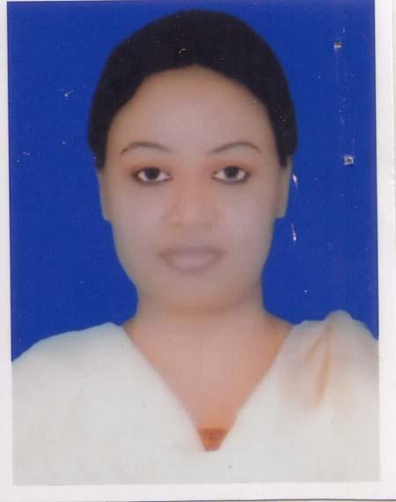 | DR. NADIA SULTANA LUNA  F/Name: Dewan Md. Nazim Uddin  M/Name: Nasima Dewan  BM & DC Reg. No: 49343  NID: 3745306195  Cell: 01748989695  Address: H#166, R#11, Sonadanga R/A (1st Phase), Khulna.  Blood Group: A+
820 | Voter No  LM-2900814  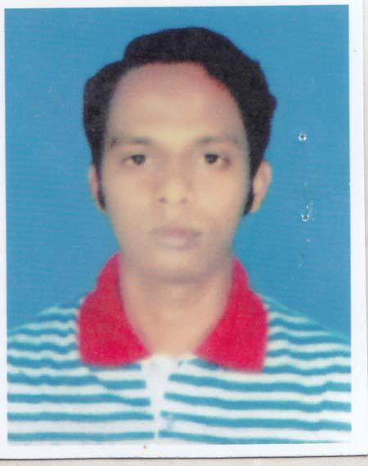 | DR. MD. MURAD HOSSAIN  F/Name: Md. Abul Hossain  M/Name: Fatema Khatun  BM & DC Reg. No: 55846  NID: 9102471985  Cell: 01911898690  Address: House No: 166, Road No: 11, Sonadanga Residential Area, Phase-I, Khulna.  Blood Group: O+
821 | Voter No  LM-2900815  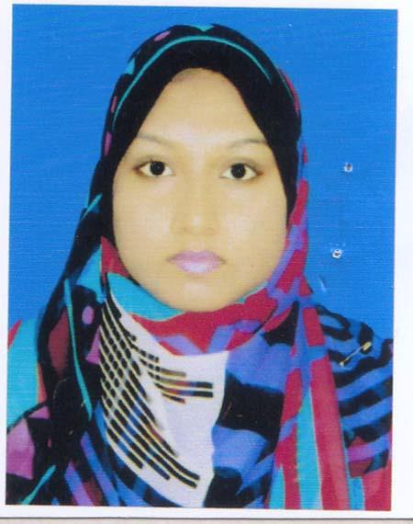 | DR. SANJIDA AKTER  F/Name: Md. Abdul Jalil  M/Name: Shahida Akter  BM & DC Reg. No: 90200  NID: 6402899071  Cell: 01762858561  Address: 149/B, Raja Bora Dakanto Road, P.O-Chanchra, Post Code-7400, Jashore.  Blood Group: B+
822 | Voter No  LM-2900816 | DR. SAHADEB KUMAR DAS  F/Name: Paritosh Kumar Das  M/Name: Karuna Bala Das  BM & DC Reg. No: 42389  NID: 2697557397300  Cell: 01710894635  Address: 153/6, Boyramain Road Boyra, Sonadanga, Khulna.  Blood Group: B+
823 | Voter No  LM-2900817  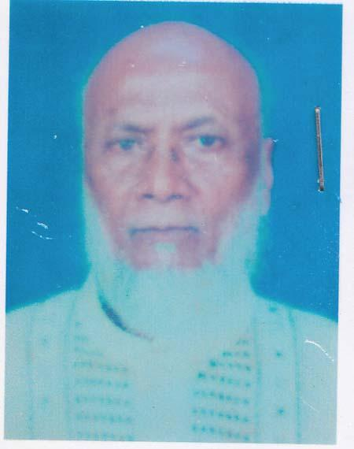 | DR. MUHAMAD NAZRUL ISLAM  F/Name: Late: Md. Ibrahim Miah  M/Name: Zebunnesa Islam  BM & DC Reg. No: 1114  NID:  Cell: 01918600352  Address: College Pahrmacy Daulay Pur Khulna.  Blood Group: B+
824 | Voter No  LM-2900818 | DR. SUMIT PAUL  F/Name: Asit Boron Paul  M/Name: Kanika Rani Sarker  BM & DC Reg. No: 82861  NID: 4189116637  Cell: 01739026013  Address: Ahasania Residential Area, Khulna University Lane, Gollamari, Khulna.  Blood Group: B+
825 | Voter No  LM-2900819 | DR. NURSARAT AHMED  F/Name: Nakib Uddin Ahmed  M/Name: Samsad Ahmed  BM & DC Reg. No: 41842  NID: 1955379571  Cell: 01726800716  Address: 59, Ahsan Ahmed Road, Khulna.  Blood Group: A+
826 | Voter No  LM-2900820  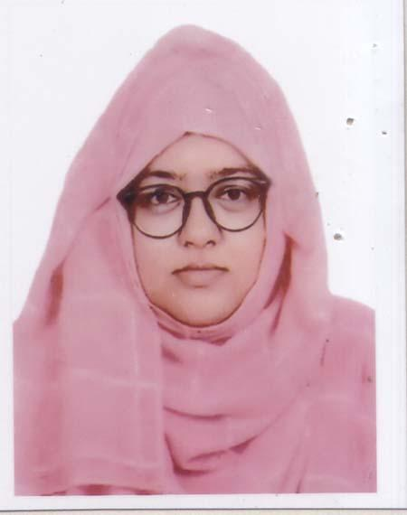 | DR. AFRIN JARIN MOU  F/Name: Syed Mustafizur Rahman  M/Name: Syeda Somela Sultana  BM & DC Reg. No: 100173  NID: 6901758570  Cell: 01768181144  Address: KDA Appsoach Road, Holding No-1/1 Sonadanga, Khulna.  Blood Group: A+
827 | Voter No  LM-2900821  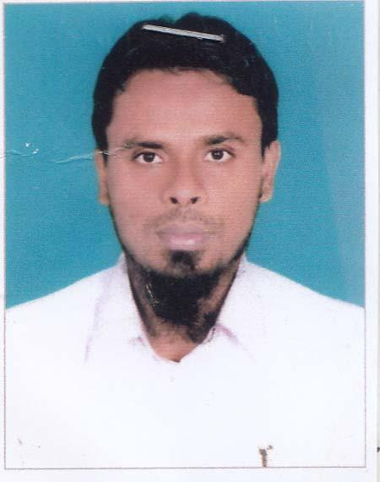 | DR. MD. ABDUL WADUD  F/Name: Md. Rois Uddin  M/Name: Mrs. Ayesha Khatun  BM & DC Reg. No: 42494  NID: 19794411989177477  Cell: 01816513395  Address: House No-304, Road No-17, Nirala Resident Area, Khulna.  Blood Group: A+
828 | Voter No  LM-2900822  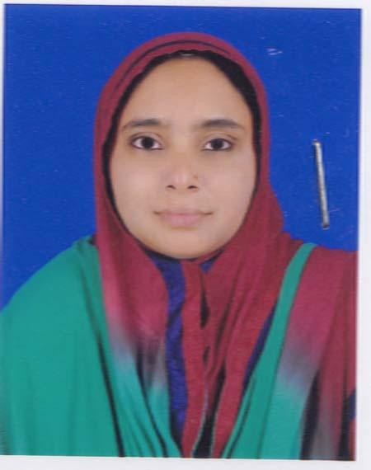 | DR. NURJAHAN AKTER  F/Name: Abdur Rashid Howlader  M/Name: Mamotaz Begum  BM & DC Reg. No: 50787  NID: 1017946151  Cell: 01712995374  Address: B-5/2, Residential Area Khulna Power Station, Khalishpur, Khulna.  Blood Group: B+
829 | Voter No  LM-2900823  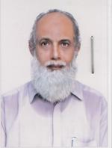 | DR. SHEIKH MOTIAR RAHMAN  F/Name: Late: Sheikh Zeher Ali  M/Name: Late: Mrs. Maleka Begum  BM & DC Reg. No: 12029  NID: 4798519276694  Cell: 01715292222  Address: 64/1, K D A Avenue, Khulna (5th Hoor)  Blood Group: B+
830 | Voter No  LM-2900824 | DR. PRITOM SAKSWAR CHAKRABORTY RAHUL  F/Name: Prabir Kumar Chakraborty  M/Name: Suchitra Rani Chakraborty  BM & DC Reg. No: 66274  NID: 19924798516000329  Cell: 01674258346  Address: Vill-Dumury, Post-Nasaratpur, Upazilla-Adadighi, Dist-Bogra.  Blood Group: O+
831 | Voter No  LM-2900825 | DR. HIMEL GHOSH  F/Name: Prodip Kumar Ghosh  M/Name: Baruna Ghosh  BM & DC Reg. No: 95201  NID: 1952778759  Cell: 01861857904  Address: 65, Shamsur Rahman Road, Khulna, Sadar, Khulna.  Blood Group: B+
832 | Voter No  LM-2900826  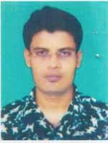 | DR. MD. KAZI ABDUR ROUF  F/Name: Md. Modhu Kazi  M/Name: Rina Begum  BM & DC Reg. No: 85123  NID: 7796077019  Cell: 01834400644  Address: 669, Bidc Road, Khalishpur, Khulna.  Blood Group: A+
833 | Voter No  LM-2900827 | DR. K. M. SADIK FAISAL  F/Name: Khan Mahbub Hossain  M/Name: Lili Afroz  BM & DC Reg. No: 109064  NID: 4154439931  Cell: 01975820766  Address: 26/1, Foraji para lane, Moylapota, Khulna  Blood Group: B+
834 | Voter No  LM-2900828 | DR. MD. MAHFUJUR RAHMAN  F/Name: Md. Mujibur Rahman  M/Name: Mrs. Momtaj Begum  BM & DC Reg. No: 27298  NID: 1956615163  Cell: 01974559175  Address: Haji Ismail Link Road-2 Banorgati, Khulna.  Blood Group: O+
835 | Voter No  LM-2900829 | DR. MD. SAIFULLAH IBNE MANNAN  F/Name: Md. Abdul Mannan Sarder  M/Name: Tahmina Begum  BM & DC Reg. No: 77036  NID: 19914716416000412  Cell: 01917953605  Address: Gazalia, Paikgacha, Khulna.  Blood Group: B+
836 | Voter No  LM-2900830  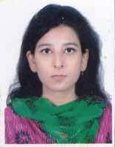 | DR. NABILA NUSRAT  F/Name: Prof. Choudhury Habibur Rasul  M/Name: Laila Jesmeen  BM & DC Reg. No: 78797  NID: 19894795129499285  Cell: 01313245509  Address: 7B, National Tower 26, Ahsan Ahmed Road, Khulna.  Blood Group: AB+
837 | Voter No  LM-2900831 | DR. BAISHAKHI ROY  F/Name: Mihir Kumar Roy  M/Name: Rekha Rani Roy  BM & DC Reg. No: 90630  NID: 19944721708000016  Cell: 01611417941  Address: Kabir Tower, Nobopolli, Sonadanga, Khulna.  Blood Group: B+
838 | Voter No  LM-2900832  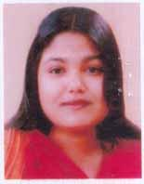 | DR. SADIA AFRIN LOPA  F/Name: Md. Abdul Hannan  M/Name: Mst. Hosne Ara Khatun  BM & DC Reg. No: 73666  NID: 1938658836  Cell: 01701395878  Address: Dowlotpur, Khulna.  Blood Group: A+
839 | Voter No  LM-2900833  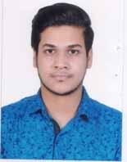 | DR. HASAN SHAHRIAR  F/Name: A. M. Habibur Rahman  M/Name: Salma Nahid  BM & DC Reg. No: 102191  NID: 4164029870  Cell: 01732700314  Address: 14, Zahidur Rahman Cross Road Bagmara Tetultala, Khulna.  Blood Group: n_a
840 | Voter No  LM-2900834 | DR. ROSHNI KHANAM  F/Name: Sk. Nazrul Islam  M/Name: Firoza Islam  BM & DC Reg. No: 67922  NID: 09878199017366945  Cell: 01787268128  Address: Vill: Vawakhali, Post: Ratangonj, Thana+District: Narail.  Blood Group: B+
841 | Voter No  LM-2900835  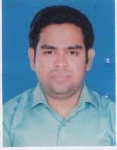 | DR. SYED AUROWNGAZEB  F/Name: Syed Abdus Sobhan  M/Name: Kamrun Nahar  BM & DC Reg. No: 87798  NID: 5090693093  Cell: 01818871441  Address: Road No-13, House No-208, Nirala Khulna.  Blood Group: A+
842 | Voter No  LM-2900836 | DR. ARIFA BEGUM  F/Name: Md. Mustafa Alam  M/Name: Jahanara Begum  BM & DC Reg. No: 57731  NID: 2716469298486  Cell: 01745626018  Address: Flat - 5/A, Farin Villa, 13, Faraji Para Road, Khulna  Blood Group: B+
843 | Voter No  LM-2900837  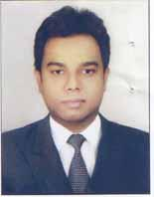 | DR. SAUMITRA RANZAN AOHIKARY  F/Name: Late. Ranzit Kumer Adhikary  M/Name: Late. Promila Rani Adhikary  BM & DC Reg. No: 69973  NID: 7768560711  Cell: 01715255408  Address: Purba Bania Khamar  Blood Group: A-
844 | Voter No  LM-2900838 | DR. SRABONI RANI KANTA  F/Name: Anil Kumar Shil  M/Name: Karuna Rani Mondal  BM & DC Reg. No: 88641  NID: 5097924715  Cell: 01740826040  Address: 15/1, Jahidur Rahman Cross Road, Bagmara, Tetultola, Khulna.  Blood Group: B+
845 | Voter No  LM-2900839  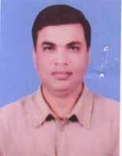 | DR. GOUPAM KUMAR MUKHERJEE  F/Name: Subodh Kumar Mukherjee  M/Name: Gouri Rani Mukherjee  BM & DC Reg. No: 37622  NID: 8710460842511  Cell: 01718266689  Address: 25/2 H Lahidur Rahman Road Khulna Sadar- Khulna.  Blood Group: B+
846 | Voter No  LM-2900840  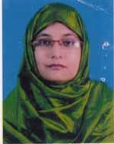 | DR. SHIREEN AKTAER  F/Name: Md. Abdus Samad  M/Name: Mosammad Taiyaba Tahera  BM & DC Reg. No: 32154  NID: 2696828264726  Cell: 01720107354  Address: 443/1, Road,#6, Sonadanga, Phase, Khulna.  Blood Group: A+
847 | Voter No  LM-2900841 | DR. TANVIR ZAHIN  F/Name: A.j.m.m Morshed  M/Name: Meher-e-taj  BM & DC Reg. No: 79328  NID: 19924716938000062  Cell: 01713409570  Address: A. Gafur memorial Hospital, Fultala Khulna.  Blood Group: A+
848 | Voter No  LM-2900842  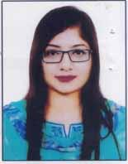 | DR. SHARMIN SULTANA  F/Name: Selim Uddin Khan  M/Name: Ferdawsy Khan  BM & DC Reg. No: 84885  NID: 8217215956  Cell: 01799783106  Address: A. Gafur memorial Hospital, Fultala Khulna.  Blood Group: O+
849 | Voter No  LM-2900843 | DR. ANAL ROY  F/Name: Nirode Behari Roy  M/Name: Arati Roy  BM & DC Reg. No: 60187  NID: 4798516214702  Cell: 01718737027  Address: Assistant Registrar Medicine, Khulna Medical College Hospital, Khulna  Blood Group: O+
850 | Voter No  LM-2900844 | HIMADRY SHAKHAR SARKER  F/Name: Subodh Kumar Sarker  M/Name: Niva Rani Sarker  BM & DC Reg. No: 67049  NID: 8192213105849  Cell: 01717077353  Address: Assistant registrar, surgery, Khulna Medical College Hospital, Khulna  Blood Group: O+
851 | Voter No  LM-2900845  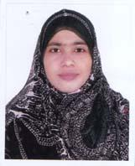 | DR. SABINA PARVIN  F/Name: Late: Md. Abdul Aziz Shaikh  M/Name: Momena Begum  BM & DC Reg. No: 69710  NID: 7308195069  Cell: 01721-686695  Address: Tahir Mention, 13/1 Farajipara Main Road, Khulna  Blood Group: A+
852 | Voter No  LM-2900846  No Image | DR. MD. MOSTAFA KAMAL  F/Name: Mohammad Ali Moral  M/Name:  BM & DC Reg. No: 26998  NID:  Cell:  Address: House # 5, Road # 36 Gulshan-2, Dhaka-1212.  Blood Group:
853 | Voter No  LM-2900847  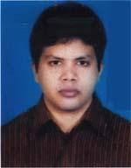 | DR. RAJIB KUMAR PAUL  F/Name: Prohlad Kumar Paul  M/Name: Eva Rani Paul  BM & DC Reg. No: 55370  NID: 19858198510209475  Cell: 01738113706  Address: 152/1, Boyra Main Road, Pujo Khola, Soanadanga, Khulna  Blood Group: A+
854 | Voter No  LM-2900848 | DR.SHAGORIKA PAULL  F/Name: Bhola Nath Paull  M/Name: Shikha Rani Paul  BM & DC Reg. No: 63988  NID: 19882910310300348  Cell: 01737377595  Address: Lecturer, Department of Microbiology, Khulna Medical College  Blood Group: B+
855 | Voter No  LM-2900849  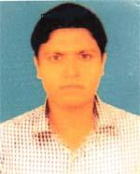 | DR. DEBASISH KUMAR GHOSH  F/Name: Krishna Pada Ghosh  M/Name: Monita Rani Ghosh  BM & DC Reg. No: 42304  NID: 4112389844839  Cell: 01717591660  Address: Building 3/B, 1st Floor, Khulna Medical College Hospital Qarter, Khulna  Blood Group: AB+
856 | Voter No  LM-2900850  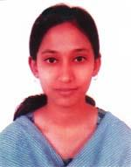 | DR. LAXMI RANI BISWAS  F/Name: Ramen Kumar Biswas  M/Name: Bina Pani Roy  BM & DC Reg. No: 51517  NID: 6125214123350  Cell: 01712181178  Address: Building 3/B, 1st Floor, Khulna Medical College Hospital Qarter, Khulna  Blood Group: B+
857 | Voter No  LM-2900851  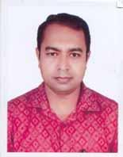 | DR. MADHUSUDAN SAHA  F/Name: Mukunda Prasad Saha  M/Name: Chhabi Rani Saha  BM & DC Reg. No: 42550  NID: 8719011439745  Cell: 01718859912  Address: IMO, Shahid Sk Abu Naser Specialised Hospital Khulna.  Blood Group: O+
858 | Voter No  LM-2900852  No Image | DR. PARTHO PRATIK ROY  F/Name: Paritosh Roy  M/Name: Kalyani Roy  BM & DC Reg. No: 48297  NID: 3722780800  Cell: 01712670573  Address: Flat: 2D House: 48, Road: 3A Dhanmondi Dhaka.  Blood Group: A+
859 | Voter No  LM-2900853  No Image | DR. SUMIYA AKUNJEE  F/Name: Amir Ali Akunjee  M/Name: Shalina Akhter  BM & DC Reg. No: 95560  NID: 4153264033  Cell: 01835404911  Address: 34, Ahsan Ahmed Road, Khulna.  Blood Group: B+
860 | Voter No  LM-2900854  No Image | DR. NAYEEM BAKER  F/Name: Dr. Baker Hossain  M/Name: Mrs. Zohora Baker  BM & DC Reg. No: 90986  NID: 2822747263  Cell: 01924999222  Address: 34, Ahsan Ahmed Road, Khulna.  Blood Group: AB+
861 | Voter No  LM-2900855  No Image | DR. ARMAN BAKER  F/Name: Dr. Baker Hossain  M/Name: Mrs. Zohora Baker  BM & DC Reg. No: 90983  NID: 9551717821  Cell: 01910222000  Address: 34, Ahsan Ahmed Road, Khulna.  Blood Group: O+
862 | Voter No  LM-2900856  No Image | DR. TARIT KANTI GHOSH  F/Name: Dr. Kiron Chandra Ghosh  M/Name: Mrs. Aroti Bala Ghosh  BM & DC Reg. No: 23232  NID: 2823365230  Cell: 01711331372  Address: 9/3, Gagan Babu Road, Khulna.  Blood Group: B+
863 | Voter No  LM-2900857  No Image | DR. SHAIENDA NATH BISWAS  F/Name: Birendra Nath Biswsa  M/Name: Binata Lata Biswas  BM & DC Reg. No: 47246  NID: 0115647969610  Cell: 01712159579  Address: S2-S4, Fatema Height Shamsun Nahar, Road, Khulna.  Blood Group: B+
864 | Voter No  LM-2900858  No Image | DR. NEAZ NOWSHER  F/Name: Nowsher Ali  M/Name: Nasrin Nowsher  BM & DC Reg. No: 60190  NID: 4798526318794  Cell: 01722271842  Address: 4/1 Nazirghat Cross Road, Khulna.  Blood Group: B+
865 | Voter No  LM-2900859  No Image | PROFESSOR DR. DIN-UL ISLAM  F/Name: Late: Md. Rafiqul Islam  M/Name: Late: Jerina Khatun  BM & DC Reg. No: 22490  NID: 8251377738  Cell: 01552420598  Address: Principal, Khulna Medical College, Khulna.  Blood Group: O+
866 | Voter No  LM-2900860  No Image | DR. M.M. ABDUS SHAMIM  F/Name: Late: Nur Ali Morol  M/Name: Mrs. Rehana Begum  BM & DC Reg. No: 37789  NID: 1595512176437  Cell: 01761646471  Address: 314, Tamanna Tower, Nirala reni area, Khulna.  Blood Group: A+
867 | Voter No  LM-2900861  No Image | DR SUKANTA BISWAS  F/Name: Swapan Kumar Biswas  M/Name: Reba Rani Dey  BM & DC Reg. No: 79586  NID: 19924792105000076  Cell: 01687916669  Address: Vill: Pabla, Post: Daulatpur, Thana: Daulatpur, Dist. Khulna  Blood Group: A-
868 | Voter No  LM-2900862  No Image | DR. HALIMA KHATUN MUNNI  F/Name: Md. Habibur Rahman  M/Name: Begum Ayrin Rahman  BM & DC Reg. No: 76561  NID: 9147581996  Cell: 01972680107  Address: 27/2, Keshablal Road, Pabla, Daulatpur, Khulna.  Blood Group: AB+
869 | Voter No  LM-2900863  No Image | DR. SHIMUL CHAKRA BORTTY  F/Name: Profulla Kumar Chakra Bortty  M/Name: Jayonti Chakra Bortty  BM & DC Reg. No: 85144  NID: 19934716938000033  Cell: 01914647463  Address: Vill: + Post:- Damodar, Upazilla:- Phultala District:- Khulna.  Blood Group: A+
870 | Voter No  LM-2900864  No Image | DR. G M SAFAT ALDIN  F/Name:  M/Name:  BM & DC Reg. No: 85397  NID: 1016303198  Cell: 01914661497  Address: Boyra, Khulna.  Blood Group: O+  TRANSFERED to BMA Dhaka City  LM-1405543
871 | Voter No  LM-2900865  No Image | DR. MD. SAIFUL IMAM  F/Name: Gazi Jobed Ali  M/Name: Saleha Begom  BM & DC Reg. No: 23025  NID: 4726404038796  Cell: 01714083866  Address: 7 Arjan Ali Lane Khulna.  Blood Group: O+
872 | Voter No  LM-2900866  No Image | DR. FIROZ HASAN  F/Name: Md. Jamshed Ali  M/Name: Mst. Jesmin Nahar  BM & DC Reg. No: 73514  NID: 1902478963  Cell: 01717737036  Address: Medical officer Khulna.University.  Blood Group: O+
873 | Voter No  LM-2900867  No Image | DR. MD. MEHEDEE HASAN  F/Name: Rezwan Ali Mollah  M/Name: Marzina Khatun  BM & DC Reg. No: 77230  NID: 8676180188  Cell: 01740333228  Address: 37/5, Soto Boyra (Hasan Bag) Thana: Sonadanga, P.O: GPO-9000, Dist: Khulna.  Blood Group: B+
874 | Voter No  LM-2900868  No Image | DR. MALIHA MAHJABIN PROMY  F/Name: SK. Abdul Kadir  M/Name: Habiba Kadir  BM & DC Reg. No: 103231  NID: 1923785313  Cell: 01759887708  Address: 113/3, Nirjon R/A,-1, Sher-E-Bangla Road, Khulna Sadar, Khulna.  Blood Group: O+
875 | Voter No  LM-2900869  No Image | DR. SHAELA RAHMAN  F/Name: M.M. Mujibur Rahman  M/Name: Mahmuda Rahman  BM & DC Reg. No: 65645  NID: 5951275980  Cell: 01775887845  Address: 30. Kader Khan Road, Bahorgati Metepul, Khulna.  Blood Group: B+
876 | Voter No  LM-2900870  No Image | DR. MOHAMMAD ALI  F/Name: Md. Fazlur Rahman  M/Name: Hosneara Mrjina  BM & DC Reg. No: 28606  NID: 2820304927  Cell: 01916184047  Address: Assistant Professor, Pathology, Khulna Medical College, Khulna.  Blood Group: A+
877 | Voter No  LM-2900871  No Image | DR PALASH TARAFDER  F/Name: Dayal Chandra Tarafder  M/Name: Sadhana Rani Tarafder  BM & DC Reg. No: 42563  NID: 3700541059  Cell: 01712404425  Address: Khulna Medical Hospital, Khulna  Blood Group: B+
878 | Voter No  LM-2900872  No Image | DR MD ISHAQUE ALI  F/Name: Md. Johir Uddin Molla  M/Name: Hazera Khatun  BM & DC Reg. No: 11436  NID: 3273138176  Cell: 01715166897  Address: 7, Shamsur Rahman Road, Khulna  Blood Group: O+
879 | Voter No  LM-2900873  No Image | DR SIDDHARTHA BAOWALY  F/Name: Kartick Baowaly  M/Name: Gurudashi Baowaly  BM & DC Reg. No: 51755  NID: 4798516214513  Cell: 01717613713  Address: Holdin-453, Road-1,,poschimpara, Boro Boyra, GPO: 9000, Khalispur, Khulna  Blood Group: B+
880 | Voter No  LM-2900874  No Image | DR PURABI SARKAR  F/Name: Anadi Ranjan Sarkar  M/Name: Hashi Rani Sarker  BM & DC Reg. No: 63403  NID: 8681372705  Cell: 01720993780  Address: : 453/5Ka, Road 1, Poschimpara, Khalishpur, Khulna-9000  Blood Group: A-
881 | Voter No  LM-2900875  No Image | DR MD ATIAR RAHMAN SHAIKH  F/Name: : Late Reza Uddin Shaikh  M/Name: Late Khodeja Khatun  BM & DC Reg. No: 15295  NID: 19614713027317241  Cell: 01712659278  Address: 2, Nasima House, Bhanga Pol  Boyra, Khulna.  Blood Group: B+
882 | Voter No  LM-2900876  No Image | DR RAIHANA RAINE  F/Name: Sk. Amzad Hossain  M/Name: : Ferdoushe Sultana  BM & DC Reg. No: 77384  NID: 5987305892  Cell: 01772700450  Address: House-339, Road-18, Nirala R/A, Khulna Sadar, Khulna  Blood Group: A+
883 | Voter No  LM-2900877  No Image | DR MD NAZRUL ISLAM  F/Name: Late Md. Amjad Ali Gain  M/Name: Maloti Begum  BM & DC Reg. No: 27932  NID: 19702697556416861  Cell: 01712030428  Address: Room-306, Khulna Medical College Hospital, Khulna  Blood Group: B+
884 | Voter No  LM-2900878  No Image | DR SHIBENDU MISTRY  F/Name: Arindom Mistry  M/Name: Kanaklota Mistry  BM & DC Reg. No: 41088  NID:  Cell: 01712994743  Address: Doctor Quarter, KMCH  Blood Group: AB+
885 | Voter No  LM-2900879  No Image | DR KEYA DEBNATH  F/Name: Mihir Kumar Debnath  M/Name: Sita Rani Debnath  BM & DC Reg. No: 48356  NID: 8693504139  Cell: 01720612536  Address: Munshipara, 1st lane, Lower Jessore Road, Khulna  Blood Group: B+
886 | Voter No  LM-2900880  No Image | DR MD HAME ZAMAL  F/Name: Late Sazzad Hossain Mondal  M/Name: Late Alesan Nesa  BM & DC Reg. No: 5674  NID: 19524795129000001  Cell: 01711899561  Address: 67/3, Munical Tank Road, Khulna  Blood Group: O+
887 | Voter No  LM-2900881  No Image | MD. ABDULLAH-AL-MAMUN  F/Name: Md. Nazir Ahmed  M/Name: Mst. Mazeda Begum  BM & DC Reg. No: 32344  NID: 3286015551  Cell: 01727440080  Address: H-30, Sahapara, Daulatpur, Khulna.  Blood Group: AB+
888 | Voter No  LM-2900882  No Image | DR. RATAN LAL DUTTA BANIK  F/Name: DEB SUNDAR DUTTA BANIK  M/Name: TULSHI RANI BANIK  BM & DC Reg. No: 21691  NID: 6400814544  Cell: 01721320021  Address:  Blood Group: O+
889 | Voter No  LM-2900883  No Image | DR. FARJANA YASMIN  F/Name: Daud Ali Mollah  M/Name: Nefizul Fatema  BM & DC Reg. No: 35548  NID: 19782694069207149  Cell: 01710851511  Address: Flat-6B, Sel Rupsha, Road-5, House-50,Sonadanga , R/A Ph-I, Khulna  Blood Group: O+
890 | Voter No  LM-2900884  No Image | DR. MD. SAYFUR RAHMAN  F/Name: Md. Mashiur Rahman  M/Name: Mrs. Tahura Khatun  BM & DC Reg. No: 41100  NID: 4120406748930  Cell: 01815824394  Address: H-2, R- 19, South Central Road, Khalishpur Housing Area,Khalishpur, Khulna.  Blood Group: A+
891 | Voter No  LM-2900885  No Image | DR. MS. PARUL AKTER  F/Name: Late: Sk. Ebadali  M/Name: Monnuzan Begum  BM & DC Reg. No: 48582  NID: 0111463087810  Cell: 01716747699  Address: 3/A, 1st Floor, Kmc Hospital Quarter  Blood Group: O+
892 | Voter No  LM-2900886  No Image | DR. FARUQUZZAMAN  F/Name: Md. Moazzem Hossain  M/Name: Late: Mrs. Noor Jahan Begum  BM & DC Reg. No: 49457  NID: 50822508  Cell: 01792587135  Address: 7, Islambag Road, Palpara, Railgate, Daulatpur-9202, Khulna.  Blood Group: O+
893 | Voter No  LM-2900887  No Image | DR. JULEKHA ACTER  F/Name: Md. Badshah Mia  M/Name: Runu Begum  BM & DC Reg. No: 41870  NID: 01980012080311062  Cell: 01558126849  Address: Boyra, Sonadanga, Khulna.  Blood Group: B+
894 | Voter No  LM-2900888  No Image | DR. MANIKA RANI KUNDU  F/Name: Pulin Behari Kundu  M/Name: Manju Rani Kundu  BM & DC Reg. No: 36934  NID: 5523689825  Cell: 01711009984  Address: 83/3 Gagon Babu Road, Khulna.  Blood Group: A+
895 | Voter No  LM-2900889  No Image | DR. CHINMAY SAHA  F/Name: Chitta Ranjan Saha  M/Name: Mira Roy  BM & DC Reg. No: 42248  NID: 19812695044873742  Cell: 01712264455  Address: Chest Disease Hospital Fulbarigate, Khulna.  Blood Group: A+
896 | Voter No  LM-2900890  No Image | DR. MUCKTI KANIZ FATEMA (PAPRI)  F/Name: Md. Abul Kalam  M/Name: Mamotaj Kalam  BM & DC Reg. No: 42833  NID: 19800798517247885  Cell: 01712100692  Address: Housing-N/E-114, Road # 210, Khalishpur, Khulna.  Blood Group: B+
897 | Voter No  LM-2900891  No Image | DR. MUSTARI RABEYA KUMRI  F/Name: Md. Waliar Rahman  M/Name: Farida Banu Chistry  BM & DC Reg. No: 60179  NID: 8671740564  Cell: 01762115525  Address: House-212, Road-13, Nirala R/A, Khulna.  Blood Group: O+
898 | Voter No  LM-2900892  No Image | DR. TANZILA RUBABA RAHMAN  F/Name: Md. Nazibur Rahman  M/Name: Arjumand Banu  BM & DC Reg. No: 48956  NID: 4714057207818  Cell: 01725136298  Address: House-90, Road-13, Sonadanga R/A (2nd Phase), Khulna-9100.  Blood Group: B-
899 | Voter No  LM-2900893  No Image | DR. S.M. MASUM IQBAL  F/Name: Sk. Golam Mostafa  M/Name: Anowara Begum  BM & DC Reg. No: 26548  NID: 7322811915  Cell: 01712091733  Address: 3. T.B. Cross Road (1st Phase) Khulna-9100.  Blood Group: O+
900 | Voter No  LM-2900894  No Image | DR. NUSRAT JAHAN  F/Name: Md. Nazrul Islam  M/Name: Khaleda Yesmen  BM & DC Reg. No: 67039  NID: 5050512234  Cell: 01717320974  Address: 27, B.K. Roy Road, Dalmil, Sonadanga, Khulna.  Blood Group: A+
901 | Voter No  LM-2900895  No Image | DR. MD. SHAHINUR RAHMAN  F/Name: Abdus Samad Moral  M/Name: Romecha Khatun  BM & DC Reg. No: 94048  NID: 6450745127  Cell: 01721936050  Address: Shipyard Colony, Rupsha, Khulna.  Blood Group: O+
902 | Voter No  LM-2900896  No Image | DR. SAKIR HOSSAIN  F/Name: Rezaul Karim Molla  M/Name: Hafija Begum  BM & DC Reg. No: 66906  NID: 3282745854  Cell: 01776440705  Address: 13/1, Tahir Moshior Frazipara, Khulna.  Blood Group: O+
903 | Voter No  LM-2900897  No Image | DR. ASHANUR ISLAM  F/Name: Abed Mia  M/Name: Sokina Begum  BM & DC Reg. No: 102509  NID: 1903773438  Cell: 01966179981  Address: Building# 4B, Khulna Medical College, R/A, Khulna  Blood Group: B+
904 | Voter No  LM-2900898  No Image | DR. DEBIYOTI BAIRAGI  F/Name: Binania Kumar Bairagi  M/Name: Bina Rani  BM & DC Reg. No: 89548  NID: 19942924706000004  Cell: 01875508500  Address: 196, Road-9, Sonadanga R/A, (1st Phase), Khulna.  Blood Group: O+
905 | Voter No  LM-2900899  No Image | DR. GOPAL CHANDRA ROY  F/Name: Brommo Das Roy  M/Name: Shefali Roy  BM & DC Reg. No: 51081  NID: 4711769412887  Cell: 01914659527  Address: Grameen Abasik Area, Sonadanga, Khulna.  Blood Group: O+
906 | Voter No  LM-2900900  No Image | DR. MD. SAZZAD-UR-RAHMAN  F/Name: Md. Mizanur Rahman  M/Name: Mst. Saleha Rahman  BM & DC Reg. No: 83783  NID: 5066077404  Cell: 01742172567  Address: Vill-Jugnipasha, Post office: Rajghat, Upazilla:Phultala, Khulna Dist: Khulna.  Blood Group: O+
907 | Voter No  LM-2900901  No Image | DR MD NAZMUL HOSSAIN  F/Name: Md. Rois Uddin  M/Name: Mst. Nasrin Sultana  BM & DC Reg. No: 87351  NID: 1491636187  Cell: 01721506641  Address: Ma Monzil, Madrasa Road, front of KMCH, Sonadanga, Khulna  Blood Group: B+
908 | Voter No  LM-2900902  No Image | DR NABONITA BANIK  F/Name: Rabindra Nath Banik  M/Name: : Krishna Banik  BM & DC Reg. No: 101988  NID: 4198187934  Cell: 01754558000  Address: Holding no 63,Islampur Road, Dolkhola, word no 27m Khulna sadar, Khulna  Blood Group: B-
909 | Voter No  LM-2900903  No Image | DR FATEMA AKHTER  F/Name: : Late Abdur Razzak  M/Name: Monowara Begum  BM & DC Reg. No: 32738  NID: 2696352218792  Cell: 01741306868  Address: 8B, Road-5, House-50, Sonadanga (1st Phase, Khulna  Blood Group: B+
910 | Voter No  LM-2900904  No Image | DR MUHAMMAD YASSER ARAFAT  F/Name: Muhammad Earjong Ali Imam  M/Name: Rashida Jahanara  BM & DC Reg. No: 25124  NID:  Cell: 01714120363  Address: 8B, House-50, Road-5, Sonadanga R/A, Khulna  Blood Group: B+
911 | Voter No  LM-2900905  No Image | SHAIKH SHAHED RAHMAN  F/Name: SK Sazlur Rahman  M/Name: Mrs. Shaida Rahman  BM & DC Reg. No: 29395  NID: 19704798525314882  Cell: 01730746653  Address: 26, Hazi Ismail Link ROad, Banargati, Khulna  Blood Group: B+
912 | Voter No  LM-2900906  No Image | DR MEHNAZ MOSHAROF  F/Name: Syed Mosharef Ali  M/Name: Rebeka Ali  BM & DC Reg. No: 81365  NID: 19912696635000092  Cell: 01750105452  Address: House-288, Road-04, Sonadanga, R/A, Khulna  Blood Group: AB+
913 | Voter No  LM-2900907  No Image | SUMAN BISWAS  F/Name: Dilip Biswa  M/Name: Suprova Biswas  BM & DC Reg. No: 114476  NID: 9113146386  Cell: 01778381210  Address: Sachadah, Terokhada, Khulna  Blood Group: AB+
914 | Voter No  LM-2900908  No Image | DR HUMAIRA MUSLIMA BABLY  F/Name: Dr. Rafiqul Haque Bablu  M/Name: Mrs. Bilkis Banu  BM & DC Reg. No: 63679  NID: 5500227961  Cell: 01675792110  Address: Afraa Garden, 35/5, Sonadanga R/A, 1st Phase, Khulna  Blood Group: O+
915 | Voter No  LM-2900909  No Image | CHAND MOHAMMAD SHAIKH  F/Name: Md. Ashraf Ali Shaikh  M/Name: : Mrs. Komela Bewa  BM & DC Reg. No: 35607  NID: 8685816314  Cell:  Address: 65, East Block, New Market Road, Puraton Colony, Khalishpur, Khulna  Blood Group:
916 | Voter No  LM-2900910  No Image | SYED IMTIAZ AHMED  F/Name: Syer Farid Ahmed  M/Name: Syed Jharna Ahmed  BM & DC Reg. No: 65441  NID: 2696653240652  Cell: 01673019092  Address: : H-31, R-15, Sonadanga R/A, Phase-2, Khulna  Blood Group: B+
917 | Voter No  LM-2900911  No Image | DR MD MASHIAR RAHMAN  F/Name: G.M. Mohasin Reza  M/Name: Masuma Khatun  BM & DC Reg. No: 56085  NID: 19868198510364730  Cell: 01718249218  Address: Indoor Medical Officer, KMCH, Khulna  Blood Group: A+
918 | Voter No  LM-2900912  No Image | DR IFFAT SHARMIN  F/Name: Majon Sirajul Islam Sareng  M/Name: Raveka Parvin  BM & DC Reg. No: 57357  NID: 2650898262742  Cell: 01701883253  Address: H-1609/1, Buikara Hospital Road, Noapara, Abhaynagar, Jashore  Blood Group: B-
919 | Voter No  LM-2900913  No Image | MOSTAFA MAHDI AL HUSSAIN  F/Name: Mostofa Anwar Hossain  M/Name: Rokeya Khatun  BM & DC Reg. No: 65118  NID: 4798516214747  Cell: 01719392220  Address: Holding No 220, Road-1/13, Nirala, R/A, Khulna  Blood Group: B+
920 | Voter No  LM-2900914  No Image | DR MITHUN DEBNATH  F/Name: SAILENDRA DEBNATH  M/Name: SUCHITRA DEBNATH  BM & DC Reg. No: 60272  NID: 4717554687400  Cell: 01724843275  Address: Vill+Po.: Naihati, Rupsha, Khulna  Blood Group: A+
921 | Voter No  LM-2900915  No Image | S.M ANWER HOSSAIN  F/Name: Sheikh Altaf Hossain  M/Name: Morium Begum  BM & DC Reg. No: 46407  NID: 4710919764287  Cell: 01712114049  Address: Sonadanga R/A, Khulna  Blood Group: B+
922 | Voter No  LM-2900916  No Image | MAUSUMI PAUL  F/Name: Sushanta Kumar Paul  M/Name: Suchitra Paul  BM & DC Reg. No: 59442  NID: 9111382108  Cell: 01712487278  Address: Medical Officer, Khulna Medical College, Khulna  Blood Group: B+
923 | Voter No  LM-2900917  No Image | SHAIKH MD REZWAN  F/Name: Late Dr. A.f.s. Badsha Mia  M/Name: Late Raziatun Maleka Banu  BM & DC Reg. No: 33552  NID: 5071616279  Cell: 01959990999  Address: Dr. Badsha Mia Memorial Clinic & Diagnostic, Farazipara, Khulna  Blood Group: B+
924 | Voter No  LM-2900918  No Image | DR SHARIF MOHO ZULKER NAYEEM  F/Name: Late S.M. Nurul Alam  M/Name: Late Mrs. Mehrunessa  BM & DC Reg. No: 25499  NID: 6431371761  Cell: 01712079140  Address: 85, Sultan Ahasan Road Moulvipara, Khulna  Blood Group: O+
925 | Voter No  LM-2900919  No Image | DR KHAN ASHABUL HAQUE  F/Name: Khan Ekramul Haque  M/Name: Nazma Haque  BM & DC Reg. No: 38604  NID: 7333442106  Cell: 01711981283  Address: 62, Outer By Pass Road, Sonadanga, Khulna  Blood Group: B+
926 | Voter No  LM-2900920  No Image | DR. SHAH WALIA NAZNEEN  F/Name: Dr. Shah Md. Eiaquab-Ul-Azad  M/Name: Dr. Rowshan Ara Begum  BM & DC Reg. No: 43812  NID: 6879070651  Cell: 01715001052  Address: 62, Outer by Pass Road, Sonadanga, Khulna  Blood Group: O+
927 | Voter No  LM-2900921  No Image | DR SABUJ SAHA  F/Name: Late: Sree Nitya Gopal Saha  M/Name: Shukla Rani Saha  BM & DC Reg. No: 63129  NID: 2800820595  Cell: 01723354027  Address: 2/Kha, Gagon Babu Road, Khulna  Blood Group: O+
928 | Voter No  LM-2900922  No Image | DR SUFIA KHATUN  F/Name: Late Jaban Fazle Karim Sarder  M/Name: Late Mrs. Momena Karim  BM & DC Reg. No: 16250  NID: 3702432075  Cell:  Address: Sher-E-Bangla Road, Gollabari, Khulna  Blood Group: O+
929 | Voter No  LM-2900923  No Image | CHANDAN SAHA  F/Name: Mrinal Kanti Saha  M/Name: Mita Saha  BM & DC Reg. No: 76129  NID: 3737525653  Cell: 01936770919  Address: 96/2, Boyra Cross Road, Sayra Saroni, Sonadanga, Khulna  Blood Group: B+
930 | Voter No  LM-2900924  No Image | S.M. FARHANUL HAQUE  F/Name: Azizul Haque Sharder  M/Name: Farhana Haque  BM & DC Reg. No: 68330  NID: 4795123418100  Cell: 01797230225  Address: 61, Ahsan Ahmed Road, Khulna  Blood Group: AB+
931 | Voter No  LM-2900925  No Image | MD. SHAMSUL AREFIN  F/Name: Late Md. Waliur Rahman Poltu  M/Name: Nazmun Nahar  BM & DC Reg. No: 76134  NID: 5101185527  Cell: 01918414199  Address: Agrani Bank Town, H. No-190/2 Gollamari, Khulna  Blood Group: A+
932 | Voter No  LM-2900926  No Image | TONMOY BISWAS  F/Name: Tapon Kumar Biswas  M/Name: Nondita Biswas  BM & DC Reg. No: 106079  NID: 5507513496  Cell: 01876522400  Address: Holding-4, 2, Cross Road, South Tootpara, Khulna  Blood Group: A+
933 | Voter No  LM-2900927  No Image | H M ZAFOR SHARIF  F/Name: Dr. G.M. Monsur Habib  M/Name: Shamima Habib  BM & DC Reg. No: 42927  NID: 7302151894  Cell: 01741604207  Address: 246, Hazi Ismail Road,Khulna  Blood Group: A+
934 | Voter No  LM-2900928  No Image | KAMRUN NAHAR  F/Name: Khoaz Ali  M/Name: Late Fatema Khatun  BM & DC Reg. No: 43854  NID: 2352148288  Cell: 01741604207  Address: 246, Hazi Ismail Road, Khulna  Blood Group: O+
935 | Voter No  LM-2900929  No Image | DR. NIRUPOM MONDAL  F/Name: Nirupom Mondol  M/Name: Rina Mondol  BM & DC Reg. No: 45128  NID: 0125807341191  Cell: 01770887755  Address: 15/1 American House, R-4 Sonadanga. Khulna  Blood Group: O+
936 | Voter No  LM-2900930  No Image | DR KAMALESH SAHA  F/Name: Ranajit Saha  M/Name: Varati Saha  BM & DC Reg. No: 43864  NID: 2699040674792  Cell: 01717593065  Address: 7/D Sardar Tower Lowee Jessore Road , Khulna  Blood Group: B+
937 | Voter No  LM-2900931  No Image | DR MD TAZRUL ISLAM  F/Name: Md. Mohiuddin Khan  M/Name: Jahanara Begum  BM & DC Reg. No: 50888  NID: 19844798516214907  Cell: 01713310397  Address: Bulding No-3D, 1st Floor , Khulna Medical College R/A  Blood Group: AB+
938 | Voter No  LM-2900932  No Image | DR. MD. SAIFUL ISLAM  F/Name: Md. Sakawat Ali Sarder  M/Name: Hamida Khatun  BM & DC Reg. No: 13788  NID: 4631311737  Cell: 01711297572  Address: Flat-06, House-4, Bangladesh Platinium Housing 16, Farajipara Main Road,Khulna  Blood Group: B+
939 | Voter No  LM-2900933  No Image | DR NOSHIN TASNIM  F/Name: Dr. Md. Saif Ul Islam  M/Name: Syeda Kaniz Nahar  BM & DC Reg. No: 67479  NID: 4795124430188  Cell: 01732033832  Address: Flat: 4/6 Bangladesh Platinum Housing Society, 16 Farazipara Main Road, Khulna  Blood Group: B+
940 | Voter No  LM-2900934  No Image | SAZIMA MAHER  F/Name: Kabir Ahmed  M/Name: Hahika Kabir  BM & DC Reg. No: 33705  NID:  Cell: 01711347926  Address: Shiromoni Khulna  Blood Group: B+
941 | Voter No  LM-2900935  No Image | DR SUZIT KUMAR BAIDYA  F/Name: Kiran Chandra Baidya  M/Name: Suchitra Rani Baidya  BM & DC Reg. No: 71789  NID: 19894715355000066  Cell: 01727902909  Address: Vill+P.o :Madinabad, Thana: Koyra, Drst: Khulna  Blood Group: A+
942 | Voter No  LM-2900936  No Image | PROF DR MD ASHFAQUR RAHMAN  F/Name: AKM Shafiqur Rahman  M/Name: Anowara Begum  BM & DC Reg. No: 38611  NID: 3283730392  Cell: 01910010313  Address: Pricipal, Ad-Din Akij Medical College Khulna  Blood Group: A+
943 | Voter No  LM-2900937  No Image | MD EHSANUL ISLAM  F/Name: Md. Tajizul Islam  M/Name: Syeda Shamsunnahar  BM & DC Reg. No: 51745  NID: 8250947903  Cell: 01714108016  Address: House 151, Road 11, Sonadanga Phasell, Khulna 4000  Blood Group:
944 | Voter No  LM-2900938  No Image | ANUSUYA PAUL  F/Name: Ashish Kumar Paul  M/Name: Minakhee Rani Paul  BM & DC Reg. No: 111219  NID:  Cell: 01957574160  Address: 9/24, Boyra Market Road, Sonadanga Khulna-9000  Blood Group: O+
945 | Voter No  LM-2900939  No Image | DR SUMA NANDI  F/Name: SONATAN NANDI  M/Name: ASHA NANDI  BM & DC Reg. No: 93701  NID: 6896783898  Cell: 01777361314  Address: House No-4/5, Rafique Housins, Shekertek, Dhaka  Blood Group:
946 | Voter No  LM-2900940  No Image | DR SUDIP PAUL  F/Name: Subsata Kumar Paul  M/Name: Kalpana Rani Paul  BM & DC Reg. No: 77236  NID:  Cell: 01917629795  Address: Assistant resistrar Medicine KMCH, Khulna  Blood Group: B+
947 | Voter No  LM-2900941  No Image | DR RIPON ROY  F/Name: Jamini Roy  M/Name: Manju Rani Roy  BM & DC Reg. No: 56267  NID: 19878198510364731  Cell: 01716874867  Address: Rajshahi Unit-5, KMCH  Blood Group: AB+
948 | Voter No  LM-2900942  No Image | DR RANA KUMAR BISWAS  F/Name: Ashok Kumar Biswas  M/Name: Hashi Biswas  BM & DC Reg. No: 41859  NID: 4124707101533  Cell: 01711467307  Address: Senior Consultant Paediatrics 250 Bed General Hospital, Khulna  Blood Group: B+
949 | Voter No  LM-2900943  No Image | RD KANIZ MAHMUDA  F/Name: Late: Md. Abdul Haque  M/Name: Mrs. Jahanara Begum  BM & DC Reg. No: 44797  NID: 19834795129503475  Cell: 01780200001  Address: Baitul Falah 42 no. Municipal Tank Road , Khulna  Blood Group: AB+
950 | Voter No  LM-2900944  No Image | DR MD BAYZID MOSTAFA  F/Name: Md. Bazlur Rahman Molla  M/Name: Ms Badrunnesa  BM & DC Reg. No: 41261  NID: 1470292002  Cell: 01716873761  Address: 65/2 Mujgunni Highway, Choto Boyra , Doctor Para, Khulna  Blood Group:
951 | Voter No  LM-2900945  No Image | DR SAYERA SULTANA  F/Name: Md. Akteruzzaman  M/Name: Mst Kohinur  BM & DC Reg. No: 86397  NID: 8201954537  Cell: 01739911223  Address: Sardar Tower, 13 (kha) Lower Jashore Road, Khulna  Blood Group: O+
952 | Voter No  LM-2900946  No Image | RD SOHALEE SARMIN  F/Name: Md. Muzibur Rahman  M/Name: Monowara Begum  BM & DC Reg. No: 42733  NID: 0695112193111  Cell: 01716002266  Address: 48/1 Faraipara Road, Khulna  Blood Group: A+
953 | Voter No  LM-2900947  No Image | SHUSMTTA RAHMAN SHOSHI  F/Name: Md. Manzilur Rahman Mallick  M/Name: Nasima Sultana  BM & DC Reg. No: 113731  NID: 4202627438  Cell: 01685676277  Address: 230/2 Khan Jahan Ali Road, Khulna  Blood Group: AB-
954 | Voter No  LM-2900948  No Image | DR S. M. ABDUR RAHMAN  F/Name: Late Mohammad Ali Sardar  M/Name: Late Sufua Khatun  BM & DC Reg. No: 25048  NID: 2393753948  Cell: 01712503570  Address: 47, Tuppara Central Road, Khulna  Blood Group: O+
955 | Voter No  LM-2900949  No Image | DR MD NAZRUL ISLAM  F/Name: Late Md Moklesur Rahman  M/Name: Late Saburun Nesa  BM & DC Reg. No: 33551  NID: 8681914043  Cell: 01711109418  Address: 14/3 Pabla Natun Rastar More Mujgunni Main Road, Daulatpur Khulna  Blood Group: O+
956 | Voter No  LM-2900950  No Image | SK NISHAT ABDULLAH  F/Name: Abul Kalam Mumajjad Ahmad  M/Name: Nazira Begum  BM & DC Reg. No: 38305  NID: 4798526328170  Cell: 01552369741  Address: 305/1, Shere Banga Road, Khulna  Blood Group: O+
957 | Voter No  LM-2900951  No Image | DR. MD. FAYZUR RAHMAN  F/Name: Alhaz Abdur Rahman  M/Name: Mrs. Rowshan-ara-begum  BM & DC Reg. No: 46943  NID: 9118213835  Cell: 01918023091  Address: 46, Shahid Sharawardhy College road, Banorgati, Khulna.  Blood Group: O+
958 | Voter No  LM-2900952  No Image | PROF. DR. A.B.M SAIFUL ALAM  F/Name: Late: Abdur Rouf  M/Name: Mrs. Saleha Khatun  BM & DC Reg. No: 22307  NID: 19674111194094439  Cell: 01711734334  Address: Professor & Head, Dept. of Medicine, Khulna Medical Collgeg.  Blood Group: B+
959 | Voter No  LM-2900953  No Image | DR. MD MEHEDI HASAN RANA  F/Name: Md. Mokhlesar Rahman  M/Name: Rina Begum  BM & DC Reg. No: 80670  NID: 1474044839  Cell: 01725957226  Address: Khalishpur Khulna  Blood Group: AB+
960 | Voter No  LM-2900954  No Image | DR. SANGEETA MUKHERJEE  F/Name: Bimal Kumar Mukherjee  M/Name: Shikha Mukherjee  BM & DC Reg. No: 64271  NID: 6887002076  Cell: 01715204392  Address: ``Geeta Kunjo Pabla, Banik Para Daulatpur  Blood Group: B+
961 | Voter No  LM-2900955  No Image | DR. JYOTIRMOY SARKAR  F/Name: Bhudhar Chandra Sarkar  M/Name: Reba Sarkar  BM & DC Reg. No: 49521  NID: 1477207136  Cell: 01717667717  Address: 39, Poltecnic College Road Khalispur, Khulna.  Blood Group: O+
962 | Voter No  LM-2900956  No Image | DR. LAILATUNNESSA  F/Name: S.m. Mohar  M/Name: Monira Begum  BM & DC Reg. No: 42893  NID: 4632171452  Cell: 01674384002  Address: Nivirita, H/N-24, Munshipara 2nd Lane, Khulna.  Blood Group: B+
963 | Voter No  LM-2900957  No Image | DR. SK. FUAD AL-AMIN  F/Name: S.A. Ghani  M/Name: Chamonara Champa  BM & DC Reg. No: 62964  NID: 1901321446  Cell: 01717916838  Address: 70, No Nabapally, Sonadanga, Khulna-9100.  Blood Group: AB+
964 | Voter No  LM-2900958  No Image | DR. ARINA SHORANI MOUSI  F/Name: Sk. Helal Uddin  M/Name: Rahana Khatun  BM & DC Reg. No: 71441  NID: 8661180607  Cell: 01732034188  Address: House-25/17, Madrasha Road by Lane, Choto Boyra, Sonadanga, Khulna.  Blood Group: B+
965 | Voter No  LM-2900959  No Image | DR. MOUMITA DEY BITHI  F/Name: Probir Dey  M/Name: Chaina Mozumder  BM & DC Reg. No: 74185  NID: 19904124708000168  Cell: 01848316545  Address: 153, Basa, Road-11, 2nd Phase, Sonadanga Abashik, Khulna.  Blood Group: B+
966 | Voter No  LM-2900960  No Image | DR. MRINAL KANTI SANA  F/Name: Kartick Chandra Sana  M/Name: Jamuna Rani Sana  BM & DC Reg. No: 50884  NID: 8198510364640  Cell: 01674678643  Address: Sonadanga R/A/ 2nd Phase. Houe-153, Khulna.  Blood Group: B+
967 | Voter No  LM-2900961  No Image | DR. SK. AZIZ HASAN  F/Name: Sk. Abu Hassan  M/Name: Parvin Aktar  BM & DC Reg. No: 74600  NID: 1926023258  Cell: 01715091589  Address: 14, Iqbal Nagar masjid Road, Khulna Sadar, Khulna.  Blood Group: A+
968 | Voter No  LM-2900962  No Image | DR. SAJAL KANTI BISWAS  F/Name: Dhirendra Nath Biswas  M/Name: Reboti Prova Biswas  BM & DC Reg. No: 44695  NID: 0111415073782  Cell: 01920442312  Address: Grameen Abasik, Sonadanga, Khulna.  Blood Group: B+
969 | Voter No  LM-2900963  No Image | DR. SAMIA ASKARY  F/Name: Sk. Lokman Hossain  M/Name: Zakia Askary  BM & DC Reg. No: 57985  NID: 2369839952  Cell: 01674691783  Address: 72, Khanjahan Nagar Main Road, Sonadanga, Khulna.  Blood Group: A+
970 | Voter No  LM-2900964  No Image | DR. FARZANA RASHID  F/Name: Jarun-Ur-Rashid  M/Name: Shamsunnahar  BM & DC Reg. No: 38057  NID:  Cell: 01714087355  Address: Flat 2/A, House-120, Road-2, Mujgunni R/A, Boyra, Khulna.  Blood Group: B+
971 | Voter No  LM-2900965  No Image | DR. SHIRIN AFROZ  F/Name: Late Abdul Khaleque Mia  M/Name: Late Mrs. Moziron Begum  BM & DC Reg. No: 41557  NID: 5538557736  Cell: 01718775747  Address: House-183, Road-12, Sonadanga R/A 2nd Phase, Khulna.  Blood Group: B+
972 | Voter No  LM-2900966  No Image | DR. SHAHANAZ PERVIN  F/Name: Md. Habibullah  M/Name: Ambia Khatun  BM & DC Reg. No: 31444  NID: 9101697655  Cell: 01711972854  Address: Associate Professor (Microbiology) Khulna Medical College  Blood Group: A+
973 | Voter No  LM-2900967  No Image | DR. AMINA AKHTER  F/Name: Abdul Hamid  M/Name: Marina Khatun  BM & DC Reg. No: 77048  NID: 5521216993  Cell: 01533416131  Address: Plot-44, Central Block, Khalishpur Housing State, Khalishpur, Khulna.  Blood Group: AB+
974 | Voter No  LM-2900968  No Image | DR. MD. SAHEDUR RAHMAN (SAGOR)  F/Name: Md. Haider Ali  M/Name: Shahnaz Begum  BM & DC Reg. No: 49192  NID: 3702482500  Cell: 01744224368  Address: H-201, R-10, Sonadanga R/A (2nd Phase) Khulna  Blood Group: B+
975 | Voter No  LM-2900969  No Image | DR. MAHMUDA KHATUN (ELORA)  F/Name: Md. Shahakub Hossain  M/Name: Shirina Hossain  BM & DC Reg. No: 49193  NID: 9134698860  Cell: 01763497913  Address: H-201, R-10, Sonadanga R/A (2nd Phase) Khulna  Blood Group: O+
976 | Voter No  LM-2900970  No Image | DR. AYSHARJA LAXMI PODDER  F/Name: Bijan Kumar Podder  M/Name: Mamata Podder  BM & DC Reg. No: 71872  NID: 8232258395  Cell: 01957257608  Address: 212, Khan Jahan Ali Road, Glaxo More, Khulna Sadar, Khulna.  Blood Group: B+
977 | Voter No  LM-2900971  No Image | MD EMRANUL ISLAM  F/Name: Md. Noorul Islam  M/Name: Mrs. Laily Islam  BM & DC Reg. No: 39559  NID:  Cell: 01712297450  Address: 413, Sisvas Bustan, Flat 5B, Road-6, Sonadanga R/A (2nd Phase) Khulna  Blood Group: AB+
978 | Voter No  LM-2900972  No Image | NAZNEEN PARVIN  F/Name: Md. Jafar Ullah  M/Name: Fatema Jafar  BM & DC Reg. No: 54742  NID: 19852694812055530  Cell: 01712297450  Address: 413, Sisvas Bustan, Flat 5B, Road-6, Sonadanga R/A (2nd Phase) Khulna  Blood Group: O+
979 | Voter No  LM-2900973  No Image | S.M TAWHID BILLAH  F/Name: S.M Bayazid  M/Name: Phrvin Akhter  BM & DC Reg. No: 78255  NID: 4173977523  Cell: 01680892974  Address: 26, Mistripara, 3rd Lane East Bania Khamar, Khulna  Blood Group: B+
980 | Voter No  LM-2900974  No Image | MD TANVEER HASAN  F/Name: Anwar Hossain  M/Name: Samsun Nahar  BM & DC Reg. No: 55553  NID: 0695111184884  Cell: 01711993934  Address: Prthopedic Dept. Khulna Medical College, Khulna  Blood Group: B+
981 | Voter No  LM-2900975  No Image | MD MAHABUBUR RAHMAN  F/Name: Md. Anwar Ali Moral  M/Name: Momotaz Begum  BM & DC Reg. No: 80235  NID: 19914716483000020  Cell: 01741420064  Address: Vill+Post-Raruli, Paikgacha, Khulna  Blood Group: B+
982 | Voter No  LM-2900976  No Image | DR SANJAY KUMAR MONDAL  F/Name: Harendra Nath Mondal  M/Name: Geeta Rani Mondal  BM & DC Reg. No: 45428  NID: 19804726405041125  Cell: 01977144143  Address: House-19, Ward-5, Sarul, Paikgacha, Khulna  Blood Group: B+
983 | Voter No  LM-2900977  No Image | RATNA ROY  F/Name: Narayon Chandra Roy  M/Name: Sabita Rani Roy  BM & DC Reg. No: 81547  NID: 55324662388  Cell: 01841186242  Address: 279/20, Mujgunni R/A, Khalishpur, Khulna  Blood Group: B+
984 | Voter No  LM-2900978  No Image | DR FARHANA HAQUE  F/Name: Late: Obaidul Haque  M/Name: Afroza Begum  BM & DC Reg. No: 40614  NID: 4155541826  Cell:  Address: 44/7, Darogapara, Mohiuddin Lane, Khulna  Blood Group: O+
985 | Voter No  LM-2900979  No Image | DR A.A. F. M. ASHIKUL HAQ  F/Name: A. K. M. Hafizul Haq  M/Name: Shamsun Nahar  BM & DC Reg. No: 43970  NID: 6433032817  Cell: 01717544655  Address: H-50, Shakil Plaza, B.K. Roy Road, Sonadanga, Khulna  Blood Group: O-
986 | Voter No  LM-2900980  No Image | DR MD NAZMUL KABIR  F/Name: MD. JOYNAL ABEDIN  M/Name: SALEHA BEGUM  BM & DC Reg. No: 41299  NID:  Cell: 01711487086  Address: House-431, Road-7, Sonadanga R/A, 2nd Phase, Khulna  Blood Group: B+
987 | Voter No  LM-2900981  No Image | DR. UMME AOUFA MAFRUHA BEGUM  F/Name: Md Afzal Hossain  M/Name: Soraiya Begum  BM & DC Reg. No: 43978  NID: 1013367716548  Cell: 01717544654  Address: H-50, Shakil Plaza, B.K. Roy Road, Sonadanga, Khulna.  Blood Group: B+
988 | Voter No  LM-2900982  No Image | DR MD SHARAFAT HOSSAIN  F/Name: Md. Sowkat Hossain Dhazi  M/Name: Mst Jamela Khatun  BM & DC Reg. No: 34840  NID: 47951305  Cell: 01712158202  Address: General Hospital Khulna  Blood Group: O-
989 | Voter No  LM-2900983  No Image | DR DOLENA KHATUN  F/Name: Md. Israel Molla  M/Name: Alea Begum  BM & DC Reg. No: 74880  NID: 7778617238  Cell: 01717858461  Address: Flat-4B, House-60, Road-1, 3rd R/A, Sonadanga, Khulna  Blood Group: B+
990 | Voter No  LM-2900984  No Image | DR PABITRA RAY  F/Name: Brihaspati Ray  M/Name: Rekha Ray  BM & DC Reg. No: 102728  NID: 4164190714  Cell: 01748520208  Address: Vill-Sukhdara, Post-Sukhdara, Batiaghata, Khulna  Blood Group: B+
991 | Voter No  LM-2900985  No Image | DR PARIHAYA GHOSH  F/Name: Tushar Khanti Ghosh  M/Name: Manju Rani Ghosh  BM & DC Reg. No: 51020  NID: 5050458479  Cell: 01717613597  Address: 51/4, Pripali, Choto Boyra, Shawshan Ghat Rod Pujakhola, Sonadanga, Khulna  Blood Group: B+
992 | Voter No  LM-2900986  No Image | DR DM KAMRUL HASAN  F/Name: Md. Tofael Uddin  M/Name: Mst Sufia Begum  BM & DC Reg. No: 103579  NID: 6005336075  Cell: 01712122605  Address: Keshabpur Shishu Hospital, Keshabpur, Jessore.  Blood Group: A+
993 | Voter No  LM-2900987  No Image | DR. S. M. ZAVED MAHMUD  F/Name: Sheikh Abu Bakar  M/Name: Mrs. Farida Khanom  BM & DC Reg. No: 46825  NID: 6449539813  Cell: 01723072375  Address: Vill-Post-Buriardanga, Phultala, Khulna.  Blood Group: B+
994 | Voter No  LM-2900988  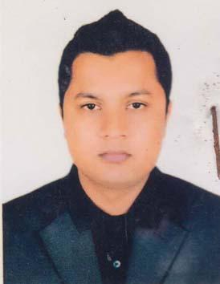 | TUSHAR DKUMAR PODAR  F/Name: Kshitish Chandra Podar  M/Name: Komola Rani Poddar  BM & DC Reg. No: 51727  NID: 8685557814  Cell: 01717304854  Address: IMO (Nephrroology) Khulna Medical College Hospital, Khulna  Blood Group: B+
995 | Voter No  LM-2900989  No Image | DR AHMED FOISAL  F/Name: Alauddin Ahmed  M/Name: Rima Ahmed  BM & DC Reg. No: 61039  NID: 19889196201102631  Cell: 01766906000  Address: 551/1, Guakhola, Abhaynagar, Jashore  Blood Group: O+
996 | Voter No  LM-2900990  No Image | DR. SWEETY DAS  F/Name: Sheful Chandra Das  M/Name: Laxmi Rani Das  BM & DC Reg. No: 77202  NID: 19902697520000007  Cell: 01799440326  Address: Daktarpara, Chhotoboyra, Khulna Medical College Hospital, Khulna  Blood Group: O+
997 | Voter No  LM-2900991  No Image | YASMIN SULTANA ANNY  F/Name: Sheikh Abdul Hannay  M/Name: Ozita Khatuy  BM & DC Reg. No: 81963  NID: 1457491365  Cell: 01931277611  Address: 22/18, Old Gollamari Road, Khulna  Blood Group: O+
998 | Voter No  LM-2900992  No Image | DR MD IKTIER HASSAN KHAN  F/Name: Md. Abdul Goni Khan  M/Name: Shamsun Nahar  BM & DC Reg. No: 26712  NID: 2694811038764  Cell: 01712675814  Address: 106, Khanjahan Ali Road, Khulna  Blood Group: B+
999 | Voter No  LM-2900993  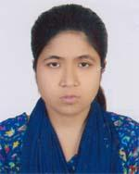 | DR LOPA SAHA  F/Name: Swapan Saha  M/Name: Anjazi Rani Saha  BM & DC Reg. No: 75982  NID: 19906125214000099  Cell: 01760499089  Address: House- 3, 1 Kakuli Bhaban, Khulna  Blood Group: O+
1000 | Voter No  LM-2900994  No Image | DR ANINDO KUMAR SAHA  F/Name: Dr. B. D. Saha  M/Name: Dr. Shima Poddar Saha  BM & DC Reg. No: 46464  NID: 19842691649103013  Cell: 01919435427  Address: House: 3, 1 Kakulibag Lane, Khulna  Blood Group: AB+
1001 | Voter No  LM-2900995  No Image | DR LUCKY BISWAS  F/Name: Bishwanath Biswas  M/Name: Kamala Biswas  BM & DC Reg. No: 107502  NID: 3754756967  Cell: 01609027672  Address: 180, West Baniakhamar Main Road, Bihari Colony More, Khulna  Blood Group: B+
1002 | Voter No  LM-2900996  No Image | DR. B. M. SAIFUR RAHMAN  F/Name: Md. Bador Uddin Biswas  M/Name: Awria Begum  BM & DC Reg. No: 29488  NID: 5529664780  Cell: 01711184530  Address: 48, KDA, Avenue, Sonadanga, Khulna  Blood Group: B+
1003 | Voter No  LM-2900997  No Image | ROKSANA PARVIN  F/Name: Md. Makbul Hossain  M/Name: Nurjahan  BM & DC Reg. No: 54419  NID: 4798517233371  Cell: 01717410308  Address: Sonadanga R/A, House-431, Road-7, Sonadanga, Khulna  Blood Group: O+
1004 | Voter No  LM-2900998  No Image | DR. NAZDAN LASKER  F/Name: Shawkat Ali Lasker  M/Name: Farzana Begum  BM & DC Reg. No: 68960  NID: 2619551169060  Cell: 01722077651  Address: 86, Islampur Road, Dolkhola, Khulna  Blood Group:
1005 | Voter No  LM-2900999  No Image | DR. HADIUR RAHMAN SIAM  F/Name: Habibur Rahman  M/Name: Shahana Rahman  BM & DC Reg. No: 91322  NID: 7355056925  Cell: 01712958782  Address: Flat-5C, Shopnil Garden, PTI More, Khulna  Blood Group: A+
1006 | Voter No  LM-2901000  No Image | DR. ADIBA HABIB  F/Name: Ashabul Habib  M/Name: Farah Naz Mahmud  BM & DC Reg. No: 101336  NID: 8251108760  Cell: 01123953331  Address: Flat-5C, Shopnil Garden, PTI More, Khulna  Blood Group: B+
1007 | Voter No  LM-2901001  No Image | DR. ABDULLAH -AL-MAMUD  F/Name: Mia Md. Shahjahan  M/Name: Shahina Akter  BM & DC Reg. No: 59119  NID: 3293471102  Cell: 01756820972  Address: Mia Mansion, B-30, Road-171, Central West Block, Housing Estate, Khalishpur, Khulna  Blood Group: O+
1008 | Voter No  LM-2901002  No Image | DR. MOHAMMAD REZAUL MOMIN  F/Name: Mohammad Abdul Karim  M/Name: Sajeda Begum  BM & DC Reg. No: 34633  NID: 19742695435953002  Cell: 01715405237  Address: 6, Beni Babu Road, Flat 3/C, Icon MM Height, Khulna  Blood Group: B+
1009 | Voter No  LM-2901003  No Image | DR. FATEMA JORORA  F/Name: Mohammad Abdul Halim  M/Name: Tanlila Khanom  BM & DC Reg. No: 49318  NID: 1483925028  Cell: 01724514448  Address: 6, Beni Babu Road, Flat 3/C, Icon MM Height, Khulna  Blood Group: O+
1010 | Voter No  LM-2901004  No Image | DR. FOUZIA AKHTER  F/Name: Md. Hemayet Uddin  M/Name: Mrs. Noorjahan Begum  BM & DC Reg. No: 44653  NID: 7331268875  Cell: 01712188438  Address: 629, House, oad-9, Mujgunni R/A, Boyra, Khulna  Blood Group: B+
1011 | Voter No  LM-2901005  No Image | DR. MD. AMINUR RAHAMAN  F/Name: Md. Atiar Rahaman  M/Name: Mahfuza Rahaman  BM & DC Reg. No: 87355  NID: 4172402960  Cell: 01779250529  Address: Halder Bari, Vill-Arazi Dumuria, Post-Sajiara, P.S: Dumuria, Dist: Khulna  Blood Group: O+
1012 | Voter No  LM-2901006  No Image | TANIA ZAMAN  F/Name: A. K. M. Khalequzzaman  M/Name: Nurun Nahar  BM & DC Reg. No: 56378  NID: 8231301048  Cell: 01912524456  Address: 107, Sir Iqbal Road, Khulna (Behind Khulna Press Club)  Blood Group: O+
1013 | Voter No  LM-2901007  No Image | DR. IFTEKHAR BIN RAZZAQUE  F/Name: Hazra Abdur Razzaque  M/Name: Mrs. Lutfunnessa  BM & DC Reg. No: 73419  NID: 8203561116  Cell: 01921801756  Address: 87/1, Hazi Ismail Link Road, Al-Amin Moholla, Sonadanga, Khulna  Blood Group: O+
1014 | Voter No  LM-2901008  No Image | DR. MD. MONIRUZZAMAN  F/Name: Md. Wazzel Haque  M/Name: Meherunnesa  BM & DC Reg. No: 29468  NID:  Cell: 01711302894  Address: Khulna Medical College, Khulna  Blood Group: A+
1015 | Voter No  LM-2901009  No Image | FATEMA TUZ ZOHORA  F/Name: Md. Mostafizur Rahman  M/Name: Fauzia Hossain  BM & DC Reg. No: 108399  NID: 1952275202  Cell: 01969805427  Address: Khulna University Engineering & Technology, Khanjahan Ali, Khulna  Blood Group: A+
1016 | Voter No  LM-2901010 | DR. MD. ABDUR RAHIM  F/Name: Md. Abdul Malek  M/Name: Rokeya Begum  BM & DC Reg. No: 109230  NID: 3758019727  Cell: 01705992246  Address: Room No-303, Dormitory Block-B, Khulna University Of Engineering & Technology, Khulna.  Blood Group: O+
1017 | Voter No  LM-2901011  No Image | SURAIYA BINTE AZAM  F/Name: Md. Saiful Islam  M/Name: Kaniz Fatema  BM & DC Reg. No: 71444  NID: 1456488665  Cell: 01766329812  Address: 139, Khanjahan Ali Road, Khulna  Blood Group: B+
1018 | Voter No  LM-2901012  No Image | DR. BONDONA RAY BHADON  F/Name: Rabindro Nath Ray  M/Name: Usha Rani Sewly  BM & DC Reg. No: 78589  NID: 5084028223  Cell: 01930339211  Address: 21/1, Sobeda Tolar More, Nirala, Khulna  Blood Group: B+
1019 | Voter No  LM-2901013  No Image | DR. MD. MAINUL ISLAM  F/Name: Late Md. Maksudur Rahman  M/Name: Nurzahan Begum  BM & DC Reg. No: 51778  NID: 19847914763000012  Cell: 017469390  Address: Sonadanga Abashik-3, Khulna  Blood Group: B+
1020 | Voter No  LM-2901014  No Image | DR. JANNATUL FERDOUSI  F/Name: K.M Bazlur Rahman  M/Name: Mrs. Hasina Khatun  BM & DC Reg. No: 42529  NID: 6419553471  Cell: 01754739159  Address: Flat-5A, Road-6, Plot-426, Sonadanga 2nd Phase, Khulna  Blood Group: O+
1021 | Voter No  LM-2901015  No Image | DR. MD. SHOWKAT ALI  F/Name: Habibur Rahman  M/Name: Firoza Begum  BM & DC Reg. No: 32185  NID: 2691649460646  Cell: 01711474954  Address: 3/F, Doctors Quater, Khulna Medical College, Khulna  Blood Group: B+
1022 | Voter No  LM-2901016  No Image | DR. MD. SHAMIN-UZ-ZAMAN  F/Name: Abdul Hamid Mollah  M/Name: Fatema Begum  BM & DC Reg. No: 49069  NID: 19844798516214913  Cell: 01712237451  Address: Vill+Post-Damodar, P.S-Fultola, Khulna, Dist: Khulna.  Blood Group: B+
1023 | Voter No  LM-2901017  No Image | DR. MD. ABU NAYEEM QURAISHE  F/Name: Md. Quraishe Rashidunnabi  M/Name: Mst. Nasima Begum  BM & DC Reg. No: 49252  NID: 5059661891  Cell: 01712281526  Address: 63/1, 8 Chowdhury Para Road, Mirerdanga, Fulbarigate, Daulatpur, Khulna.  Blood Group: B+
1024 | Voter No  LM-2901018  No Image | DR. JAKEYAH FERDAUSHI  F/Name: Md. Amzad Hossain  M/Name: Mrs. Sufia Nasrin  BM & DC Reg. No: 48447  NID: 2694066782367  Cell: 01717460381  Address: Fulbarigate, Khulna  Blood Group: B+
1025 | Voter No  LM-2901019  No Image | DR. DIPTA DEY  F/Name: Shankar Dey  M/Name: Mala Dey  BM & DC Reg. No: 110672  NID: 7314031126  Cell: 01751785412  Address: House-65, Road-14, Sonadanga R/A, Phase 2, Khulna  Blood Group: B-
1026 | Voter No  LM-2901020  No Image | DR. B.M KHALID ERFAN ABIR  F/Name: B.M.A. Nasir  M/Name: Rahima Ferdousi  BM & DC Reg. No: 103597  NID: 6871423320  Cell: 01717981589  Address: House-278, 3rd Floor, Road-20, Mujunni, Khalishpur, Khulna.  Blood Group: O+
1027 | Voter No  LM-2901021  No Image | DR. SHAMIMA SULTANA  F/Name: Moustaque Abedin  M/Name: Tahamina Abedin  BM & DC Reg. No: 71410  NID:  Cell: 01675850974  Address: 47, West Lane, South Toothpara Circuler Road, Khulna.  Blood Group: A+
1028 | Voter No  LM-2901022  No Image | DR. SHAMIA ZAMAN  F/Name: A.K.M. Khalequazzaman  M/Name: Nurun Nahar  BM & DC Reg. No: 95673  NID: 4193345305  Cell: 01920395736  Address: Noorjahan House, 107, Sir Iqbal Road (Behind Khulna Press Club), Khulna.  Blood Group: A+
1029 | Voter No  LM-2901023  No Image | DR. MD. ISTIAK AHMED  F/Name: Md. Abdul Motin Howlader  M/Name: Salma Sultana  BM & DC Reg. No: 113796  NID: 5548398907  Cell: 01923948550  Address: Vill-Sonatola, Post-Bagerhat Sadar, Dist-Bagerhat.  Blood Group: O+
1030 | Voter No  LM-2901024  No Image | DR. HOLY BISWAS  F/Name: Samar Kanti Biswas  M/Name: Protiva Biswas  BM & DC Reg. No: 103598  NID:  Cell: 01748164533  Address: Sur Mahammod Road, Karimnagar, Khulna.  Blood Group: O+
1031 | Voter No  LM-2901025  No Image | DR. MD. SHAHIN AKTER SHAIKH  F/Name: Md. Bayzied Ali  M/Name: Nasima Begum  BM & DC Reg. No: 58098  NID: 8223519862  Cell: 01718775710  Address: 44/55, Anisnagar, 2, Islamia College Road, Khulna.  Blood Group: O+
1032 | Voter No  LM-2901026  No Image | DR. DIPANKAR GHOSH (PALASH)  F/Name: MR. Ananta Kumar Ghosh  M/Name: Mrs. Hena Rani Ghosh  BM & DC Reg. No: 60191  NID: 8652480727  Cell: 01718849695  Address: Department of Neurosurgery, KMCH.  Blood Group: A+
1033 | Voter No  LM-2901027  No Image | DR. RAIRUZ ZAHIN  F/Name: Sk. Amzad Hossain  M/Name: Mst. Ferdaushi Sultana  BM & DC Reg. No: 108400  NID: 8255305990  Cell: 01711950268  Address: P-02, Doctor para, CHoto Boyra, Sonadanga, Khulna.  Blood Group: A+
1034 | Voter No  LM-2901028  No Image | DR. KEYA RANI DAS  F/Name: Bikash Chandra Das  M/Name: Laxmi Rani Das  BM & DC Reg. No: 76559  NID: 19924792105000025  Cell: 01915902402  Address: KDA, Boundar Road, Daulatpur, Khulna.  Blood Group: O+
1035 | Voter No  LM-2901029  No Image | DR. BADAL CHANDRA DEBNATH  F/Name: Ratan Dulal Debnath  M/Name: Mira Debnath  BM & DC Reg. No: 74068  NID: 19891324909425230  Cell: 01823632073  Address: 32/8, Sur Mohammad Road, Karimnagar, Boyra, Sonadanga, Khulna.  Blood Group: B+
1036 | Voter No  LM-2901030  No Image | DR. MD. FAZLE RABBY  F/Name: Md. Harun Or Rashid  M/Name: Mst. Rahima Yasmin  BM & DC Reg. No: 105496  NID: 5556272358  Cell: 01700821013  Address: 32/3, Sahebpara, Daulatpur, Khulna City Corporation, Khulna.  Blood Group: O+
1037 | Voter No  LM-2901031  No Image | DR. MD. SOHEL RANA  F/Name: Md. Harun-or-rashid  M/Name: Saleha Begum  BM & DC Reg. No: 46360  NID: 4716976016810  Cell: 01716371011  Address: Vill-Jugnipasha, Post-Rajghat, P.S.-Fultola, Dist-Khulna.  Blood Group: A+
1038 | Voter No  LM-2901032  No Image | DR. SK. FARHANA FARUK  F/Name: Sk. Golam Faruk  M/Name: Tahmina Khatun  BM & DC Reg. No: 95400  NID: 1953673512  Cell: 01926229729  Address: H-25/17, Madrasa Road (In front of KMCH) Choto Boyra, Sonadanga, Khulna.  Blood Group: B+
1039 | Voter No  LM-2901033  No Image | DR. ANUP KUMAR GHOSH  F/Name: Mukunda Kumar Ghosh  M/Name: Nanda Rani Ghosh  BM & DC Reg. No: 59995  NID: 4798517246358  Cell: 01912964643  Address: Vill-Soto Boyra, G.P.O- 9000. Sonadanga, Khulna.  Blood Group: B+
1040 | Voter No  LM-2901034  No Image | DR. MD. MOHAIMINUL HOQUE  F/Name: Late. Md. Sakhawat Hossain  M/Name: Late. Begum Rokea Khatun  BM & DC Reg. No: 58704  NID: 5950810837  Cell: 01772684765  Address: H/N-180, R/N-11, 2nd Phase, Sonadanga R/A, Sonadanga, Khulna  Blood Group: O+
1041 | Voter No  LM-2901035  No Image | DR. FARZANA YASMIN  F/Name: Muhammad Shamsul Alam  M/Name: Khaleda Akhter  BM & DC Reg. No: 76773  NID: 8250740787  Cell: 01737190280  Address: Vill-Rampal, Post-Rampal, Dist-Bagerhat.  Blood Group: O+
1042 | Voter No  LM-2901036  No Image | DR. ABDULLAH AL MAMUN  F/Name: Md. Abdul Mannan  M/Name: Mst. Moriom Begum  BM & DC Reg. No: 67042  NID: 4161647146  Cell: 01722865288  Address: Flat 5C, Shopnil Garden, PTI More, Khulna.  Blood Group: n_a
1043 | Voter No  LM-2901037  No Image | DR. SANJANA RAHMAN  F/Name: Habibur Rahman  M/Name: Shahana Rahman  BM & DC Reg. No: 67037  NID: 4184438754  Cell: 01756990897  Address: Flat 5C, Shopnil Garden, PTI More, Khulna.  Blood Group: A+
1044 | Voter No  LM-2901038  No Image | DR. S.M. ABDUL AZIZ  F/Name: S.M. Wahiduzzaman  M/Name: Selina Begum  BM & DC Reg. No: 98834  NID: 3253009629  Cell: 01932086704  Address: Vill+Post-Kahalpur, Thana-Mollahat, Dist-Bagerhat.  Blood Group: O+
1045 | Voter No  LM-2901039  No Image | DR. M.M. RAFIQUZZAMAN  F/Name: Sirazul Islam  M/Name: Taslima Islam  BM & DC Reg. No: 98835  NID: 5951838951  Cell: 01921111771  Address: UHC, Mujibnagar, Meherpur  Blood Group: A+
1046 | Voter No  LM-2901040  No Image | DR. FATEMA JAHAN METY  F/Name: Kabir Uddin Chowdhury  M/Name: Nurjhan Begum  BM & DC Reg. No: 108579  NID: 7352258623  Cell: 01559074055  Address: Vill-Garpha, Post-Mollahat, Dist-Bagerhat.  Blood Group: B+
1047 | Voter No  LM-2901041  No Image | DR. BIVUTY MOLLIK  F/Name: Binoy Mollik  M/Name: Rekha Mollik  BM & DC Reg. No: 88266  NID: 2824020552  Cell: 01774482828  Address: Bramhondanga, Chunkhola, Mollahat, Bagerhat.  Blood Group: AB+
1048 | Voter No  LM-2901042  No Image | DR. MD. HARUN-OR-RASHID  F/Name: Md. Jamsed Ali  M/Name: Tohmina Begum  BM & DC Reg. No: 98836  NID: 9114504773  Cell: 01951419495  Address: UHC, Terokhada, Khulna  Blood Group: B+
1049 | Voter No  LM-2901043  No Image | DR. ANIK KUNDU  F/Name: Tapash Kundu  M/Name: Purnima Kundu  BM & DC Reg. No: 100436  NID: 7767246544  Cell: 01725564179  Address: 38, Islampur Road, Dolkhola, Khulna Sadar, Khulna.  Blood Group: B+
1050 | Voter No  LM-2901044  No Image | DR. MD. RIDWANUL ISLAM  F/Name: Dr. Md. Rafiqul Islam  M/Name: Dr. Mst. Dilruba Parvin  BM & DC Reg. No: 93706  NID: 2383857949  Cell: 01677475536  Address: P-02, Doctor Road, Chto Boyra, Sonadanga, Khulna.  Blood Group: O+
1051 | Voter No  LM-2901045 | DR MD EBRAHIM MOLLA  F/Name: Ab Rokib Molla  M/Name: Jesminia Begum  BM & DC Reg. No: 79937  NID: 7794595376  Cell: 01718861015  Address: 92/1 West Bniayakhamar Cross Road, Bashtola Bashupara, Khulna.  Blood Group: O+
1052 | Voter No  LM-2901046  No Image | DR. RIFAT MAHMOOD DOLA  F/Name: A.s.m. Shahabuddin Mahmood  M/Name: Sabera Ahmood  BM & DC Reg. No: 94688  NID: 3302641453  Cell: 01706163771  Address: 80' Mollahat UHC.  Blood Group: A+
1053 | Voter No  LM-2901047  No Image | DR. APURBA BISWAS  F/Name: Tarun Biswas  M/Name: Tripti Biswas  BM & DC Reg. No: 105201  NID: 5514233864  Cell: 01711453979  Address: Shahid Dr. Murtoza Internee Hostel, KMCH.  Blood Group: O-
1054 | Voter No  LM-2901049  No Image | DR. A.S.M.HUMAYUN KABIR (APU)  F/Name: S.m. Abdur Rashid  M/Name: Jahanara Begum  BM & DC Reg. No: 34698  NID:  Cell: 01712687456  Address: Urology Dept. Sheikh Abu Naser Specialized Hospital Khulna.  Blood Group: AB-
1055 | Voter No  LM-2901050  No Image | DR. SK. KHALIDUZZAMAN  F/Name: Late: Sk. Amzad Ali  M/Name: Late: Khaleda Ali  BM & DC Reg. No: 25748  NID: 2697557402089  Cell: 01726779997  Address: 8, Nazirghat Cross Road, West Baniakhamar, Khulna.  Blood Group: B+
1056 | Voter No  LM-2901051  No Image | DR. S.M MORSHED  F/Name: Abdul Aziz  M/Name: Morsheda Begum  BM & DC Reg. No: 17919  NID: 2822753915  Cell: 01716241750  Address: 99/1 (ka) South Central Road, Khulna.  Blood Group: O+
1057 | Voter No  LM-2901052  No Image | DR. NUSRAT JAHAN LINDA  F/Name: Sheikh Akram Hossain  M/Name: Nur Jahan Sabiha  BM & DC Reg. No: 56212  NID: 4716919755583  Cell: 01934103160  Address: Shiromoni Khulna.  Blood Group: B+
1058 | Voter No  LM-2901053  No Image | DR. FIROZ AHMED  F/Name: Md Abdus Samad  M/Name: Firoza Begum  BM & DC Reg. No: 79405  NID: 19938827802000107  Cell: 01755267186  Address: House-413 (Bustan) Road-1 Sonadanga 2nd phase Khulna.  Blood Group: O+
1059 | Voter No  LM-2901054  No Image | DR. GAZI TANZUMA SHEHNAZ  F/Name: Gazi Mizanur Rahman  M/Name: Tania Rahman  BM & DC Reg. No: 113104  NID: 3302995877  Cell: 01714086834  Address: H.N: 9th Floor, A 19-21 Mazid Saroni Sonadanga Khulna.  Blood Group: n_a
1060 | Voter No  LM-2901055  No Image | DR. MD. SHARIFUL ISLAM  F/Name: Md. Hakim Gazi  M/Name: Rehana Begum  BM & DC Reg. No: 56057  NID: 19884798516214722  Cell: 01725453874  Address: Karim Nagor, Sonadangha, Khulna.  Blood Group: O+
1061 | Voter No  LM-2901056  No Image | DR. ZIASMIN AKTER  F/Name: Late. Mizanur Rahman Mufti  M/Name: Anowara Sultana  BM & DC Reg. No: 56078  NID: 4798517233103  Cell: 01717087043  Address: Karimnager Sonadanga Khulna  Blood Group: B+
1062 | Voter No  LM-2901057  No Image | DR. AZAZ AHMAD ROMY  F/Name: Late. Shaikh Abdul Wadud  M/Name: Late. Khairun Nahar  BM & DC Reg. No: 100205  NID: 2402999672  Cell: 01716714686  Address: 160, Choto boyra Main Road, Sonadanga KHulna.  Blood Group: B+
1063 | Voter No  LM-2901058  No Image | DR. TAHMINA FERDOUES TANNI  F/Name: Farid Ahmed  M/Name: Tahera Begum  BM & DC Reg. No: 98263  NID: 19911595707002403  Cell: 01614586058  Address: 160, Choto Boyra Main Road Sonadanga Khulna.  Blood Group: B+
1064 | Voter No  LM-2901059  No Image | DR. MD. REAZ AHMED HOWLADER  F/Name: Md. Readul Islam Howlader  M/Name: Mrs. Saleha Begum  BM & DC Reg. No: 51249  NID: 6422835782  Cell: 01717323161  Address: Khulna Medical College Hospital, Khulna.  Blood Group: B+
1065 | Voter No  LM-2901060  No Image | DR. RAHNUMA ARMAN MEGHLA  F/Name: Sk. Aminur Rahman  M/Name: Ruksana Perveen  BM & DC Reg. No: 108342  NID: 7793364287  Cell: 01745027646  Address: Mujgunni 23 No Road, Khulna.  Blood Group: A+
1066 | Voter No  LM-2901061 | DR. MD. HASANUZZAMAN  F/Name: Md. Kafiluddin Ahmed  M/Name: Mrs. Sabironnesa  BM & DC Reg. No: 35446  NID: 6429782060  Cell: 01711064908  Address: Jr. Con(surg) Khulna Medical College KHulna  Blood Group: O-
1067 | Voter No  LM-2901062  No Image | DR. MD KHAN ARAFAT ISLAM  F/Name: Khan Nurul Azam  M/Name: Mrs. Rupia  BM & DC Reg. No: 108641  NID: 1927423234  Cell: 01621585065  Address: Kalishpur, Khulna  Blood Group: O+
1068 | Voter No  LM-2901063  No Image | DR. PREYA GHOSH  F/Name: Babul Ghosh  M/Name: Keka Ghosh  BM & DC Reg. No: 116050  NID: 1025751916  Cell: 01312366636  Address: Sonadanga, Khulna  Blood Group: O+
1069 | Voter No  LM-2901064  No Image | DR. JISHNU PADA MUKHERFEE  F/Name: Jagat Bondhu Mukherjee  M/Name: Usna Rani Mukherjee  BM & DC Reg. No: 15489  NID: 4716450074504  Cell: 01715028945  Address: Suvo Diagnostic Clinic, Kapilmuni Paikgacha  Blood Group:
1070 | Voter No  LM-2901065  No Image | DR. MD. ASIFUL ISLAM  F/Name: Md. Nizam Uddin  M/Name: Forida Begum  BM & DC Reg. No: 40181  NID: 5520181990  Cell: 01718230166  Address: 71/10 Boundary Road, Deana Uttar Para Daulatpur Khulna  Blood Group: O-
1071 | Voter No  LM-2901066  No Image | DR. MAHBUB UL ALAM  F/Name: Ibrahim Khalil  M/Name: Anjuman Ara  BM & DC Reg. No: 81986  NID: 5983802603  Cell: 01717201483  Address: 48/6 Ispahani 1st Lane, Rusha Stand road Khulna  Blood Group: O+
1072 | Voter No  LM-2901067  No Image | DR. NIPA RANI GHOSH  F/Name: Gobinda Kumar Ghosh  M/Name: Sabita Rani Ghosh  BM & DC Reg. No: 63123  NID: 4602475164  Cell: 01717360058  Address: Boyra, Khulna  Blood Group: A+
1073 | Voter No  LM-2901068  No Image | DR. SUMONA SHARMIN  F/Name: Md. Abdul Aziz Mir  M/Name: Roksana Dilruba  BM & DC Reg. No: 69203  NID: 7349205257  Cell: 01553450600  Address: 38/4 Nazir Ghat Road Khulna  Blood Group: B+
1074 | Voter No  LM-2901069  No Image | DR. MOLLICK ISTTAK AHMED CHAYON  F/Name: Mollick Bokttar Hossain  M/Name: Nelufa Afroz  BM & DC Reg. No: 112121  NID: 7772403742  Cell: 01713900777  Address: Holding No:141/09 Vill: Rampal , Post: Rampal.Bagerhat  Blood Group: B+
1075 | Voter No  LM-2901070  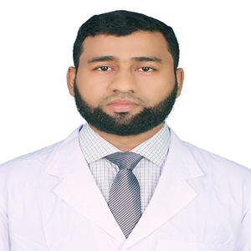 | DR. MD. NAZMUL HUSSAIN  F/Name: Md. Golam Mostafa  M/Name: Nazma Khatun  BM & DC Reg. No: 71604  NID: 7798338575  Cell: 01715351491  Address: Shahid Sheikh Abu Naser Specialized Hospital Quater, Khulna  Blood Group: B+
1076 | Voter No  LM-2901071  No Image | DR. MITHUN KUMAR BISWAS  F/Name: Bimal Krishna Biswas  M/Name: Geeta Rani Biswas  BM & DC Reg. No: 73266  NID: 1990871039000004  Cell: 01138105823  Address: Khulna Medical College Hospital, Surgery Unit-11  Blood Group: B+
1077 | Voter No  LM-2901072  No Image | DR. RAJIB KUMER KUNDU  F/Name: Shyamal Kumer Kundu  M/Name: Ila Nandi  BM & DC Reg. No: 102269  NID: 8667919776  Cell: 01724534083  Address: Vill: Goalpara Post+Thana: Digholia-9220, Dist: KHulna  Blood Group: O+
1078 | Voter No  LM-2901073  No Image | DR. MADHABENDU SARKAR  F/Name: Sarkar Bireshwar  M/Name: Aruti Sarkar  BM & DC Reg. No: 104247  NID: 1965156373  Cell: 01753506798  Address: Shahid Dr. Murtuta Interny Hostel  Blood Group: O+
1079 | Voter No  LM-2901074  No Image | DR. SK ARAFAT MAHMOOD  F/Name: SK. Md. Abdur Mayiean  M/Name: Rubina Zesmin  BM & DC Reg. No: 70759  NID: 5052471280  Cell: 01711048950  Address: House No-200 Road No-10 Sonadanga R/A (phase-11) Khulna  Blood Group: O+
1080 | Voter No  LM-2901075  No Image | DR. SONEYA HAIDER  F/Name: SK. Daud Haider  M/Name: Kamrun Nahar  BM & DC Reg. No: 51629  NID: 4632671378  Cell: 01983001657  Address: House 86, Modhaydanga Main Road Daulatpur Khulna  Blood Group: A+
1081 | Voter No  LM-2901076  No Image | DR. NIPA GHOSH  F/Name: Bjoy Ghosh  M/Name: Rekha Ghosh  BM & DC Reg. No: 71443  NID: 9554350133  Cell: 01724716268  Address: 9/2 Islampur Cross Road, Kholna  Blood Group: A+
1082 | Voter No  LM-2901077  No Image | DR. SHAKILA KABIR  F/Name: Late Humayun Kabir  M/Name: Jahanara Kabir  BM & DC Reg. No: 48243  NID: 8198510364368  Cell: 01734749138  Address: Road No: 156 PLot No: 96 Hosing estate Khalishpur Khulna  Blood Group: A+
1083 | Voter No  LM-2901078  No Image | DR. SILVIA PARVIN  F/Name: Sk Abul Kalam  M/Name: Zahanara Kalam  BM & DC Reg. No: 76560  NID:  Cell: 01929035019  Address: Shahid Sheikh Abu Naser Specialized Hospital Quarter  Blood Group: O+
1084 | Voter No  LM-2901079  No Image | DR. KHAN RIAZ MAHMUD ZIKO  F/Name: Md. Kuddus Ali Khan  M/Name: Rehena Khanam Rina  BM & DC Reg. No: 69693  NID: 8684131231  Cell: 01723909786  Address: House: 391, Road:22 Mijgunni Residential Area, Khalishpur, Khulna  Blood Group: B+
1085 | Voter No  LM-2901080 | DR. RAZIB KRISHNA MANDAL  F/Name: Nirmal Chandra Mandal  M/Name: Sumita Ran Mandal  BM & DC Reg. No: 47466  NID: 19820126005698232  Cell: 01722888965  Address: Abu NAser Specialized Hospital, KHulna  Blood Group: B+
1086 | Voter No  LM-2901081  No Image | KANCHAN SUTRADHAR  F/Name: Manoranjan Sutkadhar  M/Name: Swarna Rani Sutradhar  BM & DC Reg. No: 64971  NID:  Cell: 01915872230  Address: 2, Sir Iqbal Road, Khulna  Blood Group: O+
1087 | Voter No  LM-2901082  No Image | ASHRAFUL ALAM  F/Name: MD. Saha Alam  M/Name: Mrs. Manjuara Alam Mukti  BM & DC Reg. No: 114076  NID: 7355359071  Cell: 01754199992  Address: 39, Moddhopara School Road, Khalishpur, Khulna  Blood Group: A+
1088 | Voter No  LM-2901083  No Image | DR. ASHRAFUL ALAM  F/Name: Ramendra Nath Mallick  M/Name: Mousumi Mallick  BM & DC Reg. No: 77830  NID: 507546937  Cell: 0172002349  Address: 250, Bedded General Hospitalm Meherpur,  Blood Group: B+
1089 | Voter No  LM-2901084  No Image | DR. SOHAG DAS  F/Name: Ardhendu Shekhar Das  M/Name: Susama Das  BM & DC Reg. No: 74436  NID: 1480953742  Cell:  Address: Holding No-150/2 (ka) boyra MAin Road KHulna  Blood Group: O+
1090 | Voter No  LM-2901085  No Image | DR. KANETA TALAT CHOWDHURY  F/Name: Babul Ahmed Chowdhury  M/Name: Hamida Begum  BM & DC Reg. No: 77231  NID: 2405594439  Cell: 01731304277  Address: 37/5 Soto Boyra Chasarobas Sonadanga KHulna  Blood Group: O+
1091 | Voter No  LM-2901086  No Image | DR.MD AKTER UZZAMAN.  F/Name: Md. Motahar Ali  M/Name: Rehena Begum  BM & DC Reg. No: 81632  NID: 9574473857  Cell: 01728446436  Address: A 19/21 MAjid Sarani Sonadanga KHulna  Blood Group: B+
1092 | Voter No  LM-2901087  No Image | DR. SURYA ISLAM  F/Name: S.M. Monirul Islam  M/Name: Shirin Sultana  BM & DC Reg. No:  NID: 9117683079  Cell: 01719327718  Address: H-199, Road No: 06 Prottasha R/A South Nirala Khulna  Blood Group: B+
1093 | Voter No  LM-2901088  No Image | DR. PRITHWY SHANKAR BISWAS  F/Name: Ram Chandra Biswas  M/Name: Shefali Biswas  BM & DC Reg. No: 62988  NID: 2617272869168  Cell: 01916982478  Address: Gazi Medical college, Khulna  Blood Group: B+
1094 | Voter No  LM-2901089  No Image | DR. SHARMIN AHMED NISHE  F/Name: Gazi Sultan Uddin  M/Name: Nasima Khatun  BM & DC Reg. No:  NID: 5516160453  Cell: 01706442338  Address: Road No. 05, 2nd Phase Sonadanga KHulna  Blood Group: B+
1095 | Voter No  LM-2901090  No Image | DR. SYEDA NOORJAHAN KARIM  F/Name: Syed Abdul Karim  M/Name: Selina Karim  BM & DC Reg. No:  NID: 4795123416009  Cell: 01676110315  Address: Castle Momtaz, Hose No-297, Road No- 9 Sonadanga R/A Khulna  Blood Group: A+
1096 | Voter No  LM-2901091  No Image | DR. ABU MD. MAYEENUDDIN AL AMIN  F/Name: S.M. Mahabubul Amin Selim  M/Name: Daulatun Nahar Hashi  BM & DC Reg. No: 60972  NID: 4798516214730  Cell: 01670714951  Address: Castle Momtaz, Hose No-297,2B Road No- 9 Phase-1, Sonadanga Residential Area, Khulna.  Blood Group: B+
1097 | Voter No  LM-2901092  No Image | DR. BIPLAB KUMAR ROY  F/Name: Samir Roy  M/Name: Dipti Roy  BM & DC Reg. No: 69699  NID: 19871926709062123  Cell: 01723726212  Address: Road No- 11, House No- 152, 2nd phase Sonadanga R/A Khulna.  Blood Group: O+
1098 | Voter No  LM-2901093  No Image | DR. LUIES SOURAV SARKAR  F/Name: Badal Sarkar  M/Name: Makulet Sarkar  BM & DC Reg. No: 105358  NID: 5520742536  Cell: 01727071375  Address: 58, Khan Jahan Ali Road Khulna Sadar 9100, Khulna.  Blood Group: B+
1099 | Voter No  LM-2901094  No Image | DR. ASHRAFUNNESA ZERIN  F/Name: F.M. Sheriful Islam  M/Name: Mehfuze Khatun  BM & DC Reg. No: 60795  NID: 4172850234  Cell:  Address: KDA Approach Road Sonadanga R/A Khulna.  Blood Group: A+
1100 | Voter No  LM-2901095  No Image | DR. NADIA TABASUM TISHA  F/Name: Yunus Ali  M/Name: Rowgon Ara  BM & DC Reg. No: 70866  NID: 5100470813  Cell: 01911134009  Address: Tutpara Khulna.  Blood Group: n_a
1101 | Voter No  LM-2901096  No Image | DR. WASILUL ISLAM ZISAN  F/Name: Sariful Islam  M/Name: Mahfuza Khatun  BM & DC Reg. No: 86209  NID:  Cell: 01911134009  Address: Gollamari Khulna.  Blood Group: n_a
1102 | Voter No  LM-2901097  No Image | DR. HUMAIRA PARVEEN  F/Name: Sardar Aminur Rahman  M/Name: Kazi Afroza Parveen  BM & DC Reg. No: 95811  NID: 2403004266  Cell: 01791314145  Address: 7/5 Puraton Gollamari Road West Bania Khamar Khulna.  Blood Group: AB+
1103 | Voter No  LM-2901098  No Image | DR. SUKANTA KUMAR PAL  F/Name: Shanti Ranjan Pal  M/Name: Mamata Rani Pal  BM & DC Reg. No: 52172  NID:  Cell:  Address: V.I.P- Gilatala Thana- Rampal, Dist- Bagerhat.  Blood Group:
1104 | Voter No  LM-2901099  No Image | DR. S.M.A JABBAR FARUQUEE  F/Name: Shaikh Md. Shafiur Rahman  M/Name: Khadizatul Kobra  BM & DC Reg. No: 86077  NID: 6425194526  Cell: 01744969605  Address: Vill: Uttarpara, P.O+P.S: Fakirhat , Dist: Bagerhat.  Blood Group: O+
1105 | Voter No  LM-2901100  No Image | DR. ABIDATOUSE SUMAIYA  F/Name: Md. Alauddin Howlader  M/Name: Nasima Mustafa  BM & DC Reg. No: 109738  NID: 4155642327  Cell: 01766288475  Address: House No- 302, Road No-04, Sonadanga Residential Area (2nd Phase) Khulna.  Blood Group: A+
1106 | Voter No  LM-2901101  No Image | DR. MARIAM  F/Name: Md. Forhad Hossain  M/Name: Shahana Hossain  BM & DC Reg. No: 74066  NID: 9103781747  Cell: 01711285893  Address: Khalishpur New Road, Khulna.  Blood Group: n_a
1107 | Voter No  LM-2901102  No Image | DR. SUMONA HUQ  F/Name: Khan Md. Nasirul Alam  M/Name: Maharunnasa  BM & DC Reg. No: 64504  NID: 59799885719  Cell: 01935637753  Address: 71/10 Boudary Road Deana Uttar para Daulatpur Khulna.  Blood Group: B+
1108 | Voter No  LM-2901103  No Image | DR. SWAPON KUMAR MONDAL  F/Name: Suvash Chandra Mondal  M/Name: Jaba Rani Mondal  BM & DC Reg. No: 64908  NID: 19874798516214680  Cell: 01717558690  Address: 5/1 South central road Khulna Sadar Khulna.  Blood Group: O+
1109 | Voter No  LM-2901104  No Image | DR. MD. ABDUR ROB  F/Name: Md. Nazrul Islam  M/Name: Rowshanara Khatun  BM & DC Reg. No: 66997  NID: 19892694266000034  Cell: 01732039128  Address: KMCH, Madrasha Road, Khulna.  Blood Group: B+
1110 | Voter No  LM-2901105  No Image | DR. SOHANUR RAHMAN SUVO  F/Name: Mahabubur Rahman  M/Name: Monowara Begum  BM & DC Reg. No: 112784  NID: 19928524904000026  Cell: 01915828840  Address: Vill: Deyara Purbopara, Daulatpur, Khulna.  Blood Group: B+
1111 | Voter No  LM-2901106  No Image | DR. SUDIP BALA  F/Name: Binoy Krishna Bala  M/Name: Kabita Bala  BM & DC Reg. No: 57699  NID: 9196202120202  Cell: 01717411798  Address: Upazila Health Complex Koyra, Khulna.  Blood Group: B+
1112 | Voter No  LM-2901107  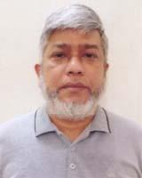 | DR. MD. MUKITUL HUDA  F/Name: Shamsul Huda  M/Name: Masuda Shahana  BM & DC Reg. No: 24853  NID: 8658708527  Cell: 01768994694  Address: Khulna Medical College.  Blood Group: O-
1113 | Voter No  LM-2901108 | DR. SHAOLI HASAN  F/Name: Prof. Dr. Kazi Abul Hasan  M/Name: Prof. Dr. Shamsun Nahar Lucky  BM & DC Reg. No: 108340  NID: 2396815546  Cell: 01768455560  Address: 58, Ahsan Ahmed Road, Khulna.  Blood Group: B+
1114 | Voter No  LM-2901109  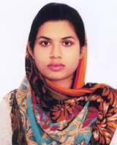 | DR. SHAJIDA RUMPA  F/Name: Rezaul Karim  M/Name: Farida Parvin  BM & DC Reg. No: 100667  NID: 19932611038000547  Cell: 01798378401  Address: C/O Rubiat Mustak (Ass: Prof Dept: of Machanical Eng:) Kuet, Khulna-9203  Blood Group: B+
1115 | Voter No  LM-2901110  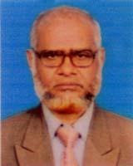 | DR. FM SHAHJAHAN ALI  F/Name: Late. Fm Harun-ur-rashid  M/Name: Late. Uzala Begum  BM & DC Reg. No: 12300  NID: 4795129502222  Cell: 01718152834  Address: 619, Mujgunni R/A, Road No-12, Khulna.  Blood Group: O+
1116 | Voter No  LM-2901111  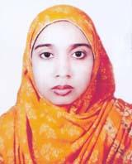 | DR. SADIA FARZANA EPPA  F/Name: Mulla Rafiuddin Ahmad  M/Name: Jolly Nasrin  BM & DC Reg. No: 100335  NID: 6443626509  Cell: 01790854404  Address: 60, Gogon Babu Road, Khulna.  Blood Group: O+
1117 | Voter No  LM-2901112 | DR. MD. ASADUZZAMAN  F/Name: Md. Azizur Rahman  M/Name: Aktar Banu  BM & DC Reg. No: 57593  NID: 19874795124452713  Cell: 01712995822  Address: 1/7, Gogon Babu Road, 1No, Custom Ghat, Khulna.  Blood Group: AB+
1118 | Voter No  LM-2901113 | DR. SHAIKH SALMAN SALAM  F/Name: Shaikh Abdus Salam  M/Name: Kamrun Nessa Salam  BM & DC Reg. No: 83884  NID:  Cell: 01714470690  Address: Gazi Medical College Hospital Khulna.  Blood Group: AB+
1119 | Voter No  LM-2901114  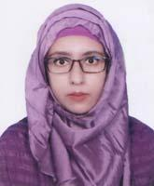 | DR. NISHAT TASNIM  F/Name: Mollick Moniruzzaman  M/Name: Nurun Nahar  BM & DC Reg. No: 99242  NID: 5953555876  Cell: 01979051177  Address: 31/13/Ka, Doctor Para Road, Choto Boyra Sonadanga, Khulna.  Blood Group: B+
1120 | Voter No  LM-2901115 | DR. SHAH ISHRAT ALAM BRINTO  F/Name: Shah Iftikhar Alam  M/Name: Shirina Alam  BM & DC Reg. No: 117947  NID: 4639315359  Cell: 01760662501  Address: Road-6, House-105, Nirala, R/A, Khulna.  Blood Group: O+
1121 | Voter No  LM-2901116 | DR. NAYAN PAUL  F/Name: Robin Paul  M/Name: Archona Paul  BM & DC Reg. No: 128797  NID: 6004296387  Cell: 01783411149  Address: Vill: Tipna, Post: Khuria, Dumuria, Khulna.  Blood Group: B+
1122 | Voter No  LM-2901117 | DR. SAGAR ROY  F/Name: Asit Baran Roy  M/Name: Kollani Roy  BM & DC Reg. No: 128812  NID: 5551839011  Cell: 01933641084  Address: Vill: Hazidanga, Post: Saziara, dumuria, Khulna.  Blood Group: B+
1123 | Voter No  LM-2901118 | DR. S.M. MAHMUDUL HAQUE  F/Name: S.m. Nurul Haque  M/Name: Mrs. Mahmuda Haque  BM & DC Reg. No: 109151  NID: 3752541270  Cell: 01908100454  Address: Korania Madrasa Road, Pabla, Doulatpur Khulna.  Blood Group: AB+
1124 | Voter No  LM-2901119 | DR. HORIDAS KUMAR PAUL  F/Name: Niranjan Kumar Paul  M/Name: Biva Rani Paul  BM & DC Reg. No: 44049  NID: 2691650162245  Cell: 01720344996  Address: Doctor's Quaters, Boira, Khulna.  Blood Group: B+
1125 | Voter No  LM-2901120 | DR. SM ASHFAQUE SADIQUE  F/Name: Shaikh Md. Anowarul Haque  M/Name: Sultana Shamima Yesmin  BM & DC Reg. No: 76370  NID:  Cell: 01555012755  Address: 32/2, Boyra Farukeya Masjid Road, Boyra Gpo-9000 Boro Boyra, Khulna City Corporation, Sonadanga, Khulna.  Blood Group: B+
1126 | Voter No  LM-2901121 | DR. SANJANUR SANIM  F/Name: M.m. Jamil Hayder  M/Name: Sonia Afrin  BM & DC Reg. No: 109619  NID: 1953081567  Cell: 01933174857  Address: 7/1, P.T.I More, Miapara, Khulna.  Blood Group: A+
1127 | Voter No  LM-2901122 | DR. RIDOY SAHA  F/Name: Nando Saha  M/Name: Shipra Saha  BM & DC Reg. No: 116418  NID: 5102693032  Cell: 01963993258  Address: New Beipara, Jashore Sadar, Jashore.  Blood Group: B+
1128 | Voter No  LM-2901123  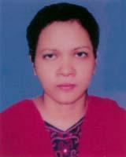 | DR. SINTHIA PAROI  F/Name: Bivash Paroi  M/Name: Manolina Paroi  BM & DC Reg. No: 49966  NID: 1466362090  Cell: 01716078012  Address: House No: 174, 58 Khanjahan Ali Road, Sachin Para, Rupsha, Khulna.  Blood Group: B+
1129 | Voter No  LM-2901124  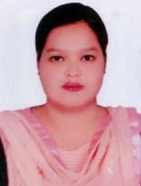 | DR. SHUVOSHREE SAHA SRISTY  F/Name: Sahassita Nanda Saha  M/Name: Kalpana Rani Saha  BM & DC Reg. No: 117977  NID: 7802649082  Cell: 01533627753  Address: 2 Number Kashtomghat, Khulna.  Blood Group: A+
1130 | Voter No  LM-2901125 | DR. PROVA RANI SARDAR  F/Name: Provash Chandro Sardar  M/Name: Uttra Rani  BM & DC Reg. No: 107039  NID: 19948714747000113  Cell: 01926000070  Address: 24/1 Ka Noor Mosque Road West Tooth Para Khulna.  Blood Group: O+
1131 | Voter No  LM-2901126 | DR. MD. ASHIKUR RAHMAN  F/Name: Md. Jabed Ali Zamaddar  M/Name: Shamchhun Nahar  BM & DC Reg. No: 101860  NID: 8693902705  Cell: 01767600432  Address: 31/9 (GA), Chotoboyra, Doctor Para, Sonadanga, Khulna.  Blood Group: O+
1132 | Voter No  LM-2901127  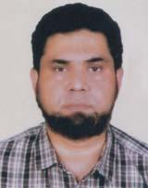 | DR. SHARIF SAMMIUL ISLAM  F/Name: Dr. Md. Nurul Islam  M/Name: Momtaz Begum  BM & DC Reg. No: 32287  NID: 2350540684  Cell: 01715295104  Address: 63. Mojid Sworoni Sonadanga, Khulna.  Blood Group: O+
1133 | Voter No  LM-2901128  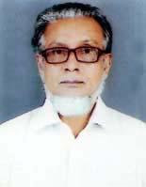 | DR. ABU REZA AZIZ AHMED CHOWDHURY  F/Name: Asraf Uddin Maqbul Chowdhury  M/Name: Afia Khatun  BM & DC Reg. No: 10463  NID:  Cell: 01718444319  Address: 73/1, Sultana Ahmed Road Moulovi Para Khulna-9100  Blood Group: A+
1134 | Voter No  LM-2901129 | DR. MURSHIDA SHABNAM  F/Name: Humayun Kobir  M/Name: Anowara Begum  BM & DC Reg. No: 87527  NID: 3278055276  Cell: 01686554639  Address: Pabla Sabuj Sangho Road Daulatpur Khulna.  Blood Group: A+
1135 | Voter No  LM-2901130 | DR. MD. TAIFUR RAHMAN  F/Name: Mollah Ayub Ali  M/Name: Taslima Akter  BM & DC Reg. No: 101788  NID: 3733865194  Cell: 01517819677  Address: 83/2, Boyra Junction Road, Soburer More, Boyra, Khulna.  Blood Group: O+
1136 | Voter No  LM-2901131  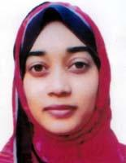 | DR. UMME HABIBA TRINA  F/Name: A.k.m. Liakat Ali  M/Name: Selina Liakat  BM & DC Reg. No: 87612  NID: 5957054272  Cell: 01517057815  Address: 83/2, Boyra Junction Road, Soburer, More, Boyra, Khulna.  Blood Group: A+

